Sewell Reserve, Glenroy

Park Upgrades 2024

Consultation summary report
Prepared by
Phil Smith Landscape Architect
Open Space Design & Development Unit
October 2023
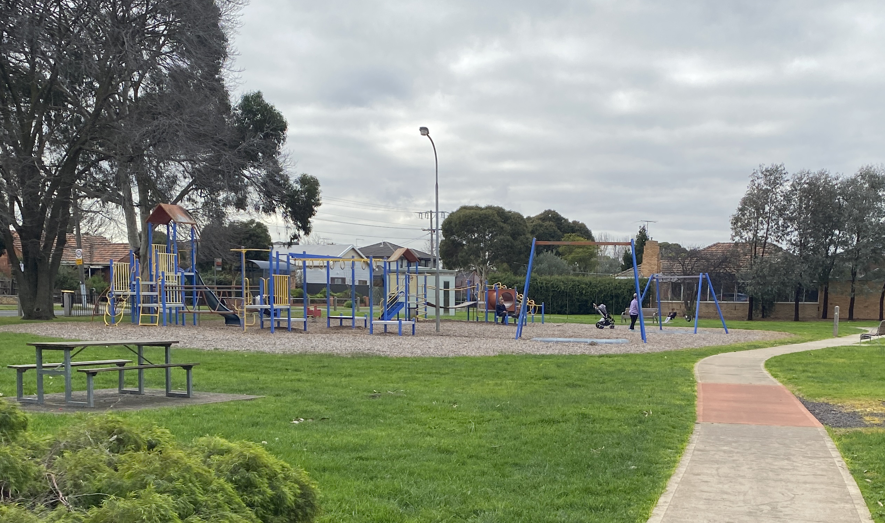


Sewell Reserve

Consultation summary report

October 2023
Council has funded upgrades to Sewell Reserve in the 2023-24 period. Works are to occur across two financial years allowing for a longer design and consultation period before construction. The scope of works includes a full reconstruction of the existing play space, a fenced dog park and general park amenity upgrades.
- Background
Council’s Open Space Design and Development unit are conducting three consultation phases with the
local community for the upgrade of Sewell Reserve, Glenroy.
- Initial Consultation
Council have requested input from the community in Glenroy about what they like about Sewell Reserve and what they would like to see included in the upgrades.
- Draft Concept Plan Consultation
Council will develop a draft concept plan from the input received and submit this to the community for further input.
- Final Concept Plan Consultation
This final concept plan will reflect changes from the draft concept plan, incorporating the community’s
feedback where possible. This final concept plan will close the consultation process, prior to the team
proceeding to detailed design.

Consultation timings:
Voting exercise: 6 September – 6 October 2023
Draft concept plan consultation: Jan-Feb 2024
On-site community meeting: April 2024
Final concept plan issued: July 2024.

For the initial stage of the consultation, postcards were distributed to 4000 households within 800m of Sewell Reserve.
For the draft concept plan consultation, postcards will be distributed to the same 4000 households, advising residents that they can provide feedback on Council’s website at
https://conversations.merri-bek.vic.gov.au/sewell-reserve-glenroy. Posters will also be displayed through Sewell Reserve showing the draft concept plan and inviting people’s responses. An on-site consultation meeting will be held in February before responses close.
The final concept plan will be displayed on the website and on-site posters following completion of feedback on the draft concept
plan. Thereafter the Open Space Design and Development team can proceed to detailed design.

- Initial Feedback Findings
Responses closed on 6 Oct 2023 with 106 contributions and 814 site views. This is considered an excellent level of engagement.
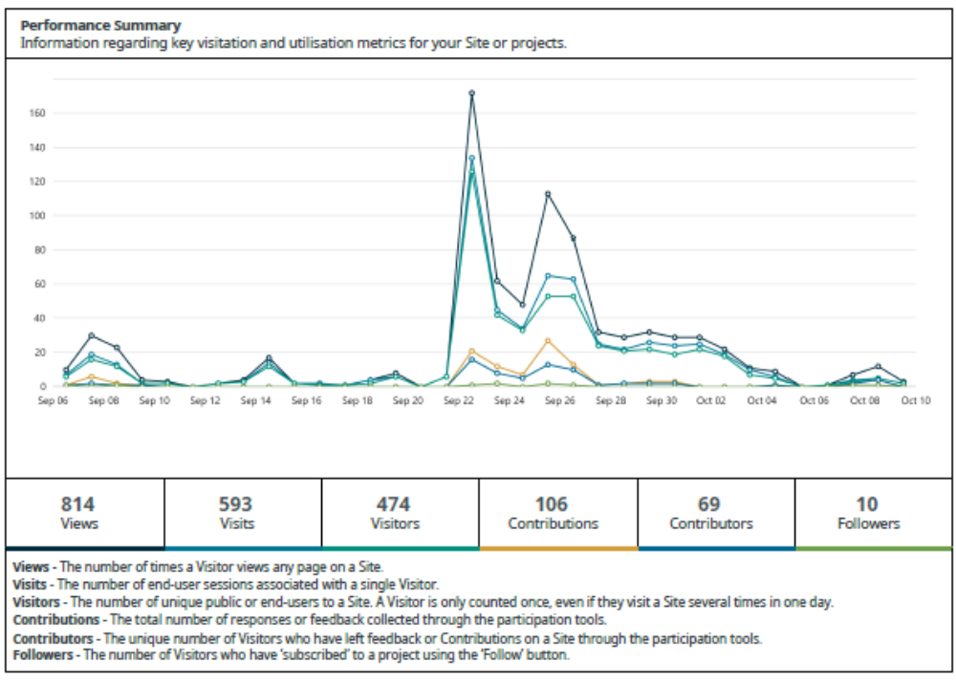
Figure 1: Graph of website engagement
55 comments related directly to children and play. All were supportive of the upgrade.
30 comments related directly to the fenced dog park. All were supportive of the fenced dog park.
16 comments related to park amenities.

A summary of the issues of most concern for the community is as follows.
Play space related;
- Nature play - 7
- Water play - 10
- Fencing to Glenroy Rd. - 11
- Range of ages – 6
- Seating for parents/families - 5
- Shade – 4
- All abilities - 1
- Specific equipment
  - Flying fox - 3
  - Slides - 3
  - Swings - 4
  - Climbing – 3
  - Sandpit – 3
  - Monkey bars - 2
Dog park related;
- drinking fountains with dog bowls – 3
- space for larger dogs - 7
- maintain off-lead area outside fenced dog park – 2
- Keep dogs off oval - 2
- Poo bags and bins – 1
- Agility equipment - 1
Amenities related;
- Toilets – 4
- Rubbish - 3
- Running circuits –
- Lighting – 3
- BBQ/shelter - 3

- Draft Concept Plan Consultation Feedback Findings
Consultation feedback from this stage will be included here.

- Final Concept Plan
A summary of the final concept plan will be added once it has been completed.

- Next Steps
The Open Space Design and Development team are developing a draft concept plan, using feedback received from the initial feedback stage. Once ready, this draft plan will be displayed to the community via the website, alerts by postcard and on-site posters, inviting review responses.
The final concept plan will then be developed, reflecting feedback on the draft concept plan. Thereafter the Open Space team will produce detailed design and procure materials so can construct with intention of completing works before end of 2024.
- Further information
Any questions can be directed to Council’s Open Space Design & Development Unit via email openspace@moreland.vic.gov.au or by phoning 9240 111.
- Appendix
Below is all feedback received from the community for each stage of consultation for the Sewell Reserve and images of the posters and postcards issued.
7a Initial consultation
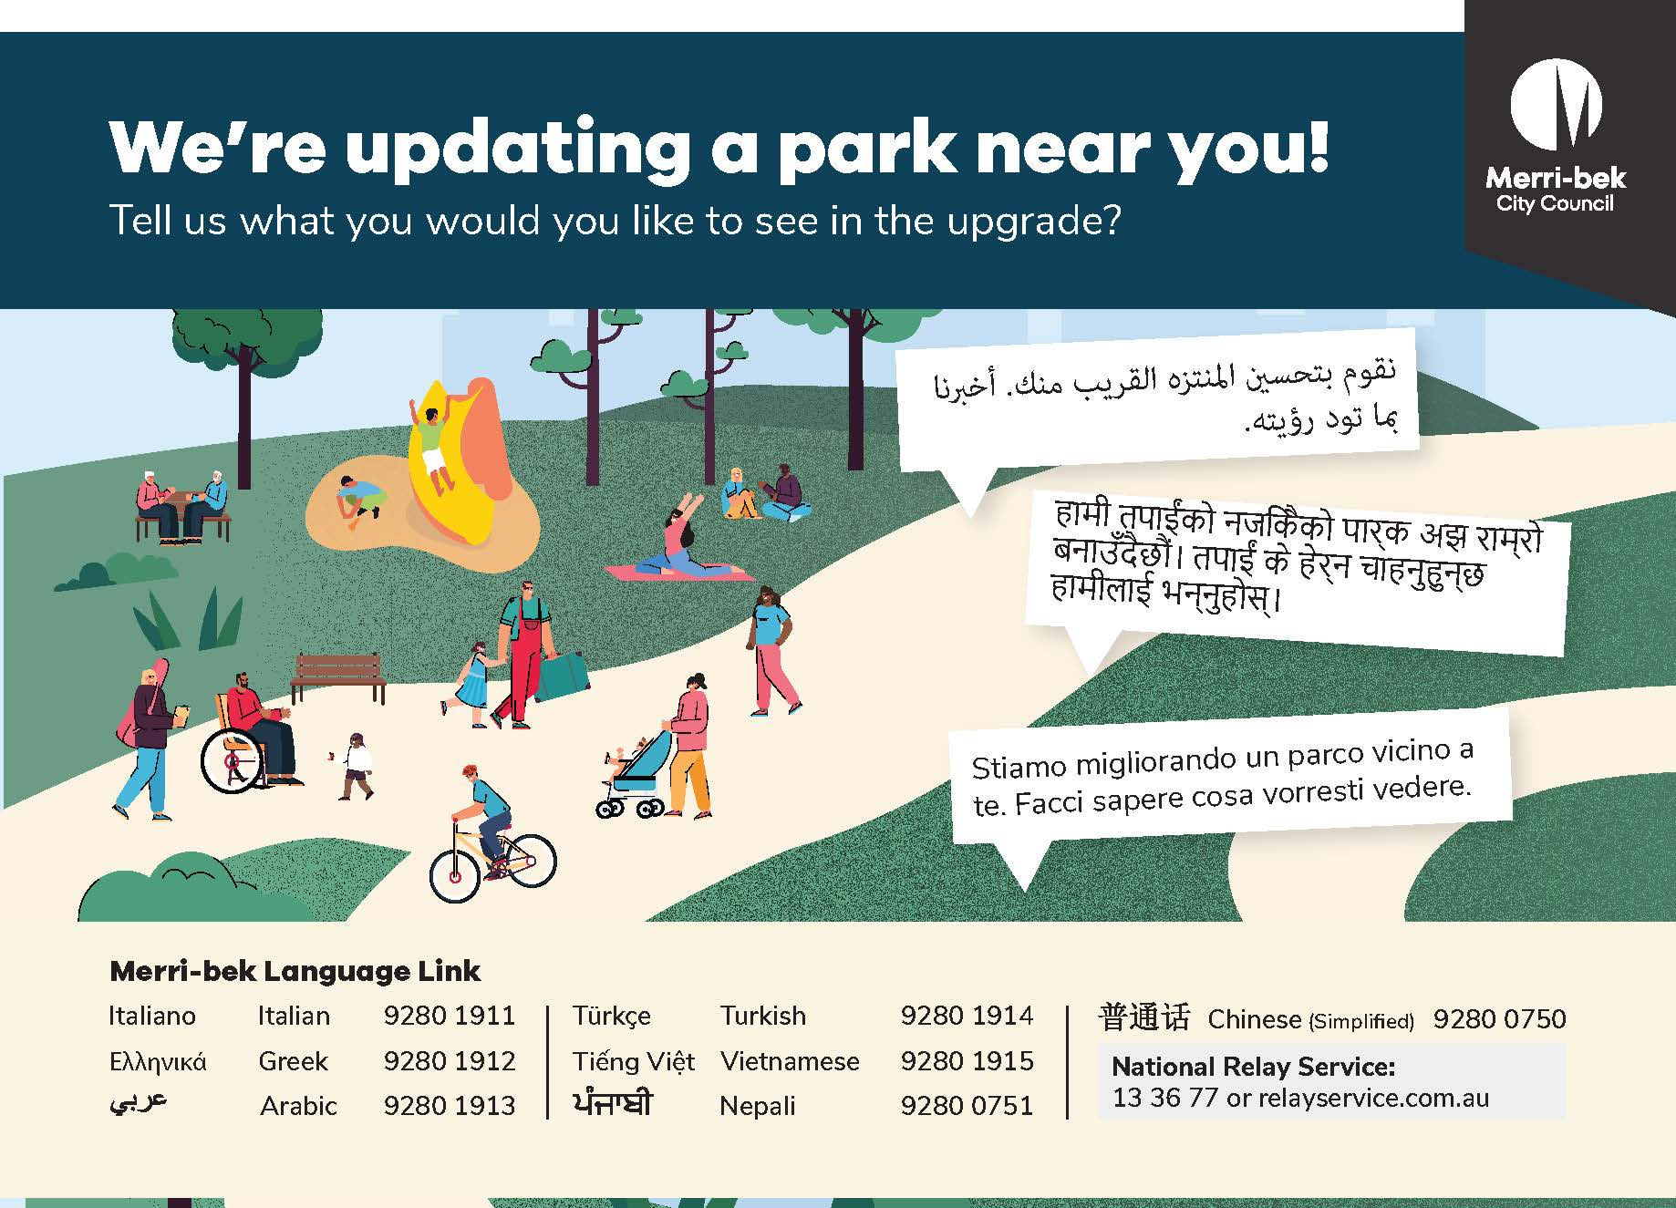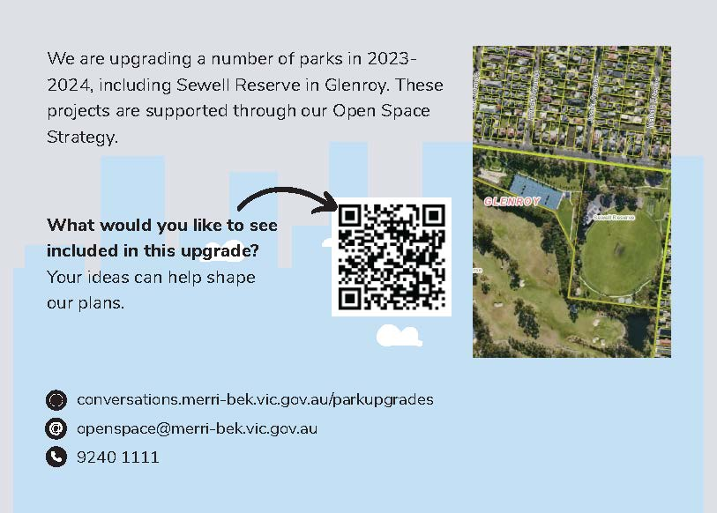

Figure 3: Postcards issued to households within 800m of Sewell Reserve.

7b Initial Consultation Responses
The following are responses to the initial consultation for Sewell Reserve upgrades from 6th September – 6th October 2023:

Response
Check out Warburton water parkNow that’s something to aspire too!
More 24 hour public toilets would be great! I love to go for walks in the evening.
I really would love the existing play space to be converted into a large garden with native flowers such as bottle brushes and kangaroo paws
Water park. Natural play space/climbing areas (like Royal Children’s Hospital playground). BMX dirt track to spread demand on skate park.
Would love to see some a more modern and versatile kids playground for a variety of ages, incorporating elements of the natural environment
A fenced off dog area with suitable amenities such as multiple drinking fountains, dog poo bags, more bins, etc.
I’d like to see automatic toilets put in at Sewell Reserve. Thanks.
Second the idea of water play features for kids like Cardinal rd play ground - but don’t sacrifice a slide this time!
Please improve play equipment. Maybe consult some actual children? It would be great to have things for a variety of ages eg 2-10.
To cater for a more well equipped and sizeable dog park, I suggest that the ‘open overflow space’ and overflow space be swapped around
Fenced dog park would be amazing for the community! With grass rather than dirt grounds please. Or else the dogs will dig holes!
A kids playground with water features and soft flooring like the one on 132 Cardinal Road! With shaded areas of course :)
Ensure that the park is maintained after its refurb so sad to see broken glass graffiti everywhere making it a real dump! Make glenroy cool
New playground to be ‘adventure style’ with water play & similar natural design & landscaping to the one next to royal children’s hospital
Please leave the basketball courts because they seem to get used more than the netball courts. Revamp gym area to make it more inclusive.
A running track around the oval
Appropriate fencing to ensure kids aren’t able to run to the busy road or carpark.
Water play space that caters for all ages and abilities. Would be lovely to see something of this kind within our council
I’d like to see more bench and picnic tables and chairs for parents supervising at park and skatepark. Similar to seating at raeburn reserve
Really love to see new concept play area, something that makes u want to go there - similar to cross keys reserve pirate park Water play. Shade
A small bike track for kids with stop signs, speed bumps etc. look at elevation blvd Craigieburn for examples
Another outdoor fitness area with Duffey equipment would be fantastic please.
Hadfield Park in Wallan have built a water park, that would be a great addition for Sewel Reserve. Toilets & change rooms for b/ball courts
A soccer pitch would be a great addition for a multi-functional sport area of basketball/netball. 1 of the existing courts can be repurposed
Some form of water play would be a fantastic addition to the children's play
An improved playspace with updated features, additional fitness equipment, designated dog off lead area, with drinking fountain.
Park needs more parking as you cannot park anywhere when the football is on including the streets surrounding!
A running loop that can help extend the 4K around the golf course into 5k.
Small dog park area would be fantastic. Fully support this idea.
Our kids like to go there but they get bored easily as there’s not much to play. A flying fox would be nice and shaded play area too.
Shading over the gym equipment and other areas to conduct outdoor exercises. A bike lane to avoid Glenroy road would be fantastic! More bins
A secure dog park fence with gates
Yes , keep dogs off the oval . No pooling there .
Id like to lay down on the grass on the oval without thinking .... Has a dog pooped here.
We would love a closed off leash dog area for the dogs to play when footy is on. Also another drinking fountain with dog bowl on the oval.
happy the playground is getting an upgrade. Love that there will be a dog space. More bins at the scoreboard end would be great.
Closed gated area for dogs to play & socialise off lead & not run out to the road. My dog has no recall or road sense, loves to run & play with dogs
A flying fox would be amazing as well as play equipment aimed at younger kids.
“themed” main equip such as a boat or digger =)
Toilets Shade sails Large slide Picnic tables BBQs
Love the idea of moving the playground to a more shaded area. would be great for the playground to be fenced to ensure safety along the road
Love the idea of moving the playground to a more shaded area. would be great for the playground to be fenced to ensure safety along the road
A family friendly playground with comfort, exercise, safety and modern equipment for challenging kids of all ages
A playground for all ages, even pre teens and teens please
The look of the playground should reflect nature, natural fibres , wood, nice colours, modern , not old looking . Finally an update, woohoo!
Please create comfortable seating for carers under trees so we can watch our children play .The playground needs to be away from the road
No dogs in playground please. They are scary
A big sandpit
A sand pit, straight not circular monkey bars , water fountain, keep dogs out , safety and trees with shade
A long flying 🦊 fox .
My kids said they would like to see climbing for older children, a sand pit ,a see saw , straight monkey bars, a big swing for all ages .
Please update this playspace for my kids who are 11 and 8. Please cater for all ages and parents too
Swell reserve needs to be upgraded!! The equipment is too old , also needs to be fenced off as it’s so close to the road which is very busy
So happy to hear this! I've been waiting for a very long time, lots of years for the play space to be upgraded. My kids are eleven 8
Fenced in dog park but please not made of just dirt so that it becomes a mud pile it rains
An inclusive park, that has almost everything l. Just the children's play area is underwhelming, would love it of the playground was updated
Improve the kids play ground, incorporate some more shade. This is prime location to many residents and is well used by all ages, mostly 1-5
Keep this park kid friendly it gets so much foot traffic at all times of the day. Fenced dog park is more suitable.don’t see many dogs now
It need a much bigger playground for older kids and younger. Needs climbing, safety swings and large slides. It also needs water park
A dog fenced enclosed area is an excellent idea and we fully support it. That’s a great spot as well - and good to have a fenced area
Upgrading playground is fantastic! Please include interactive equipment such as bells that you can step on for kids, bridges and tunnels.
We need more dog parks in and around Hadfield and Glenroy.
We need more space for dogs and less for children
Even small dogs like to run
Would love to see the off lead area stay or be expanded! It’s the only off lead area we can walk to.
Playground needs to be fully enclosed with gate. Not safe!
New playground location floods and water logged 4 days- needs better draining
The playground needs to be fully enclosed with a locked fence. Very unsafe!
New location floods and is water logged for ages! Needs drain
Enclosed fence for the playground. Multiple kids have almost been hit by cars . It’s extremely unsafe.
Upgrade the running track around the Sewell reserve and golf courae area.
I would love to see a fully fenced well lit dog park that can be used all year.
Water and sand play please!
Sometimes the play area can feel unsafe, please consider location to make sure it’s not too secluded and has taps and lights.
Mix of nature play and traditional play equipment.
Please keep the dog park fenced so families without dogs can enjoy the area safely.
The playground caters for safe play for all ages and i’d like to see that continue. Pipemakers Park playground in Maribyrnong great example.
Dog park. Tree-lined walking paths that meander through the reserve. Shade.
Playground fenced off
All abilities swing and web swing
Large shaded seating/ BBQ areas
Updated play equipment in natural materials.
Fenced in play ground as too close to the road. A nature based/new playground. More beautification . More tables/space for families
The current play equipment is some of the best in Glenroy as it is simple and Carter’s to all age groups. Maybe add a fence on the road side
I barely go there.
We use this playground several times a week and would love to see play equipment that is suited to everyone. A splash park would be awesome!
Dog park section adjacent to the basketball court - long
We need a new park for kids with more seating and a fenced gate. Cars zoom down and kids can run in main road. Please build a good size park
A large dog park so people like me who has dogs can go and let them off without having to worry about them running away.
A dog park! I would also like to see an upgrade of the play equipment. It’s at least 25 years old (if not older).
We'd love to see a larger than proposed fenced dog area. We often use the courts if they're unused. A dedicated space would be perfect.
We'd love to see a larger than proposed fenced dog area. We often use the courts if they're unused. A dedicated space would be perfect.
A dog park not including large dogs is not a good idea. They need to run too.
It’s like building a playground for 2 year olds only.
Look at the all abilities playground in MilL Park of what a playground could be like? merribek has really terrible playgrounds
Agility area for all dogs (larger ones included)
I think the park is perfect for runners, but feels unsafe for lack of lighting when is too early or dark. Specially for women.
I run every day around the park. I also walk my dog and let her play with others dogs in the oval.
I love running and walk my dog around the park, sometimes I spend time with my dog and other owners in the oval.
I love to see families with dogs and babies in once space, but I think is missing a space for dogs!
I love to see families with dogs and babies in once space, but I think is missing a space for dogs!
I hope there are more slides or facilities for children to play.
I hope there are more slides or facilities for children to play.
We have existing play space expands to it's new proposed play space location along with BBQ, Netball and basketball courts and events space.
I love walking around the oval with my dog, however the amount of rubbish that is discarded is a real concern. The off-leash area is perfect
I love walking around the oval with my dog, however the amount of rubbish that is discarded is a real concern. The off-leash area is perfect
Consideration should be given to a higher fence near the netball courts. I have seen golfballs land on the courts
A bbq area would be a nice addition, with a shelter that could be used for gatherings
If the playground is moved closer to the carpark, a fence should still be included to reduce risk. Playground will be close to road still
It is stated that the proposed dog park is not suitable for big dogs, however big dogs will still enter the space which may cause issues
I would like to see a fenced play area. Glenroy road is very dangerous. There has been an increase in hooning and disobeying speed limits
Block cars fr entering behind the pavillion, shld be pedestrian/bike access only
Improve gravel car park on golf course side - pot holes
The beautiful gum trees are such a great feature. Would love to see a play space with a nature theme for all ages of kids.

7c Draft Concept Plan Consultation
Draft concept plan posters and postcards will be displayed here once ready.

7d Draft Concept Plan Consultation Response
Draft concept plan feedback will be displayed here once draft concept plan consultation stage has closed.

7e Final Concept Plan
An image of the final concept plan will be added here when the final concept plan has been developed.

