

How Merri-bek Council will ask for your feedback


  - Easy Read

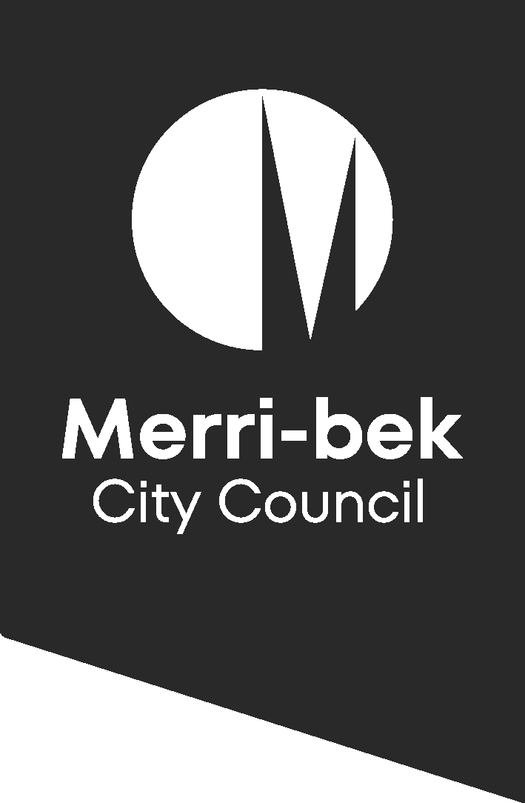
 | Merri-bek City Council wrote this.  When you see the word we or us,  it means Merri-bek City Council.
 | Acknowledgement of Country  We acknowledge the  Wurundjeri Woi wurrung People  as the Traditional Owners of Merri-bek.  They have a strong connection to the land, water and sky.  We respect Elders past and present.
 | We wrote this in an easy to read way.  We use pictures to explain some ideas.  We call this Easy Read.
 | This Easy Read document is a summary of a longer document.  The longer document is the Community Engagement Policy 2024.  We will call this the Policy.
 | We also have a plain language version of the Policy.  You can find the plain language version on our website:  https://conversations.merri-bek.vic.gov.au/sharing-information  Or you can scan this QR code:  
 | The Policy is about community engagement.  Community engagement means including you in how we make decisions.  This includes doing things like:  - Completing a survey  - Having a conversatin about a project.  - Providing feedback online.
 | We have the Policy to help people:  - Know how and when to provide feedback to us  - Understand how we will use that feedback.

 | People in Merri-bek may find it hard to provide feedback to us.  For example, some people:  - Speak languages other than English  - Don’t know where to find information  - Don’t know that they can provide feedback  - Are new to Council
 | Our Policy says that everyone has the right to be involved.  It says we should try to include everyone in our decisions.
 | The Policy includes 5 ideas for how we will include everyone. Community engagement must be:  - Meaningful  - Informative  - Representative  - Inclusive  - Organised
 | The Policy includes different ways we will ask for feedback on different projects, such as:  - Small-scale traffic changes  - Creating new parks  - Our yearly budget  - Our longer-term goals.

 | We will try to understand what is important to you.  We will:  - Give you time be share feedback  - Listen to you  - Use your ideas to improve our work.
 | We will tell you how we will use the information you give us.  We will do this:  - In reports that go to Council  - Online on the Conversations Merri-bek website  - On our social media channels  - In our newsletters  - Directly to you, if we have your contact information.

 | Everyone at Council needs to follow the Policy.  This includes:  - Councillors  - Leaders  - Staff  - People who we hire to do jobs for us. We call them ‘contractors’.
 | The Policy also includes information about how we will protect your privacy and how you can make a complaint.

