
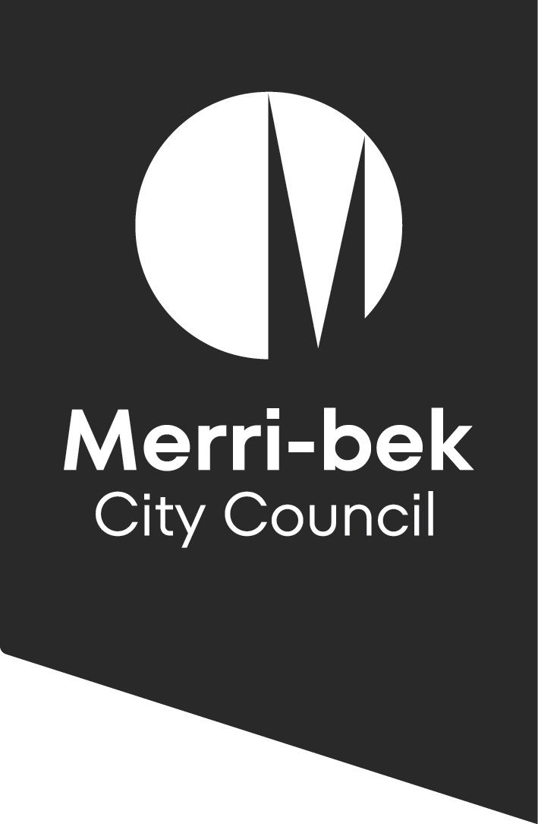

Merri-bek Libraries

  - Library Strategy 2026-2031
Introduction
This strategy will;
- describe the environment in which Merri-bek Libraries is operating, locally and at a broader level
- outline the community we serve
- celebrate achievements of the Library Strategy 2019
- define how we have engaged with the community
- reflect what we have heard from the community
- commit to acting on what we have heard from the community
- set a direction that ensures the Merri-bek community has a contemporary library service offering sustainable services and programs in welcoming spaces

Victorian Public Libraries
Victorian Public Libraries are constantly evolving. Providing access to information, shared resources and shared spaces, public libraries are one of very few locations where you can access free loans, services and space. Whether you’re seeking answers to a specific question, a place to learn, or simply somewhere to spend time without financial pressure, your local library is here for you.
Across Victoria, public libraries are navigating reduced state government funding at the same time community demand for services, collections, and programs continues to grow. During a cost-of-living crisis, free services, such as the local library can help make ends meet.
As a library user, you are in good company - almost 1/3 of all Victorians are library members and many non-members visit libraries and use their services and programs.
A rise in loneliness has emphasised the role of the library as a facilitator of community connection. There is more social programming in libraries such as Conversation and Craft Clubs, late night opening hours and partnerships such as Chatty Café, increasing opportunities for connection in the library.
Increased anti-social behaviour has impacted public libraries, creating a challenge to ensure that these loved spaces remain safe for community and staff. Libraries are implementing interventions including security guards, abolishing fines and increasing opportunities for building connections with others to address this social change.
As lives get busier, there is increased demand for longer library opening hours, libraries across the state are meeting this demand through increased operating hours, digital collections available 24/7, new libraries, lockers for item collection outside of operating hours and unstaffed access to make accessing the library more convenient.
With government services moving towards a digital-first delivery model and the rise of AI, libraries are experiencing increased demand for digital help, which they are addressing with digital literacy programming, delivered by library staff and in partnership with specialist organisations and referral to community support organisations.
Early Literacy continues to be a focus for public libraries, even after the introduction of free 3 year old kinder, programs such as Rhyme Time and Storytime continue to be in high demand, providing early literacy education for our youngest community members and support for parents and carers as their child’s first teacher.

The Merri-bek Community
Merri-bek Libraries provides services to a proudly diverse community;
Total population 186, 534, with 44,908 library members
Speakers of languages other than English exceed the metropolitan average, especially in the north of the city.
SEIFA index shows high levels of disadvantage in the city, particularly in the north.
AECD data shows improvement in school readiness, but there is still work to do here.
An average of 49 people visit a Merri-bek Library each hour that they are open
Merri-bek has a higher than average number of lone person households and renters

Alignment
Sustainable Development Goals
These goals, developed as part of the United Nations 2030 Agenda for Sustainable Development, recognize that ending poverty must go hand-in-hand with strategies that build economic growth and address a range of social needs including education, health, social protection, and job opportunities, while tackling climate change and environmental protection.
The International Federation of Library Associations and Institutions (IFLA), advocates for libraries to be recognised as essential partners for inclusive, sustainable development, through their work to provide meaningful access to information for all.
Merri-bek Libraries will aim to align with these goals and identify this work in our action planning.
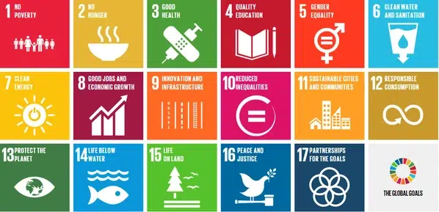
Merri-bek Council Plan
Merri-bek Libraries will deliver against the Council Plan in the following areas;
- Care for nature and climate resilience
– Supporting and encouraging the local community efforts to fight climate change
- Healthy and inclusive communities
– Providing accessible spaces, facilities and programs that support community health and safety
- Providing affordable activities and spaces for youth, seniors and families to participate and feel independent
- Supporting local food initiatives to increase access to healthy, affordable food
- Beautiful and liveable city
- Keeping public places, spaces and areas well-maintained, safe and inviting for community use
- Thriving economy and culture
- Promoting and supporting local art, festivals, and events celebrating our community’s diversity
Merri-bek Libraries
The Library Services Strategy 2019 set out 5 Key Priorities, and the following actions were implemented.
- Connect
- Dedicated programming delivered for and with LGBTIQA+ community members, people living with a disability, First Nations people and young people
- Ongoing late night library hours and programming at Glenroy Library
- Community led events such as chess club, community jigsaws and craft clubs established
- Justices of the Peace at libraries
- Library Social Worker Program introduced to connect in need community members to services
- A workforce more reflective of our diverse community
- Curate
- Programming Framework implemented
- New Library Management system, self-serve kiosks and Library app introduced
- More digital and streaming items available for loan
- Library of Things introduced
- Ganbo marra, First Nations collection established
- Bookshop style arrangement of Non-Fiction implemented
- Discover
- MakerSpaces introduced at Brunswick, Coburg and Glenroy Libraries
- Collaboration with other areas of Council to deliver large-scale events at libraries
- Learn
- Responsive program of digital support offered at the libraries
- More multi-cultural storytimes introduced
- Place
- Increased opening hours in response to community need
- New Glenroy Library opened in the Glenroy Community Hub
- Coburg Library and Piazza planned
- Planning for Brunswick, Campbell-Turnbull and Fawkner Libraries to be renovated
- Facility upgrades to improve safety and amenity

Merri-bek Libraries over the years.
Visits
In a turnaround since the last library strategy, visits to Merri-bek Libraries are growing. Ensuring that we have buildings which can support this demand is a priority.

Loans
You told us that collections are important to you, and the numbers support this. We will be curating relevant and innovative collections to meet this demand.

Active Borrowers
Merri-bek library members use of collections makes them one of the most active borrowing cohorts in the state. We will maintain collections which attract and support high usage.

Program Attendance
Attendance at library programs in Merri-bek has exceeded pre-pandemic numbers. We will target these programs so that they deliver the best value for the community and attendance numbers are maintained.

Community Engagement
Significant Community Engagement was undertaken to inform this new Library Strategy.
There were over 520 responses to the survey online and at in-person events, including;
- 84 people from the LGBTIQA+ Community
- 75 people living with or caring for someone with a disability
- Representation from a range of language groups
Over 100 people joined the online conversation
80 Children contributed their thoughts about the library at the Children’s Forum
More than 100 Post-it notes were contributed by children in the libraries

We are guided by the Merri-bek Community Vision
Merri-bek leads, and leaves no one behind.
- We are a welcoming, safe and thriving community
- We are sustainable, and our environment is respected
- Our community is engaged and informed
- Our streets are full of life
One community, proudly diverse.

Merri-bek Libraries
A contemporary library offering sustainable services and programs in welcoming spaces
What we heard | What we will deliver
Welcoming places : Merri-bek Libraries are welcoming, flexible and inclusive places for everyone in the community.
Libraries need flexible physical spaces to support a range of different uses | - New Coburg Library and Piazza  - Program of library refurbishment to increase amenity, access to study space and support programming at Brunswick, Campbell-Turnbull and Fawkner Libraries
Inspiring collections : Our collections inform, inspire and entertain, evolving to meet the changing needs and interests of the community
- Physical collections are still very important  - Strong support for borrowing non-book items (Library of Things)  - Demand for digital collections continues to grow | - An exciting Library of Things  - News about all the great library collections and how to best use them  - Inspiring digital and physical collections  - Increased digital help opportunities at the library
Community connections : Programs and services provide more opportunities to create, celebrate, learn and connect at the library.
Library programs are popular | - An annual large-scale celebration to bring the community together  - Programs that support social cohesion, social connection and build a sense of community belonging  - Range of programs designed specifically for and with our priority cohorts;  - Aboriginal & Torres Strait Islanders  - Migrant, refugee, and faith communities  - People with disability  - Women, girls, and gender diverse  - LGBTIQA+ communities
Contemporary library service : Library staff reflect our diverse community, and are trained to provide an excellent, tailored service to the Merri-bek community
- Strong support for libraries to be open more on evenings and weekends  - Library staff are valued  - Library Social Worker Program is valued | - Opening hours reflect community expectations, including for staffed library opening hours. (Unstaffed library hours will not be implemented, in line with a March 2026 Council decision.)  - The best possible service and support provided by skilled library staff  - An enhanced Library Social Work Program to support vulnerable community members

