

Community Engagement Policy

  - Plain language summary

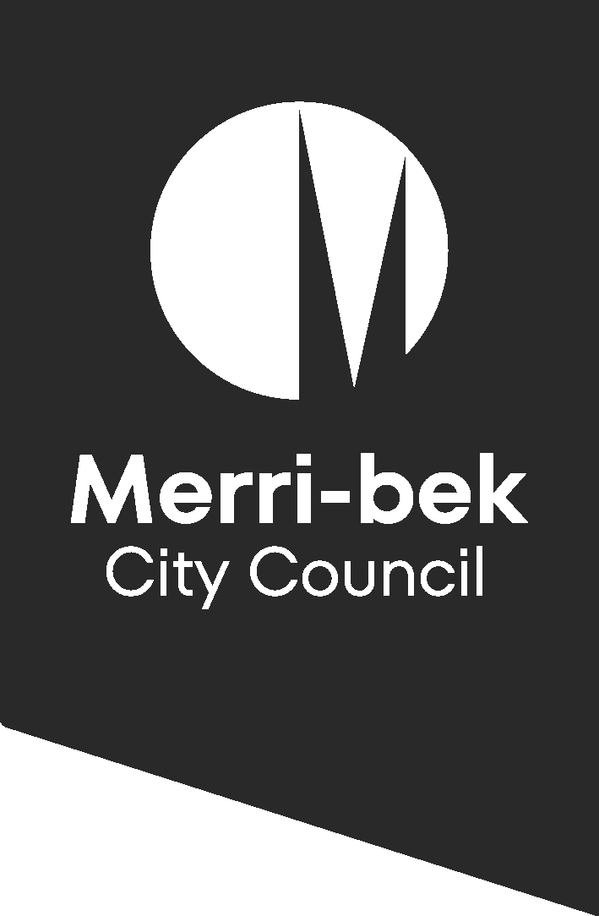

Plain language summary
This document is called a plain language summary.
It gives you the key information that is in a longer document called the Community Engagement Policy. We will call this longer document the Policy. The Policy is written by Merri-bek City Council.

Acknowledgement
We acknowledge the Wurundjeri Woi-wurrung people as the Traditional Owners and Custodians of the land and waterways in the area now known as Merri bek. We recognise their ongoing connection to the land, water, and sky Country, and we pay our respects to Elders past and present for their continued care of Culture and Country.

Purpose of this policy
Merri-bek City Council wants everyone in the community to be involved in our decisions.
This policy:
- Includes principles that guide when, who and how we will engage with the community.
- Includes how we will report back outcomes to the community.
- Explains how we will ensure that we provide a consistent approach to community engagement.
Council’s approach to community engagement is guided by legislation from the Victorian Local Government Act 2020.

Defining community engagement and deliberative engagement

Community engagement

We define this as involving you in the decisions that impact or interest you, ranging from sharing information to asking for your ideas on a project, such as a park upgrade.

Deliberative engagement

This is a process where we provide you with sufficient time and information to help you consider different options before a final decision is made.

Policy commitment
We will provide our community with an experience of community engagement that is genuine, meaningful, convenient, and friendly.
This policy is for:
- Councillors
- Council staff
- Contractors
- Consultants
Community engagement is part of Council’s core business and is the responsibility of all Council service areas, teams and employees.

Policy principles

We follow five core principles to ensure every conversation we have with you is fair and effective:
1. Meaningful: We will be clear about the goals of our engagement and what you can influence. We will use plain language to explain the scope of a project and provide the reasons why if your influence is limited.

2. Informative: We will provide objective, timely information and relevant data so you can make informed contributions. To ensure everyone can participate, we provide this information in easy-to-read, translated, and accessible formats.

3. Representative: We will identify and involve the specific people and groups affected by a decision. We assess the impact and interest of a project to ensure we are reaching a diverse and relevant cross-section of our community.

4. Inclusive: We will respect our diverse community and make it easier to participate. We provide reasonable support and use multiple methods. The will include visual, online, and verbal formats, to ensure everyone can be included.

5. Organised: We will plan our engagement in advance and allow enough time for you to participate comfortably. We coordinate our efforts across Council to ensure the process is convenient, efficient, and streamlined for you.

Council’s approach to community engagement

The Spectrum of Engagement
We use the International Association of Public Participation’s Spectrum to define your role in any given project. Your role ranges from listening to information to leading the decision-making process.
Level | Goal -What we want to achieve | Our Promise - How we will involve you
Inform | To provide you with balanced and objective information to help you understand a problem, alternatives, or solutions. | We will keep you informed.
Consult | To obtain your feedback on analysis, alternatives, or decisions. | We will keep you informed, listen to and acknowledge your concerns and aspirations, and provide feedback on how your input influenced the decision.
Involve | To work directly with you throughout the process to ensure your concerns and aspirations are consistently understood. | We will work with you to ensure your aspirations are reflected in the alternatives developed and show how your input influenced the outcome.
Collaborate | To partner with you in each aspect of the decision, including identifying the preferred solution. | We will look to you for advice and incorporate your recommendations into the decision to the maximum extent possible.
Empower | To place final decision-making in the hands of the community. | We will implement what you decide.

Examples of Participation

Inform

Projects where Council is not the final decision-maker, for example on State Government projects.

Consult

Projects required by law, such as certain public hearings, single tree installations, or small-scale traffic changes like speed humps.

Involve

Developing the 4-year Council Budget, making local laws, or upgrading a local park.

Collaborate

Creating the long-term Community Vision or the 10-year Financial and Asset Plans.

Empower

Developing the 4-year Council Plan, where the community's role is to partner with us or lead the direction. This requires Councillor approval.

When We Will Reach Out to You

We follow these "Rules of Thumb" to ensure you have a fair chance to participate:

Notice: You will receive at least 2 weeks’ notice before engagement begins so you have time to read the relevant information.

Duration: The engagement period typically lasts 4 to 6 weeks, though we may use shorter windows for low-impact or low-risk projects.

Draft Documents: You will have a minimum of 15 business days to view and comment on any draft documents or strategies.
However, some projects have timelines because of legal requirements.

For complex matters where different groups have competing needs, we look for "equitable benefits." This is linked to our principle of Inclusion; it means we balance the "loudest voices" against the needs of the whole community and future generations to find a fair outcome.

Who this Policy supports
The Policy aims to benefit the whole community, including the priority groups identified in Council’s Human Rights Policy:
- Aboriginal and Torres Strait Islander communities
- Migrant, refugee and faith communities
- People with disability
- Women, girls and gender diverse people
- LGBTIQA+ communities
- Children and young people
- People experiencing poverty, homelessness, low income and financial hardship.

Closing the Loop: Reporting Back to You

We believe it is essential to show how your input made a difference. After an engagement process ends, we will:

Advise Participants: We will directly contact those who took part to inform them of the final decision.

Explain how your feedback has been included: We will clearly outline how community input changed or influenced the final outcome.

Publish Results: We will post a summary of the engagement results on the Conversations Merri-bek website, usually within one month of the project closing.

Privacy and Complaints

Privacy Note

We protect your personal information under the Privacy and Data Protection Act 2014 and our Information Privacy and Health Records Policy. While we only collect details to stay in touch, please note that the law requires us to make objections to planning permits available for public viewing.

Complaints

If you are unhappy with an engagement process or feel it was not satisfactory, please contact us at 03 9240 1111. We handle all complaints according to our Complaint Handling Policy.

