

  - How Merri-bek Council
  - will make our information
  - easier to understand
  - 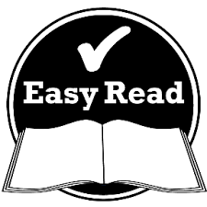
  - Easy Read
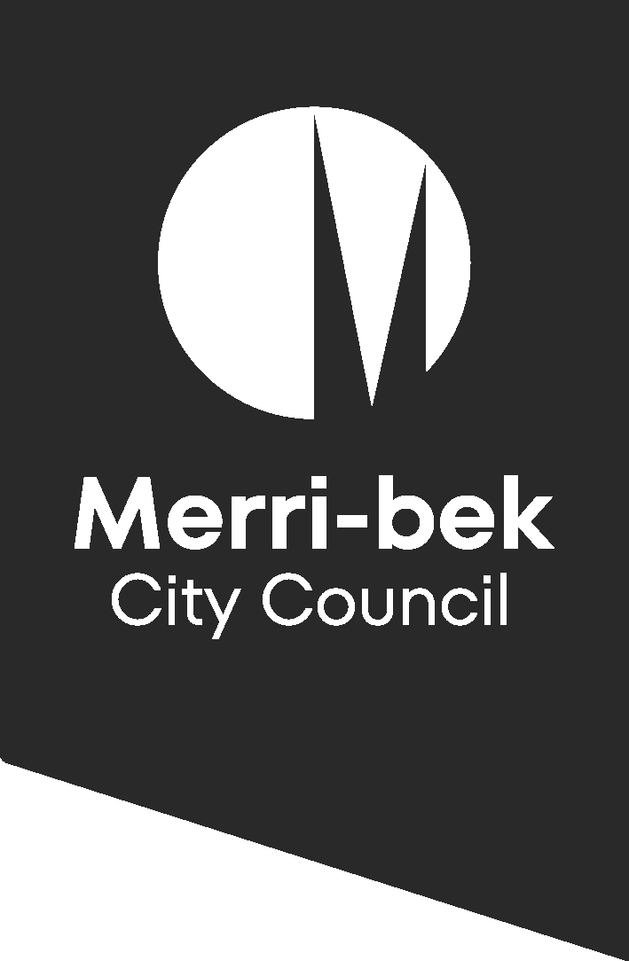
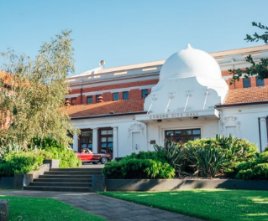 | Merri-bek City Council wrote this.  When you see the word we,  it means Merri-bek City Council.
 | Acknowledgement of Country  We acknowledge the  Wurundjeri Woi wurrung People  as the Traditional Owners of Merri-bek.  They have a strong connection to the land, water and sky.  We respect Elders past and present.
 | We wrote this in an easy to read way.  We use pictures to explain some ideas.  We call this Easy Read.
 | This Easy Read document is a summary of a longer document.  The longer document is the Accessible and Inclusive Communications Policy 2021-2024.  We will call this the Policy.
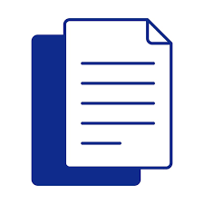 | We also have a plain language version of the Policy.  You can find the plain language version on our website:  [insert website link]

 | The Policy is about Council communication.  Communication means sharing information.  This includes information about things like:  - events  - decisions  - projects  - services.
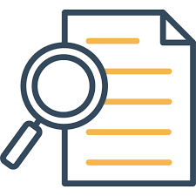 | We have the Policy to help people:  - find our information  - understand our information  - use our information.

 | People in Merri-bek may need information in different ways.  For example, some people:  - speak languages other than English  - find it hard to read  - have disability  - are new to Council
 | Our Policy says that everyone has the right to clear information.  It says we should try to give people information in the ways that suit them.
 | The Policy includes information we give to people.  These could be people who live, work or study in Merri-bek.
     | The Policy says what we need to do on our:  - website  - social media  - newsletters  - printed information  The Policy also includes the information we give to our staff.

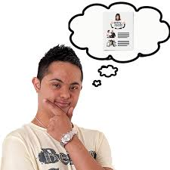 | The Policy says we will think about:  - who our information is for  - what people need
 | We will try to understand our community.  We will:  - listen to people  - use your ideas to improve our work.
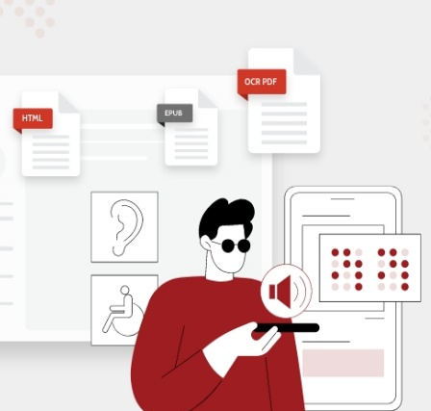 | We will give people information in different ways.  These different ways can include:  - Easy Read  - plain language  - large print  - braille  - translations into community languages, including Auslan

 | We will share information in the right places.
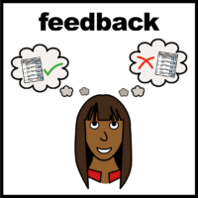 | We will give people the chance to ask questions and give feedback.
 | Everyone at Council needs to follow the Policy.  This includes:  - leaders  - staff  - customer services  - people who we hire to do jobs for us. We call them ‘contractors’
 | The Policy also has an action plan.  This action plan shows our staff what to do.
 | The action plan says that Council will do these things:  - help our staff give the community clear information  - use plain language  - use Easy Read  - offer interpreters  - support staff who use community languages  - learn what our community needs  - keep improving.

Contact us

 | You can contact us if you need  more information or support.
 | You can call us on 9240 1111.  We can arrange for someone to speak to you in your language.  We also have accessible call options.  If you have a speech or hearing impairment, you can call:  - TTY - 1800 555 677  - Speak and Listen - 1800 555 727  - National Relay Service - 133 677
 | We can meet you in person.
 | You can email us:  accessibility@merri-bek.vic.gov.au  Or you can give your feedback on our website [insert website address]
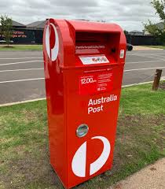 | You can write us a letter.  You can send the letter to:  Accessible and Inclusive Communications  Merri-bek City Council  Locked Bag 10  Coburg  Victoria  3058
 | You can tell us if you need this Policy in a different format.  You might need it translated into your language.
 | We will try to help you.

