

Fortnightly rubbish trial –evaluation report

prepared for
Merri-bek City Council

January 2026

Key contact
Patrick Gilmour
First Person Consulting Pty Ltd
ABN 98 605 466 797
pat@fpconsulting.com.au
www.fpconsulting.com.au


Contents
Executive Summary 1
1 Introduction 4
1.1 Overview 4
1.2 Aims of the fortnightly rubbish trial 4
1.3 Objective of the evaluation and structure of this report 4
2 Background to the Trial 5
2.1 Current system 5
2.2 Fortnightly rubbish collection Trial 5
3 Approach to the evaluation 7
3.1 Key steps 7
3.2 Limitations 8
4 Key findings 9
5 Changes to the contents and composition of bins 11
5.1 Disposal of food waste 11
5.2 Disposal of other waste categories 16
5.3 Waste generation volumes 19
5.4 Presentation rate and bin fullness 20
5.5 Dumping and public bins use 22
6 Participant perspectives on the Trial 24
6.1 Sentiment towards fortnightly rubbish collection 24
6.2 Issues and challenges 28
7 Cost implications 32
7.1 Bin size choices and the uptake of concessions 32
7.2 Overall costs for Council and residents 33
8 Learnings around implementation 35
8.1 Efficacy of support mechanisms 35
8.2 Key delivery lessons from a council perspective 37
9 Appendix A – Variation in contributions to food waste in rubbish 39

Document details
Date | Version | Details | Authors
23/01/2026 | Draft v01-v07 | Internal working drafts | Patrick Gilmour & Joe Lea
23/01/2026 | Draft v08 | Draft provided to MCC | Patrick Gilmour & Joe Lea
2/02/2026 | Final v01 | Final draft incorporating MCC feedback | Patrick Gilmour & Joe Lea

Executive Summary
The fortnightly rubbish trial
Merri-bek City Council (MCC) is trialling a fortnightly collection of rubbish bins to inform a municipal-wide transition away from weekly rubbish collection. Fortnightly collection is expected to deliver a range of benefits for council and the community, including reductions in collection/disposal costs and increased diversion of organic material out of landfill.
The fortnightly rubbish trial (the Trial) started in July 2025 across approximately 3000 households, apartments, units, businesses and other organisations in parts of Hadfield and Brunswick/Brunswick West.
This report outlines an evaluation of the Trial six months after it started. It considers whether the Trial has delivered its intended benefits and what lessons there are for the future. Key sources of data include:
- Waste audits of 180 households in the Trial area, before the Trial and after six months of fortnightly rubbish collections.
- Reporting from 1991 bin inspections that were used over the course of the Trial to explore any issues of contamination, overfilling and public bin use.
- Total weights from rubbish collection trucks used in the Trial areas.
- Feedback from nine pop-up engagement activities in Trial areas, including a simple survey of people’s sentiment about the Trial (n=93).
- Online surveys of Trial participants before (n=133) and during the Trial (n=352). Participants were invited as part of the information mailed to each property for the Trial. The surveys provide insights on people’s experience with the Trial and fortnightly rubbish collection but, because it is subject to self-selection bias, it should not be used as a representative sample of Trial participants.
- Interviews of trial participants (n=11) and staff (n=8) to explore any additional insights on the Trial implementation.
- Records about Trial implementation including bin allocations, financial modelling, customer service interactions and observations recorded by the street cleansing team.

Key findings
The fortnightly rubbish trial has been a significant investment by MCC into better understanding the feasibility of fortnightly rubbish collections in Merri-bek. While there are varied views in the Trial community on fortnightly rubbish collection, overall, the Trial has successfully demonstrated that fortnightly rubbish collection is achieving its key goals:
- There has been a substantial increase in the proportion of food waste being disposed of in FOGO bins and a corresponding decrease in what is being disposed of in the rubbish bin. Between June 2025 and December 2025 the proportion of food waste being disposed of in FOGO bins has almost doubled – going up from 29% to 56%. In Hadfield, the improvement has been even more pronounced, with 2.5 times more food waste ending up in FOGO bins (an increase from 22% to 56%).
- Because of this change in disposal the weight of rubbish bins being collected each fortnight has dropped. Data directly from waste collection services show a decrease of 19% in the average weight of rubbish bins collected per fortnight – from 14.1 kg per fortnight per property serviced (pre-Trial) to 11.4 kg per fortnight in December 2025.
- In aggregate, the overall diversion rate in the Trial area has increased from a baseline of 59% pre-Trial to 65%. This far exceeds the average diversion rate of 48% for councils in the Port Phillip region.
- While FOGO contamination has been a concern in other councils, the overall FOGO contamination rate did not change, staying stable at 1%. While there were increases in recycling contamination in Brunswick / Brunswick West, these have been offset by decreases in Hadfield. They appear to be driven largely by people trying to recycle types of paper, metal and plastic that are not recyclable (e.g. coffee cups).
- The changes above are being driven by residents paying more attention to their waste and how they are disposing of it. Around two-thirds (66%) of survey respondents reported they had changed key waste-related behaviours. This includes using their FOGO bins more, more carefully sorting recyclables and changing purchasing decisions to reduce the waste coming into their homes.
- The potential cost savings from the changes, if they were to be rolled-out council-wide, are estimated to be in the order of $1.3 million to $2.1 million per year, with potential for even more cost savings with higher diversion of food waste from the rubbish bin.
Data on public bin use and dumping does not show any change attributable to the Trial – despite public concern that this could be a consequence of less frequent rubbish collections. That said, longitudinal data across Merri-bek does indicate that public dumping is a growing issue to address regardless of the collection frequency of the rubbish service – consistent with trends across the metropolitan region.
Importantly, the Trial has also demonstrated that once people adjust to fortnightly collection, their views become more positive and they find it easier. After just six months of the Trial, 37% of survey respondents found the fortnightly collection to be ‘easy’ or ‘very easy’ – up 7% from the pre-trial survey. This trend is expected to continue as people get more used to the fortnightly collections and changes to behaviour become more of a habit.
In terms of overall sentiment, there was a split between suburbs - 65% of respondents from Brunswick / Brunswick West being positive or neutral about the prospect of fortnightly collections as compared to 35% for Hadfield respondents. The main issues that people reported having with the transition to fortnightly rubbish collection were:
- A lack of capacity in bins. This was specifically mentioned by 10% of survey respondents and is supported by evidence from the bin audits and inspections. These data sources showed over half (57%) of rubbish bins were being presented full and around 2-10% being regularly ‘overfull’
- Concerns over smell and cleanliness. This was specifically mentioned by 15% of survey respondents. It relates to both concerns about putting food waste in the FOGO bins without being in some sort of bag, as well as concerns over having items such as nappies and pet waste in rubbish bins for two weeks.
The two key factors that appeared to drive how easily survey respondents adapted to the fortnightly collection were:
- Household size – respondents from larger households found the fortnightly collection more difficult. Those with children in nappies had further difficulties but the additional impact was much less than household size alone.
- Suburb – respondents from Hadfield were more likely to report that fortnightly rubbish collection is difficult as compared to respondents from southern suburbs. This appears to be independent of household size, housing type or whether families have children in nappies. Importantly it also does not appear to have impacted their actual performance in terms of adaption - Hadfield improved food waste diversion and contamination levels more substantially than occurred in Brunswick / Brunswick West.
When considering the potential for broader roll-out, several council support mechanisms appeared to be important. This included:
- Calendars and SMS reminders to help residents put the correct bin out.
- Providing flexibility in bin size selection
- Providing a range of concessions that, in turn, helped people to access larger bins at no additional cost.
There were some gaps in people’s awareness of the bin options and concessions. This is a potential area of opportunity to enhance the already good level of council support, particularly for any future roll-out.
Scheduling additional services during periods such as Christmas may further help people during peak periods of waste generation.
Concerns about smell and cleanliness are more difficult to address. However, there were gaps in people’s understanding of their options and approaches with FOGO, meaning that there may be opportunities here too – for example in greater promotion of paper bags and kitchen caddies and education on how to use the FOGO bin more effectively. This may also help in further increasing the diversion rate for food organics.
Ultimately, the Trial has shown that fortnightly rubbish collection does work in reducing the amount of waste to landfill and in reducing costs. It is also clear that after six months of the changed collection frequency, Trial participants have started to adjust their behaviours and survey respondents have indicated their level of comfort with the service has improved.

Introduction

Overview
Merri-bek City Council (MCC) is trialling a fortnightly collection of rubbish bins to inform a municipal-wide transition away from weekly rubbish collection. Fortnightly collection is expected to deliver a range of benefits for council and the community, including reductions in collection/disposal costs and increased diversion of organic material out of landfill.
The fortnightly rubbish trial (the Trial) started in July 2025 across approximately 3000 households, apartments, units, businesses and other organisations in parts of Hadfield and Brunswick/Brunswick West. Merri-bek City Council, with support from First Person Consulting (FPC), has monitored the delivery of the Trial from July to December 2025. The results are reported in this document and will inform Council’s decision about the approach to municipal-wide fortnightly rubbish collection. The Trial service is expected to continue while council works through feedback for the full municipality roll-out.

Aims of the fortnightly rubbish trial
The overarching aims of the fortnightly rubbish trial are to
- Test the anticipated benefits of fortnightly collections for the Merri-bek community
- Identify lessons that can help with implementation across the municipality
- Provide information that will help Merri-bek Councillors decide about broader roll-out.

Objective of the evaluation and structure of this report
This report outlines the findings from monitoring and evaluation of the Trial. This was focused on four high-level questions:
- What outcomes did the fortnightly Trial achieve?
- How were participant perspectives influenced by the Trial?
- What did the Trial show in terms of potential cost implications?
- What was learned about implementing fortnightly collections?
The structure of this report includes:
- Background to the Trial and the waste system in Merri-bek (Section 2)
- A summary of the data collection methods (Section 3)
- Key findings (Section 4)
- Results in detail relating to:
  - Changes to the contents and composition of bins (Section 5)
  - Participant perspectives on the Trial (Section 6)
  - Cost implications (Section 7)
  - Lessons for Council (Section 8)

Background to the Trial

Current system
In December 2021, MCC decided to make a series of changes to its kerbside waste system. Since then, the system has evolved to reduce environmental impacts, provide a better service for residents and align with statewide standards as outlined by Recycling Victoria. As of the start of 2025, the kerbside collection service included:
- A weekly food and garden organics (FOGO) collection
- A fortnightly mixed recycling collection
- A monthly glass recycling collection
- A weekly rubbish (landfill) collection.
Some of the key issues with the existing system are:
- The overall costs for kerbside collection and disposal are increasing. This cost is passed on directly to the community as cost recovery, emphasising a need for efficiencies and cost-saving measures. The biggest cost driver that Council can influence is the landfill (general rubbish) stream. Costs for this stream have been increasing much faster than other streams. This is particularly as a result of growth in the State government waste levy, which has more than doubled in the last 5 years, increasing from $65.90 per tonne in 2020-21 to $169.79 per tonne in 2025-26.
- Almost one third (27%) of rubbish bin contents in Merri-bek are organic, including both food waste and garden organics. This could be disposed of directly in the FOGO bin. A further 8% of rubbish bin contents is food waste in containers and plastic bags that, after being removed from this packaging, could also be disposed of in the FOGO bin.
- A further 9% of rubbish bin contents is recyclable material for which there are alternative disposal pathways, including mixed recyclables (6%), glass (1%) and hazardous or e-waste (2%).
The organic and recyclable content in rubbish bins represents an opportunity to reduce landfill and environmental impacts at the same time as minimising the rate of cost increases for kerbside waste disposal.

Fortnightly rubbish collection Trial
One of the ways in which other local governments across Victoria have significantly reduced waste collection costs for the community has been through a transition to fortnightly rubbish collection.
Part of the underlying rationale for reducing rubbish collection frequency (while maintaining weekly FOGO) is to increase people’s awareness of the waste going into their rubbish bin. In turn, this is expected to encourage them to divert more of their organic and recyclable waste into other bins and services that are less costly and where the materials can be recovered. Reducing rubbish collection frequency is thus expected to deliver cost savings by lowering collection and disposal costs over time.
As part of its broader waste transition plan, MCC agreed in 2021 to trial fortnightly rubbish collection to confirm it is appropriate for the Merri-bek community.
The Trial has been setup in two parts of Merri-bek:
- Brunswick and Brunswick West (~1,500 properties)
- Hadfield (~1,500 properties)
Each zone captures a mix of housing stock and resident demographics with the aim of testing fortnightly collection across a broad spectrum of the Merri-bek community. This includes single-unit dwellings (SUDs; 2490 households), multi-unit dwellings (MUDs; 441 households) and some businesses and other organisations (201 properties).
Residents residing in SUDs are able to choose a rubbish bin that suits their individual needs:
- 80 litres (previous standard size) – at a discount from the standard waste charge
- 120 litres (new standard size) – included in the standard waste charge
- 240 litres – at a higher cost than the standard waste charge (with concessions available)
- 360 litres (using two bins) – at a higher cost than the standard waste charge (with concessions available).
For MUDs, council engaged a contractor to work directly with households prior to the Trial commencing. Each MUD property was assessed to determine the most appropriate bin set-up and use of shared bins.
Roll-out of these bins was also an opportunity to standardise the rubbish bin-lid colour so that it matches state standards (red).
This evaluation of fortnightly rubbish collections covers the first six-month period of the Trial: July to December 2025. However, fortnightly rubbish collections will continue in the trial areas at least until Council makes any further decision on the municipal-wide roll-out. The Trial was supported by:
- Bin exchange and delivery of information about the Trial
- Bin inspections to help monitor and prompt residents about collection cycles, contamination etc.
- SMS reminders
- Community ‘pop-up’ engagement events
- Customer support via phone, email and the council website.
The key outcomes that council planned to test through running the trial were:
- Whether fortnightly rubbish collection would lead to:
  - people being more aware of their waste and correct disposal practices
  - people better separating their waste into appropriate bins and/or potentially changing their purchasing habits
  - an overall increase in the amount of recoverable material being diverted to FOGO and mixed recycling streams and/or a reduction in the total amount of waste being generated and disposed of by participants.
- Whether fortnightly rubbish collection could be done without any undesirable increase in contamination or public dumping.
- Whether the Trial itself would help participating households to better understand and adapt to fortnightly collection.
- Lessons that council could apply to any future municipal-wide roll-out.

Approach to the evaluation

Key steps
After planning monitoring and evaluation activities in early 2025, FPC and MCC collected a range of data to support the Trial. This included:
- Waste audits of household bins in the Trial area. These weight-based audits were done before the Trial to establish a baseline and then repeated after six months of fortnightly rubbish collections. Auditors followed standard methods to identify and sample the waste from 180 properties – 90 each from Hadfield and Brunswick / Brunswick West, with the same properties visited each audit. Data collection involved sorting and categorising the waste from all four kerbside bins. Both standalone households and multi-unit-dwellings were sampled.
- Bin inspections. This involved a series of visual inspections of bins over the course of the Trial to explore any issues of contamination, overfilling and public bin use. The team inspected 1991 bins over the course of the Trial. This included tagging bins to help raise awareness about overfull bins, what goes in each bin and collection week reminders.
- Data from rubbish collection trucks. Dedicated waste collection trucks were used for the Trial to help monitor waste tonnages. The total number of bins emptied and weight collected was collated and provided to council on a fortnightly basis.
- Pop-up engagement activities in Trial areas. MCC ran 9 pop-up events in activity centres and public spaces of Trial suburbs. These aimed to build awareness of the Trial, provide a point of contact and understand barriers and community sentiment. Data collection at these events included a simple survey of people’s sentiment about the Trial (n=93).
- Surveys of Trial participants. MCC and FPC surveyed Trial residents using an online questionnaire before and during the Trial. Participants were invited as part of the information mailed to each property as part of the Trial. A voucher incentive to encourage participation in the surveys was offered. 133 valid responses were received in the pre-Trial survey in June 2025 and 352 in the follow-up in December 2025. As noted below, this feedback provides useful insights on the Trial and fortnightly rubbish collection but should not be used as a representative sample of Trial participants.
- Interviews of trial participants. FPC interviewed 11 households who volunteered to share their perspective on the Trial after six months. These interviews built on the survey data to further explore people’s experiences of fortnightly collections. Interviews were done either online or by phone.
- Interviews with project staff. FPC interviewed a range of key staff and service providers to explore any additional insights on the Trial implementation. This included two waste collection drivers, two bin inspectors and four key MCC staff.
- Documentation of key aspects of trial delivery: Merri-bek staff collated council records about Trial implementation including bin allocations, financial modelling, customer service interactions and observations recorded by the street cleansing team.
These data have been collated, analysed and integrated into this overall evaluation report

Limitations
There are several limitations to this evaluation that need to be kept in mind when interpreting the data:
- Waste volumes and types fluctuate week-to-week and seasonally. As such, small changes in the audited weight of bin contents do not necessarily reflect meaningful changes in disposal behaviour. Longer-term monitoring is typically necessary to understand whether small observations are reflective of underlying systematic change. That said, the larger the change, the greater the likelihood that it reflects a meaningful change in behaviour. Only substantial changes in audited bin weights/proportions of materials have been discussed in detail in this report. These observations have also been triangulated against other data where available.
- Monitoring of the Trial has only been able to be done for six months. This is because of the need for the results to help inform council decision-making. While the patterns of change observed at this point are expected to continue (e.g. increase in people’s comfort with the system), a longer window of monitoring would be needed to test and demonstrate this.
- The participant survey is not necessarily a representative sample of Trial participants. While all households were invited to respond, the response rate for pre-Trial and six-month surveys was 4% and 11%, respectively. While this is a workable sample, the greater issue is the potential for self-selection bias among the respondents (i.e. those that are more interested or upset by an issue are more likely to respond). Examples are identified in Section 6. This simply means that the feedback and insights need to be taken as indicative and that they may not accurately reflect the views of the broader Trial community, particularly for people who are neutral about the change.

Key findings
The fortnightly rubbish trial has been a significant investment by MCC into better understanding the feasibility of fortnightly rubbish collections in Merri-bek. While there are varied views in the Trial community on fortnightly rubbish collection, overall, the Trial has successfully demonstrated that fortnightly rubbish collection is achieving its key goals:
- There has been a substantial increase in the proportion of food waste being disposed of in FOGO bins and a corresponding decrease in what is being disposed of in the rubbish bin. Between June 2025 and December 2025 the proportion of food waste being disposed of in FOGO bins has almost doubled – going up from 29% to 56%. In Hadfield, the improvement has been even more pronounced, with 2.5 times more food waste ending up in FOGO bins (an increase from 22% to 56%).
- Because of this change in disposal the weight of rubbish bins being collected each fortnight has dropped. Data directly from waste collection services show a decrease of 19% in the average weight of rubbish bins collected per fortnight – from 14.1 kg per fortnight per property serviced (pre-Trial) to 11.4 kg per fortnight in December 2025.
- In aggregate, the overall diversion rate in the Trial area has increased from a baseline of 59% pre-Trial to 65%. This far exceeds the average diversion rate of 48% for councils in the Port Phillip region.
- While FOGO contamination has been a concern in other council, the overall FOGO contamination rate did not change, staying stable at 1%. While there were increases in recycling contamination in Brunswick / Brunswick West, these have been offset by decreases in Hadfield. They appear to be driven largely by people trying to recycle types of paper, metal and plastic that are not recyclable (e.g. coffee cups).
- The changes above are being driven by residents paying more attention to their waste and how they are disposing of it. Around two-thirds (66%) of survey respondents reported they had changed key waste-related behaviours. This includes using their FOGO bins more, more carefully sorting recyclables and changing purchasing decisions to reduce the waste coming into their homes.
- The potential cost savings from the changes, if they were to be rolled-out council-wide, are estimated to be in the order of $1.3 million to $2.1 million per year, with potential for even more cost savings with higher diversion of food waste from the rubbish bin.
Data on public bin use and dumping does not show any change attributable to the Trial – despite public concern that this could be a consequence of less frequent rubbish collections. That said, longitudinal data across Merri-bek does indicate that public dumping is a growing issue to address regardless of the collection frequency of the rubbish service – consistent with trends across the metropolitan region.
Importantly, the Trial has also demonstrated that once people adjust to fortnightly collection, their views become more positive and they find it easier. After just six months of the Trial, 37% of survey respondents found the fortnightly collection to be ‘easy’ or ‘very easy’ – up 7% from the pre-trial survey. This trend is expected to continue as people get more used to the fortnightly collections and changes to behaviour become more of a habit.
In terms of overall sentiment, there was a split between suburbs - 65% of respondents from Brunswick / Brunswick West being positive or neutral about the prospect of fortnightly collections as compared to 35% for Hadfield respondents. The main issues that people reported having with the transition to fortnightly rubbish collection were:
- A lack of capacity in bins. This was specifically mentioned by 10% of survey respondents and is supported by evidence from the bin audits and inspections. These data sources showed over half (57%) of rubbish bins were being presented full and around 2-10% being regularly ‘overfull’
- Concerns over smell and cleanliness. This was specifically mentioned by 15% of survey respondents. It relates to both concerns about putting food waste in the FOGO bins without being in some sort of bag, as well as concerns over having items such as nappies and pet waste in rubbish bins for two weeks.
The two key factors that appeared to drive how easily survey respondents adapted to the fortnightly collection were:
- Household size – respondents from larger households found the fortnightly collection more difficult. Those with children in nappies had further difficulties but the additional impact was much less than household size alone.
- Suburb – respondents from Hadfield were more likely to report that fortnightly rubbish collection is difficult as compared to respondents from southern suburbs. This appears to be independent of household size, housing type or whether families have children in nappies. Importantly it also does not appear to have impacted their actual performance in terms of adaption - Hadfield improved food waste diversion and contamination levels more substantially than occurred in Brunswick / Brunswick West.
When considering the potential for broader roll-out, several council support mechanisms appeared to be important. This included:
- Calendars and SMS reminders to help residents put the correct bin out.
- Providing flexibility in bin size selection
- Providing a range of concessions that, in turn, helped people to access larger bins at no additional cost.
There were some gaps in people’s awareness of the bin options and concessions. This is a potential area of opportunity to enhance the already good level of council support, particularly for any future roll-out.
Scheduling additional services during periods such as Christmas may further help people during peak periods of waste generation.
Concerns about smell and cleanliness are more difficult to address. However, there were gaps in people’s understanding of their options and approaches with FOGO, meaning that there may be opportunities here too – for example in greater promotion of paper bags and kitchen caddies and education on how to use the FOGO bin more effectively. This may also help in further increasing the diversion rate for food organics.
Ultimately, the Trial has shown that fortnightly rubbish collection does work in reducing the amount of waste to landfill and in reducing costs. It is also clear that after six months of the changed collection frequency, Trial participants have started to adjust their behaviours and survey respondents have indicated their level of comfort with the service has improved.

Changes to the contents and composition of bins

Disposal of food waste
The most notable shift in the first six months of the Trial is that substantially less food waste is being disposed of in rubbish bins. It is, instead, being disposed of in the FOGO bins:
- Prior to the Trial, around two-thirds (68%) of all the food waste being generated by households was ending up in rubbish bins (Figure 1). Only around a third (29%) was disposed of in FOGO bins.
- After the first six months of the Trial, less food waste is ending up in rubbish bins – just 43% compared to the 68% pre-Trial.
- This food waste is, instead, going into FOGO bins, where it will eventually be turned into compost. Between June 2025 and December 2025 the proportion of all food waste disposed of in FOGO bins has almost doubled – going up from 29% to 56%.
- This pattern is broadly repeated at the suburb level (Figure 2). Both households in Hadfield and in Brunswick / Brunswick West increased the proportion of food waste that was going into FOGO bins. This increase was most pronounced in Hadfield - coming off a low base of just 22%, the rate has increased 2.5 times and now 56% of all food waste is disposed of in FOGO.
- This change is also reflected in the composition of rubbish bins. Prior to the Trial, around a third (34%) of the average rubbish bin in the Trial area was comprised of food waste. That figure has now dropped after six months to just 20% (Figure 3).
- Interestingly, a substantial proportion of the reduction in food waste has come from households that disposed of large amounts of food in their rubbish (Figure 4). Before the Trial, 43% of single-unit dwellings disposed of two or more kilograms of food waste per week. They alone accounted for 87% of all food waste in the rubbish bins. After six months of fortnightly rubbish collection, only 16% of households dispose of two or more kilograms of food per week in the rubbish. (see Appendix A for further details).

Figure 1. Proportion of all food waste disposed of in different bins during June 2025 (pre-trial baseline) and December 2025 (Trial).

Figure 2. Proportion of all food waste disposed of in different bins during June 2025 (pre-trial baseline) and December 2025 (Trial) in both Brunswick / Brunswick West and Hadfield.

Figure 3. Average weight of waste disposed of in rubbish bins during June 2025 (pre-trial baseline) and December 2025 (Trial).

Figure 4. Proportion of households with different amounts of food waste (note - data is only presented from single-unit dwellings to simplify interpretation; n=91) during June 2025 (pre-trial baseline) and December 2025 (Trial).

These changes clearly show that participants in the Trial areas are changing their behaviours in response to the fortnightly rubbish collection schedule. Survey feedback supports this, with responses showing:
- More survey respondents reported being ‘very aware’ of the waste they produce after the Trial had run for six months – rising to 57% from 50% in the pre-trial survey (Figure 5). Given self-reported awareness levels were already relatively high across respondents (88% were ‘aware’ or ‘very aware’ in the pre-Trial survey), this modest increase is still an important outcome. Comments in surveys and interviews reinforced this, highlighting the heightened level of thought and attention participants were putting into managing different components of their waste – particularly food waste.
It's helped us make better use of our green bin, recycling bin and generally made us think more about what we're using (Survey respondent – December 2025)
- As part of this increased awareness and attention, most survey respondents (66%) reported that they had changed key waste-related behaviours (Figure 6). In particular, 45% of people reported using their FOGO bin more.

It took a while to get used to it, but it has meant that I now feed my worm farm, and place more food waste in the green bin. The change has meant that I now am more conscious of what goes in the rubbish bin. (Survey respondent – December 2025)
- In line with this, 57% of people self-reported that they dispose of all their food and garden organics in the FOGO bin, up from 38% pre-Trial. While audit data suggests that only around 28% of bins actually had no food waste in them (Figure 4), 58% had less than one kilogram, which may better reflect the reality of what people mean as ‘all’ their food waste.

- Survey and interview feedback suggests that:
  - Some of this behavioural shift is about people putting more deliberate effort into sorting their waste.
  - Some of it relates to people better understanding what can and cannot be disposed of in different bins, particularly the FOGO bin.

That's been like a real game changer … I'm not going to pick through salad and chicken bones … I can just take the whole plate and put it in (Community interviewee – December 2025)

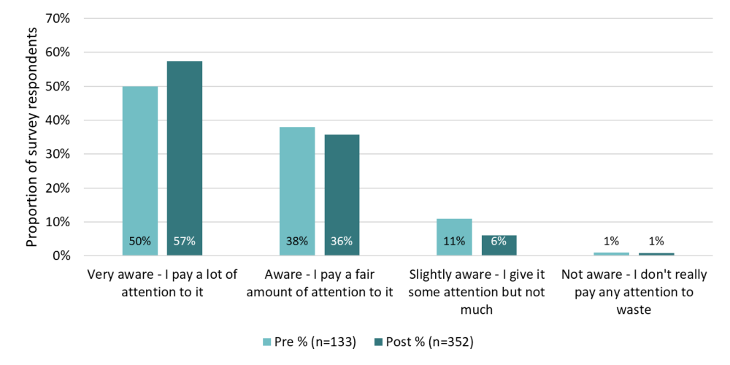
Figure 5. Survey respondents’ reported level of awareness about their waste before and after six months of the Trial.

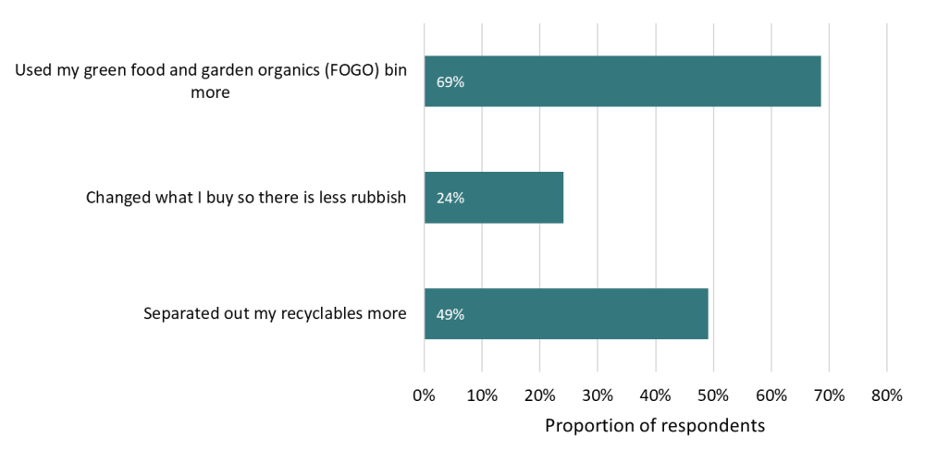
Figure 6. Survey respondents' self-reported changes in behaviour as a result of the Trial. n=352.

Changing behaviours to make it work
A Brunswick West resident living with his elderly parents described a neutral, adaptable stance toward Merri-bek’s fortnightly rubbish trial. He notes that he and his family adjust their output to fit whatever bin size or frequency is set by Council whether weekly or fortnightly, noting the red bin sometimes overflows slightly but they handled it by storing a bag in the driveway.
They’ve increased recycling efforts, like flattening cardboard and rinsing milk containers as a result of the trial and, although they are composting at home, they have also increased the use of FOGO. Despite complaining about the change at first, this resident has observed his family adapting to the trial regardless of their concerns.
“Mum’s not keen on keeping food scraps at all. She doesn't like the idea of anything to do with food scraps. But she sort of just does whatever the council tells her. So, when the council says, keep your food scraps, put them in this bin, she started doing that. And then she mumbles about it and complains about it, but at the end of the day, she will do what it says.”
Notably, they found support provided by Council, such as fridge printouts, useful for remembering collection schedules, though bin night still sparks momentary confusion each week. He advised he would be happy with fortnightly continuing, praising simple aids like fridge charts and drawing parallels to granular waste sorting systems in Europe and Japan that shape behaviour effectively.
(Based on interview with Trial participant, November 2025)

Disposal of other waste categories
Aside from food waste, the only other waste category that changed markedly was glass (Table 1). While there were changes in how other categories of waste were disposed of, they tended to be small. For most, it is not yet clear whether this reflects a systemic change in disposal behaviour or natural variability. Key points here are that:
- The vast majority of garden organics were overwhelmingly disposed of in the FOGO bin – both before and during the Trial. This category of waste was also the most prevalent (Figure 8), accounting for about a third (35%) of the overall waste disposed of by households in the Trial area.
- Most rubbish was disposed of in the rubbish bins - 84% and 86% before and during the Trial, respectively. While some rubbish contaminated mixed recycling bins, glass bins and FOGO bins, this did not change markedly once collections became fortnightly.
- Although around a third (32%) of survey respondents reported that they separated out their recyclables more (Figure 6), mixed recycling was stable. Most mixed recyclables (85%) continued to be disposed of in the mixed recycling bin, leaving around 15% being disposed of in the rubbish bin – something that represents a further opportunity for council.
- The minimal change in the distribution of waste among bins also means that there were no overall changes in contamination rates across the streams. While FOGO contamination has been a concern in other council, the overall FOGO contamination rate did not change from 1%. The exception to the above, however, is that suburb-level analysis shows there has been some increase in contamination of mixed recycling bins in the Brunswick / Brunswick West region. It increased from 9% to 23%. This change was masked overall by a decrease in contamination rates in Hadfield bins, which dropped from 26% to 19% during the same period. The increase in contamination in Brunswick / Brunswick West appears to be driven largely by increases in materials that are similar to recyclable materials but that are not technically recyclable themselves (at least not through the mixed recyclable kerbside system) – this includes:
  - non-recyclable paper, including coffee cups (up 4%)
  - non-recyclable metal (up 3%)
  - non-recyclable rigid plastics (up 2%)
  - donatable goods (up 2%)
  - food in containers (up 1%).
- The proportion of glass captured in glass recycling bins increased from 84% to 93%, with corresponding decreases in the amount of glass in rubbish and mixed recycling bins.
- While there were small shifts in where non-kerbside materials were being disposed, these shifts are unlikely to represent meaningful changes in behaviour. These materials (e.g. e-waste, hazardous materials) were relatively low volume overall (Figure 8) and tended to be highly varied between households.
- In aggregate, the changes above mean that the overall diversion rate in the Trial area has increased from a baseline of 59% pre-Trial to 65%. This is far above the average diversion rate of 48% for councils in the Port Phillip region. The general expectation is that this rate will continue to improve as households further refine and improve their waste generation and disposal practices to accommodate the fortnightly rubbish collection schedule.

Table 1. Proportion of waste that was disposed of in different bins during June 2025 (pre-trial baseline) and December 2025 (Trial). Arrows indicate notable changes (>5%) in how different materials are being disposed of, with green arrows representing positive changes and red negative (less desirable) changes.
Waste category | Disposal stream | Baseline audit | Trial audit
Food waste | FOGO bin | 29% | 56% ↑
Food waste | Rubbish bin | 68% | 43% ↓
Food waste | Mixed recycling bin | 2% | 0%
Garden organics | FOGO bin | 98% | 97%
Garden organics | Rubbish bin | 2% | 3%
Rubbish | FOGO bin | 1% | 2%
Rubbish | Rubbish bin | 84% | 86%
Rubbish | Mixed recycling bin | 14% | 11%
Rubbish | Glass bin | 1% | 1%
Mixed recycling | Rubbish bin | 16% | 15%
Mixed recycling | Mixed recycling bin | 84% | 85%
Glass | Rubbish bin | 6% | 2%
Glass | Mixed recycling bin | 10% | 5%
Glass | Glass bin | 84% | 93% ↑
Non-kerbside waste | Rubbish bin | 74% | 70%
Non-kerbside waste | Mixed recycling bin | 26% | 30%

Figure 7. Contents of mixed recycling bins in Brunswick / Brunswick West and Hadfield during June 2025 (pre-trial baseline) and December 2025 (Trial).

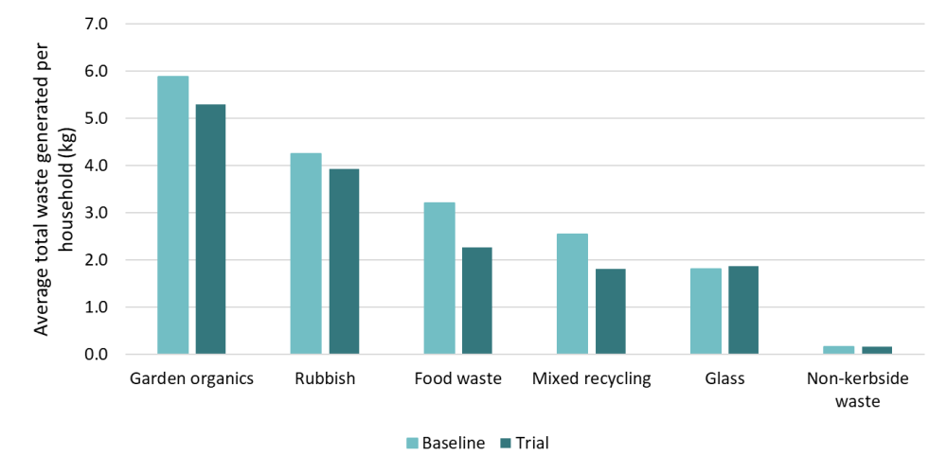
Figure 8. Average total waste generated per household during June 2025 (pre-trial baseline) and December 2025 (Trial).

Waste generation volumes
In addition to changes in how waste is being distributed among the different kerbside bins, there is also evidence that the level of waste being disposed of in those bins has decreased:
- Data from rubbish collection trucks show a decrease in the average weight of rubbish collected from households in the Trial area (Figure 9). This dropped from 14.1 kg per fortnight per property serviced (pre-Trial) to 11.4 kg per fortnight per property serviced across the Trial. This represents a decrease of 19% and is a pattern observed in both the Hadfield and Brunswick / Brunswick West Trial areas.
- Data from the baseline and Trial audits show a similar decrease. The average rubbish bin weight per household audited decreased from 13.0 kg per fortnight to 9.9 kg per fortnight – a 24% decrease (Figure 3).
- The audit data suggests that much of this decrease is driven by having less food waste in the rubbish bin. This is because more food waste is being disposed of in the FOGO bin, as discussed in Section 5.1. It is also because there has been an overall decrease in the amount of food waste disposed of in the kerbside system – an average of 0.9 kg per household (Figure 8).
- There was also a small decrease in the amount of recyclable material (0.1 kg per household - 6%) and rubbish (0.2 kg per household – 6%) in rubbish bins.
- It is unclear how much the decreases in food waste, rubbish and mixed recycling are part of normal variability versus how much they reflect more systematic changes. However, as outlined in Figure 6, 16% of survey respondents indicated that they have changed their purchasing habits to accumulate less rubbish. For example, several respondents mentioned they now try to purchase products with less packaging. This suggests that at least some of the overall decrease in waste volumes is driven by broader changes in community behaviour. Ongoing monitoring would be helpful here.

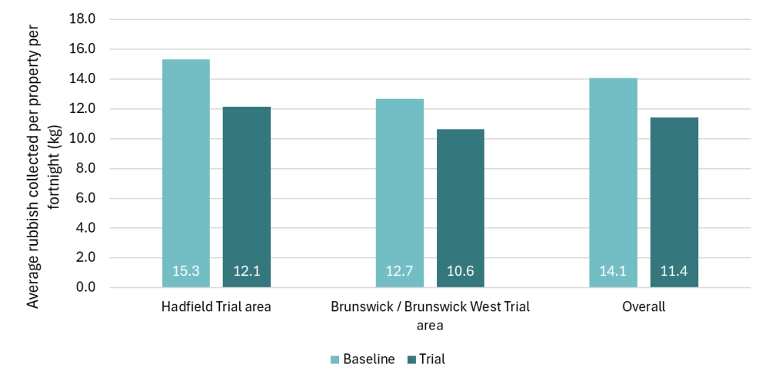
Figure 9. Average weight of waste collected from kerbside rubbish bins (per fortnight) during the Trial and the average from the Hadfield and Brunswick / Brunswick West suburbs in prior year (July 2024 to June 2025).

Presentation rate and bin fullness
Unsurprisingly, while overall waste generation was lower in the Trial, there was an increase in how many people were putting their bins out (the presentation rate) and how full those bins were (Figure 10). Key points here are that:
- Presentation of rubbish, mixed recycling and FOGO bins all increased.
- Based on estimates during audits, the average fullness of rubbish and mixed recycling bins also increased. This was most notable for rubbish bins, which increased by 20% - from 68% to an average of 88% full. More than half (57%) of the rubbish bins in the Trial audit were 100% full, compared to just 35% in the pre-trial audit.
- Observations by bin inspectors aligned with these results. They showed a spike in the number of bins that were considered ‘overfull’ in the weeks following implementation of the Trial (Figure 12). This peaked at 14% for properties in Brunswick / Brunswick West and 21% for properties in Hadfield. It then levelled off in the 2-10% range for the remaining period of the Trial with the exception of a temporary peak of 14% in the collection following the AFL Grand Final long-weekend.

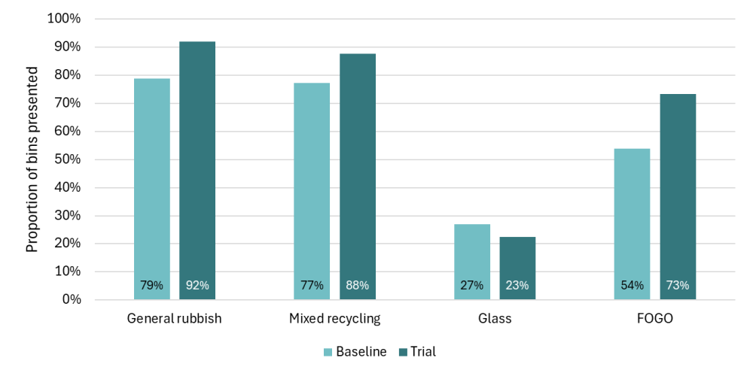
Figure 10. Proportion of bins presented for collection at properties audited prior to (pre-trial baseline) and during the Trial (based on waste audit data).

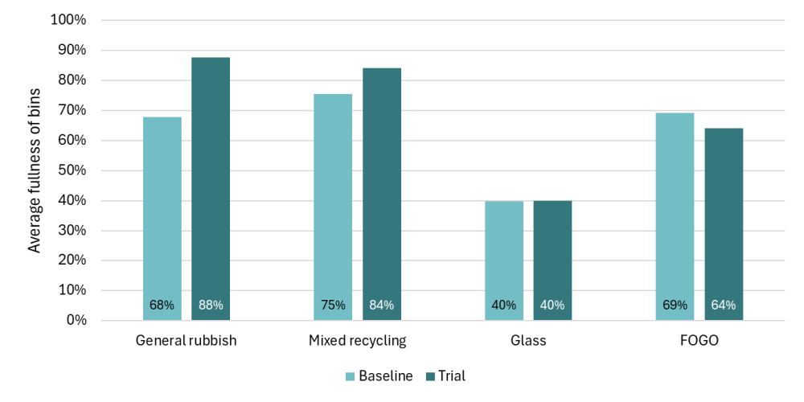
Figure 11. Average fullness of audited bins prior to (pre-trial baseline) and during the Trial (based on waste audit data).

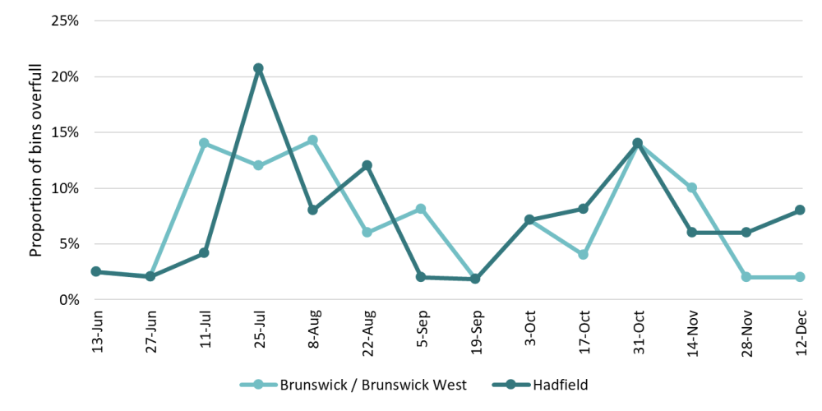
Trial start
Figure 12. Proportion of inspected bins judged to be ‘overfull’ by bin inspection staff during two inspections prior to the Trial and fortnightly throughout the Trial.

Dumping and public bins use
One of the concerns with the transition to fortnightly rubbish collection is that it will encourage a greater level of public dumping of household rubbish. 9% of survey respondents provided feedback that they had seen an increase in rubbish being dumped in public bins or public places. This was a key source of frustration and dissatisfaction these respondents expressed with the Trial.
The amount of rubbish that has been dumped on the streets, at the local shops and parks is disgusting. (Survey respondent – December 2025).
However, there is no quantitative evidence that dumped rubbish increased during the trial. MCC data, instead, points to a broader problem with illegal dumping that has been growing through time. MCC has been collecting data on reports of illegal dumping for many years and commissioned additional inspections of public bins as part of the Trial. These data show:
- Rates of public bins being used to dump household waste are volatile. There was no clear trend or increase in the proportion of public bins that were experiencing dumping during the fortnightly collection trial (Figure 13). Pre-trial auditing showed that household dumping in public bins was already occurring prior to the Trial. It has since continued, fluctuating around an overall average of 29% of bins having evidence of dumping. It is a recurring issue in both suburbs, but consistently higher in Hadfield than Brunswick. Reflecting the ongoing significance of household dumping, one public bin in Hadfield was removed in the week ending 2 November 2025 due to persistent household dumping.
- Broader, suburb-level data on reports of illegal dumping are outlined in Figure 14. Although these show aggregated data across all of Hadfield and Brunswick West, they do not show any clear change in trend between the Trial period in 2025 and the preceding year. Importantly, change between these two periods is just 4% - a minor change relative to broader trends in reports of dumping. Over the last five years, for example, complaints about illegal dumping in these suburbs have increased 67%, or 14% per year on year. Thus, while observations of illegal dumping are clearly frustrating residents in Trial areas, they may be related more to broader increases in dumping behaviour than any Trial specific increases. Irrespective of the cause, however, this clearly represents a significant issue for MCC to consider.

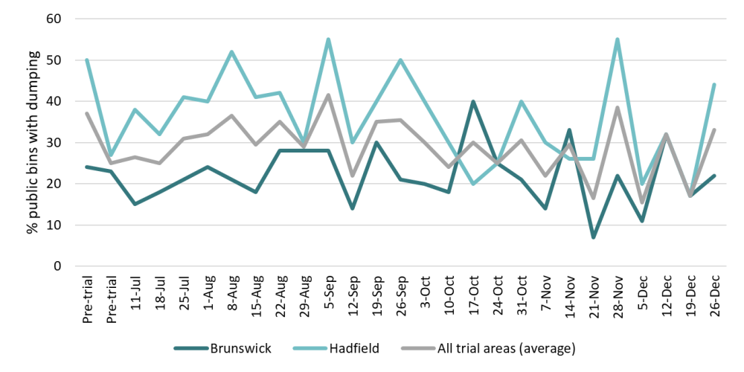
Figure 13. Rates of dumping of household waste in public bins in the Trial areas.

Figure 14. Merri-bek City Council data on reports of illegal dumping for the Trial period (July to December 2025) and the equivalent period in the previous year (municipal-wide).

Participant perspectives on the Trial

Sentiment towards fortnightly rubbish collection
Survey respondents and interviewees were highly varied in their views on fortnightly collection. Some found the change to be challenging and highly unappealing. Others praised council’s work in this area and were welcoming of the economic, environmental and other benefits it would bring.
It is important to remember when interpreting the results below that the responses to the survey are not necessarily a representative sample of Trial participants. While all households were invited to respond, there is potential for bias in the sample. For example:
- A social media post on a community forum in the last days of the pre-Trial survey called for people to complete the survey to express their dissatisfaction with the proposed fortnightly rubbish collection. This led to large spike in responses. While most were filtered out during data cleaning as ineligible (i.e. from outside the Trial area), it highlights the potential impact of small numbers of dissatisfied community members on survey representativeness.
- Some of the demographic data also points to a skew in responses. Around 18% of the responses were from households who have children in nappies. This is at least 50% (or more) of the estimated proportion of households across Merri-bek that have nappy-aged children.
While these points do not invalidate the feedback and insights, it highlights that the results may not accurately reflect the views of the broader Trial community – particularly for people who are reasonably neutral about the change.
Overall, 37% of survey respondents found the fortnightly collection to be ‘easy’ or ‘very easy’. This reflected an improvement from the pre-Trial survey. Similarly, the proportion finding the fortnightly collections to be ‘very difficult’ decreased from 41% to 34%. Thus, while some people did experience difficulties with the fortnightly rubbish collection, the reality was more positive than expected.
There was some concern in my house before the trial started but it has helped us naturally recycle and use the organic bin more, reducing our waste. We haven't fully filled the landfill bin since the switch to 2 weeks. (Survey respondent – December 2025)
Another respondent articulated a similar sentiment – that they found it difficult but, surprisingly, workable:
Overall, I thought it would be impossible, but was somewhat pleasantly surprised as we put focus on the green bin usage. But, there is no ifs or buts, it is like a rubbish whack-a-mole and juggle for my family. (Survey respondent – December 2025)

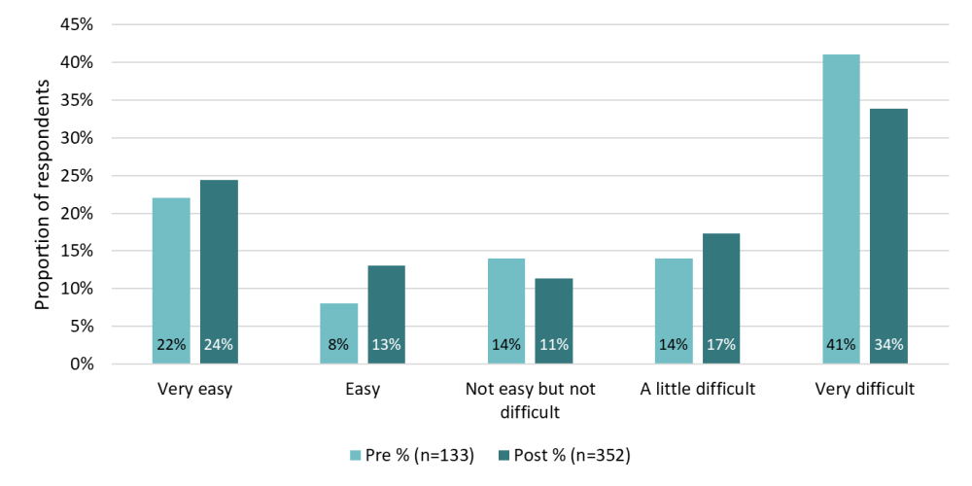
Figure 15. Survey respondents' perceptions of how easy they thought the fortnightly rubbish collection would be / was.

Views about the ease of fortnightly rubbish collections are expected to further improve through time as people continue to adapt their behaviours (see Section 5.1) and/or upsize their bins to match their needs. In this context, several factors appeared to influence how difficult households found the fortnightly rubbish collection:
- Larger households reported having more difficulty coping with fortnightly collections (Figure 16). While survey respondents from one and two-person households tended to rate it as relatively ‘easy’, larger households on average tended to rate it as ‘difficult’.
- The challenges of nappies were mentioned in a range of survey responses. Households with nappies did tend to rate the fortnightly collection as slightly more difficult than other households, but it appeared to matter less than the overall household size (Figure 16).
- Survey respondents from Hadfield tended to report higher levels of difficulty than respondents from Brunswick / Brunswick West (Figure 17). This difference is reasonably substantial (2.6 in Hadfield versus 3.7 in Brunswick / Brunswick West). This difference in sentiment is reflected in people’s overall views of fortnightly rubbish collection:
  - Feedback from pop-up community consultations (Figure 18) showed around 68% of respondents from Brunswick / Brunswick West pop-ups were positive or neutral as compared to 47% for respondents from Hadfield.
  - Survey feedback provided similar results, with 65% of respondents from Brunswick / Brunswick West being positive or neutral compared to just 35% for Hadfield respondents (Figure 19).
- The difference between suburbs appears to be largely independent of household size, which does not differ substantially between the two suburbs (2.9 in Hadfield compared to 2.8 in Brunswick / Brunswick West). Instead, other factors appear to be driving the differing perspectives of the two suburbs. As outlined in Section 5.3, Hadfield households produce greater quantities of rubbish (12.1 verses 10.6 kg per fortnight) but, again, it is not clear what the underlying factor is here.
- Overall, standalone houses appeared to rate the fortnightly collection as more difficult (Figure 17). However, this difference appears to relate more to the fact that standalone houses tend to have larger households – an average of 3.0 people per household as compared to an average of 2.5 people per household in apartments, units and townhouses. Thus, when considered independent of household size, dwelling type does not appear to have any consistent or substantive impact on the perceived difficulty of fortnightly collection, as shown in Figure 20.

Figure 16. Average rating of the difficulty of fortnightly rubbish collections (where 1 is ‘very easy’ and 5 is ‘very difficult’) for households of different size (total size including children) and whether or not they have children in nappies. Note that the number of responses has been included to illustrate the low sample size in some cases.

Figure 17. Average rating of the difficulty of fortnightly rubbish collections (where 1 is ‘very easy’ and 5 is ‘very difficult’) for households in the two Trial areas and for different housing types.

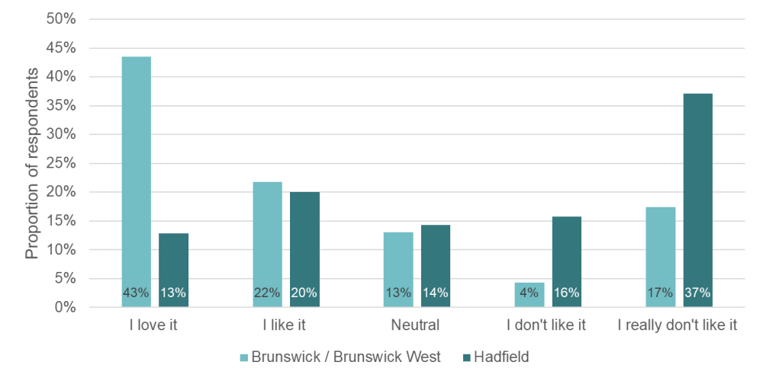
Figure 18. Feedback from community engagement ‘pop-ups’ showing relative sentiment towards the fortnightly rubbish collection (n=182).

Figure 19. Feedback from survey respondents in Hadfield (n=204) and Brunswick / Brunswick West (n=148) showing the relative sentiment towards the fortnightly rubbish collection.

Figure 20. Average rating of the difficulty of fortnightly rubbish collections (where 1 is ‘very easy’ and 5 is ‘very difficult’) for households of different sizes and housing types.

In addition to the challenges and issues of the Trial (discussed above and below), several interviewees and survey respondents also highlighted the benefits and positivity of the Trial. As outlined in Section 5, this included improved awareness of waste and changes to waste behaviours. However, it also included feedback around:
- General support for MCC’s work in this space and the broader need to reduce waste (3/352 responses)
- Support for the environmental benefits that the changes would lead to (12/352 responses)
- Support for the amenity benefits of having fewer trucks and bins on the street (3/352 responses).
This is a great initiative - even with fortnightly collection, we never have a full bin. It's also fantastic for the amenity in the area. Fewer truck movements and not as many bins on the street greatly improve the liveability of the area. (Survey respondent – December 2025)

Issues and challenges
Survey respondents and interviewees mentioned a range of issues and challenges with the move to fortnightly rubbish collection. These issues underpin the overarching views above.
- One of the key challenges that some people experienced with fortnightly collection was not having enough room for all of their waste. This was mentioned by 10% of survey respondents (35/352). They noted that this led to their (or other’s) bins overflowing or, in some cases, they noted that they would instead:
  - Take rubbish to public or workplace bins (7/352 responses)
  - Dispose of rubbish in recycling bins (1/352 responses)
  - Make trips to the tip (2/352 responses)
  - Store waste in their garage or similar area for later collections (10/352 responses).
We religiously utilise soft plastic recycling at Woolworths, normal recycling for appropriate items, food waste green bin, glass recycling; and STILL we find it is not possible to fit our general waste in for a fortnightly collection. (Survey respondent – December 2025)
This feedback is supported by evidence from the bin audits and inspections, which showed over half of rubbish bins were being presented full and around 2-10% being regularly ‘overfull’ (see Section 5.4).
- Some of the related points here included the challenge of managing waste:
  - After events or parties
  - With young children who are in nappies
  - If fortnightly collections are accidentally missed or missed because people are away
  - From home renovations or other activities that create an unusual spike in waste.

As a family of 5 we have struggled to keep to this restriction, particularly when we entertain. This also limits our ability to throw away larger items. It would help if you increased hard rubbish collection limits. (Survey respondent – December 2025)
- A key gap here appears to be in people’s understanding (and/or willingness) of the option to upsize their bin to suit their needs. Of the 35 respondents who mentioned not having enough room for their waste:
  - The vast majority (22/35) had either the standard 120 L bin or even smaller 80 L bins (10/35). Only two out of the 35 had opted for the larger 240 L bin and only one for 360 L of capacity.
  - While some mentioned they were doing everything they could to reduce waste, several others explicitly mentioned that they were not using the FOGO bin because of concerns over smell and hygiene.
As a household with 4 adults, it simply isn't enough. Our bin is usually full by the end of the first week, and we have been forced to take extra rubbish to work or to the tip. We recycle religiously. With regard to the green bin however, we use it where we can but refuse to use it for everyday food waste as we are not allowed to use plastic bags. Putting food waste, unbagged, in the green bins, is unhygienic, smelly and dangerous. (Survey respondent – December 2025)
- Concerns over smell and hygiene were the most commonly mentioned issue among survey responses (15% of responses; 53/352). This related to two different aspects of waste disposal:
  - Some respondents were concerned about the smell of their rubbish bin when left for the extra week. This included smells from nappies and animal faeces, but also from food scraps that people were reluctant to put into their FOGO bin.
As a small household we can manage fortnightly rubbish collection. At the moment the issue is the constant smell of the rubbish sitting in the bin for 2 weeks as our son is in nappies. Constantly cleaning and spraying the bin but the nappy smell is always there, heading into summer will only get worse. (Survey respondent – December 2025)
  - Alternatively, some people were concerned about the smell and cleanliness of the FOGO bin itself, including the potential to attract pests. Not being able to put food waste into compostable bags was a key part of this and it seems to be one of the main reasons people give for not using their FOGO to its full extent. While some interviewees and a small number of survey respondent discussed alternatives such as using paper bags and freezing food waste, it was clear that these options or solutions were not widely known or practiced.
We kept on running out of space. Not allowing for compost/organic material to be put into bags meant it was a choice of either not using the green bin, or having the green bin get very smelly and dirty. (Survey respondent – December 2025)
- It is also important to note that while overall there was a mix of positive and negative views about fortnightly rubbish collections (see Figure 18), some of the feedback from survey respondents conveyed very high levels of dissatisfaction and frustration with the change. This was typically linked to the key issues of cleanliness and capacity above, as well as a more general dissatisfaction with council services and the perception that they were ‘paying more for less’.
- While renters were able to choose their bins through the initial allocation, several interviewees and survey respondents noted that the power dynamic between renters and landlords meant that some avoided changing their bin size, while others had their requests refused.
We are renting and have asked our landlord to increase our bin size but it has not been approved so we are drowning in dirty nappies and rubbish and it’s affecting my mental health as a mother of 2 young children. (Survey respondent – December 2025)
- Businesses face a number of unique barriers and hoped for more tailored services and support. Interviewed businesses noted that the nature and volume of their waste was different to residential properties and that they had to increase private collection frequency to deal with the longer collection cycle.
- One challenge, which is expected to be temporary, is the disruption of routine and confusion about when bins are collected. While this was mostly seen to be a minor inconvenience, missed collections exacerbated the challenges some households had with a lack volume. In this context, the SMS service, with 373 subscribers as of December 2025, was cited as a key resource that helped people to adapt to fortnightly collections (see also Section 8.1).

The challenge of cleanliness, not just capacity - Family in Hadfield
Bin capacity is not the biggest concern for some in the community. For many, the issues of odour and hygiene were raised as more significant challenges when moving to fortnightly rubbish collections. This was the case for a family in Hadfield, with two young children. For this household and many of their immediate neighbours, the core issue is nappies and food waste creating pungent odours over summer. With an eight month old and a toddler, disposable nappies rapidly fill the red bin, which then sits near the back door “cooking” in the sun for up to two weeks, creating what he sees as a genuine hygiene and health risk for his children.
“The problem is the majority of the families here all have kids … it seems to be the problem here is the nappies and the safety issue”
The family have increased their composting of food scraps and use of the glass bin and recycle but noted that nappies still made it challenging to fit all their rubbish into their available bin. After contacting Council, this family received a concession for a larger bin at no extra cost, helping them to manage the change to fortnightly collection. However, their concern over the smell and cleanliness of having rubbish bins collected fortnightly still remains a major concern.
“I have a bigger bin now because of the nappies … if I didn't have that larger bin, then that would be a disaster for me. But because of the nappies, it's not hygienic. … and even though the nappies are wrapped, you can’t control it the smell.”
This highlights both the importance of having larger bins available for households with high waste needs, as well as the need for broader support and awareness raising from council about how smells and cleanliness issues can be managed.
(Based on interview with Trial participant, November 2025)

Cost implications

Bin size choices and the uptake of concessions
As part of the Trial, the standard bin size for households increased from 80 L to 120 L. While this was the default, prior to the start of the Trial residents were asked whether they would like a standard bin or an alternative smaller or larger bin (Table 2). Residents were also provided the opportunity to change their bin throughout the Trial period.
- Across the six month trial period, 134 (4%) households changed their bins. Approximately 40% of these changes occurred before the fortnightly collection began.
- The vast majority (85%) retained the standard size 120 L bin for at least the first six months of the Trial (i.e. to December 2025).
- Most requests to change were for bigger bins - 70% of requests in Brunswick / Brunswick West and 85% of requests in Hadfield. A relatively high proportion of these upsized changes were made with the use of concessions – almost half (47%) of the 240 L bin changes were made using concessions.
- 138 concessions were provided to trial participants, providing access to a bin size increase at no extra cost. Concessions for nappy users was the most common, followed by financial hardship concessions (Figure 21). As discussed in Section 8.1, feedback from participants indicates that concessions proved to be useful in terms of helping participants adjust to fortnightly collections. The leniency and discretion applied to the concession process also helped to remove barriers to obtaining those concessions (i.e. for the purposes of the Trial, MCC did not require the same level of evidence as what might be required under a municipal-wide roll-out).

Table 2. Bin size options and costs.
Bin size options | Cost for Trial participants | Comparative cost (non-Trial areas) | Number of bins (Dec 2025) | Proportion of bins (Dec 2025) | Proportion with concession
80 L | $102 | $166 | 145 | 5% | 0%
120 L (standard size) | $136 | $374 | 2553 | 85% | 0%
240 L | $305 | $582 | 207 | 7% | 47%
360 L | $474 | Not available | 21 | 0.7% | 71%
Shared waste |  |  | 82 | 3%
Total |  |  | 3008

Figure 21. Concessions provided throughout the Trial.

Overall costs for Council and residents
Modelling done as part of the Trial and future planning show that a transition to fortnightly rubbish collection would save council and its ratepayers in the order of $16 million over 10 years, compared to maintaining weekly rubbish collections (Figure 22). Key factors considered in this modelling include estimated collection costs, disposal costs (including the State government waste levy), bin rollout, waste education, etc.
The modelling shows:
- Transitioning to fortnightly collections will lead to a total savings of $16.1 million over a 10-year period, or $1.6 million per year.
- The rate of savings are expected to grow over time. Fortnightly rubbish collection would see savings of around $3 million per year in 2036/37 ($36 million per year as compared to the cost of the status quo which is expected to be $39 million the same year).
- Importantly, the current modelling provided to FPC at the time of writing used an assumed 40% diversion of food organics. Audit data from the Trial (Section 5.1) shows a diversion rate of 56%. Under this scenario, savings would be expected to be greater - an average of $2.1 million per year on the rubbish service cost. Furthermore, it is expected that food organics diversion would increase over time as residents adapt to the service change, leading to further potential cost savings.

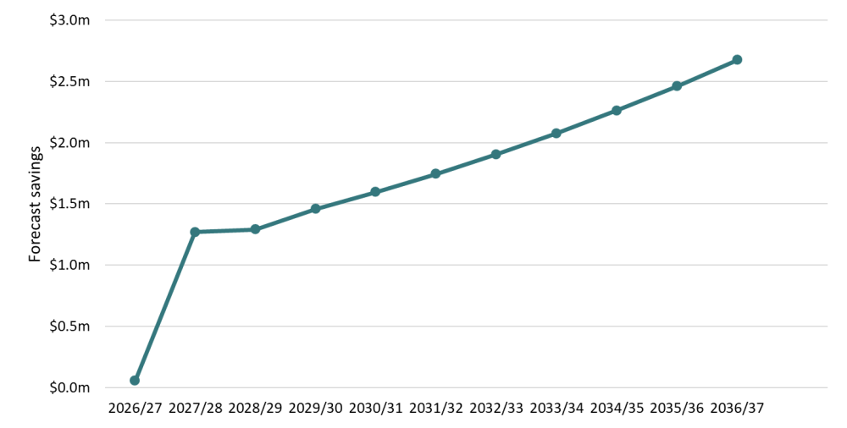
Figure 22. Modelled savings of fortnightly rubbish collection as compared to status quo. Assumes municipal-wide fortnightly rubbish collections in 2027/28 Data sourced from MCC.

Learnings around implementation

Efficacy of support mechanisms
Merri-bek City Council provided a suite of support to properties in the Trial area. Feedback from interviews and surveys indicate that this support was valued in a range of different contexts and to differing extents:
- Of the main elements of support offered by Council, the general resources and information from Council were the most frequently cited as helpful (Figure 23). Over a third of respondents (35%) indicated that these had helped them adjust to the fortnightly collection. Bin calendars, in particular, were highlighted by several interviewees and survey respondents as being particularly useful.
Remembering which bins to put out is hard - please budget to send the printed A5 calendars with magnet to all houses every year. Don't skimp!!! (Survey respondent – December 2025)
- The SMS reminder service was also singled out in interviews and survey comments as being highly helpful. 32% of survey respondents noted that the reminder was helpful, with several interviewees further elaborating how helpful and important they had been (see also the Box text below).
Each week, I get a text, telling me which colour bin. It's just brilliant. If they want this to succeed, they will get most people on board with that system, I think. (Community interview – December 2025).
- Several interviewees and survey respondents specifically mentioned that having the option of a larger bin was critical to them being able to adapt to the fortnightly collection. This is interesting in the context of the modest uptake of larger bins – as noted previously, only 8% of Trial households opted for a bin larger than the standard 120 L. Indeed, only 9% of the survey respondents that indicated their bin volume was inadequate (see Section 6.2) had upsized their bins. Key drivers here are likely to include households being:
  - unaware of the options related to bin changes
  - unwilling or unable to pay for the larger bin costs
  - unaware or ineligible for the concessions available (see below).
Some survey respondents clearly misinterpreted the costs associated with bin changes. One noted, for example, that upsizing their bin would cost them an additional $400 in rates – something that is not possible under the Trial charges, even moving from the smallest to largest bin option.
- Complementing the options for different bin sizes, having accessible concessions was a key piece of support highlighted in both survey responses and interviews. These concessions provided eligible households with the opportunity to upsize their bin size at no extra cost, reducing the difficulty of dealing with the large amounts of waste created by, for example, young children in nappies, large households or people with medical needs. Important to the Trial, these concessions required minimal evidence at the time of application, further reducing the burden on participants. The key issue to note here is that it appears that not all households were aware of the concessions available. For example, 29 of the 36 survey respondents with 5 or more people in their households (potentially making them eligible for concessions) did not have larger bins (24% had only an 80 L bin). Similarly, some survey respondents highlighted the need for support for people with medical waste – something that is covered by the concession process.
- While 12% of survey respondents indicated that bin-tags were helpful reminders of what can go into bins, several respondents also indicated that they found these tags to be annoying and/or anxiety-inducing. That said, feedback from bin inspectors also revealed instances where the tags had directly helped people to recycle more appropriately. As noted by one interviewee:
A gentleman was on the street while I was doing the bin audits and he came up to me, to say he was putting the wrong milk packs in the recycling and how he saw the tag explaining they're not allowed in recycling, and he no longer puts them in, he was very excited to tell me. (Stakeholder interview – December 2025)
- Interviewees and survey respondents also provided feedback about how the Trial had, more generally, helped them to use their FOGO bin better. This included key steps such as:
  - The provision of FOGO caddies at Council’s service centres (which staff also noted to be beneficial in terms of prompting discussions with households)
  - The allowance of brown paper bags in FOGO as an alternative to biodegradable plastic bags helped in conversations, however the use of this method was not widely known in the community.
Giving out the caddies at customer service gave the customer something positive to walk away with, some positive thinking. (Merri-bek staff interview – November 2025)
I was surprised by how easy it has been. The kitchen caddy has been the key (Survey respondent – December 2025)

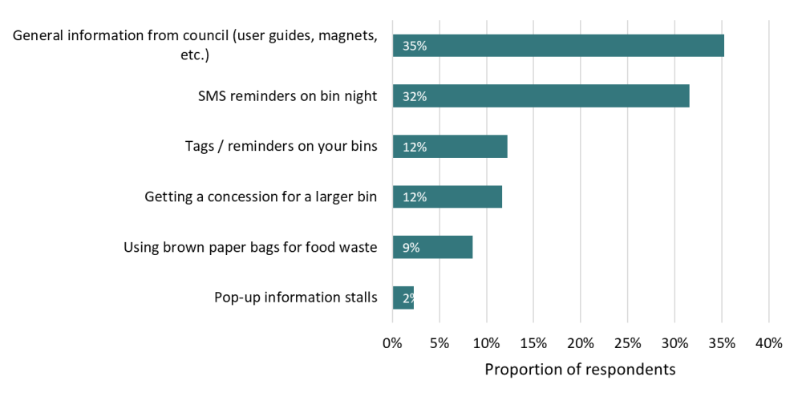
Figure 23. Proportion of survey respondents who found different support mechanisms useful. N=352.

Challenging but workable – the experience of a young family in Brunswick
A couple in Brunswick described feeling genuinely supportive of the change, seeing it as a practical way to reduce waste, which aligns with their environmental values. Before the birth of their first child, the system worked smoothly. Between composting at home and using the FOGO bin for food scraps, meat and bones, the red landfill bin was only ever about half full. However, everything changed once the baby arrived.
Overnight, the volume of waste the household produced increased drastically, with 8–12 disposable nappies a day quickly filling the red bin, even while they continued composting and using the FOGO bin as much as possible. Additionally, the small size of their bin was a challenge, with only 1 baby in a nappy, they were not eligible for a concession for a larger bin.
Despite struggling with adapting to the trial, the couple continue to support the fortnightly collection. Importantly, they also found some of the support from Council to be valuable - especially, the weekly SMS bin reminder as a way to help manage the change in routine.
“About a month or two ago, I signed up to the text updates. That is an absolute game changer. Like I really like cannot stress enough, I don't know what the cost is to Council, but if you want to put it like bold and underline, that is sensational.”
(Based on interview with Trial participant, November 2025)

Key delivery lessons from a council perspective
Council staff’s experiences in delivering the fortnightly rubbish collection provided a range of insights for council in terms of what would be required for a council-wide roll-out. This includes:
- The high levels of community inquiries and the associated need for appropriate resourcing of customer service. The pre-trial period and early weeks of the Trial saw a spike in customer service inquiries related to the Trial and to waste management more generally (Figure 24). This then declined through time. For example, missed collections requests rose in the weeks immediately after the trial began, peaking at 62 requests in July and then declining over the trial period. The key point here is that the change to fortnightly collection led to a marked uptick in inquiries that would need to be accounted for if planning a municipal-wide roll-out; whether through increased resourcing or staged delivery.
- The need for clarity and certainty in communications. Staff reflected that there were a range of difficult conversations with community members during the early stages of planning for and delivery of the Trial at a point when the exact costs for ratepayers and the length of the Trial itself were unknown. This uncertainty was noted to create additional dissatisfaction among community members. While specific to the Trial, this provides a more general lesson around the importance of reducing ambiguity as much and as early as possible where significant changes are being implemented.
- Sequencing bin-changes so that they are manageable. The Trial adopted a highly flexible approach to bin changes, allowing residents to change their bins at any stage of the Trial process. This is not expected to be feasible for any municipal-wide roll-out. Instead, staff suggested:
  - Rather than asking residents at the start about their preferred bin size, communicating that the 120 L bin will be the default unless people apply for something different.
  - Adopting a clearer set of windows during which changes to bins can occur (rather than having the option of changing bins at any stage).
- Establishing the viability of the SMS reminder service. As noted above, this service was highly valued among Trial participants. However, it was highly manual and requires resourcing. If it is to be adopted across the municipality a more automated and cost-effective approach would be required.

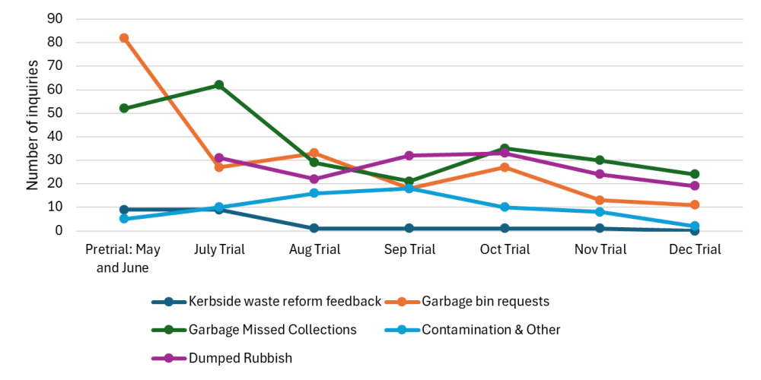
Figure 24. Customer service inquiries related to the Trial over time.

Appendix A – Variation in contributions to food waste in rubbish
As discussed in Section 5.1, audit data showed households differ substantially from each other in terms of how much food waste they were disposing into rubbish bins. Before the Trial, households disposing more than two kilograms of food waste in the rubbish bin accounted for 87% of all of the food waste in the rubbish stream (Figure 25).
This highlights several important points:
- Fortnightly rubbish collections effectively shifts the behaviour of these households. As of December 2025, those in this highest disposal category (putting more than two kilograms of food waste into the rubbish) accounted for 47% of the food waste (compared to 87% of the food waste pre-Trial).
- Households already putting low amounts of food waste into the rubbish contribute minimally to the overall level of food waste in the rubbish stream – the bottom 50% of households (i.e. half of audited properties) account for only around 7% of all the food waste in the rubbish.
- These points combine to emphasise the value of providing communications and support to those households who are disposing of large volumes of food waste into the rubbish (rather than the ones who are already using the FOGO bin to a modest extent). They are by far the most significant contributors to organics in the rubbish stream.
- Even after the dramatic improvements in food waste disposal achieved through the shift to fortnightly rubbish collection, a substantial amount of food waste (43%) remains in the rubbish stream. This means there is still further opportunity for improvement here.

Figure 25. Proportion of all food waste disposed of in rubbish by households with different levels of disposal (note - data is only presented from single-unit dwellings to simplify interpretation; n=91). Data compared between June 2025 (pre-trial baseline) and December 2025 (Trial).

Kerbside bin audit 2024. Knowwaste for Merri-bek City Council. 2024.
Fortnightly rubbish trial: Trial waste audits. January 2026. Knowwaste on behalf of Merri-bek City Council.
Guidelines for Auditing Kerbside Waste in Victoria: Leading practice for measuring kerbside waste, recycling and green organics. 2009. Sustainability Victoria.
Fortnightly rubbish trial: Project report. January 2026. Reground on behalf of Merri-bek City Council.
Fortnightly bin trial: Engagement outcomes report. Conversation Co. on behalf of Merri-bek City Council.
Note this is comparable to other waste-related surveys from councils – e.g. Yarra Ranges in 2023 had an 11% response rate to its community waste survey; Hobsons Bay had a 4% response rate in relation to its waste and recycling strategy; Brimbank had a 1% response rate to its waste reforms survey.
https://www.vic.gov.au/victorian-local-government-waste-data-dashboard
If a bin is not listed for a waste stream then the proportion disposed in that bin is 0% for both the baseline and Trial
E.g. hazardous waste, e-waste, tetrapaks that could be recycled through the container deposit scheme
Data from Fortnightly rubbish trial: Project report. January 2026. Reground on behalf of Merri-bek City Council.
Based on estimates from 2021 ABS Census data there are 9731 children 0-4 in the MCC LGA. Among the 74,384 households, this equates to a maximum of 13% of households with nappy aged children.
Noting that this respondent could access a concession for a larger bin without landlord permission if they have two children in nappies.
Based on Merri-bek tracking data for the Trial.

