

  - Accessible and Inclusive Communications Policy and Implementation Plan
  - 2021-2024

  - Plain language summary
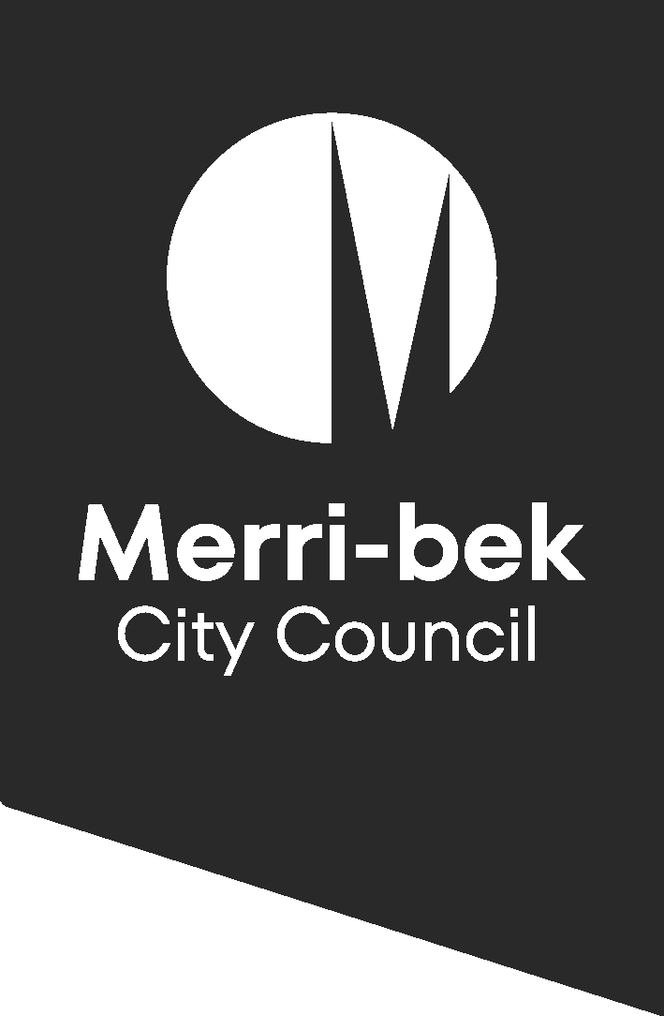


Accessible and Inclusive Communications Policy

2021-2024

Plain language summary

This document is called a plain language summary.
It gives you the key information that is in a longer document called the Accessible and Inclusive Communications Policy and Implementation Plan 2021 – 2024. We will call this longer document the Policy. The Policy is written by Merri-bek City Council.

Acknowledgement

We acknowledge the Wurundjeri Woi-wurrung people as the Traditional Owners and Custodians of the land and waterways in the area now known as Merri bek. We recognise their ongoing connection to the land, water, and sky Country, and we pay our respects to Elders past and present for their continued care of Culture and Country.

We recognise that their sovereignty was never ceded. This always was, and always will be, Aboriginal land.

Purpose of this policy
Merri-bek City Council wants everyone in the community to be able to find, understand and use Council information. This includes information about:
- Services,
- Programs,
- Events
- and decisions.
That is why Council has the Policy. The Policy explains how Council will make its communication more accessible and inclusive.
Accessible and inclusive communication means sharing information in a way that everyone can find, understand and use. It means it is our job to remove barriers that can stop people from accessing our information. It also means that we communicate in a way that makes everyone feel respected and included.

The Policy is for:
- Council staff
- Contractors
- Consultants who create information for the community.

Why we need this Policy
Merri-bek is a diverse community. Many people speak languages other than English. Some people have barriers to accessing written information. Some people are older, some have disability, and others are new to Council processes.
Everyone has the right to clear and accessible information and to communicate with Council easily. Council puts the community first in everything it does. This means Council’s communications must meet the needs of everyone in the community.

Who the Policy supports
The Policy aims to benefit the whole community, including the priority groups identified in Council’s Human Rights Policy:

- Aboriginal and Torres Strait Islander communities
- Migrant, refugee and faith communities
- People with disability
- Women, girls and gender diverse people
- LGBTIQA+ communities
- Children and young people
- People experiencing poverty, homelessness, low income and financial hardship.

The Policy also aims to support:

- people who speak languages other than English
- people who have barriers to accessing written information
- people with complex communication support needs
- people who are unfamiliar with Council services.

What accessible and inclusive communication means
Accessible communication:
- is clear and easy to understand
- removes barriers that stop people from getting, understanding or using information.
Inclusive communication:
- recognises and values the diversity of the community
- responds to the different ways people access and use information
- means thinking about who the audience is, what they need, and how to reach them
Both accessible and inclusive communication:
- Consider the different identities and life experiences people have
- Recognise that these differences can affect how people receive and understand information

Key principles
The Policy is based on the following principles:
- Everyone should be able to have a voice in our democracy and take part in Council decisions without communication barriers.
- Council communications should reflect the diversity of the Merri-bek community and respond to community needs and feedback.
- Access to information is a human right. Failing to provide accessible information can be discriminatory.
- Staff must understand their audience and tailor their communication accordingly.
- Council information must reach people where they are and not rely on people to seek out information.
- Council will review and improve its communication practices over time.

Types of communication covered
The Policy applies to Council’s public information, such as:
- website
- social media
- emails
- printed publications
It also applies to internal communication used by staff.
Key standards include:
- using plain language
- meeting web accessibility guidelines
- providing translations
- making information available in different formats when needed.

Key focus areas
The Policy outlines seven areas of work that will guide Council’s efforts:

- Preparation
Identify target audiences and understand their communication needs before creating content.
Choose communications formats and channels that match these needs.

- Understand community needs
Use research, community consultation and data to understand the community’s needs. Use this information to develop and test content.

- Create accessible and inclusive content
All community communications must be accessible. This includes Council’s website, social media and newsletters. Council needs to deliver information in multiple formats. For example, plain language, Easy Read, audio, print and translated versions.

Use Aboriginal and Torres Strait Islander language, artwork and cultural elements with permission and guidance.

Follow existing Council guidelines on respectful language and representation.
Offer different communication options.

- Use accessible and inclusive communication channels
Make sure information is shared in places and formats that people use, including community spaces.

- Support two-way communication
Ensure community members can easily ask questions, give feedback and access interpreter services. Promote interpreter services widely. Ensure all frontline staff know how to book, use and work with interpreters, including Auslan.

- Support staff
Provide training and tools to help staff communicate in accessible and inclusive ways.

- Evaluation
Review progress, learn from community feedback, and improve over time.

Multilingual communication
More than 10,000 Merri-bek residents have low or no spoken English. Council will:
- Make interpreter services, including Auslan, easy to access and well known.
- Train staff to use interpreters and support people who speak another language.
- Provide translated materials when needed.
- Use different methods to reach multilingual communities.

Community engagement
When Council seeks community input on projects or decisions, it will:
- provide information in plain language
- translate materials where needed
- make accessible formats available
- give people enough time to prepare
- provide an accessible summary of the issue
- offer interpreting and communication support at forums and meetings.

Staff responsibilities
Accessible and inclusive communication is a shared responsibility. All Council staff must follow the Policy. This includes:
- Directors
- Senior officers
- Council officers,
- Communications Unit,
- Customer service staff
- Contractors and consultants.
All these people have defined responsibilities to make sure communication is accessible and inclusive.

Monitoring and evaluation
Council will use a monitoring and evaluation framework to check how this Policy is working and what needs improvement. The community will have opportunities to contribute to these reviews. The Policy will be reviewed every three years, with yearly progress checks.

Accessible and Inclusive Communications Implementation Plan

2021-2024

Plain language summary

The Accessible and Inclusive Communications Implementation Plan sets out the practical steps Council staff will take to put the Policy into practice.
These practical steps include:
- Making sure Council departments use the Policy.
- Creating guidelines Council staff. For example, guidelines on how to use plain language and Easy Read formats.
- Developing and promoting an Accessible and Inclusive Communications Toolkit.
- Training Council staff. For example, delivering plain language training.
- Developing guidelines around using interpreter services.
- Promoting interpreter services to the community.
- Making planning processes more accessible and inclusive.
- Developing a resource that gives a breakdown of the different communities in Merri-bek and outlines their communication needs.
- Providing key Council documents in plain language and Easy Read formats.
- Supporting staff who can use community languages. These staff may communicate with community members in their community language, where appropriate.
- Developing a framework for monitoring and evaluating the Policy.
- Creating an Accessible and Inclusive Communications Working Group.
- Reviewing accessible and inclusive communications at Council meetings.

Accessibility
Merri-bek City Council is committed to making our information accessible and inclusive.
We welcome feedback and requests for alternative formats.
If you need this document in a different language or a different format, please let us know. We will try to help.
You can reach us by:
Phone: 9240 1111
Email: Accessibility@merri-bek.vic.gov.au

