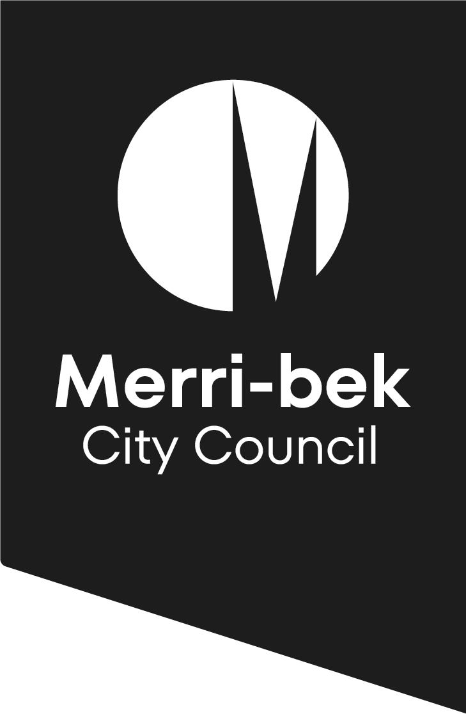

Living and Ageing Well in Merri-bek:
  - An Age-Friendly Framework
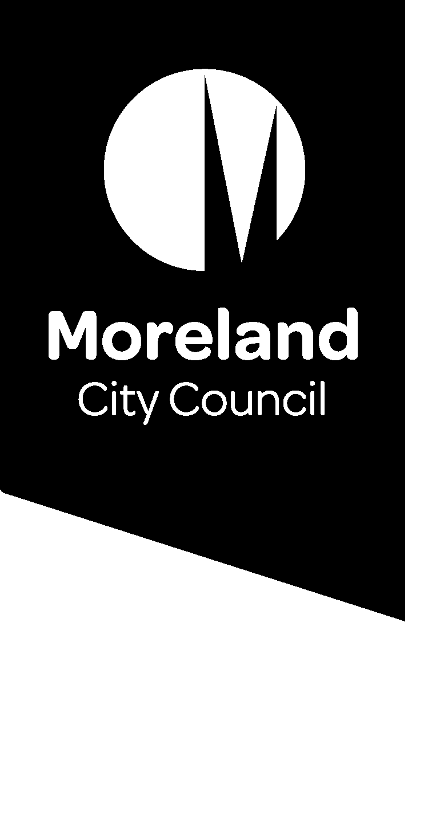

Contents

1. Introduction 3
2. Policy Context 4
3. Older people in Merri-bek 7
4. Consultation 8
5. The Living and Ageing Well in Merri-bek Framework 9
World Health Organisation’s Age Friendly Environments 9
The Framework Actions 12
6. Implementation 16
7. Bibliography 17

This Framework was developed with the assistance of Meg Henderson, Everybody’s Business and Emanuela Savini, The Public Value Studio.

Introduction

The Living and Ageing Well in Merri-bek Framework establishes principles and practices which inform relevant, timely and responsive action across all areas of Council to support older people in our municipality. It brings together the key objectives of existing Council policies, plans, strategies and external partnerships, that contribute to improving the health and wellbeing of older people living in Merri-bek.
Local government has a pivotal role in leading and facilitating communities where people of all ages, regardless of ability or life stage, can live a quality life.
This Framework draws strongly on the active ageing and age friendly cities policy frameworks developed by the World Health Organisation. Key drivers behind the development of these include:
- People are living longer and the proportion of older people in the population is growing
- Older people, regardless of age or ability, want to participate and be included in society, have purpose and stay active in their later years
- An improved understanding of the barriers that inhibit active and healthy ageing and how these barriers can be removed
- Increased evidence of individual and community benefits from an active and healthy older population
- The need to reduce the demand on health, care and support services that is anticipated with population ageing
- The need to refocus and reinvest in how older people are supported to live out their lives.
Health and wellbeing are determined not only by our genes and personal characteristics but also by the physical and social environments in which we live our lives.
An age-friendly city encourages active ageing by optimising opportunities for health, participation and security in order to enhance quality of life as people age. In practical terms, an age-friendly city adapts its structures and services to be accessible to and inclusive of older people with varying needs and capacities.
Almost 14% of Merri-bek’s population is aged over 65 years, and this number expected to grow in the next 20 years with a further 14% aged 50 and over. The advantages of taking an approach that supports older people is well recognised and benefits the community as a whole. It is core council business; drawing upon the range of strategies and skills that Merri-bek City Council can bring to play in supporting the community to thrive and older people to live and age well.

Policy Context

International
The World Health Organisation’s Global Age Friendly Cities suggests that policies, settings and structures support and enable people to age actively by:
- Recognising the wide range of capacities and resources among older people
- Anticipating and responding flexibly to ageing related needs and preferences
- Respecting older people’s decisions and lifestyle choices
- Protecting those who are most vulnerable
- Promoting their inclusion in and contribution to all areas of community life
The international context for ageing has been refocused following the release of World report on ageing and health (WHO, 2015) and the Framework for action on ageing and health (WHO, 2016). The report resulted in 2020-2030 being declared the global Decade of Healthy Ageing.

Australia
The Australian government has determined that reform is necessary to ensure the aged care sector can meet the needs of an ageing population in an efficient, fair and sustainable way. Reform is being guided by the Aged Care Roadmap that identifies short, medium and longer-term goals to make the aged care system more consumer-driven, market-based, sustainable, and nationally consistent. Some reforms are already in place such as the centralised funding of aged care, My Aged Care, the NDIS and client directed care through home care packages.
The reform agenda provides an opportunity for councils to consider their role in ongoing delivery of direct community services, allowing exploration of strengthening the broader role in supporting their older population to age and live well.

Victoria
The Victorian government funded the Commissioner for Senior Victorians to explore the issue of isolation and loneliness of older Victorians. The final report, Ageing is everyone's business: a report on isolation and loneliness among senior Victorians, identified that at least ten percent of Victoria’s older population experiences loneliness at any one time.
Addressing loneliness among older people is ‘everyone’s business’ – we all have a role to play as neighbours, business owners, members of community groups or service providers in reaching out to and creating a welcoming and supporting environment for older people.
The report, which nominated local government as a key stakeholder, suggests that the building blocks in combatting social isolation and loneliness include:
- Integrated and coordinated seniors action planning
- Promoting the meaningful roles, value and purpose of people as they age
- Strengthening inclusion at the local level including increasing opportunities to join, attend and participate in existing clubs, groups, organisations or activities, both seniors-specific and generic
- Strengthening referral pathways and professional practice
- Community education and access to information to increase older people’s knowledge of the importance of maintaining and strengthening their levels of social participation and promote what is available through streamlined information and community education
- Addressing personal mobility and local transport issues by building on existing networks to facilitate access to services and involvement in local activities.
Following the report, the Victorian government and the Municipal Association of Victoria (MAV) signed the Age-friendly Victoria Declaration to provide leadership for better state and local planning for more age-friendly communities. Merri-bek is a signatory to this declaration.

Merri-bek City Council
As demonstrated by the figure below, the Living and Ageing Well in Merri-bek Framework is informed by Council’s key strategic plans. The Merri-bek Community Vision 2025 articulates the shared long term priorities for Merri-bek and refers to supporting people of all ages throughout. This Vision underpins the outcome areas of the Council Plan 2017-21 which then subsequently informs the Municipal Public Health and Wellbeing Plan 2017-21.

Each of these strategic plans has greatly influenced the development of this Framework.
Relevant initiatives of the Merri-bek Council Plan 2017-21 include:
- Determine the best way for Merri-bek to continue supporting our community throughout, and after Aged Care & NDIS reforms
- Help people feel safer in our neighbourhoods
- Improved Health and Wellbeing outcomes for Seniors in Merri-bek
Merri-bek City Council is committed to improving the health and wellbeing of residents by influencing the conditions needed for good health. Creating a supportive environment is a key driver of Council work and occurs through population-level planning, enabling residents to make healthy lifestyle choices - Municipal Public Health and Wellbeing Plan
The Municipal Public Health and Wellbeing Plan (MPHWP) identified six guiding principles for its implementation which are highly relevant to Living and Ageing Well in Merri-bek Framework. These are:
- Whole of council approach
- Partnerships Approach
- Human rights approach
- Life-course approach
- Health equity focus
- Place-based solutions
In addition to these key documents, the Framework has been informed by a number of other Council strategies such as the Human Rights Policy, the Merri-bek Integrated Transport Strategy and other area specific strategies such as the Library Services Strategy 2019-2023 and the Aquatic and Leisure Strategy 2018-2038. An age-friendly approach is promoted in a range of principles articulated in these documents, including:
- A human rights based approach where people of all ages and all abilities are included and respected
- Services that support Lifelong learning
- Independence, wellbeing and quality of life for all people as they age.
Finally, Council currently provides a range of services assisting older people to live as independently as possible for as long as they can and wish to do so. The Commonwealth and State Governments provide partial funding to Councils to deliver these services including:
- Assessment
- Service supports such as delivered meals, domestic assistance, personal care, individual social support, property maintenance, and respite
- Community transport
- Community development and social support programs
- Care coordination
- Senior Citizens Clubs engagement and support
- Volunteer support.

Older people in Merri-bek

People are living longer and populations are ageing, resulting in increased numbers of older people and a change in the make-up of our communities and municipalities. Although older people generally refers to people who are aged 65 years and above, the Living and Ageing Well in Merri-bek Framework encompasses a greater age scope and also considers the needs of those in pre-retirement from 50 and above. This constitutes a broad diversity of older people ranging from active retirees, individuals still in the workplace, as well as frail aged. Added to this, there is a wide variability in health status, function and well-being at any age.
The estimated resident population of Merri-bek was 166,770 in June 2015, with approximately 67,831 households in 2016. Population projections suggest significant growth will occur in Merri-bek over the coming years. It is predicted that the Merri-bek population will be 214,320 in 2036 and that there will be 85,919 households in the municipality. This equates to a population increase of 39% between 2011 and 2036.
In 2015, there were 22,237 older adults living in the City of Merri-bek. This represents 13.7% of the total Merri-bek population. Merri-bek has consistently higher proportions of residents in all age groups over 75 years, when compared with the Melbourne and the Australian average.
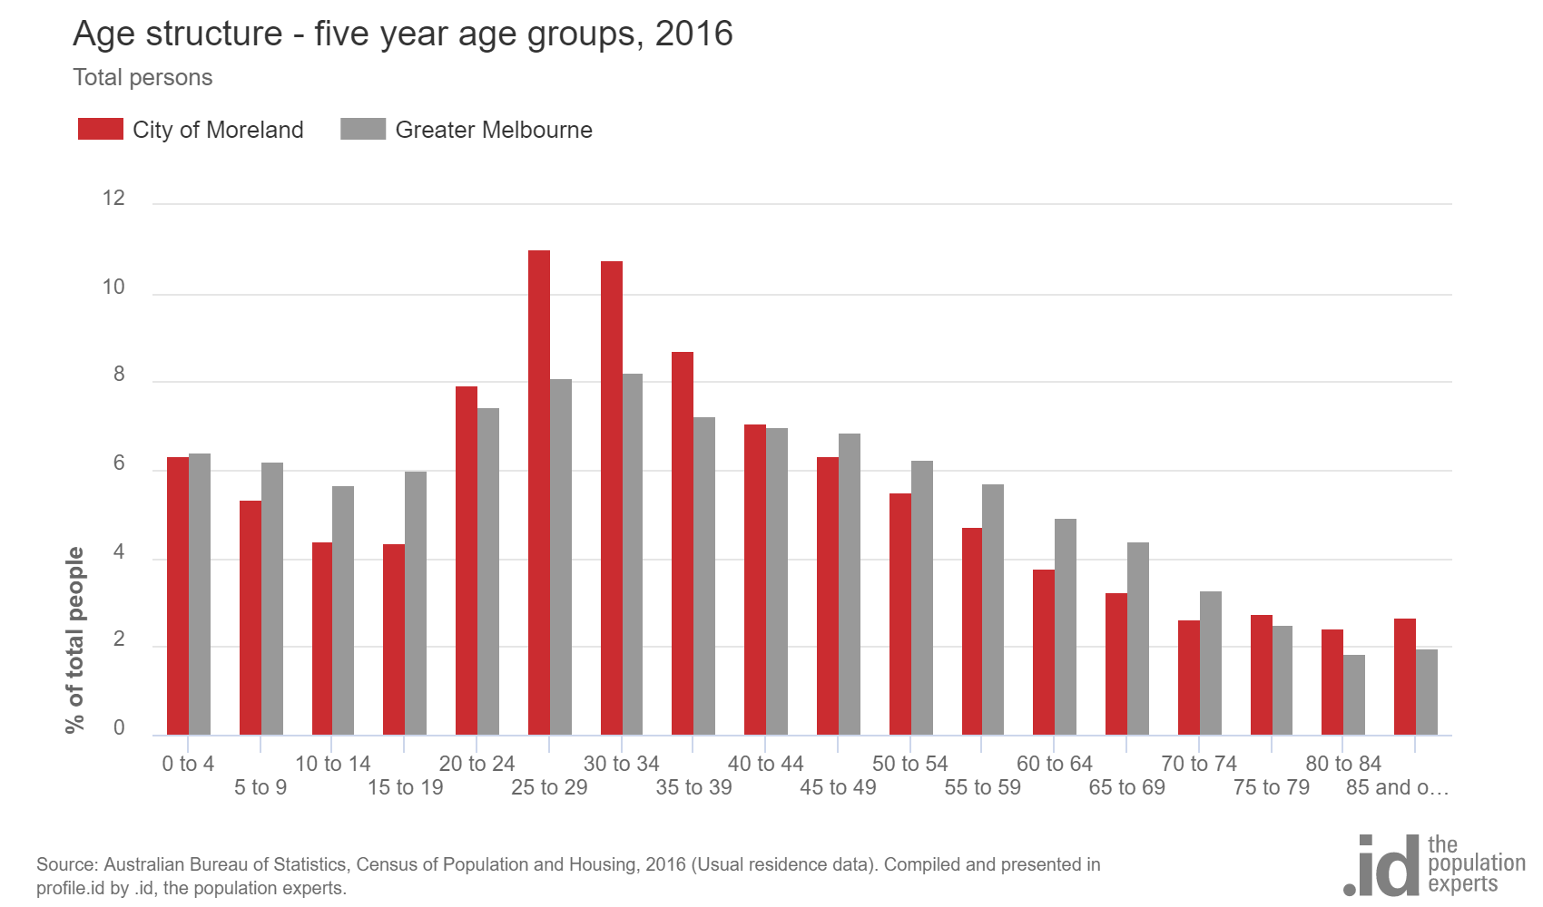

Consultation

An extensive consultation and engagement strategy was developed to support the development of this Framework.
Consultation and engagement included:
- The establishment of an Older Persons’ Reference Group with nine community members who have informed the development of the Framework
- Consultation with Aged Services Staff
- Survey of all Assessment Services clients during the month of March
- Meetings with the executive members of Merri-bek’s Senior Citizens Groups
- Three Focus Groups
- Fawkner Leisure Centre Seniors Morning Tea
- Internal Stakeholders workshop
- Consultation meetings with various areas of Council including: Strategic Transport, Community Development, Library Services, Facilities, Community Grants, Urban Design, Communications, Community Engagement, Aquatic and Leisure Services and Open Space Design
- Consultation with Merri Health (Community Engagement and Carers areas), U3A and Northern Region Seniors Hub Reference Group and three neighbourhood houses
- Seniors for Seniors Forum held in collaboration with U3A
- Further consultation phase for the Draft Framework

In addition to this, research that also informed the Framework included, but is not limited to:
- Previous research conducted for Aged Services by various consultants
- Analysis of consultation postcards from 2018 - 154 respondents
- Cross referencing of relevant existing Council policies and plans
- Consultation notes from the Living and Ageing Well in Merri-bek Seniors Forum held in November 2017
- Evaluation Report and Project Booklet for the ‘Strengthening Seniors Inclusion and Participation in local communities’ project funded by Department of Health and Human Services
- Overview of relevant organisations current initiatives including COTA, NARI and Carers Victoria

The Living and Ageing Well in Merri-bek Framework

World Health Organisation’s Age Friendly Environments
The Living and Ageing Well in Merri-bek Framework has been structured based on the World Health Organisation’s Age Friendly Environments as shown below.

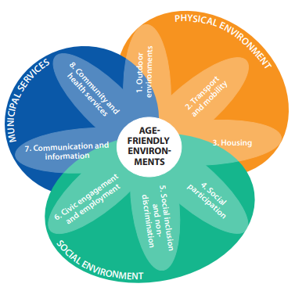

World Health Organisation Age Friendly Environments (2017)
Each of the eight Domains within the three Environments has been addressed in the Framework with proposed areas of action. These are explained below:

Physical environment
The Physical Environment includes the outdoor environment, transport and housing. Its underlying principle is that the built environment can turn impairment into a disability, thus reducing access for people, and risking social isolation.
“Feeling secure in ones living environment is a major factor in older people’s choice to leave their homes and engage in their communities.”
For older people, the ability to get “out and about” is critical to wellbeing. Public benches and other opportunities to rest, as well as, adequate toilets, are essential for older people with some functional limitation to feel confident in public spaces. In addition, more active activities to engage in when outdoors, such as physical exercise stages are also highly beneficial. Therefore, urban design and infrastructure are particularly important for supporting older people’s participation in community life.
Likewise, transportation is crucial for maintaining social connections with families, friends and neighbours and for keeping engaged in life and participating in society more broadly, including access to health and social services.
Finally, housing security is becoming a more significant issue in Merri-bek, particularly for older women. Research has shown that lower income older single women, who are currently private tenants with little savings or superannuation funds, are more vulnerable to homelessness than men.

Social Environment
The Social Environment focuses on social participation, social inclusion and non-discrimination, civic engagement and employment.
Social participation affects all aspects of health and wellbeing, from mental health and dementia to the risk of emergency admissions to hospital resulting from avoidable conditions such as severe dehydration or malnutrition. Social isolation has a tendency to occur alongside other risk factors of poorer wellbeing such as health problems, limitations in functioning, financial difficulties and political or neighbourhood exclusion.
Lack of social relationships was a risk factor for mortality comparable with, if not greater than, such well-established risk factors as smoking, obesity and physical inactivity.
It is important to create environments that are socially inclusive, where all people – regardless of age, gender, social position, health or disability – are respected and have opportunities to participate and contribute. To enhance equity, it is crucial to complement population-based interventions with targeted efforts, reaching out to people most at risk of poor health and exclusion, understanding their specific needs and promoting their health and quality of life.
In addition, ensuring older people are celebrated in our community and discrimination is addressed is important. The public health impacts of issues such as gambling and are significant and it is well known that older people are more vulnerable to this harm. Equally important are programs that mitigate against elder abuse and other forms of discrimination.
Changes in retirement patterns mean that older adults will work longer. Council can play a role in advocating employment opportunities for older adults. At the same time, the creation of volunteering opportunities allows older people to contribute to the local community after retirement and to share their knowledge and skills with younger generations.

Municipal Services
This Environment primarily describes how information is shared and includes how older people are engaged in co-designing and accessing services.
The way formal community support services are being delivered is rapidly changing with the shift in funding models and program design. The role that Council can play in ensuring older people are informed and supported to access appropriate supports is of even more importance during this transition.
Activities to improve communication and information aimed at all groups of older people play a key role in closing the gaps in access to services, activities and events, and in reaching out to more vulnerable parts of the population.
Council currently provides a comprehensive range of quality community care services and active leisure programs. Whilst many of these may continue, the aged care reforms have brought about an opportunity for Council to reflect and consider its role going forward. Council is well placed to consult with older adults to identify changing service needs and to advocate to State and Federal Governments for the provision of relevant local services where gaps are identified.

Vision and objectives
In line with the overarching vision in the Council Plan, the vision for the Living and Ageing Well in Merri-bek Framework is that:

Moreland is a connected, progressive and sustainable city for older people to live, work and play

This Vision will be realised through the Framework’s Strategic Indicators:
- Outdoor environments support the needs of all to enjoy regardless of physical capacities
- Older people are able to get around the municipality as they need and feel safe
- Current, and future housing needs of older people are considered
- Older people lead active and healthy lives where they participate in a range of activities
- Older people are celebrated in our community and discrimination is addressed
- Older people have opportunities to participate in, and inform, civic life
- Communication about programs and services that are relevant to older people’s needs is informative and easy to access
- Older people have access to a range of quality services that are responsive to their needs and aspirations
In addition, Merri-bek Council is one of hundreds of local and regional governments acknowledging that we are in a state of climate emergency that requires urgent action by all levels of government. Merri-bek has a long and proud history of leadership action on climate change and environmental sustainability. We acknowledge the need to step up further. We will be engaging more deeply to support our community to take individual and collective action and collaborating in our advocacy to State and Federal Government for urgent and effective policy and legislative reform.

The Framework Actions

Physical Environment
Strategic indicators | Actions
S:1  Outdoor environments support the needs of all to enjoy regardless of physical capacities | Create open spaces that engage older people in more active use and improve walkability such as: age-friendly physical exercise equipment, accessible footpaths; adequate resting points; sufficient toilets; and adequate lighting*
 | Undertake an annual program of disability access audits to resolve a range of accessibility needs across Council facilities in line with the Merri-bek Disability Access and Inclusion Plan*
 | Ensure older adult needs, interests and safety is considered in the design of buildings, public spaces, development and management of Council assets and parklands – including scoping opportunities to design age-friendly and dementia friendly spaces*
S:2  Older people are able to get around the municipality as they need and feel safe | Promote pedestrian accessibility and walking through initiatives such as installing and advocating for safer and wider footpaths, pedestrian crossings or developing walking maps with accessibility descriptions*
 | Promote the use of public transport, and if needed, support older people to build awareness and confidence using public transport*
 | Advocate to the State Government for improvements to public transport routes, availability and accessible services, particularly in the north of the municipality*
 | Review Council’s Community Transport service to ensure it continues to meet older people’s needs, both medical and social+
 | Ensure older people’s needs are considered as part of the Council Plan strategic priority to ‘Help people feel safer in our neighbourhoods’ (C6)*
S:3  Current, and future housing needs of older people are considered | Encourage the design of dwellings to meet the needs of people with limited mobility, and increase the supply of housing that is visitable and adaptable to meet the needs of different sectors of the community*
 | Ensure that the needs of older people are considered in Merri-bek’s housing initiatives*

Social Environment
Strategic indicators | Actions
S:4  Older people lead active and healthy lives where they participate in a range of activities | Provide of a range of opportunities that are either low cost or no cost for older people to be physically active, including aqua programs, exercise equipment in local parks or walking groups*
 | Promote and support programs that provide opportunities for older people to develop and lead activities, particularly activities that are low cost or no cost, such as those in libraries, U3A and community houses+
 | Promote libraries as hubs for seniors, that provide access to information, opportunities for life-long learning and decreasing the digital gap, as well as spaces for social connection*
 | Develop programs that encourage interaction between neighbours and create networks of support and social connection for older people, especially for those that have limited mobility+
 | Support older people to build confidence in attending new social activities by accompanying them in initial stages and working with organisations such as senior citizens groups to become more welcoming of new members+
 | Review senior citizen’s centres to maximise their use and ensure they continue to attract new users+
 | Provide opportunities for the executive members of senior citizens’ groups to connect with each other, share resources and build skills that are relevant to their roles+
S:5  Older people are celebrated in our community and discrimination is addressed | Recognise the contribution of older people through Council publications such as Inside Merri-bek, special celebratory events and Seniors Week programs*
 | Support and publicise programs that challenge the stereotype of ageing and celebrate positive representation*
 | Support and continue to participate in programs that address gambling risks, discrimination and the prevention of elder abuse, neglect and fraud against older people, providing appropriate training to Council staff*
 | Promote inclusion and raise awareness of discrimination experienced by older population groups, particularly those that are identified as priorities in Merri-bek’s Human Rights Policy*
S:6  Older people have opportunities to participate in, and inform, civic life | Establish an Age-Friendly Advisory Group who will have a leadership role in advocating for the needs of their community and develop a range of broader opportunities for participation such as Age-Friendly Champions+
 | Encourage older residents to have a voice and take an active role in local decision-making through involving them in consultation, engagement and evaluation activities across a range of Council’s service areas+

Council Services
Strategic indicators | Actions
S:7  Communication about programs and services that are relevant to older people’s needs is informative and easy to access | Develop a set of communication strategies which are targeted at older people and include a range of channels outside of online engagement, such as an older person’s quarterly newsletter which promotes a full range of activities provided by Council and community+
 | Ensure all Council information and publications are provided in accessible formats that can easily be understood by older residents as well as translated in text, or potentially in video format, in the major language groups of older people living in Merri-bek+
 | Provide opportunities for face to face communication and ensure the distribution of communication materials includes spaces frequented by older people such as doctor’s clinics, pharmacies, libraries, RSLs, community houses and through Council’s assessment services team*
S:8  Older people have access to a range of quality services that are responsive to their needs and aspirations | Involve older people in the design, delivery and evaluation of services that affect their lives+
 | Evaluate how council services can better cater to the needs, and interests, of older people in the municipality who currently do not access services that are relevant to them+
 | Advocate to State and Federal governments to ensure older adults have access to an adequate range of health and other support services, in particular those that support older people to age in place*
 | Create a service culture that is more flexible, and client focused in how it meets the needs of older people*
 | Exchange information and expertise regarding age-friendly initiatives across Council through the formation of an interdepartmental older person’s network+

Implementation

This Framework has been developed with a whole of Council and community approach. It is therefore expected that, whilst Aged Services will be responsible for overseeing the implementation of the Framework, it will be delivered in partnership with various areas across Council and with community partners.
There is significant alignment between a number of the Framework’s actions and currently established programs or services across Council. As such, it is anticipated that the first year of the Framework’s implementation will focus on ensuring council strengthens its age-friendly practice across all Council departments in their planning and implementation of their annual plans and activities. These actions have been identified with a * symbol in the Framework Action Plan. An annual implementation plan will be developed in consultation with the Age-Friendly Advisory Group and published on Merri-bek’s website to ensure it remains to responsive to opportunities as they emerge.
In addition, a variety of community organisations across Merri-bek already deliver programs that align with the strategic indicators of the Framework. Council will work with these organisations to explore these synergies, and where appropriate, partner on the delivery of the Framework’s actions.
New initiatives proposed in this Framework will be submitted to the annual budget process. These have been indicated with a + symbol in the Framework Action Plan. The implementation of these actions will be subject to securing appropriate resourcing. Some Actions require minimal additional resources and are able to be implemented in the first year, whilst others are dependent on external funding and are more likely to be delivered in subsequent years of the of the Framework implementation.
In addition, the Framework Action Plan will be reviewed every two years, in collaboration with the Age-Friendly Advisory Group, to ensure the actions can be adapted as needs change or opportunities arise.

Bibliography

Australian Bureau of Statistics (2016). Census of Population and Housing 2016: Quick Statistics. Canberra: Australian Bureau of Statistics.
Broekhuizen K, d. V. (2013). Healthy ageing in a green living environment: a systematic review of the literature. Leiden: TNO.
Commissioner for Senior Victorians (2016). Ageing is everyone's business: a report on isolation and loneliness among senior Victorians. Melbourne.
Holt-Lunstad J, S. T. (2010). Social relationships and mortality risk: a meta analytic review. PLoS Medicine , 7 (7).
Marsden G, J. A. (2007). Transport and older people: integrating transport planning tools with user needs. Leeds: University of Leeds and Leeds Metropolitan University.
Merri-bek City Council (2014). Affordable housing strategy 2014-18. Melbourne.
Merri-bek City Council (2017). Health and wellbeing profile 2017. Melbourne.
Merri-bek City Council (2017). Municipal public health and wellbeing plan 2017-2021. Melbourne.
Surf Coast Shire (2018). Positive ageing service review: Discussion paper. Torquay.
WHO Regional Office for Europe (2017). Age-friendly environments in Europe: A handbook of domains for policy action. Copenhagen.
WHO Regional Office for Europe (2012). Strategy and action plan for healthy ageing in Europe 2012-2020. Copenhagen.
World Health Organisation (2002). Active ageing: a policy framework. Geneva.
World Health Organisation (2007). Global age-friendly cities: A guide. Geneva.
World Health Organisation (2015). Report on ageing and health . Geneva.
Wositzky, K. (2017). Age-friendly cities and communities information kit for local government councillors and senior management. COTA Victoria and Municipal Association of Victoria, Melbourne.

Wositzky, 2017
Wositzky, 2017
World Health Organisation, 2015
World Health Organisation, 2007
World Health Organisation, 2007
Commissioner for Senior Victorians, 2016
Commissioner for Senior Victorians, 2016
Commissioner for Senior Victorians, 2016
Australian Bureau of Statistics, 2016
Broekhuizen. De Vries and Pierik, 2013
Marsden et al., 2007
WHO Regional Office for Europe, 2017
Moreland City Council, 2014
WHO Regional Office for Europe, 2012
Holt-Lunstad et al., 2010

