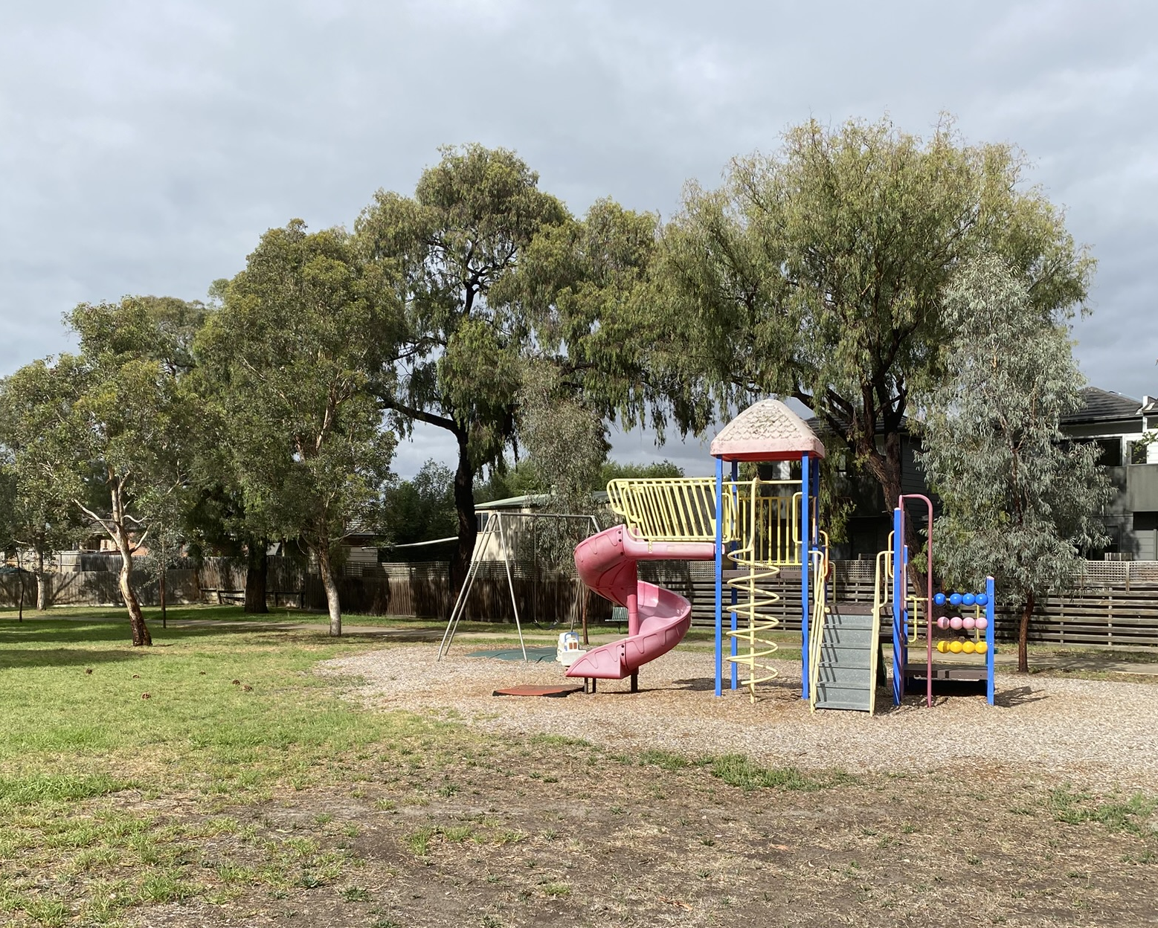


HM Dowd Reserve
  - Park upgrade

Consultation summary report
Prepared by
Wendy Skala Landscape Architect
Open Space Design & Development Unit
August 2024

Revision C

Revision A: initial consultation summary: August 2024
Revision B: draft concept consultation summary: Likely May-June 2025
Revision C: final concept plan: Likely End July 2025

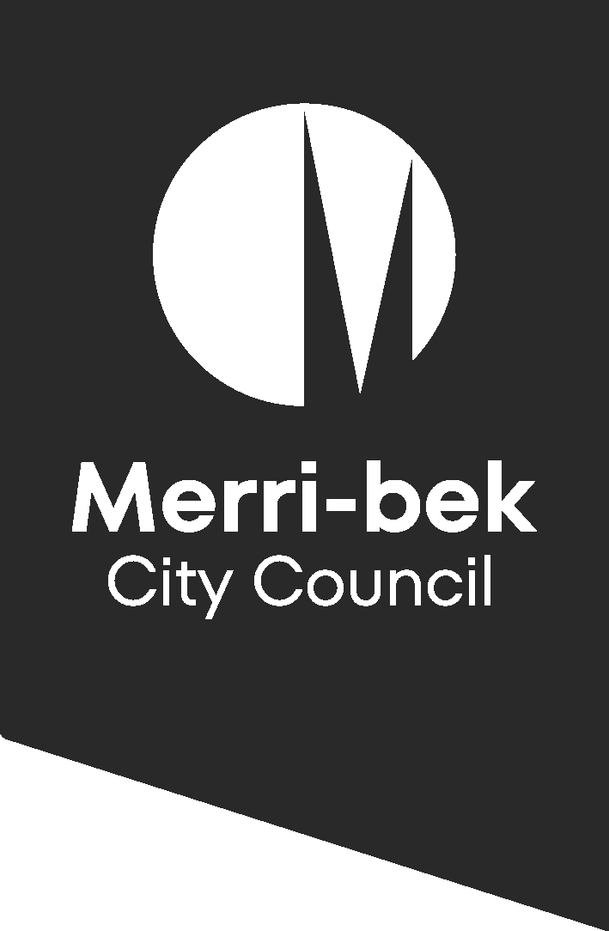

HM Dowd Reserve – park upgrade

Consultation summary report

June 2024
HM Dowd Reserve between Rhodes Parade and Crowley Court in Pascoe Vale is a reserve, currently comprising of a play-space, trees, shared path from Rhodes Parade to Crowley Court and open lawn areas. It has been determined ready for a park upgrade according to Merri-bek City Council’s Open Space and Playspace strategies.
This report provides a summary of the HM Dowd Reserve consultation – Phase 1, Ideas Gathering.
- Background
This report covers a summary of each consultation stage for the HM Dowd Reserve, park upgrade. This phase is ‘Ideas Gathering’ to inform the concept design.

As mentioned on Conversations Merri-Bek webpage, the following elements of the reserve are not negotiable as part of this upgrade:

- The upgrade will only cover the reserve and playspace area, not the surrounding areas (e.g. roads, car parking, lighting, services etc) – excepting the removal of the maintenance crossover on Rhodes Parade and the extension of the maintenance crossover on Crowleys Court (for safety and access reasons).
- This park will remain a ‘Dog on-leash’ Park
- Large-sized play elements cannot be included (e.g. a flying fox, basketball Halfcourt, Public Toilet, tower combination unit, etc) owing to the lack of space, sufficient funding and proximity of neighbouring properties.
- Unless trees are dead or in decline, they will not be removed as part of the works
- All the works must fit into the available budget.

Council’s Open Space Design and Development unit are conducting three consultation phases with the local community for the HM Dowd Reserve upgrade, these being:
- Initial consultation
Council have asked the local community what they would like to see included in the upgrade of this park. This information can be used as inputs to developing the draft concept plan. This stage has now closed.
- Draft Concept Plan Consultation
Using results from the initial consultation, Council has developed a draft concept plan using the local community’s initial input.
- Revised/Final Concept Plan Consultation
This revised concept plan reflects changes from the draft concept plan, incorporating the community’s feedback where possible. After receiving feedback, a final concept plan will be produced including any final changes to the design where possible. This will close the consultation process, prior to the team proceeding to detailed design.

Consultation timings
Initial consultation: 1st July – 24 July 2024 (completed)
Draft concept plan consultation: July 2 – 22 July 2025 (underway)
Revised/final concept plan issued: late July 2025.

For both the initial and draft concept plan consultations, postcards are distributed to households within 0.4km of HM Dowd Reserve, advising residents that they can provide feedback using Council’s website, https://conversations.merri-bek.vic.gov.au/hm-dowd-reserve-pascoe-vale. Posters are also to be displayed at the park and provided to the nearby schools.
A similar poster approach will be undertaken for the revised/final concept plan. The final concept plan will be displayed on the website along with posters at site. Thereafter the Open Space Design and Development team can proceed to detailed design. We will advise when construction will be starting and finishing once known.
- Initial Consultation Feedback Findings
Council received 19 feedback responses to the initial consultation from the Conversations website.
This feedback has been organised into the following categories (not in order):
- Fencing
The number 1 request for this park upgrade was fencing along Rhodes Parade. Council agree and the old pine log fencing will be removed, and new post and panel fencing will be installed along this busy road edge. Entrances will remain open and accessible for prams and all abilities access, with offset fencing as an additional barrier.
- Dogs
There was 1 request for a fenced dog park in this space. This is not viable given the proximity to residents. This park will remain a dog on lead park. For a list of dog off-leash parks in the municipality you can view: https://merri-bek.vic.gov.au/exploring-merri-bek/parks-and-gardens/park-amenities#autoAnchor2
- Gathering spaces and seating
Many people asked for additional seating throughout the park, especially in shaded areas and suggested a gathering space and/or shelter to be provided for carers to sit and watch their children play. We agree an improved gathering space area and shelter would greatly benefit users of this reserve.
- Additional trees and garden beds (shade, buffer and biodiversity/interest)
Further shade trees were requested as well as garden beds to provide habitat, biodiversity and natural barriers adjacent to roads and neighbours. We are planning to install a number of garden beds to improve biodiversity and provide interest along with some additional trees and grass mounding.
- Playspace upgrade (suggested items, nature play, materials)
Many respondents asked for different forms of play equipment. The majority flagged the need for the play equipment to target the 3 – 10 year olds, owing to the numbers of young families in the area and the 2 schools nearby.
Council will endeavour to source equipment that uses a mixture of new and recycled materials and to provide a range of equipment that suits this range of ages and abilities including a 360° basket pendulum swing with surfacing beneath to allow for wheelchair access. We have found that this swing provides not only for wheelchair users, but babies, elderly and teenagers equally enjoy it in their own way!
Monkey bars were also specifically requested, and we will endeavour to include them within the main combination play piece.
Several have asked for nature-based play (including logs/rocks and to encourage exploring) to be included in addition to more traditional play equipment, which will be included.
- Water play / drink fountain
Water play was requested. There is insufficient budget to include water play in this reserve. We can however include nature-based play using different and recycled materials to make the area engaging. We also intend to install drink fountain.
- Sports related (ball games, fitness equipment)
A few people asked for some ball sport courts (Pickle Ball/Basketball) or fitness equipment. Apart from insufficient budget, the proximity to neighbouring residents for the ball sports particularly, is considered potentially disruptive and noisy. Fitness equipment may be accommodated in the future if/when funding is available.
- Gathering space and Shade sails (seating, shelter, shade sails)
Several asked for more seating, shade and shelter. We intend to include a shelter with picnic table beneath along with strategically placed seats and platform benches throughout the park.
Many responses discussed the need for additional shade and in particular shade ‘sails’. We are unable to provide shade sails in this reserve owing to budget constraints, however, we intend to include shaded elements as part of the play equipment where possible (in particular, the combination unit) and to see if additional shade components can be incorporated as part of it. HM Dowd Reserve already has many established trees offering shade and we are planning to include additional shade trees within and around the playground as well, which in time will increase shade coverage at the reserve.
Toilets
A few respondents asked for a toilet. We cannot include a toilet in this upgrade, mainly owing to the budget constraints.
Inclusion of public toilets in public open space are subject to Council’s public toilet policy and not generally part of a small park upgrade such as this. Where they are included in small parks, it is where there are considered to be insufficient public toilets in the broader vicinity.
We will endeavour to address as many of these requirements as possible in the HM Dowd Reserve Concept design.
- Draft Concept Plan Consultation Feedback Findings
To be completed at the conclusion of Phase 2 of the Consultation on the Concept Plan.
- Revised/final Concept Plan
A summary of the final concept plan will be provided here once this stage of consultation has been reached.
- Next Steps
Officers will prepare the revised/final concept plan, using the feedback received from the draft and initial consultation stages and further site and stakeholder investigations. Once ready this plan will be displayed to the community on posters at site and on council’s Conversations Merri-bek webpage. This completes the community consultation component of the project and Officers will then be proceeding to detailed design and procurement before commencing construction. Updates regarding the project will be placed on the Conversations Merri-bek webpage and the community are encourage to signup to receive email updates via the website.

- Further information
Any questions can be directed to Council’s Open Space Design & Development Unit via email openspace@merri-bek.vic.gov.au or by phoning 9240 111.
- Appendix
Below are all feedback received from the community for each stage of consultation for the HM Dowd Reserve and images of the posters and postcards issued.

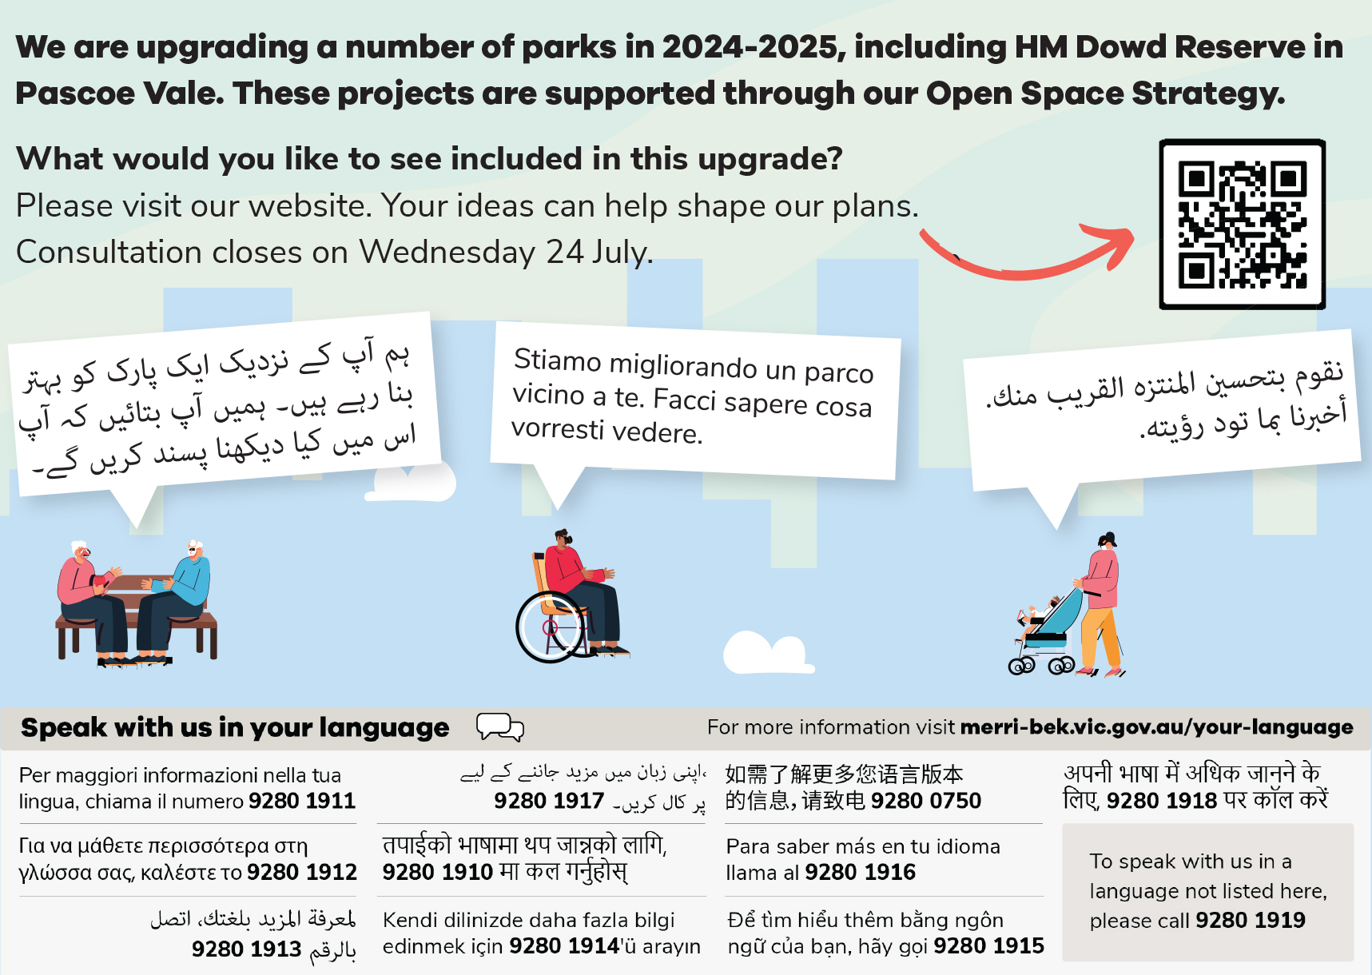
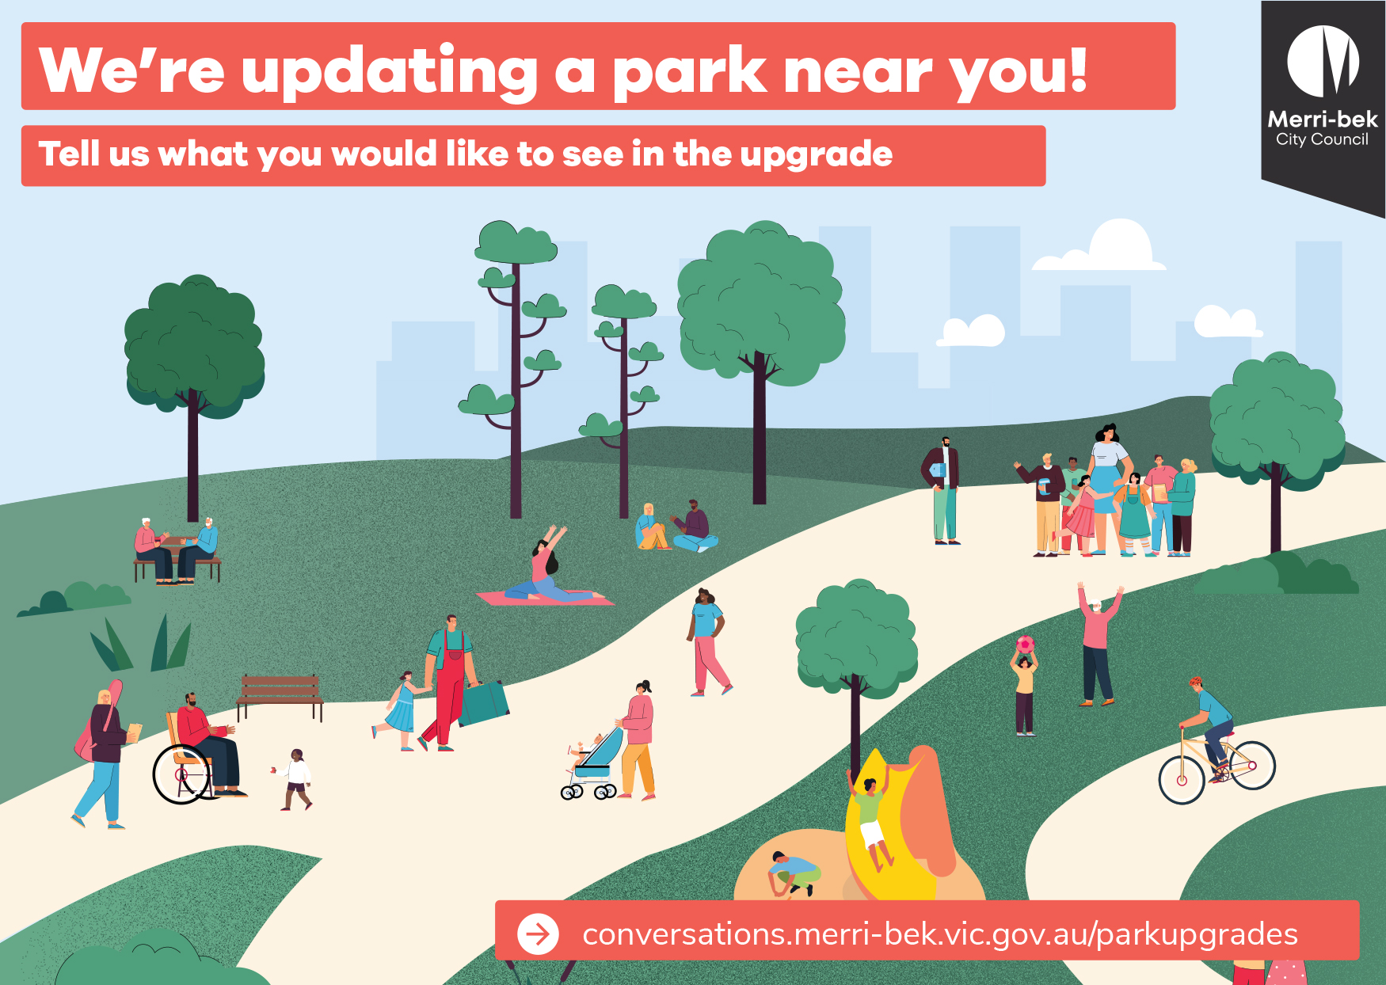
8a Initial Consultation
Figure 1: Postcards were issued to households within 0.4km of the reserve.

Below is feedback received for the HM Dowd Reserve:

Date Submitted | Title | Description
Jul 16, 2024, 11:54 AM | Good playground for toddlers | Like many others have said, this playground is perfect for toddlers and my toddler is able to reach the top of the structure by himself, which we love, so if we could keep this one toddler friendly, that would be amazing.  A fence to make it an enclosed playground would be good, a baby swing and some trampoline elements would be nice.
Jul 16, 2024, 10:48 AM | Accessible for all | Firstly I feel this area could be made safer with fencing at the main road (child freindly)  I feel this area is spacious enough for areas where there is a playground for kids, fitness equipment accessible for all, and areas for those who wish to enjoy the area and escape to some quieter pockets of space.  Further to this the grass needs to be maintained as it is consistently at a unusable length other wise the playground is the only real accessible part of the space that can be used
Jul 09, 2024, 10:49 PM | Dog fenced area/Get Active Zone | As close to busy road I feel children’s playground isn't so appropriate here. A fenced dog area at rear with seating, water fountain would be a wonderful addition locally. This could be tied in with Outdoor gym/exercise equipment (Get active Zone) that could be targeted towards adults/young adults (bars for chin up/dip/inverted row, different sized steps. Encouraging those unable to afford gym memberships to stay active and exercise locally.
Jul 08, 2024, 11:28 AM | Toddler friendly | Most of all we would love for this park to be gated for the little ones to be able to run around freely. Inground trampolines are always a win. Undercover tables and benches. Multiple swings that have a safety harness for toddlers.  Someone bought up an amazing point about toddlers being able to climb independently all the way up to the current big red slide. I asked my kids and they would love a seesaw. They also really love to balance and hop between multi level steps.  Monkey bars and slides are a given. But we would really love more shade in this space.  A half basketball court would be fantastic for the older kids.
Jul 04, 2024, 05:15 AM | Toddler friendly, no big drops in playground | As old as this park is, we enjoy the way our toddler can climb up himself all the way to the slide. Some playgrounds in merribek have really dangerous climbing ropes to get to the side or ladders which isn't suitable for toddlers. Would love to see this considered. Austin crescent for example isn't very toddler friendly for us at this stage. We adore the Service Street playground and would love to see something similar and versatile. It would be nice to keep this as a safe space for younger kids as the older groups on Pascoe Street can be quite rowdy and destructive. Also a fence is a must, too dangerous to have access to Rhodes Parade.
Jul 02, 2024, 11:27 AM | Exercise equipment | Outdoor fitness station would be a great addition to this park with Monkey bars/chin up and dips station. Not needing to take up much space in the park, and would offer a health and fitness option to local residents, would be a massive tick for Councils health and wellbeing objectives.  I second the suggestion for a fence along Rhodes Parade, have seen many kids running away from parents towards the road.  Shady spots and garden beds sounds great, love the existing trees around the perimeter of the park - definitely keep these.  I see lots of parents with toddlers at this park, updating play equipment to include this age bracket range would make the most of common users happy.  More pathways for children riding bikes would also be a great addition.  Encourage exclusive option for both kids and adults fitness to be considered when planning the redevelopment of this park.  Thank you
Jul 02, 2024, 10:51 AM | Toddler focus would good. | Very few parks in the area cater for toddlers so it would be good if this park was able to do that.
Jul 02, 2024, 02:11 AM | Outdoor gym | An outdoor gym would be great.
Jul 01, 2024, 09:38 PM | Great space- needs improvement | A water play area, climbing frames, a little bike/scooter path, vegie patch, seating for adults, water fountain and shaded/undercover area. Animal statues. An expression swing would be great! A flying fox for the older kids.
Jun 30, 2024, 07:26 PM | Upgrade ideas | A fence on the Boundary road side would be great so little ones can run around safely. Updated equipment suitable for toddler to bigger kids would be great. A shaded seating area and a sandpit would also be good additions.
Jun 30, 2024, 04:06 PM | Good location | This is a great location but it needs a swing a baby can go in, the current one only a big child who can hold on can go on.
Jun 29, 2024, 10:49 PM | A playground bring families together | We live just around the corner and have always believed that upgrading this playground would greatly benefit our community, especially considering the number of schools and families in the area. The playground is frequented by children of all ages, including students from Westbreen Primary School and Pascoe Vale Girls Secondary College. Many young families from the surrounding residential area bring their young children here too. However, the current equipment is limited, old, and unsafe.As residents with a young child ourselves, we often find ourselves walking all the way to Austin Crescent Playground, where there is newer and more extensive equipment and facilities. H M Dowd Reserve is larger and centrally located for families, making it an ideal spot to have equipment similar to that at Austin Crescent Playground. This upgrade would strengthen community connections and ensure families in our neighborhood have a safe and enjoyable place nearby for their children.
Jun 28, 2024, 01:32 PM | Toilet and water fountain | Would absolutely love a toilet and water fountain in this park. Love coming here but little people have little bladders and we often have to cut it short to go home for a bathroom break as there are no toilets close by.
Jun 28, 2024, 11:29 AM | Native plants and more shrubbery | Would love some more native garden areas like this with rocks and native flowers. Would love to see some nature incorporated play here including logs, rocks, sand and other textures.  I think some sort of obstcle course would also be good for the older kids since there's the school nearby and could be incorporated into the play space.
Jun 28, 2024, 11:21 AM | Add in multiple seating areas/picnic tables | Adding in a few more bench chairs and/or picnic tables in the park would be great addition. It would help make the park somewhere where you can go to relax, rather than just walk through to get in between the main road and the court.  Please place them in different areas e.g. one near the playground, one near the entrance to Crowley Court and one in the grassed area. This will allow multiple groups of people to all enjoy the park at the same time
Jun 28, 2024, 11:17 AM | Add in more native plants | Please consider adding in more native trees and especially small to medium native shrubs that flower, either in formal or informal garden beds.  The landscaping of the current park could be improved and there is plenty of space that could be dedicated to beautifying it to improve the look and support local wildlife.  Adding more native shrubs/plants would also help align the park more with the golf course and some of the beautiful nature strip gardens that you can see in Crowley Court.
Jun 27, 2024, 10:01 PM | So much space | There is so much underutilised space. I'd like to see some landscaping that kids can explore and use imaginative play. A previous suggestion was a pickle court, which sounds very cool (with a sturdy net of course). I don't think a basketball court is a good idea. There's unused basketball courts at Sewell Reserve. Having shade is important so planting mature canopy trees would be great.
Jun 27, 2024, 06:57 PM | Lots of possibilities | Have used this park mostly as a throughfare and for play after getting food from pascoe street.  Would be great to have a number of bbq tables / bench seating.  Love the idea of a half bball court here - there isn’t good space around for older kids.  Maybe one of those spinny things kids love - defiantly some swings and monkey bars
Jun 27, 2024, 03:52 PM | H M Dowd Park | It is truly a great space that is under utilised as it is old and dingy. A covered area with a bbq to the side would be ideal. Alot of the grassy area is uneven and would need to be levelled out for safety reasons. A quarter basketball court would be amazing like the one you have at Cole reserve. In terms of playground equipment a proper flying fox would be very popular with the kids, 2 swings minimum, bouncy trampoline and the latest would be a pickle ball court. Now a pickle ball court would be very cool!!!!

8b Draft Concept Plan Consultation
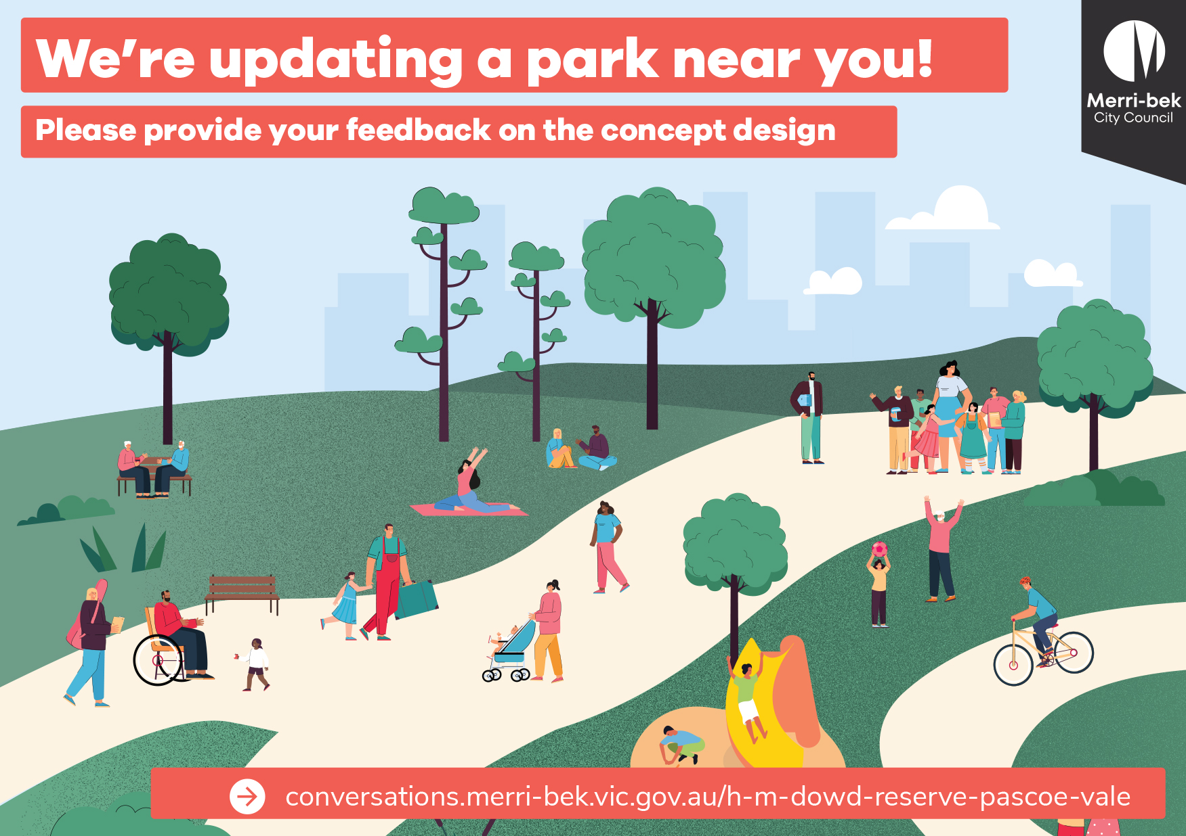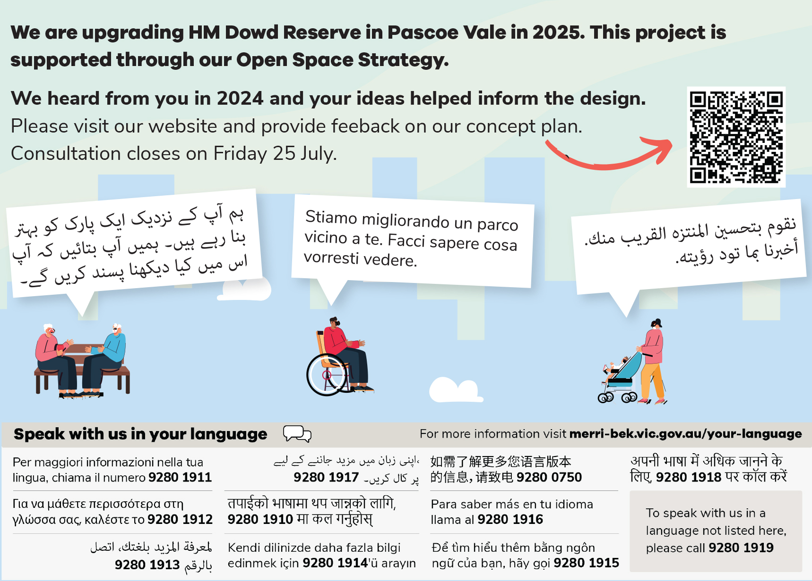
Figure 2: Postcards were issued to households within 0.4km of the park.

8c Draft Concept Plan Consultation Responses
Below will be feedback received for HM Dowd Reserve following the Draft Concept Plan consultation:
8d Revised/final Concept Plan
Below will be the revised/final concept plan. This will also be displayed at the reserve and on Conversations Merri-bek webpage.
Figure 3: Final concept plan (TBC).

