Gowanbrae Dog Park Elm’s Court Reserve
  - Park infrastructure upgrade

Consultation summary report
Prepared by
Phil Smith Landscape Architect
Open Space Design & Development Unit
August 2024

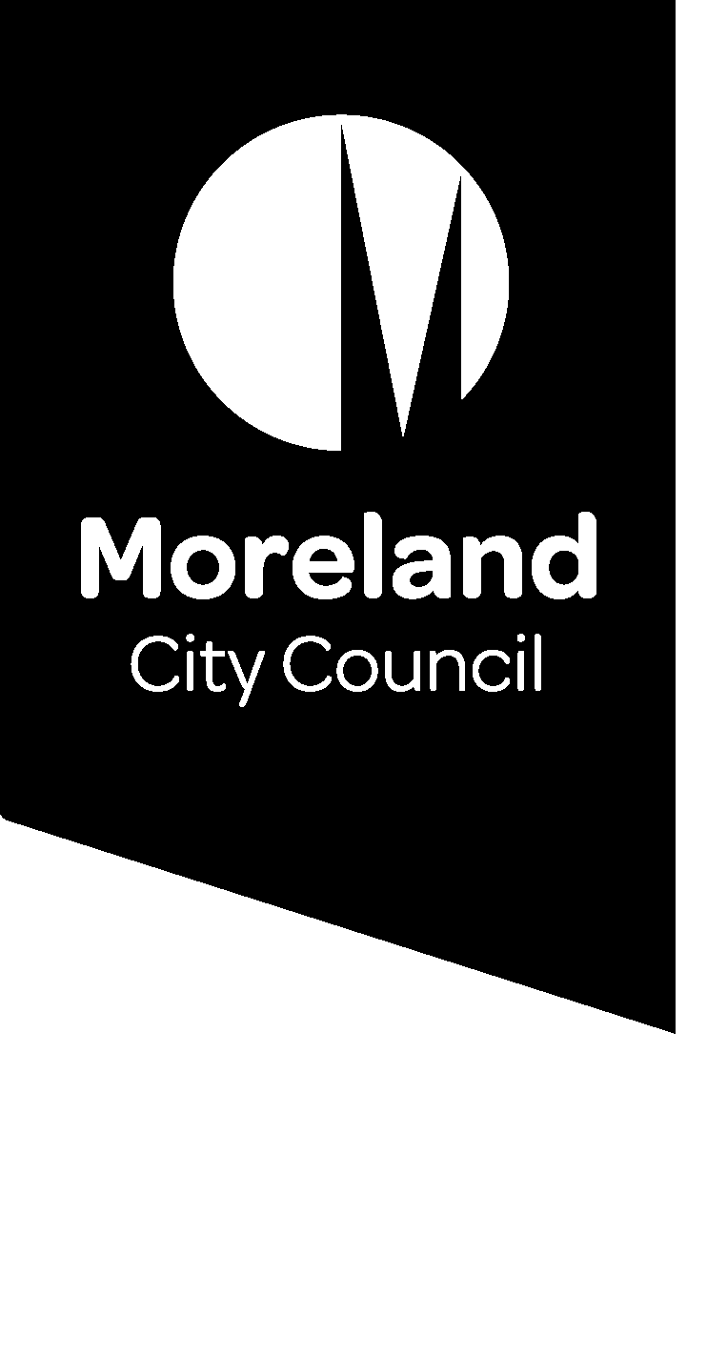
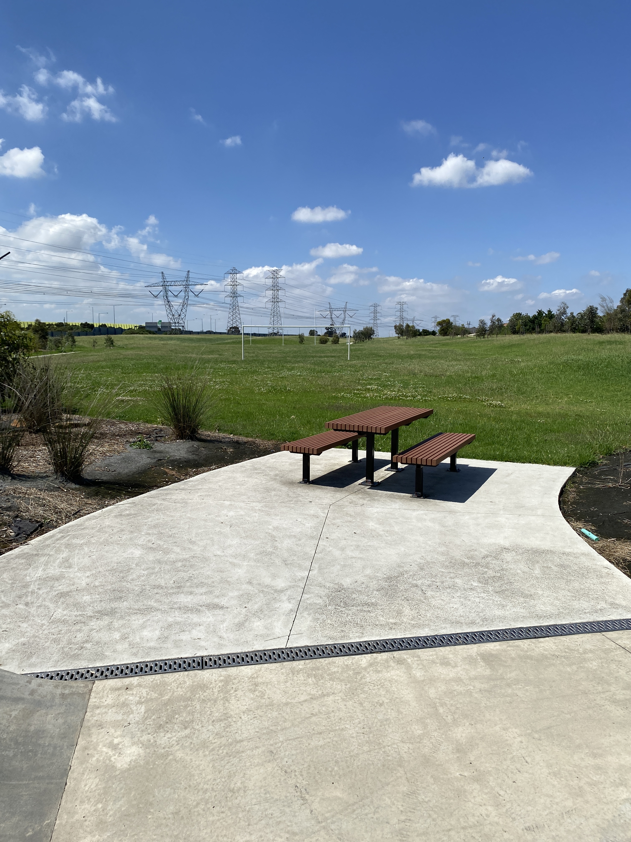

Gowanbrae Dog Park

Consultation summary report

August 2024
Council has been successful in a bid for funding via a DEECA grant program to design and construct a fenced dog park in Gowanbrae at Elm’s Court Reserve. This area was identified in a strategic review of available areas for large dog parks. There have been requests from the Gowanbrae community for a dog park for several years now. In 2022 a similar park was constructed across the Moonee Ponds Ck in Glenroy which has been well received by the community.
- Background
Council’s Open Space Design and Development unit will be conducting three consultation phases with the local community for Gowanbrae Dog Park, these being:
- Initial Consultation
Council asked the community whether they would support the proposed dog park in the proposed location (existing kickabout space). A mailout was sent to all houses in Gowanbrae with reference to the Conversations Moreland website. A problem occurred in the delivery of the postcards due to the printer incorrectly labelling the boxes and postcards for Gowanbrae were sent to McCleery Reserve, Coburg and vice versa. The cards were reprinted and re-distributed with the feedback period extended on the website to 8th Aug.
There were 14 contributions, all but one was supportive of the upgrades. A site meeting was conducted on 20th July to discuss site issues with the community. Approx. 20 people attended over 2 hours and feedback was recorded in the next section of this report.
- Draft Concept Plan Consultation
Council is developing a draft concept plan and costing from the initial feedback. A mailout will again be sent to all residents in Gowanbrae. The draft plan will be posted on the Conversations Moreland website and further feedback will be sought.
- Final Draft Plan
The final plan will be presented to the community via the Conversations Moreland website before construction begins

Consultation timings:
Initial consultation: 1st July – 8th Aug 2024
On-site community meeting: 20th July 2024
Draft concept plan consultation: 1 Nov – 29 Nov 2024
Final concept plan issued: 30th Jan 2025

Consultation postcards advised residents of the onsite meeting and the link to provide feedback on Council’s Conversations website. A QR code and text were provided for the park improvements webpage -https://conversations.merri-bek.vic.gov.au/parkupgrades. Posters with the same information were also displayed at site.

- Initial Consultation Feedback Findings
Council received 14 feedback responses to the initial consultation through Conversations Moreland. All comments were in support of the proposal. Comments are summarised as follows;
Include agility equipment – 4
Shade/trees – 4
Don’t impact existing cricket nets / skate park - 3
Include sandpit – 2
Drinking fountains – 2
Provide bins and regular collection – 1
Lighting – 1
Fencing – 1
Full comments can be seen below in appendix 7b.
Approximately 20 local residents attended the onsite consultation. Comments noted from this meeting were;
- Lights for dog park. Winter time is dark and the area is not useable before/after work.
- Lights for skate park requested
- If rotated would kickabout affect houses?
- Expand kick-about space area if moved
- Poo bags supplied?
- Location behind the skate park supported by all
- Zoning for small and big dogs requested
- Safety lighting on footpath to car park requested

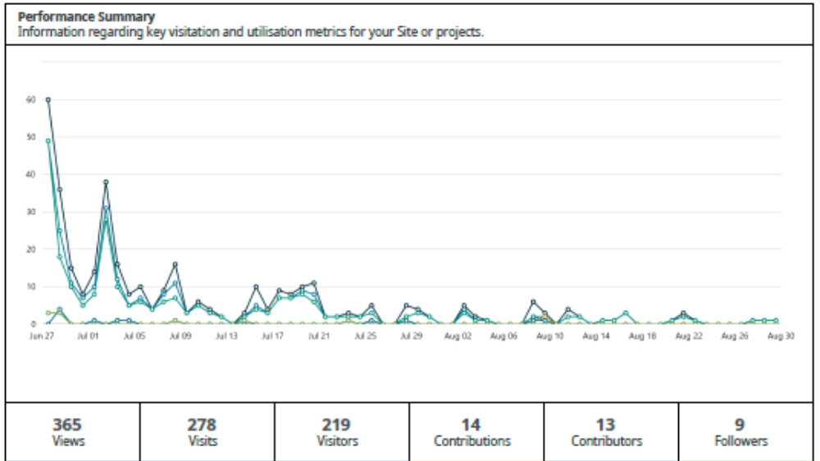

- Draft Concept Plan Consultation Feedback Findings
A draft concept plan has been developed in response to the initial consultation and posted online and onsite for comment.
- Final Concept Plan
The final concept plan will be made available to the community in January 2025
- Next Steps
A draft concept plan will be developed in response to the initial consultation and posted online and onsite for comment. Feedback from the second round of consultation will be incorporated into a final draft plan which will be posted online and onsite. Unless any major objections are received, we will proceed to construction drawings, procurement and construction.

- Further information
Any questions can be directed to Council’s Open Space Design & Development Unit via email openspace@moreland.vic.gov.au or by phoning 9240 111.

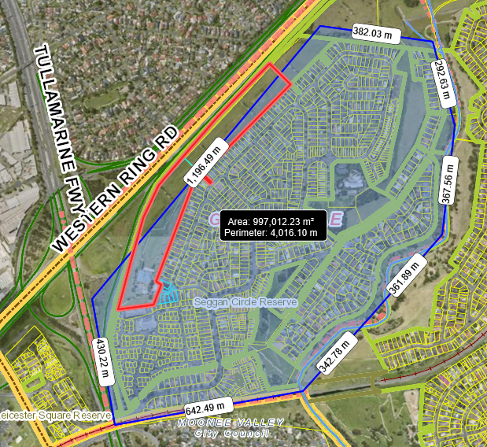
Figure 1: Mailout area - all households in Gowanbrae.

- Appendix
Below shows all mailout, posters and feedback received from the community for each stage of consultation for Gowanbrae Dog Park.

7a Initial Consultation
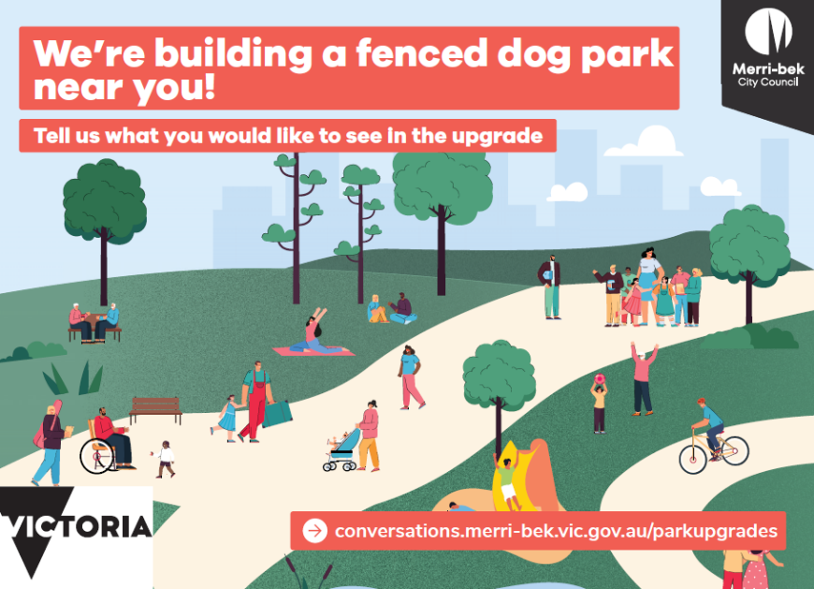

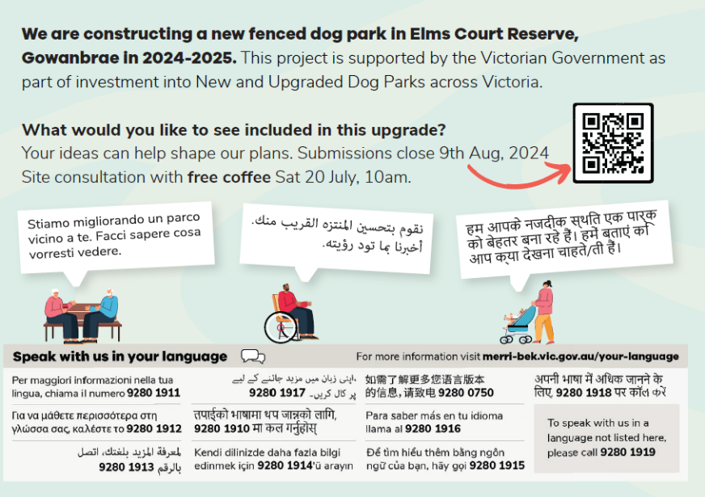

Figure 2: Initial Consultation postcard issued to all households in Gowanbrae.

7b Initial Consultation Responses
The following are responses to the initial consultation from 14 January – 28 January 2022.
Title/Question:
Tool Type: | Gather
Report Date Range: |  | 28 Jun 2024 - 12 Aug 2024
Date Exported: | 28 Aug 2024 11:14 am
Screen Name | Title | Description
Amruta | Area for senior dogs and puppies | Within the fenced off leash park, it would be helpful if there was an additional fenced off section for senior dogs, puppies and other dogs who may not be able to play in the main area for various reasons. Thank you!
Resident | Dog park | Copy the same as Glenroy dog park add lights for winter months and more shade for summer months. Doesn't matter how close to other facilities as long as it's accessible via the bitumen path.
Clarence | Good in theory | So the size and location of the dog park can’t be changed, and you’re just asking us for design suggestions?  The bins and more importantly, the frequency they are emptied needs to be increased as the bins at elms court are regularly overflowing and rubbish is often strewn across the playground and lawns. The new expensive toilet is always broken and in dire need of cleaning. These problems are only going to get worse with the increase in traffic to the area  I'm not sure how the cricket nets and oval will be affected, I’d certainly like some more information about that.  As a dog owner who walks the dog once or twice a day, I avoid dog parks
Romeofr | Can’t wait | Please include trees and or shade cloths, for shade for both dogs and their owners particularly for the summer month's, ramps and obstacles, water fountains and sandpits.
3043 | Great idea | A lot of people use the skate park and cricket nets. Does it nee to impact those ur utilities? There is a big open space near the retirement village that is under utilised. Could it go there? Or what about the hill next to the oval area?  Please also put in Ramps and obstacles for the doggies. Rocks trees and a sandpit for them to dig. It would need to be a big space simile or if not larger than the one recently put in at glenroy.
Pasq78 | Dog park | Fenced area- play equipment - ie ramps for the dogs and poles they can jump over. Rocks to sit on.
Clayton | Elm street dog park | We use the park for the playground and the oval for our dogs. How much will the dog park affect the cricket nets and oval space once finished? Surely there is enough space to have minimal effect on both spaces. I realise some of the oval space needs to be used but it shouldn’t impact the existing cricket nets. I would upgrade the other end of the oval forth goals and soccer goals for kick around.
Sezza | Community | A dog park would be great to seperate children and the elderly from dog owners and dogs who’d like to socialise, this has became more popular recently and I can understand the potential hazards that this may cause without fencing and separation. Dogs/ Dog Owners in the area has created a sense of community in Gowanbrae and makes day to day life more enjoyable and people look forward to evenings out with their furry buddies. Coming onto this website and seeing the negative comments about this new sense of community forming surrounding dogs is truly heart breaking as it’s truly a beautiful thing. Although I think I read somewhere about water features? I think these should be fenced off or not around dirt as this will make dirty puddles and dogs love those… whereas the owners don’t love those dirty dogs!
RenSar | More shade and vegetation | This area is in dire need of more shade and vegetation through native plants, shrubbery. The area is large enough that water features/water play would be a drawcard. Consider some dry creekbeds, flying foxes, ground level trampolines.  For the dog park, consider areas for the dogs to cool down and get some water and an obstacle course. More shrubbery for the dogs to be able to explore and plants that drop sticks. More tanbark in the area to compliment native plants and bushes and to encourage play by the dogs.
Resident | Separate walkway, fenced playground and signage | Dogs off leash are already a huge problem around Gowanbrae play areas. Please consider fencing the child play area also to keep dogs out and have clearly visible signage notifying owners that dogs must be on leads in all other areas. Please also have special signage noting pets are not allowed on the tennis courts at any time. (Also already a problem in this particular park.)
Gowanbrae resident | Safety of children using skatepark and playground | Please consider how the safety of children using the skatepark and playground will be maintained while dogs move between the carpark and the dog park entry. There is already a problem in the area of dogs being off leash, so it’s fair to assume some dogs may be on leads but many won’t be, regardless of leash laws. With this development encouraging more dogs to use the area, perhaps a fence around the playground and skatepark areas could be a solution to avoid children being knocked over or attacked by loose dogs. Thank you.

7c On-site Community Consultation
Below is the poster displayed on site and the postcards sent out to the local community;
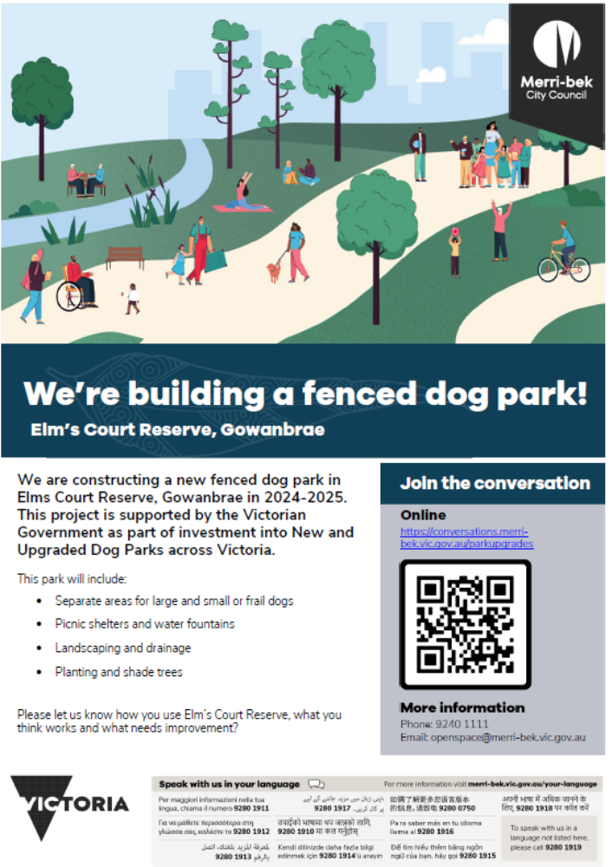
Figure 1: Posters displayed at site.
7d Concept Plan Consultation
To be provided
7e Draft Plan Consultation
8e Final Concept Plan
The Final concept Plan will be displayed at site and Conversations Moreland

