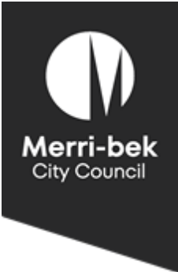


(Draft)

Climate Risk Foundational Action Plan 2023 – 2025

Climate Risk Foundational Action Plan

Meri-bek City Council’s Climate Risk Strategy 2022 – 2030 (the Strategy) was endorsed by Council in November 2022. The Strategy describes how Council will plan and respond to climate change. Our Vision is that, by 2030:
- Council competently, accountably, and responsively manages climate risks, and
- Merri-bek is climate resilient, leafy, and liveable; with
- A climate-ready and resilient community with no one left behind.

This Vision will be delivered through five Goals around:
- Managing climate risk
- Built and natural environments
- Community services
- Community and business
- Partnership approaches
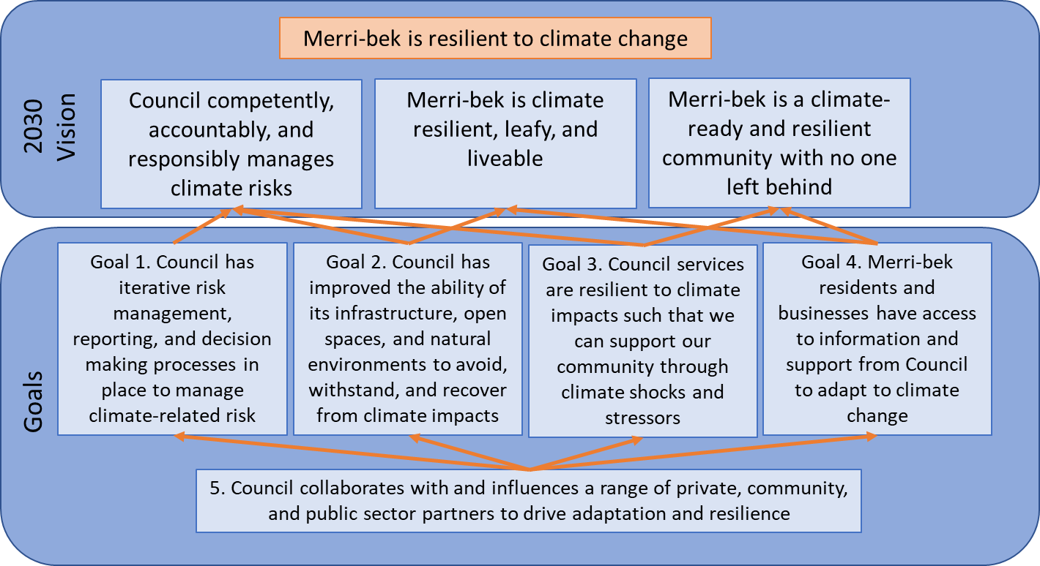
Delivering the Strategy requires an understanding of Council’s climate-related risks and having actions to address them. To do this, Council needs to gather information, do risk assessments, and have clear decision-making processes. The first two years of implementing the Climate Risk Strategy will be focused on this two-year Foundational Action Plan for 2023/24 and 2024/25 (the Action Plan).
The 36 actions identified are foundational to:
- understand Council and community’s current and future climate risks;
- integrate climate risk management into Council decision-making processes; and
- identify further actions needed to improve resilience.

The foundational actions will support us in understanding:
- What climate change means for Merri-bek across the municipality;
- The nature and extent of climate risk to Council infrastructure, open spaces, natural environments, and community services;
- The nature and extent of climate risk to the Merri-bek community, particularly vulnerable groups, and businesses;
- Council’s tolerance for climate-related physical, financial, and liability risks; and
- How we build climate resilience in impacted infrastructure, open spaces, natural environments, and community services in cost-effective ways.
Developing and implementing the Strategy and Action Plan are overseen by the Climate Resilience Integration Board (CRIB) composed of Directors and Managers in Council. These actions will enable iterative risk management so Council can build its resilience and adapt to climate change.
Some of the actions have started, such as managing of risk registers, doing emergency management planning, and street cleansing in stormwater hotspot locations. These are in the Action Plan so they can be tracked for the Strategy's implementation. A subsequent action plan for 2026 to 2030 is expected to focus on the delivery of climate adaptation actions, particularly community-level interventions.

What approaches we have taken

In developing the foundational action plan, the following approaches were taken:
- Recognising actions that the organisation is already doing to manage climate risks across different areas
- Adopting a whole-of-organisation approach and having ownership of actions
- Integration into existing processes
- Ensuring adequate resources to complete each action
- Responding to the recommendations of an independent audit on climate change adaptation (Crowe, November 2020)
- Broad alignment with the Greater Melbourne Regional Climate Change Adaptation Strategy

What we know about climate risks
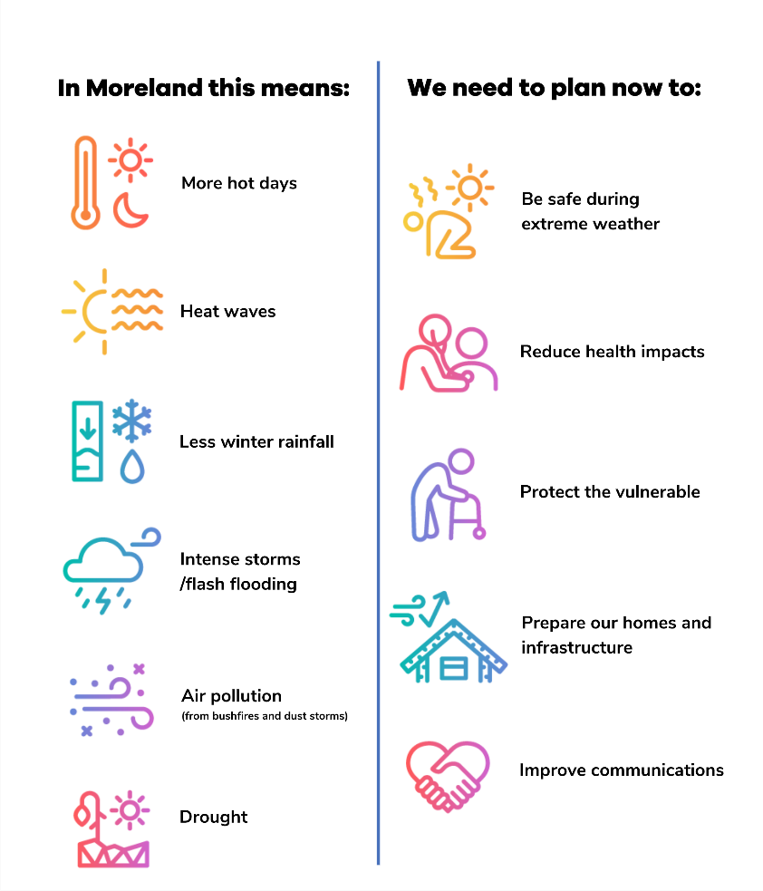
Our climate has already changed:
In Merri-bek this means:
We need to plan now to:
- Australia’s climate has warmed by an average of 1.47°C since national records began in 1910.
- In the south-east of Australia, there has been a decrease of around 10 per cent in autumn and winter rainfall since the late 1990’s.
- Although average rainfall is expected to decrease, a warmer atmosphere creates more likelihood of heavy downpours. So heavy rainfall events are becoming more intense.
- There has been an increase in extreme fire weather, and a longer fire season, across large parts of the country since the 1950s.
The future climate is expected to bring even more changes. Among other impacts, we are likely to have double the number of very hot days with average temperature increases up to 2.4 degrees by 2050.
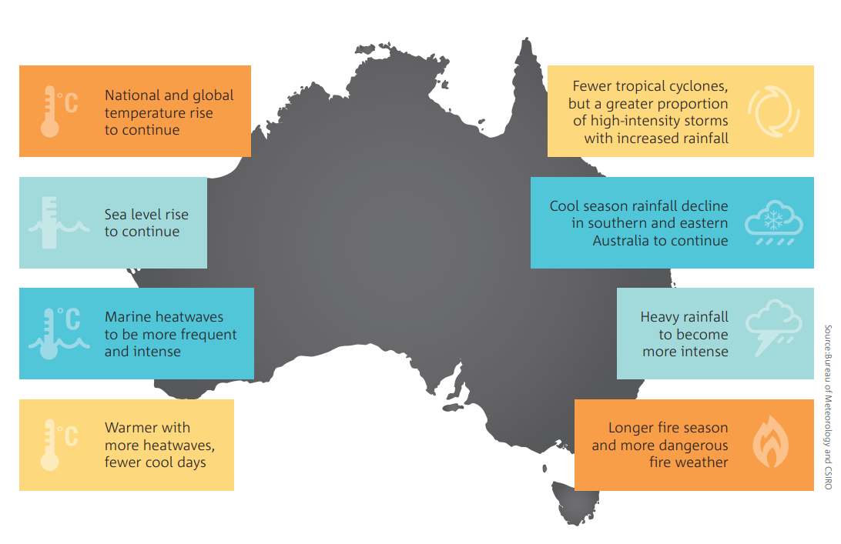
Source: State of the Climate 2022.
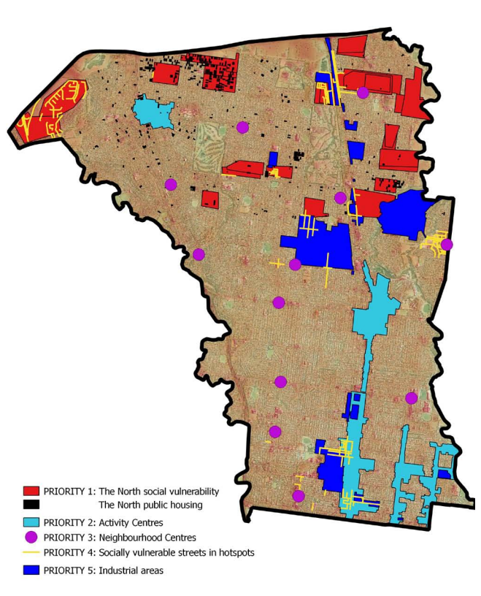
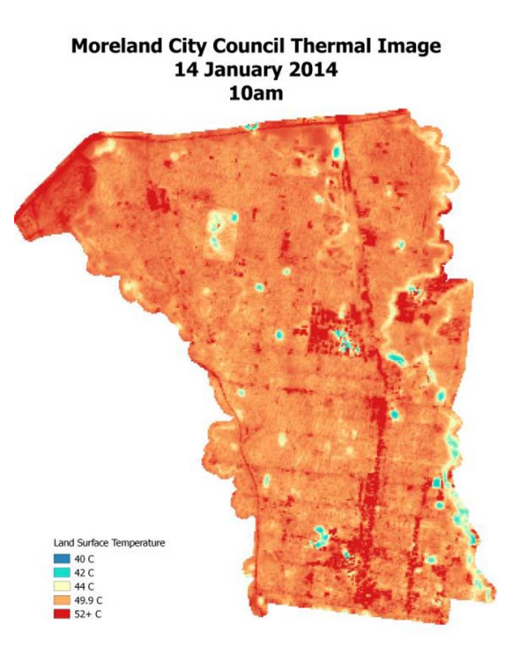
In Merri-bek, we know that there are certain areas in our municipality that get hotter than other places because of the Urban Heat Island Effect. In 2014, satellite imagery captured surface temperatures in the municipality with many areas exceeding 52°C and up to 64°C in and around our activity centres. Areas with high social vulnerability, including places with public housing are also affected by high heat. Council has started work in this space. In 2017, implemented the Cooling Communities project that retrofitted a sample of social housing to alleviate heatwave impacts on the health of residents. As part of the Action Plan, we aim to understand more about the health impacts of heatwaves across different vulnerable groups.
Source: Moreland Urban Heat Island Effect Action Plan 2016/2017 to 2025/2026.

Initial urban stormwater mapping for Council's drainage network was shared with affected landowners in 2021. This mapping included increased rainfall intensity of 18.53% for climate change. This increase comes from updated national guidelines for preparing stormwater maps.
The mapping shows land affected by the 1% Annual Exceedance Probability (AEP) storm. A 1% AEP storm event is a high-intensity storm that has only a 1% statistical chance of being exceeded in any one year. During such a storm, heavy rainfall causes stormwater to go overland, along flow paths where there may be buildings, infrastructure, and properties.
In collaboration with Melbourne Water, further stormwater mapping has been done to refine Council's 2021 mapping. This updated mapping will inform better planning and building permit outcomes. This outcome will be achieved by using the maps to update the Merri-bek Planning Scheme with a Special Building Overlay, Schedule 2 (SBO2) for the Council's drainage network.
Melbourne Water is updating its stormwater mapping for its regional drainage network in the municipality. Increased rainfall intensity has also been factored into this mapping. Melbourne Water intends to update its SBO1 in the Merri-bek Planning Scheme.
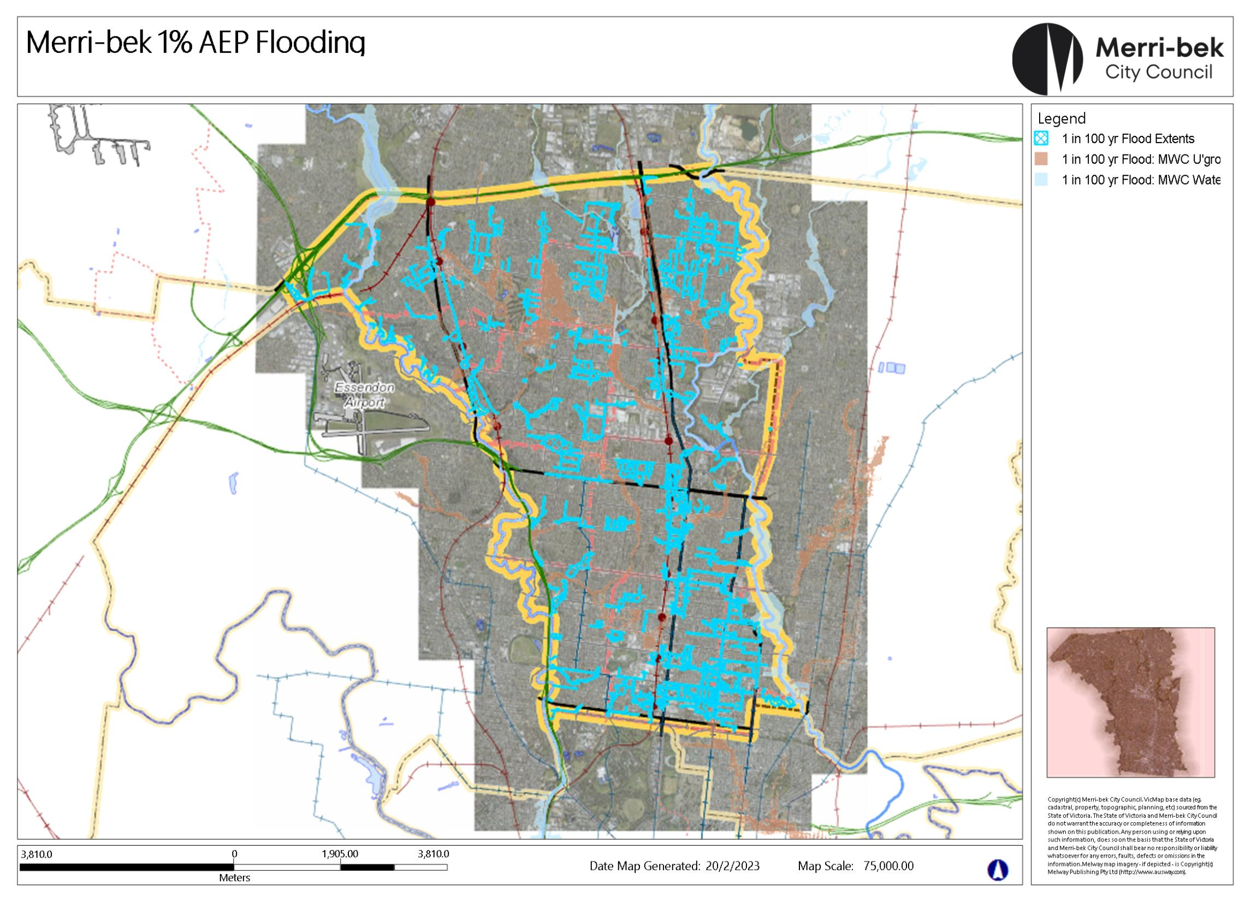
Merri-bek 1% AEP Stormwater Map. Source: moreMaps as at 20/2/2023

In addition to heatwaves and stormwater flows, Merri-bek also faces the impacts of droughts, which can harm our open spaces and natural environment. Dry conditions can dry up plants and harm animals, especially those that need moist environments like frogs and skinks. Flooding along waterways can also damage infrastructure like footpaths and bridges, as well as deposit rubbish and mud as we saw in Merri Creek the heavy rains in October 2022.

What we are already doing to reduce climate risks and adapt to climate change
In managing risks at the organisational level, we:
- Established the Climate Resilience Integration Board as the governance mechanism for climate risk work;
- Developed the Climate Risk Strategy and engaged with the community;
- Conducted internal workshops to improve understanding of climate risks and how these can impact our work and service delivery;
- Began to disclose climate risks in the Annual Report for 2020 - 2021, following the guidance of the Task force for Climate-related Financial Disclosures;
- Integrated climate risk across our risk management approaches as guided by the Risk Management Policy. We do this by actively managing our risk register, identifying a strategic risk related to climate, and continuing to monitor emergent risks;
- Integrated climate risks across different strategies, plans, and policies. A few examples include the Urban Heat Island Effect Action Plan, Integrated Water Resources Management, Urban Forest, Nature Plan, Municipal Health and Wellbeing Plan, and the Community Infrastructure Plan; and we
- Reporting the progress of work on climate risk management to the Audit and Risk Committee.
There are also many examples of how climate risk is integrated into our strategies, operations, and projects. Many Council buildings are built with sustainability and environmental outcomes in mind. Features such as external shading, double-glazed windows, and sealing for high thermal efficiency are considered in the design and construction of buildings that house key facilities. The Glenroy Community Hub, for example, is the first public building in Australia to be Passive House Certified, meaning that it has a high standard of environmental performance including low-energy use and high-comfort to support the health and well-being of users, including during heatwaves.
Council also has an Integrated Water Management Strategy and Action Plan. Among the projects delivered are stormwater harvesting systems in Dunstan and Reaburn Reserves. This system helps to irrigate our parks and saves millions of litres of drinking water each year. Irrigated parks also provide cooling through plants’ evapotranspiration, helping reduce the impacts of the urban heat island effect. We are also constructing wetlands in Moomba Park. This helps clean stormwater and provide refuge and habitat for native wildlife, such as birds, frogs, and insects, supporting them to better cope with additional pressures of climate change and urbanisation. We are designing a swale and wetland in Gilpin Park that provides wildlife habitat, cools the surrounding environment, and that can help slow down stormwater runoff and reduce the risk of flash floods.
The Urban Forest Strategy and Nature Plan together support the resilience of our natural environment to the impacts of climate change. These support ecosystem functions that provide shade and cooling during in extreme heat and also support flood management by promoting infiltration of water into our soils and slowing down water to avoid stormwater flows. Improving habitat for plants and animals in our area makes them more resilient to extreme weather.

Reading the Action Plan

The intent of the Action Plan is to support Merri-bek's transition to a climate-resilient city and community. It aims to deliver foundational actions that will guide transformation in how the Council delivers assets and services to the community under a changing climate.

During its implementation, priorities may need to be revised and reprioritised in an iterative way. This iterative approach will be based on our improved understanding of the Council's risks. For example, implementing these actions may reveal time-critical, high likelihood, and high impact climate risks. If this happens, they will be prioritised for CRIB consideration may be referred to Executive and Council to address.

Actions are organised into categories of Tier 1 and Tier 2. Tier 1 actions are typically the activities that provide information, evidence, and processes to further enable other actions. Tier 2 actions represent those that can be subsequently done and may have dependencies on Tier 1 actions.

The Action Plan is organised around Goals, objectives, desired outcomes, and specific actions. The tables below state the lead and supporting Council Units or Branches that are responsible for the delivery of actions. The tables also show expected timelines for each action.

Goal 1 – Managing climate risk – 16 Actions
By 2025, Council has iterative risk management, reporting and decision-making processes in place to manage climate-related risk to assets, service delivery, finances, and liabilities.
To effectively manage climate risk and deliver adaptation outcomes, Council requires effective internal processes to understand the risk and integrate it into organisational decision-making. These systems are foundational to prioritising, identifying, and planning climate adaptation action across the other four goals. Hence, this Goal should be delivered by 2025.
In line with the recommendations of the Taskforce on Climate-related Financial Disclosures (TCFD), Council will establish processes to actively monitor and transparently report on climate risk. Council will also build capacity and capability to provide services under climate change through workforce training and planning systems.
OBJECTIVES and desired Outcomes | Lead Unit or Branch | Supporting Unit or Branch | Delivery Year/s | Priority
  - To improve Council understanding of organisational and community climate change risk exposure and vulnerability, based on high-quality information on climate change hazards
    - Council officers have access to climate change scenarios, and locally relevant climate projections and data, to inform decision-making, asset design, service delivery, environmental management, risk and vulnerability assessment and monitoring.
- Compile data and information on climate hazards, risks, and vulnerability  Compile climate change data and projections resources and make these available to Council officers through the intranet (Grapevine) and GIS system (moreMaps).  Compile, summarise, and disseminate climate change studies, particularly on risks, impacts, vulnerability, and adaptation activities that are relevant to Merri-bek. These include studies on health impacts of heatwaves across different groups, impacts of open spaces, water in the landscape, and canopy cover to cooling, and other studies.  Update the geographic information system (moreMaps) with maps that are relevant to climate-risk such as flood risk maps, thermal maps, vulnerability maps, and others, including their metadata, to support ongoing monitoring and assessment of climate risk and vulnerability across infrastructure, open spaces, natural environments, and community services. Produce list of Council assets in at-risk areas for discussion with asset management and asset owners/managers on risk management planning.  The results of the mapping will contribute to the implementation of Actions 1 and 19. | Sustainability and Climate Branch | ICT / GIS Coordinator  Strategy and Research  Asset Management  Community Engagement  Community Development and Social Policy  Climate Resilience Integration Board | FY 23/24 to FY 24/25 | Tier 1
- Conduct a Meri-bek climate vulnerability analysis, which looks at areas In the city with compounded vulnerabilities and hazard exposure.  Conduct a desktop climate vulnerability analysis of the Merri-bek community based on local climate risks and hazards, drawing on existing ABS data and literature on the vulnerability of culturally and linguistically diverse group, first nations people, people with disability, and other disadvantaged groups and physical risk maps in the Merri-bek community. | Strategy and Research Unit | Sustainability and Climate Branch  Community Development and Social Policy  ICT/GIS Coordinator  Community Engagement | FY 23/24 to FY 24/25 | Tier 1
    - Council officers and decision-makers understand the likely range of possible future climate change impacts on the municipality, including sudden shocks and long-term stressors, and know how to use this information to appropriately inform decision-making.
- Conduct training and development activities, both general and targeted, to build capability across Council to respond to current and future changes  Develop and deliver training modules for key officers on the likely range of future climate impacts, including sudden shocks and longer-term stressors as relevant to Council planning, operations, and service delivery.  Seek out specialised training for climate risk in key areas such as asset management, enterprise risk management, financial reporting, climate resilient and sustainable materials in infrastructure, and others for relevant officers to participate in. | Sustainability and Climate Branch | People and Safety  Organisational Performance | FY 23/24 | Tier 1
    - Council decision-making is informed by established tools and processes to regularly monitor, review and evaluate, the changing exposure and vulnerability of infrastructure, open spaces, natural environments, and community services, to:
- physical and structural risks associated with climate hazards,
- risks to their functional performance as a result of climate change, and
- transition and liability risks arising from Council’s response to climate change.
Building on 1.1.1 and 1.1.2
- Review Council capital works and asset management processes in order to Integrate climate risk-based approaches and resilience building into decision making processes.  Review Council capital works and asset maintenance processes and develop recommendations to ensure Council processes consider and manage for climate risks. Implementation of recommendations will be done under action 1.4.1.1. | Capital Works Planning and Delivery (including Building Projects, Building Maintenance, Asset Management)  Open Space and Environment  Finance Unit (Asset Accounting) | Urban Design  Open Space Maintenance  City Works  Building Maintenance  Property  Transport (Transport and Development Engineering)  Sustainable Built Environment  Other Units and Branches including those that provide services in or lease to service providers such as Aquatics and Leisure, Early Years, Community Development | FY 23/24 to 24/25 | Tier 1
    - Council officers and decision-makers understand and use appropriate data, tools and approaches, including climate change projections, scenario planning and business continuity planning, to understand how climate change is likely to impact the delivery of council services at different timescales, including:
- The ability of council to deliver the service,
- The ability of the community to access the services, and
- Increases or decreases in demand for services, or the need for entirely new services.
Building on 1.1.1 and 1.1.2
- Review climate-related risks in the Risk Register  Considering climate data and projections, risk maps, and other sources of information on climate risk, review strategic and operational risks to systematically assess the climate risks to infrastructure, open spaces, natural environments, and community services considering:  - physical and structural risks associated with climate hazards,  - risks to functional performance as a result of climate change, and  - transition and liability risks resulting from Council’s response to climate change | Risk Owners  Climate Resilience Integration Board | Integrity, Risk, and Resilience Unit | FY 23/24 to FY 24/25 | Tier 1
    - Council monitors and understands the changing exposure and vulnerability of the Merri-bek community, residents, and businesses (especially vulnerable cohorts) to the risks and impacts of climate change, regularly reviews this through established processes (such as the Risk Register) and forward scans for new and emerging risks.
Related to 1.1.3
- Develop climate risk tolerance statement for endorsement by Council and integration into decision-making.  The climate risk tolerance statement may outline the levels of financial, liability, workforce, and service delivery risk Council is willing to accept in policy, program, investment, and operational decisions. | Integrity, Risk, and Resilience Unit  Sustainability and Climate Branch |  | FY 23/24 | Tier 1
- Identify and monitor emerging climate risks  Ensure that existing risk management systems and processes adequately identify emerging risks and regularly monitor, report, and evaluate these as they change over time. | Integrity, Risk, and Resilience Unit | Climate Resilience Integration Board | FY 23/24 to FY 24/25 | Tier 1
  - To make informed decisions on prioritising, preparing for and proactively addressing climate risk, driving climate adaptation and building resilience
    - Council design, delivery and management of its infrastructure, open spaces, natural environments, and community services is informed by an understanding of the level of climate-related financial and liability risk it is willing to tolerate; Council actively limits the creation of future financial risk.
- Embed climate risk in policy, strategy, and action plan development as refreshes/renewals occur, and as new policy is developed  Embed consideration of climate-related risks and impacts into policy development updates occurring and including new strategies and action plans and their respective monitoring frameworks. Priority strategies currently being reviewed / renewed include the Open Space Strategy, Strategic Property Framework, Risk Management Policy (internal), Transport Strategy, Economic Development Action Plan, Circular Economy Strategy, Vehicle Crossing (Driveways) Policy, and Sustainable Buildings Policy. | Open Space Design and Development  Transport (Transport and Development Engineering Units)  Integrity, Risk and Resilience Unit  Property  Sustainable Built Environment  Economic Development  Sustainable Communities  Community Development and Social Policy | Governance Unit  Sustainability and Climate Branch  Corporate Planning | FY 23/24 to FY 24/25 | Tier 1
    - Council has embedded clear and transparent tools for considering climate adaptation implications and trade-offs in decision-making across its infrastructure, open spaces, natural environments, and service provision functions.
Building on 1.1.4 and 1.2.1
  - To improve monitoring, reporting and evaluation of climate risks and adaptation action to better inform investment decisions and resource allocation
    - Council officers actively monitor and evaluate the outcomes of adaptation action against new and emerging climate risks to its infrastructure, open spaces, natural environments and community services. Council has embedded a culture of evaluation and learning which influences and informs climate change adaptation decision-making.
Building on 1.1.3, 1.2.1
- Establish a monitoring and evaluation framework for the Climate Risk Strategy and Action Plan  Develop the monitoring and evaluation framework including output and outcome-level indicators to achieve risk management, resilience, and adaptation objectives in Merri-bek,  Map actions and indicators across other relevant strategies and action plans that contribute to reducing climate risks such as the Nature Plan, Urban Forest Strategy and Action Plan, Integrated Water Management Action Plan and other relevant plans and where they link to the Climate Risk Foundational Action Plan outcomes. | Sustainability and Climate Branch | Strategy and Research Unit  Relevant Units  Open Space Design and Development  Urban Forest  Sustainable Built Environment  Corporate Planning  Integrity, Risk, and Resilience | FY 23/24 | Tier 1
- Develop the Climate Risk Stage 2 Action Plan for 2026 – 2030  Based on initial learning from the Climate Risk Stage 2 Action Plan for 2023 – 2025, formulate the next iteration of the action plan to achieve goals and objectives in the Climate Risk Strategy. Conduct robust community engagement process, particularly targeting feedback from vulnerable populations. | Sustainability and Climate Branch | Climate Resilience Integration Board | FY 24/25 | Tier 1
    - Council officers actively monitor climate adaptation support provided to residents and businesses, including through Zero Carbon Merri-bek community engagement.
- Report and communicate progress against actions  Report risk management, resilience, and adaptation actions to the community and public through different channels such as the Merri-bek City Council Sustainability and Climate Annual report, Council Action Plan reporting, and other relevant channels. | Sustainability and Climate Branch | Finance  Governance  Communications | FY 23/24 to FY 24/25 | Tier 1
  - To improve the proactive and accountable management of climate-related liability and financial risk within the organisation
    - Council effectively integrates climate risk and opportunity into financial management and strategic planning processes to manage the impacts of climate change on the organisation.
Building on 1.1.1, 1.1.2, 1.1.3, 1.1.4 and 1.2.1
- Develop and implement an approach to budget planning that considers climate risks  Following the recommendations of the process review under 1.1.3, develop and implement an approach to include climate resilience and adaptation as criteria in the decision-making framework for budget allocation and investment planning. | Finance | Capital Works Planning and Delivery  Strategic Planning Oversight Committee | FY 24/25 | Tier 1
    - Council is transparent in its accountability for climate-related risks and regularly reports on them within our organisation and to the community.
Building on 1.1.3, 1.1.4, 1.3.1 and 1.4.1
- Conduct a financial expenditure review to record the costs of climate change  Collect baseline data on costs of climate events to the Council, including costs of repairs, insurance claims, preparedness activities and additional operational costs, costs of capital works delays, lost productivity, and other costs | Finance | Asset management | FY 23/24 | Tier 1
- Report on climate risks in financial reports  Report annually on climate risks in the Merri-bek Annual Report following the recommendations of the Task Force on Climate-related Disclosures (TCFD). | Sustainability and Climate Branch | Finance | FY 23/24 to FY 24/25 | Tier 1
1.5 To improve the ability of our workforce to deliver priority services while responding to the impacts of climate change
1.5.1 Council officers and decision-makers have the training, knowledge, and capability to make critical decisions informed by current and probable future climate contexts.
Related to 1.1.1, 1.1.2, 1.1.3 and 1.1.4
- Establish a Community of Practice in Merri-bek City Council  Establish a community of practice among Council for officers working to integrate climate-related risk and resilience into their service area to share information and coordinate actions to maximise impact. | Sustainability and Climate | People and Safety  Organisational Performance | FY 23/24 to FY 24/25 | Tier 2
    - Council operational planning is used to proactively manage officer safety, wellbeing, and workloads in response to the challenges posed by climate change.
- Review Occupational Health and Safety policies and procedures in particular, the Revised Heat Procedure and Thermal Comfort Policy to manage climate-related risks  Review Occupational Health and Safety policies and procedures and their implementation to ensure that OHS risks related to climate are managed to ensure staff safety and wellbeing particularly for staff who work outdoors. | HR, Safety, and Wellbeing  Sustainable Built Environment | Climate Resilience Integration Board | FY 23/24 to FY 24/25 | Tier 1

Related strategies and initiatives
- Voluntary disclosures in line with the recommendations of the Taskforce on Climate-related Financial Risk  - 10-year Financial Plan  - 4-year Budget  - Procurement Policy 2021-25 | - Public Transparency Policy  - Enterprise Risk Management Policy  - Thermal Comfort Policy  - Occupational Health and Safety Policy  - Heat Management Procedure  - Bushfire Smoke Hazards Procedure

Goal 2 – Built and natural environments – 9 Actions
By 2030, Council has improved the ability of its infrastructure, open spaces and natural environments to avoid, withstand and recover from climate impacts, while continuing to provide for community wellbeing, amenity and ecosystem services.
Built and natural environments define how urban populations experience climate change. The Urban Heat Island Effect exacerbates the severity of increasingly high temperatures and heatwaves for urban populations while reduced rainfall limits the establishment and retention of tree cover.
Climate change can impact on Council’s ability to provide effective services, and community members ability to access those services. Managing Councils built and natural environments therefore requires understanding the service delivery purpose of Council facilities, e.g. maternal and child health services require facilities that are safely accessible during extreme weather and which are comfortable for staff, mothers and new babies.
Natural environments and open spaces are critical for urban amenity under climate change as they provide ecosystem services such as shade, water retention and cool transit corridors. These areas also support diverse plant and animal species and community wellbeing. Effective Council action is necessary to maintain and improve these spaces under climate change.
OBJECTIVES and desired Outcomes | Lead Unit or Branch | Supporting Unit or Branch | Delivery Year/s | Priority
  - To improve the climate adaptation and resilience of new and existing high-priority Council infrastructure to support the delivery of council services
    - Council understands the changing climate-related risk, vulnerability and exposure of its infrastructure, open spaces, and natural environments, has prioritised these and is developing and implementing appropriate responses.
Building on 1.1.3 and 1.1.4
- Conduct climate resilient infrastructure assessments/audits  Conduct audits of key Council assets to assess climate risks, safety, and serviceability of selected assets and develop recommendations for mitigating risks, particularly to heatwaves, storms, and stormwater flooding. This action is related to the Council Action Plan Action 127. | Sustainable Built Environment Unit | Aged and Community Services  Early Years and Youth  Municipal Emergency Management Officer  Emergency Management Coordinator  Library Services  Aquatics and Leisure Services  Community Development and Social Policy  Open Space and Environment  Building Maintenance  Asset Management | Process started in FY 22/23 continuing into FY 23/24 | Tier 1
    - Based on Council’s risk tolerance, highest priority council services, centres, hubs and leased properties are built, adapted and operated to remain accessible, safe and serviceable during chronic and extreme weather events, including high heat days.
Building on 1.1.4, 1.2.1 and 1.3.1
- Review options to proactively manage assets for resilience to climate risks and review how damages to Council assets from extreme events are captured in audits and condition assessments and recorded in the asset management system (Assetic).  Costs of loss and damage from extreme events will be calculated and will inform the TCFD section of the annual report as described in 1.4.2.1. | Asset Management Steering Committee | Building Maintenance  City Works  Building Maintenance  Open Space Maintenance  Street Cleansing  Capital Works Planning and Delivery (Asset Management)  Transport Unit  Finance | FY 23/24 | Tier 1
- Monitor at-risk assets identified in Action 1. (e.g. assets in flood zones), and establish thresholds, triggers, or alerts for asset management responses.  Thresholds for asset management responses identified (e.g. floor levels below maximum flood depth in 1% AEP event, certain levels of building performance). | Asset Management Coordination | Aged and Community Services  Early Years and Youth  Municipal Emergency Management Officer  Emergency Management Coordinator  Library Services  Aquatics and Leisure Services  Community Development and Social Policy  Open Space and Environment  Transport Unit  Property  Building Maintenance  Asset Management | FY 24/25 | Tier 1
    - Council’s new designs and developments, as well as upgrades and retrofits of existing priority infrastructure, contribute to the climate resilience of the community and the services those assets support, in line with Council’s risk tolerance.
Building on 1.1.4, 1.1.5, 1.2.1 and 1.3.1
- Continue to implement Sustainable Buildings Policy (ESD) in Capital Works Building Program  Continue to implement the Sustainable Buildings Policy in all Council capital works on buildings to support climate resilience outcomes such as energy efficiency and insulation for thermal comfort and other recommendations. | Capital Works Planning and Delivery | Sustainable Built Environment Unit | FY 23/24 to FY 24/25 | Tier 1
- Develop a Sustainable Infrastructure Policy  A Sustainable Infrastructure Policy will provide guidelines on sustainability standards across Council infrastructure beyond buildings. Provisions in the policy to support climate resilience outcomes include for example, the preservation of trees, integration of water sensitive urban design assets, and increase of permeable surfaces. | Sustainable Built Environment | Capital Works Planning and Delivery  Urban Design  Transport  City Works  Open Space and Environment | FY 23/24 to FY 24/25 | Tier 2
- Review and trial industry standards on climate resilient and sustainable infrastructure and materials  Review climate resilient and sustainable infrastructure and materials specifications and processes based on industry standards such as from AS 5334-2013 Climate change adaptation for settlements and infrastructure - A risk-based approach, IPWEA Practice Note 12.2 on Climate Resilient Materials for Infrastructure Assets, Infrastructure Sustainability Council of Australia, Green Star Communities, and other guidance. Develop recommendations on what specifications and processes have the potential for trialling and adoption such as through the Merri-bek Technical Notes, technical specification s for tender documents, and other guidance documents. | Sustainable Built Environment Unit | Capital Works Planning and Delivery  Urban Design  Transport  City Works  Open Space and Environment | FY 23/24 to 24/25 | Tier 2
    - Council has established processes to rapidly recover from climate impacts to its infrastructure, open spaces and natural environments, learn from these experiences and rebuild to a better adapted state.
Building on 1.3.1
- Conduct Street Cleansing for flood prevention  Use flood risk maps and other information to identify priority cleaning activities, particularly in preparation for storms and/or wet winter season. | Street Cleansing Unit |  | FY 23/24 to FY 24/25 | Tier 1
- Review service delivery in core Council services for climate resilience  Conduct climate risks scenario analysis to look at short, medium, and long-term impacts in service delivery across a subset of critical functions or essential council services, such as building maintenance, road maintenance, and tree maintenance. | Sustainability and Climate Branch | City Works  Open Space Maintenance  Building Maintenance  Animal Management and Local Laws  Compliance Operations Unit  Waste Services | FY 24/25 | Tier 2
  - To improve the climate adaptation and resilience of new and existing high-priority Council open spaces and natural environments to support community wellbeing, deliver ecosystem services, and protect plant and animal health.
    - Council designs its open spaces to contribute to local cooling and flood risk mitigation, to reduce community exposure to climate impacts, especially heat, and to improve climate-related community health and wellbeing outcomes.
Building on 1.1.4, 1.1.6 and 1.2.1
    - Council designs and manages its open spaces and natural environments to withstand and function under hotter, drier conditions, as well as higher flood risk conditions, while fostering biodiversity and ecosystem services.
Building on 1.1.3 and 1.1.4
- Review the implementation of the Urban Heat Island Effect Action Plan and Cooling the Upfield Corridor Action Plan  Review outputs and contribution to strategic outcomes of the implementation of the UHIE Action Plan from FY 2016/17 and develop recommendations for subsequent phase. Review the progress of implementation of the Cooling the Upfield Corridor Action Plan 2018 - 2029. | Sustainability and Climate Branch | Urban Design  Open Space and Environment  Transport (Transport and Development Engineering Units) | FY 23/24 to 24/25 | Tier 1

Related strategies and initiatives
- Integrated Water Management Strategy 2040  - Asset Management Policy  - Developing and implementing a 10-year Asset Plan  - Drainage Asset Management Strategy  - Urban Heat Island Effect Action Plan  - Urban Forest Strategy  - Open Space Strategy  - Community Infrastructure Plan  - Zero Carbon Merri-bek – Climate Emergency Action Plan | - Nature Plan  - Park Close to Home Framework  - Towards a Water Sensitive City  - Cooling the Upfield Corridor - Action Plan  - Sustainable (Council) Buildings Policy  - Victorian Built Environment Adaptation action plan  - Victorian Natural Environment Adaptation Action Plan  - Victorian Water Cycle Adaptation Action Plan
Goal 3 – Community services – 3 Actions
By 2030, Council services are resilient to climate impacts such that we can support our community through the shocks and stressors associated with climate change.
Council Plan Strategic Objective 3.3 recognises the importance of effective climate change adaptation to delivering health and wellbeing outcomes to the Merri-bek community. Older people, infants and young children and other vulnerable persons are most at risk to the impacts of climate change, with potential for significant health impacts and even death. Climate change is also likely to contribute to poor mental health and increase the vulnerability of sections of the broader population. In combination, the demand for Councils’ community services is likely to increase, while the provision of these services will become more challenging through chronic and extreme events.
The demand placed on Council’s emergency management functions is already increasing in response to more frequent and severe weather events. Proactive planning is necessary to allow Council to continue delivering these services as demand increases, while also providing support to neighbouring local governments through partnerships arrangements.
OBJECTIVES and desired Outcomes | Lead Unit or Branch | Supporting Unit or Branch | Delivery Year/s | Priority
  - To build the resilience of essential Council services to ensure service continuity through chronic and extreme climate events
    - Council understands the community’s changing vulnerability to climate impacts, has prioritised these and is developing and implementing appropriate responses through its services.
Building on 1.1.5, 1.2.1, and 1.3.1.
- Review service delivery in early years and aged and community services for climate resilience  Pilot climate resilient service delivery assessments to understand the vulnerability and exposure of Council’s community services to climate risk and develop recommendations to improve processes, business continuity plans, and protocols. | Early Years and Youth Branch  Aged and Community Services | Sustainability and Climate Branch | Process started in FY 22/23 to FY 23/24 | Tier 1
    - Council’s business continuity, service resilience and disaster recovery planning include provision of prioritised services through acute, chronic, sustained and compound climate events, in line with the organisational risk tolerance statement and climate scenarios.
Building on 1.1.2, 1.1.4, 1.2.1 and 1.3.1
    - Council undertakes medium/long-term service planning based on a range of climate scenarios and expected changes in the demand on services in these plausible futures.
Building on 1.1.4, 1.3.1 and 3.1.1
  - To improve Council’s emergency management capacity in line with preparedness for likely future climate change events
    - Council integrates and draws on climate scenarios, climate change projections and adaptation planning approaches to ensure its emergency planning and preparedness accounts for future climate change impacts and responds to the needs of the most vulnerable.
Building on 1.1.1, 1.1.2, 1.1.3 and 1.1.4
- Conduct emergency management planning with consideration of climate risks  Continue to review business continuity, service delivery, and disaster recovery plans for resilience to future acute and long-term climate risks and impacts. | Municipal Emergency Management Officer |  | FY 23/24 to FY 24/25 | Tier 1
    - Council has established processes to rapidly recover from climate events that draw on our emergency management capability, learn from these and rebuild to a better adapted state.
Building on 1.3.3 and 1.3.4
- Evaluate emergency management response and recovery actions for continuous improvement  Continue to evaluate emergency response and recovery actions after events and identify lessons learned for continuous improvement particularly those relevant to building longer term climate resilience | Municipal Emergency Management Officer |  | FY 23/24 to FY 24/25 | Tier 1

Related strategies and initiatives
- Municipal Emergency Management Plan  - Human Rights Policy  - Social Cohesion Plan  - Community Infrastructure Plan  - Children, Young People and Families Plan  - Living and Aging Well Framework  - Disability Access and Inclusion Plan | - Early Years Infrastructure Plan  - Aquatic and Leisure Strategy 2018 -2038  - Victorian Health and Human Services Climate Change Adaptation Action Plan 2022-2026  - Victorian Public Health and Wellbeing Plan 2019 -2023

Goal 4 – Community and business – 4 Actions
By 2030, Merri-bek residents and businesses have access to relevant and appropriate information and support from Council to take meaningful action to adapt and build resilience to climate change.
Council recognises that communities and businesses face significant and increasing challenges due to climate change and other emerging risks. Understanding these challenges and having access to appropriate support can help drive community and business climate adaptation. Council action can empower individuals to make effective choices to reduce their exposure to climate risk and build resilience.
Climate resilience for communities and businesses is a function of social and economic factors, as well as environmental ones. Resilient communities are highly connected, equitable and just. Building the climate resilience of Merri-bek’s community is therefore closely tied to the effective delivery of Council’s work to protect and enhance human rights, local affordable housing, resilient food systems and social cohesion. These outcomes underpin people’s sense of safety, belonging and willingness to help one another, all of which support resilience.
OBJECTIVES and desired Outcomes | Lead Unit or Branch | Supporting Unit or Branch | Delivery Year/s | Priority
  - To support and empower the merri-bek community, and businesses, in identifying how they are impacted by climate change, now and into the future, and in acting to proactively manage these impacts
    - Council understands the barriers and challenges Merri-bek residents face in adapting to climate change and building resilience.
Building on 1.1.5, and 1.2.2
Related to 3.1.1
- Conduct research on what actions are taken by community members to cope with heatwaves and storms and any barriers and challenges to accessing Council services  This work helps Council establish a baseline for existing coping mechanisms of residents, particularly the most vulnerable cohorts, to heatwaves and storms. The information collected can inform how Council can best support building of individual and community resilience and understand any changes to the demand for or accessibility of Council services during extreme events. | Sustainability and Climate Branch  Strategy and Research | Community Development and Social Policy  Emergency Management Coordinator  Aged and Community Services | FY24/25 | Tier 1
- Map existing programs and projects and identify those that could be expanded to provide resilience and adaptation support to community, particularly the most vulnerable  Investigate opportunities within existing state and Council programs such as household and community grants, Sustainable Strata, Environmental Upgrade Finance, home maintenance program, to maximise resilience and adaptation outcomes. | Sustainability and Climate Branch | Economic Development  Community Development and Social Policy  Aged and Community Services  Strategy and Research | FY 23/24 | Tier 2
    - Council works with partners and provides appropriate support to Merri-bek residents and community, especially vulnerable cohorts, to empower them in proactively adapting to climate change and building resilience.
Building on 1.1.5 and 5.1.2
Related to 3.1.1
- Review the guidelines for the energy subsidies for low-income households  Review and revise as appropriate the existing solar and thermal subsidy program to improve climate justice and resilience outcomes. | Sustainable Communities |  | FY 23/24 | Tier 1
  - To raise community awareness and support community climate action through a coordinated climate communication approach
    - Council implements a comprehensive climate communications plan to support community and business.
    - Council officers and programs provide locally relevant climate change information to residents and businesses in an appropriate and accessible manner to reduce information and knowledge barriers.
Building on 1.1.1, 1.1.5, 4.1.2 and 4.2.1
- Continue to inform the community on risks/preparedness (e.g. heatwaves and flood events) and develop targeted climate risk and community resilience communication products  Develop targeted communications products to inform the community on climate risks in Merri-bek, including through maps, and resilience actions that can be undertaken by the community. | Communications  Sustainability and Climate Branch | Emergency Management  Community Development and Social Policy | FY 23/24 | Tier 1

Related strategies and initiatives
- Social Cohesion Plan  - Human Rights Policy (2022)  - Gender Equality Statement  - Social Cohesion Plan (2021 – 2025)  - Disability Access and Inclusion Plan (2021 – 2025)  - Statement of Commitment to Wurundjeri Woi-wurrung People and Aboriginal and Torres Strait Islander Communities  - Later Years Strategy  - Library Services Strategy  - Living and Aging Well Framework | - Economic Development Strategy  - Industrial Land Use Strategy  - Affordable Housing Action Plan  - Establishment of a Northern Food Hub  - Food Systems Strategy  - Community Engagement Policy  - Develop a Child and Youth Engagement Framework  - Accessible and Inclusive Communications Policy  - Community Engagement and Public Participation Policy  - Social Media Policy
Goal 5 – Partnership approaches – 4 Actions
By 2030, Council collaborates with and influences a range of private, community and public sector partners to drive adaptation and build climate resilience in Merri-bek.
Climate change will create significant challenges for Council; overcoming these will require coordinated action by a range of stakeholders. For instance, reducing and responding to the Urban Heat Island Effect is vital as it increases heat stress and can severely impact more vulnerable communities. Private landowners, developers, property managers and the State Government all have roles to play in increasing canopy cover and reducing heat absorbing surfaces (e.g., concrete, asphalt, brick walls). Climate change also impacts water availability. Combatting this requires close cooperation between different councils, water companies and State Government.
Council has an opportunity to influence climate resilience outcomes through its engagement with stakeholders and partners. Advocacy efforts can be used to improve outcomes for aged people, young children and diverse communities through State-based housing, transport, and health services. Council’s own policies and requirements can change the climate responses of the organisations it funds and works with, as well as its suppliers.
OBJECTIVES and desired Outcomes | Lead Unit or Branch | Supporting Unit or Branch | Delivery Year/s | Priority
  - To work with partners to effectively drive climate adaptation and resilience in the merri-bek community
    - Council works with our partners and the organisations we fund, across community services and the built and natural environment, to:
- Reduce their climate risk,
- Reduce climate risks to the goods and services they provide, and
- Build their climate resilience.
Related to 1.3.2
    - Council actively partners with community organisations and leaders to build Merri-bek’s climate resilience.
    - Council works with developers, landowners, and residents to drive climate adaptation and resilience on private land.
Dependent on 1.1.4
- Mitigate climate risks in new development through the planning application process.  Continue to review private development approval requests and provide recommendations for sustainable and climate resilient developments based on ESD Planning Policy and leading industry standards and continue to monitor compliance. | Sustainable Built Environment | Planning Enforcement  Urban Planning  Development Engineering | FY 23/24 to FY 24/25 | Tier 1
    - Council collaborates with regional and State partners, and other stakeholders, to build and leverage systems and processes to manage and respond to climate-related risk at the regional scale efficiently and effectively.
- Identify advocacy priorities and implement an advocacy plan for improved policies and funding support for climate resilience  Advocate to State and Federal government, and other relevant authorities (e.g. Melbourne Water, Insurance Council of Australia) on the development of further guidance and support to local councils on climate risk management, resilience, and adaptation by contributing to policy consultations and position papers and working with relevant local networks. Continue advocacy on environmentally sustainable development in planning processes at the State level, including through the Council Alliance for a Sustainable Built Environment (CASBE). | Sustainability and Climate Branch | Advocacy Lead | FY 23/24 to FY 24/25 | Tier 1
- Collaborate through networks and stakeholders on climate resilience to share knowledge, pool resources, and identify joint grant opportunities  Continue participation in regional and state-level alliances and networks such as the Northern Alliance for Greenhouse Action Adaptation Working Group, Climate Emergency Australia, Victorian Climate Resilient Councils, and other key stakeholders such as Melbourne Water to share knowledge. | Sustainability and Climate Branch |  | FY 23/24 to FY 24/25 | Tier 1
  - To influence other actors to drive wellbeing, climate adaptation and resilience outcomes for the Merri-bek community
    - Council advocates to and influences other levels of government and service providers to improve the provision of services that support climate resilience of the community, and particularly to vulnerable community members (e.g. services that influence health and transport outcomes for aging people).
  - To work with providers of goods and services to improve climate adaptation and resilience in the Merri-bek community
    - Council collaborates on procurement with regional and State partners, and other stakeholders, to create scale that leverages efficient and effective responses to climate-related risk.
    - Council’s procurement policy drivers our contractors to provide climate-resilient standard offerings
- Integrate climate risk management into procurement guidelines  Develop guidelines for integrating climate risk in the procurement and contracting process. The guidelines can include for example:  - information and examples of integrating climate risk management and resilience in the development of tender specifications, particularly in climate resilient infrastructure  - ensuring contractors have appropriate policies and procedures for working in heat such as through their own policies and safe work method statements. | Procurement Unit |  | FY 23/24 | Tier 1

Related strategies and initiatives
- Northern Alliance for Greenhouse Action (NAGA)  - Climate Emergency Australia  - Cities Power Partnership  - Council Alliance for a Sustainable Built Environment (CASBE)  - Climate Active  - ICLEI Oceania | - Better Futures Australia  - Chain of Ponds Collaboration  - Greening the West  - Neighbours United for Climate Action  - Merri Creek Management Committee

CSIRO and The Bureau of Meteorology. State of the Climate 2022.
Urban Heat Island Effect Action Plan
Australian Rainfall and Runoff 2019.
This responds to the climate change adaptation audit recommendation by Crowe in 2020 to “document the decision-making approach best suited for the adequate integration of climate change adaptation into business decision-making processes”.

