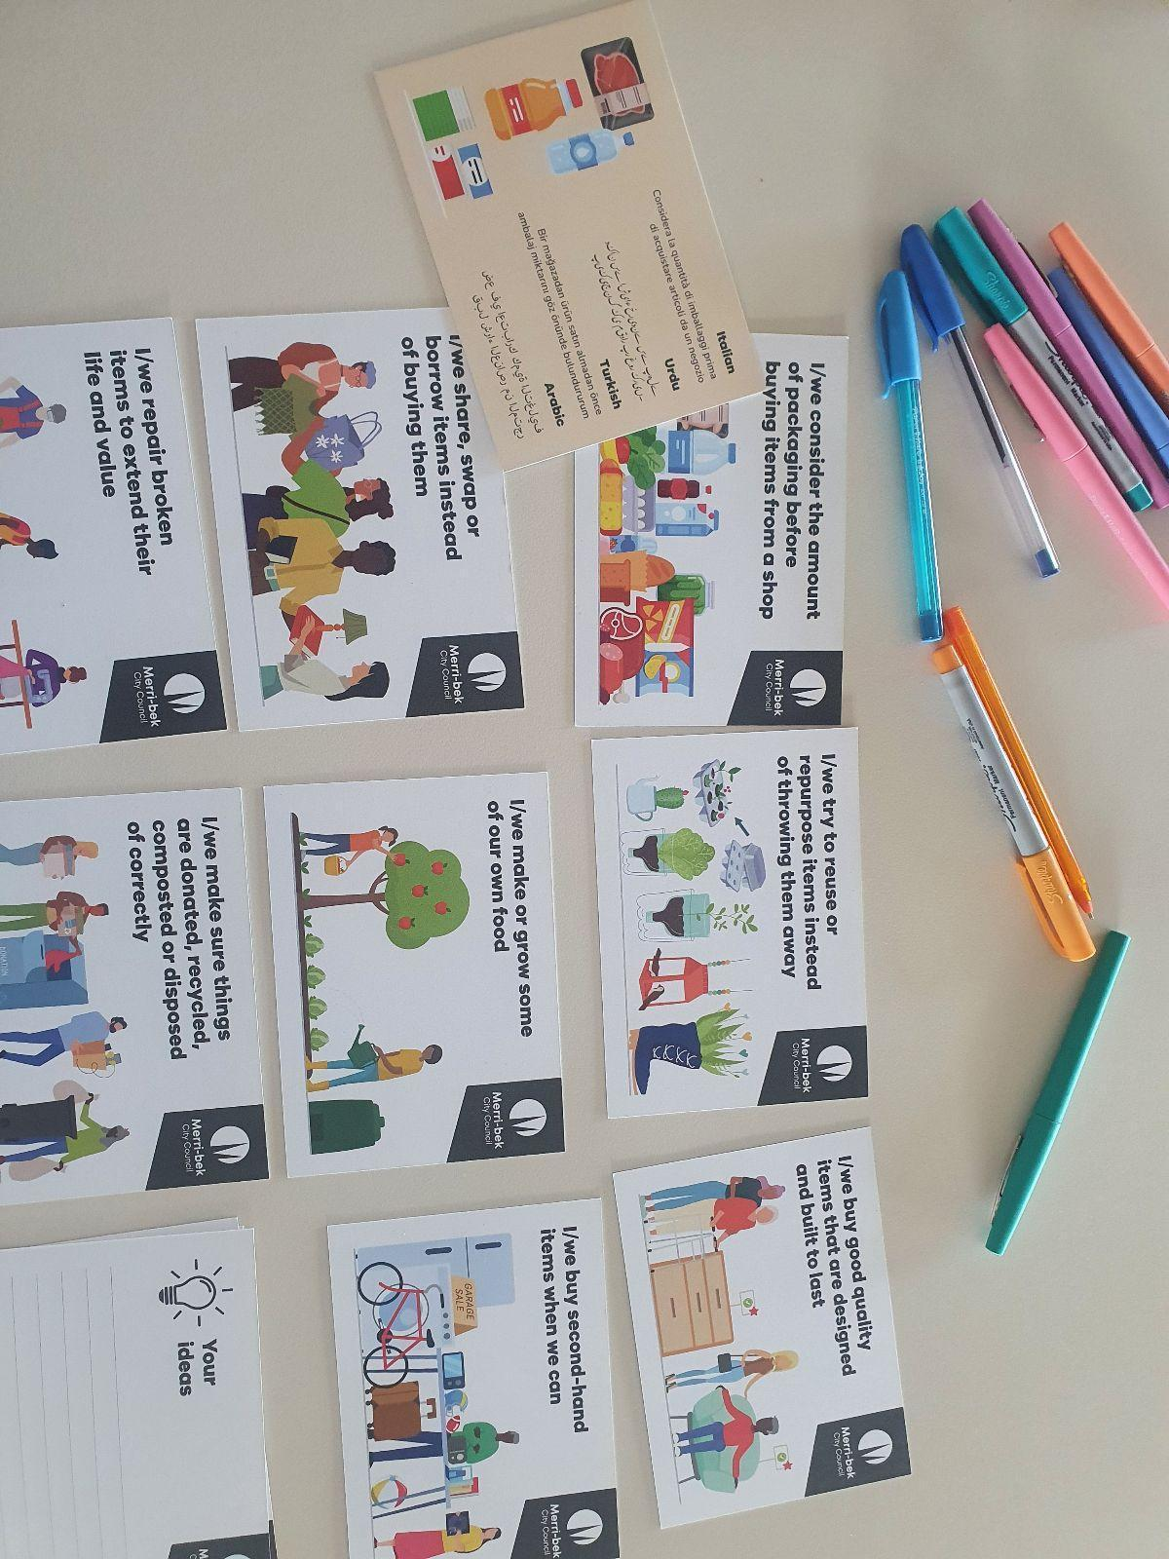

Merri-bek Circular Economy Strategy

Merri-bek City Council
Engagement Summary Report
March 2024



Table of Contents
Executive Summary 4
Participation 4
Key engagement findings 4
1. Introduction 7
1.1. Project Background 7
1.2. Engagement Purpose and Scope 8
2. Methodology 8
2.1 Engagement Objectives 8
2.2 Engagement Methods 9
2.3 Strategies to support participation 10
3. Engagement participation 11
3.1 Participation by engagement activity 11
3.2 Participation by stakeholders 12
3.3 Characteristics of participants 12
4. Key Findings 15
4.1 Current behaviours15
4.2 Barriers to adopting circular economy practices 20
4.3 Enablers for future change 29
4.4 Waste stream priorities 30
4.5 Priority actions for Council 32
4.6 Council procurement practices 39
4.7 Other feedback 40
5. Engagement evaluation 41
6. Issues to consider for the draft Strategy 43

Executive Summary
Conversation Co was engaged by Merri-bek City Council to support a community engagement seeking feedback to guide the development of the Circular Economy Strategy: Towards a Zero Waste Merri-bek (the Strategy). The Strategy will aim to improve resource management in Merri-bek by providing guidance and objectives for decision making surrounding new programs, services and initiatives that support waste reduction and the local transition to a circular economy.
This consultation with local residents and businesses aimed to:
- Understand what community priorities are for waste reduction now and into the future.
- Understand what community members and businesses already do to reduce waste to landfill.
- Better understand community and business motivations to inspire a change towards circular economy practices.
- Understand what support is needed for community members to reduce household waste.
- Understand specific needs and supports for business owners and operators in reducing waste and adopting circular economy practices into business models.
- Collect any additional feedback or suggestions for programs, initiatives or services that can support the draft strategy.

Participation
There were a total of 200 individuals providing 353 responses to this engagement program including:
- 5 business workshop participants
- 6 business survey participants
- 94 survey participants
- 53+ pop up participants
- 42 multicultural workshop participants

Participants were typically residents of Brunswick or Coburg and middle income earners. Representation was fairly equal across high and low density dwelling types and across small and large households. There was much greater participation from residents than businesses.

Key engagement findings
Current behaviours
When asked about their current behaviours community participants, engagement most commonly reported Reuse behaviours (n=430) followed by Reduce behaviours (n=207) and Recycling behaviours (n=132). Community members were most likely to practice ‘donating, recycling, composting and disposing of items correctly (n=127), reusing and repurposing items (n=126) and considering packaging before buying items (n=108). Participants most commonly shopped, and sold unwanted items, second hand, from markets, vintage stores, op shops, Facebook Marketplace and local groups like Brunswick Buy Swap, Sell; swapped or shared items through local services or community networks; bought particular items that could be easily reused or refilled and upcycled items.
Businesses undertook a range of sector-specific CE activities including sustainable marketing and community building, upcycled product manufacture or incorporated CE in food production business models. The most common current behaviours among businesses were: ‘try to reuse, repair, repurpose or donate items instead of throwing them away’ (n=6), ‘produce and/or sell items that can be reused, repurposed and/or recycled’ (n=4) and ‘produce and/or sell items made from recycled or repurposed materials’ (n=3).
Barriers to participating in CE practices
Reducing waste (n=232) was the most commonly reported barrier to participating in circular economy practices for community participants, followed by reusing items (n=166) and recycling (n=111). Participants most commonly faced difficulties in repairing items (n=84), often due to low quality of items, expense or lack of time. Participants commented that buying packaged items (n=76) was often unavoidable or unaffordable and buying items built to last (n=62) posed a challenge in terms of finding good quality items and expense. Limited time and energy were the biggest contributing factors for participants (n=48), followed by limited skills (n=44) and cost of living pressures (n=36). Participants also outlined lack of local services and facilities, limited availability of sustainable products and lack of knowledge as barriers to participation in CE practices. Other barriers provided were health reasons or family size contributing to waste, health and safety concerns with second hand items, stigma or social norms, inconvenience and cost of living pressures.

Businesses highlighted lack of influence on supply chains as their biggest barrier followed by a lack of time or energy for additional tasks as the second most common and a lack of skills or knowledge as the third.

Waste stream priorities
Overall, the top waste streams highlighted for action among residents were soft plastics, food waste and textiles. Businesses prioritised appliances and machines and food waste as top streams for immediate action, followed by textiles and soft plastics and cleaning products and construction waste. Businesses pointed to opportunities for profit making with e-waste and construction waste and opportunities for community building with textiles and appliances.

Council Actions
Overwhelmingly, participants wanted leadership from Council in terms of adopting and showcasing CE practices, with 219 (86%) participants selecting Council should prioritise reduction, reuse, repair and recycling in their decision making – even if it means goods cost more or take longer to manufacture or deliver. Community members and businesses saw a role for Council in promoting CE in businesses or services, funding community groups and spaces that support people to reuse, repair, share/borrow or recycle items and sending households and businesses information and tools to support waste reduction and CE practices. Business participants indicated that their highest priority for Council was facilitating the business community to work together and understood Council to be a conduit for this.

Introduction
Conversation Co was engaged by Merri-bek City Council to support the delivery of a community engagement for developing the Circular Economy Strategy: Towards a Zero Waste Merri-bek. Council sought to better understand the local community and business challenges, values and aspirations in relation to making changes to reduce waste to landfill. This engagement also sought feedback on which waste streams to target and how Council can best support the community and businesses to change their behaviour.
This phase one consultation will inform the direction, planning and development of the draft Circular Economy Strategy. The new Strategy will aim to improve resource management in Merri-bek by providing guidance and objectives for decision making surrounding new programs, services and initiatives that support waste reduction and the local transition to a circular economy.

Project Background
Merri-bek City Council are developing a Circular Economy Strategy to replace and expand upon the previous Waste and Litter Strategy 2018, that lapsed in June 2022 and will seek to support the transition from a ‘linear economy’ to a ‘Circular Economy’ (CE).

Merri-bek City Council has participated in circular economy programs since its Zero Waste to landfill by 2030 goal was adopted in December 2018. In order to demonstrate their commitment and ambition to reach this goal, Council is expanding on existing programs and seeking feedback from community members, businesses and interested parties to inform the development of the draft Strategy.

A Circular Economy seeks to support society and the environment to flourish and is based on the following principles:
- Design out waste and pollution.
- Keep products and materials in use and circulating at their highest value or purpose to preserve energy and resources.
- Regenerate natural systems, avoiding the use of virgin materials (especially non-renewable) and returning nutrients to the soil.

The engagement process and development of the draft Strategy is supported by the ‘Merri-bek Material Flow Analysis and Opportunities Assessment’ and waste stream research conducted by Blue Environment in 2023. The new Circular Economy Strategy will progress the theme of an environmentally proactive Merri-bek through a focus on Council services, and community and business initiatives to minimise waste and enable the transition to a circular economy.

Engagement Purpose and Scope
There will be two stages in this community consultation program. The Stage 1 consultation is focused on educating the broader community about the concept of a circular economy, understanding community strengths and challenges in taking up CE practices, as well as understanding areas where Council can support businesses and the community to achieve this goal. The components of the kerbside recycling program were considered out of scope for this engagement.

2. Methodology
Conversation Co and Merri-Bek City Council worked in partnership to plan and deliver the engagement program, within the constraints of an engagement budget.
An engagement plan was developed with Merri-bek City Council outlining:
- Project timelines and scope.
- Challenges and opportunities associated with engaging stakeholders.
- Level of stakeholder influence, including negotiables and non-negotiables for input.
- Outline of engagement activities planned.
- Communications messages and key activities.
- Measures of success for the project.

A mixed-method approach was employed in order to reach a variety of stakeholders with varying levels of interest in the project. These included activities such as:
- Community pop-ups in locations across the municipality.
- Business workshop.
- Multicultural community workshops.
- Online surveys for community members and businesses via Conversations Merri-bek.

2.1 Engagement Objectives
Engagement objectives for the project were outlined by Merri-bek City Council in the engagement plan as follows:
- To understand what community priorities are for waste reduction, now and into the future i.e which waste streams to target
- To understand what community members and businesses already do to reduce waste to landfill.
- To better understand community and business motivations to inspire a change towards circular economy practices.
- To understand what support is needed for community members to reduce household waste.
- To understand specific needs and supports for businesses owners and operators in reducing waste and adopting circular economy practices into business models.
- To collect any additional feedback or suggestions for programs, initiatives or services that can support the draft strategy.

2.2 Engagement Methods
Engagement activities were developed to best suit the project’s timeline and budget. They were conducted during the consultation period between 8 February to 11 March 2024 and are listed in Table 1.

Table 1. Engagement activities
Activity | Rationale | Stakeholders | Engagement
Online survey | Provided opportunity for participants to provide information at their convenience, without having to attend face-to-face engagement. | Broader Merri-bek community - including people who were unable to attend the face-to-face engagements. | Launched by MCC via Conversations Merri-bek:  8 February - 11 March 2024.
Community based pop-ups:  5 x 2 hour sessions | Provided opportunity for a wider range of participants to comment on the project, including participants in their local areas. | Broader community - children and young people, students using nearby libraries, pool, RMIT and secondary college campuses, CALD groups, and older residents. | Bonwick Street shops, Fawkner, 10:00 am - 12:00 pm  Thursday 15th February 2024.  Brunswick Library - Saxon Street Pocket Park Brunswick  2:00 pm - 4:00 pm  Thursday 15th February 2024.  Coburg Mall - Coburg Library Forecourt, 11 am - 1 pm  Saturday 17th February 2024.  West Street Shops (in front of West Street Woolworths) Hadfield,  2:30 pm - 4:30 pm  Saturday 17th February 2024.  Sydney Road Street Party  10:30 am - 1:00 pm  Sunday 3rd March 2024.
Business Workshop:  1 x 2 hour session | Provided opportunity for business owners and operators to learn about and discuss CE opportunities in a collaborative environment. | Business owners and operators. | Merri-bek Civic Centre  Wednesday 28th February 2024.  5.30pm - 7.30pm
Multicultural community workshops | Provided opportunity for interest groups to learn about and discuss circular economy opportunities in a collaborative environment. | CALD groups, families and young people. | Glenroy Community Hub  Session 1: 19th Feb, 5:30-7:00 pm  Session 2: 20th Feb, 5.30-7 pm  Session 3: 23rd Feb, 1-2.30 pm

2.3 Strategies to support participation
Merri-bek City Council utilised a variety of communication tools and channels to promote the project to the community and key stakeholders. The following is a list of the promotional channels used:
- Project page through Merri-bek City Council website Conversations Merri-bek.
- Social media posts across Facebook, LinkedIn and Instagram for the broader community to participate.
- In-language surveys (Arabic, Italian, Urdu and Turkish)
- Social media ads (English, Arabic, Italian, Urdu and Turkish)
- Email to community partners with information to share with relevant community groups to encourage participation.
- Promotion to community through Council eNews channels - MyMerri-bek and Eco eNews
- Promotion to businesses through Council’s Business eNewsletter
- Poster at libraries with link to online surveys
- Educational posts about local circular initiatives across Facebook and Instagram
- EOI process and incentives for multicultural community member participation in workshops

The project page on Conversations Merri-bek recorded the following measures of reach and participation:
- 2,119 page views.
- 1,407 session visits by 1,021 visitors.
- 102 contributions by 95 contributors.
- 26 project followers.

Participants came to the project page via the direct URL (47%), via social media (36%), via a search engine (10%) or via the Merri-bek Council website (3%).

3. Engagement participation

3.1 Participation by engagement activity
Throughout this report, the abbreviation (n=) will be used to indicate the number of responses or the number of participants making a particular comment.

Table 2 shows a summary of the engagement activities which involved 353 responses from 148 individuals. It should be noted that some engagement participants may have taken part in more than one engagement activity - for example attended a community pop-up and completed an online survey.

There was much greater participation from residents than businesses, which may be due to a lack of incentives, use of effective communications channels, time pressures for small business in the engagement period or a lack of interest.

Pop up engagements were successful particularly in Fawkner, Coburg and the Sydney Road Festival. Participation with multicultural groups was very successful, which may be due to the use of incentives for participation. Participants in the online surveys overall had a specific interest in the circular economy.

Table 2. Participation by engagement activity
Engagement Activity | No. | %
Online survey (community) hosted on Conversations Merri-bek | 94 | 46.8
Online survey (business) hosted on Conversations Merri-bek | 6 | 3.0
Community pop-ups* | 53+ | 26.4
Business Workshop | 5 | 2.5
Multicultural Community Workshops | 42 | 20.9
Correspondence to Council | 1 | 0.5
TOTAL participants | 201 | 100
* Note: Number of participants who filled in a demographic card at pop-ups

3.2 Participation by stakeholders
The majority of participants were residents of Merri-bek, most commonly living in Brunswick and Coburg. Figure 1 presents the breakdown of participants by connection to Merri-bek.

Figure 1: Participation by connection to Merri-bek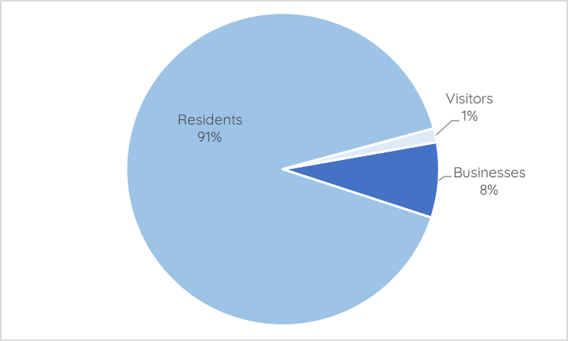
Data sources: Business workshop, business and community surveys, pop-ups demographic cards.

3.3 Characteristics of participants
Participants were asked to provide demographic details in the online surveys and the pop-ups however completion was optional. Table 3 shows their demographic characteristics in comparison to the 2021 Census data for the municipality.

The majority of engagement participants were residents of Brunswick and Coburg, middle income earners with a representative spread of household composition. This engagement reached a higher percentage of group households and other households (temporary housing, residential aged care, social housing) compared to census data. There was also good representation of participants who spoke a language other than English; particularly Spanish, Italian and Nepali speaking households. This engagement received feedback from a higher percentage of low income households with lower than average representation of high income households.

Table 3. Characteristics of community participants
Selected characteristics | Total  No. | Total  % | 2021  Census %
Household composition:
Single adult | 33 | 23.5 | 28.4
Group of adults living in shared home | 19 | 13.6 | 7.7
Couple with no children | 29 | 20.7 | 23.9
Family with children at home - youngest child is <=5 years | 16 | ) | )
Family with children at home - youngest child is 6-10 years | 11 | ) 25 | ) 21.9
Family with children at home - youngest child is 11-14 years | 8 | ) | )
Family with children at home - youngest child is 15+ years | 16 | 11.4 | 12.6
Single/couple whose children have left home | 4 | 2.9 | -
Other households (not defined, visitors only) | 4 | 2.9 | 5.4
 | 140 | 100%
Dwelling type:
Separate house | 82 | 61.2 | 51.1
Apartment/unit/villa/townhouse (medium-high density) | 50 | 37.3 | 48.2
Other | 2 | 1.5 | 0.6
Suburb of residence:
Brunswick/Brunswick East/Brunswick West | 63 | 46 | 31.4
Coburg/Coburg North | 30 | 21.9 | 20.4
Fawkner | 14 | 10.2 | 8.2
Glenroy | 9 | 6.6 | 13.9
Gowanbrae | 0 | 0.0 | 1.8
Hadfield | 3 | 2.2 | 3.7
Oak Park | 1 | 0.7 | 3.9
Pascoe Vale/Pascoe Vale South | 8 | 5.8 | 16.8
Merri-bek municipality | 128 | 93.4 | 100
Other suburbs in Greater Melbourne/Victoria | 9 | 6.6 | -
Speak a language other than English at home
No, English speaking only | 99 | 72.7 | 61.0
Yes - Italian | 9 | 6.5 | 5.8
Yes - Arabic | 2 | 1.4 | 4.5
Yes - Greek | 3 | 2.2 | 4.0
Yes - Urdu | 2 | 1.4 | 2.2
Yes - Nepali | 3 | 2.2 | 2.2
Yes - Spanish | 5 | 3.6 | 1.2
Yes - other languages | 14 | 10.1 | 14.6
Household income:
Less than $800 per week (defined as low) | 34 | 24.5 | 19.4
Between $801-$2,999 per week | 68 | 48.9 | 48.4
More than $3,000 per week (defined as high) | 18 | 12.9 | 26.5
Prefer not to say/not stated | 19 | 13.7 | 5.7
Data sources: Online community survey, pop-ups demographic cards. Data source for 2021 Census data is https://profile.id.com.au/merri-bek/
Notes: Percentages are calculated from the number of respondents to each particular demographic question. Due to a survey setup error, household composition was set as a multi-response question rather than a single response question.

Business participants
All business participants represented local small businesses. Business participants represented a number of different sectors with the higher participation from:
- Creative digital sector (n=3) including two agencies focused on sustainability marketing and digital services and a First Nations creative agency.
- Upcycled products manufacturing industry (n=3) including a recycled plastics producer, upcycled furniture producer and general upcycled products manufacturer.

The two food production participants were a specialty coffee roaster and a pet food producer. The engagement also received feedback from sole traders in sustainable building design and second-hand retail, as well as a food relief provider.

4. Key Findings
The following sections present the findings from engagement questions across all engagement activities. It should be noted that for different engagement activities, data may have been collected in varying ways (refer to the data source notes).

4.1 Current behaviours
4.1.1 What the community does to reduce, reuse and recycle
Community participants across all engagement activities were asked what they currently do to reduce, reuse and recycle or participate in CE practices. There were a total of 853 responses to this question overall - both responses to pre-coded categories (surveys) and free text responses from the pop-ups and workshops.

Figure 2 demonstrates participants' current behaviours categorised into the three main practices surrounding circular economy. Participants in this engagement most commonly reported Reuse behaviours (n=430) followed by Reduce behaviours (n=207) and Recycling behaviours (n=132).

It is worth noting however, that community survey respondents answered pre-coded categories (with more options for Reduce and Reuse behaviours) whereas pop-ups and workshops responses were open-ended. This indicates that participants do not identify what they are currently doing as a Reuse or Reduce behaviour unless reminded - this is a clear community education opportunity.

Figure 2: Participants’ current circular economy practices
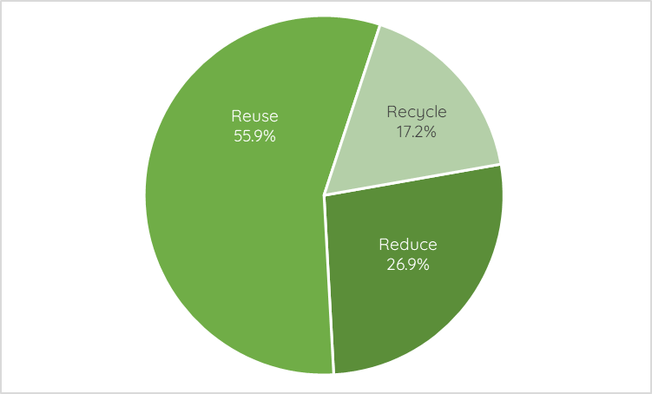
Data sources: Community survey, pop-ups, Multicultural Workshops.

Table 4 shows the detail of participants’ current behaviours showing survey options provided summarised in Figure 2. Participants most commonly reported, Donating, composting or disposing of items (n=126) and Reusing or repurposing items (n=126) followed by reducing the amount of packaging purchased (n=108) and shopping second-hand (n=105).

Table 4. Current behaviours to reduce, reuse or recycle
Current behaviours (detail) | No. | %
Make sure things are donated/recycled/composted/disposed of correctly | 127 | 14.9
Try to reuse or repurpose items instead of throwing them away | 126 | 14.8
Consider the amount of packaging before buying items | 108 | 12.7
Buy second-hand items when we can | 105 | 12.3
Share, swap or borrow items instead of buying them | 103 | 12.1
Repair broken items to extend their life and value | 84 | 9.8
Buy good quality items that are designed and built to last | 83 | 9.7
Make or grow some of our own food | 81 | 9.5
Other behaviours (refer to following Table) | 36 | 4.2
TOTAL responses | 853 | 100
Data sources: Community survey, pop-ups, Multicultural Workshop.
Notes: Pop-up participants were able to select their top three from a list and survey participants were able to select as many options that apply from a list. This is a multi-response question, percentages are expressed as % of all responses.

4.1.2 Current behaviours by demographic subgroups
The important demographic characteristics that impacted on current behaviours were considered to be dwelling type and household income. Dwelling type largely determines household composition and also is suburb-dependent due to the mix of housing in each area.

The total number of community surveys was 94 so any sub-group analysis will result in relatively small samples. Household income category was not provided by all respondents. Accordingly, these results should be considered indicative only.

The current behaviours of community survey participants were analysed as follows:
- Household income - comparing low income of less than $800 per week (26.0%) with medium-high incomes of $801+ per week (74.0%).
- Dwelling types - comparing detached houses (67.6%) with higher density dwellings such as apartments, units, villas and flats (32.4%).

Figure 3 shows that low income households were more likely to:
- Try to reuse or repurpose items instead of throwing them away (31.6%)
- Make sure things are donated, recycled, composted or disposed of correctly (29.3%).

Medium-high income households were more likely to:
- Share, swap or borrow items instead of buying them (78.8%).
- Repair broken items to extend their life and value (79.7%).

Figure 3: Community behaviours by household income levels
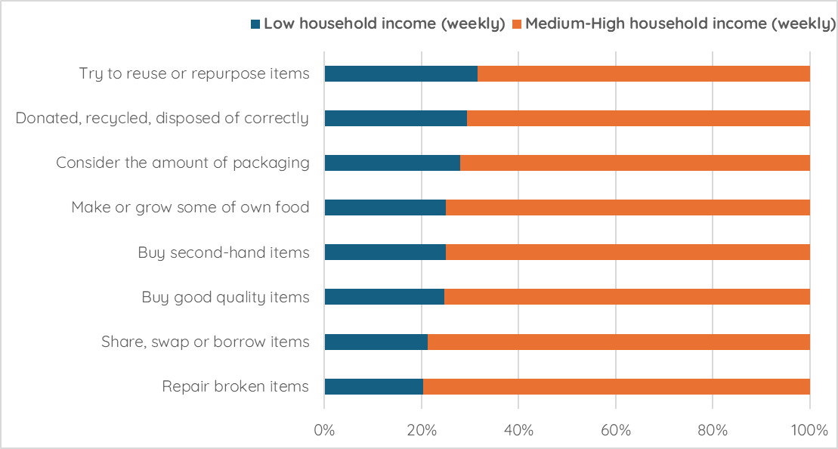
Data source: Community survey

When looking at dwelling types, the major difference in behaviours was that residents living in detached houses, having some open space, were more likely to make or grow some of their own food (75.4%). Also residents living in higher density housing were more likely to buy good quality items that are designed and built to last (35.1%).

4.1.3 Examples of what participants are currently doing
There were a total of 242 open-ended community responses to this question across pop ups, workshops and survey methods. Table 5 presents these themes in more detail with verbatim quotes from participants.

Table 5. Current behaviours (examples)
Current Behaviours | Examples | Verbatim Quotes
Try to reuse or repurpose items instead of throwing them away  (43 mentions) | - Buying particular items to reuse packaging: glass jars, plastic containers.  - Refilling items: water bottles, bags and cups.  - Upcycling waste materials: cardboard for craft projects, textiles for sewing projects, old containers for planting. | “Plastic bottles can be used as speaker”  “Glenroy art centre using stuff donated by families- craft programs”
Consider the amount of packaging before buying items  (39 mentions) | - Used menu planning, buying in bulk, refillable items, loose items and organising by use-by to avoid food wastage and packaging.  - Washing babies instead of using wipes, steaming vegetables to avoid disposing of oil, delaying decisions to buy new clothes or technology, choosing neglected fruit and veg, household plastic bans, avoiding printing and sought digital copies of textbooks  - Older participants who lived in small households who bought very little | “Organising food by the expiry date to avoid food waste - name and date- freeze items before they go off”  “I haven't bought any new clothes for 3 years”  “Buy less new things, manage with what we already have. We started doing this since having a baby, to save money and space”
Share, swap or borrow items instead of buying them  (27 mentions) | - Using libraries, Toy Library, Coburg Good Karma Network, migrant community networks, school groups.  - Sharing ‘hand me downs’ in big families. | “We repair and build computers to provide tech in Spanish for people to study or have a computer when they arrive”.
Make sure things are donated, recycled, composted or disposed of correctly  (25 mentions) | - Composting, worm farms, delivering scraps to community gardens  - Recycling items at depot points: glass deposits, soft plastics,  - Using their kerbside services correctly | “Recycling bin, garden beds, compost and worm farm”
Buy second-hand items when we can  (23 mentions) | - From markets, vintage stores, op shops, Facebook Marketplace and local groups like Brunswick, Buy Swap, Sell.  - Items bought/sold were clothing, uniforms, kids toys, books and furniture. | “Facebook Marketplace and second hand… but there can be safety issues”
Make or grow some of our own food  (17 mentions) | - Gardening at home, through school or community gardens  - Making food from scratch to avoid packaging and menu planning to avoid food wastage.  - Making household products to avoid packaging i.e cleaning products, soaps, toothpaste. | “We grow our own food and try to teach the kids skills”  “I buy eggs from my neighbours and swap with her for old egg cartons”
Repair broken items to extend their life and value  (11 mentions) | - Using repair services and bike workshops  - Restoring old furniture, machines and electronics  - Alterations and mending  - Buying specifically for warranties or repair services | “Bike repairs at a community repair workshop at the local neighbourhood house”  “I buy clothing from CE shops that provide free repairs and mending”
Buy good quality items that are designed and built to last  (7 mentions) | - ‘Buying for life’; research items that last, caring for items to increase longevity. | “Pay more for things like bikes to last longer.”
Other comments  (11 comments) | - Reusing and saving water.  - General comments about sustainability and behaviour change  - General reflections that CE practices were adopted incidentally to cope with cost of living pressures.  Multicultural Workshops:  About CE in participants' home countries:  - Sentiment that Australia has a consumerist attitude and many of the practices here lead to creation of waste.  - Sentiment that close community is needed to support CE practices and often Australian life is more separate/ private with less social capital than Tripoli, Lebanon and South America.  - Participants who supported other new migrants, multicultural communities to manage waste and learn how to correctly dispose of things. | “Try to buy local to support local businesses”  “Use my washing line instead of dryer”

4.1.4 What businesses currently do to reduce, reuse and recycle
There were six respondents for the online business survey. When businesses were asked to choose the definition that best describes a circular economy, five respondents said a circular economy is ‘designed to ensure regenerative processes and products’ and one respondent said a circular economy ‘ensures products and materials are recycled where possible’.

At the Business Workshop and in the online survey, businesses were asked ‘What things do you currently do to incorporate circular economy practices?’, resulting in 15 responses.
Businesses reported that they:
- Try to reuse, repair, repurpose or donate items instead of throwing them away (n=6).
- Produce and/or sell items that can be reused, repurposed and/or recycled (n=4).
- Produce and/or sell items made from recycled or repurposed materials (n=3)
- Reduce the amount of packaging used for the products sold (n=2).
- Make sure we recycle what we can (n= 2).

4.2 Barriers to adopting circular economy practices

4.2.1 Barriers for community members
Community participants in the survey, pop-ups and multicultural workshops were asked about the barriers to participating in CE practices ‘Which of these things do you and your household find difficult, or are reluctant, to do?’.

Figure 5: Which circular economy practices households found difficult/reluctant to do
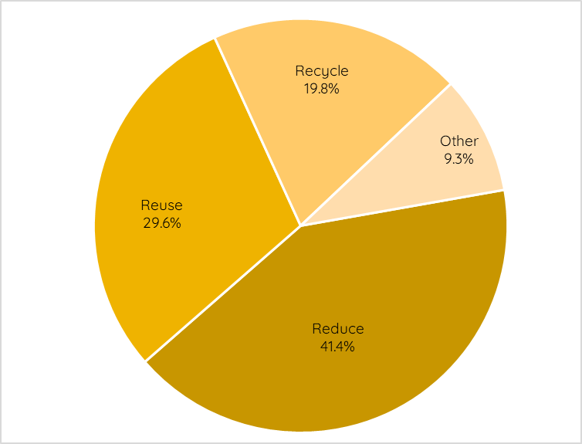
Data sources: Community survey, pop-ups and Multicultural Workshops

There were a total of 567 responses to this question. Figure 5 shows that participants most commonly reported barriers to reducing their waste (n=232) followed by reusing items (n=166) and recycling (n=111). Additionally, there were 52 other general comments such as ‘not enough time’ and ‘cost pressures’.

Table 5 shows the detail of the barriers reported by participants, expanding upon the three practices shown in Figure 5. There were a total of 561 responses to this question. Participants most commonly faced difficulties in repairing items (n=84); often due to low quality of items, expense or lack of time. Participants commented that buying packaged (n=76) items was often unavoidable or that unpackaged items were unaffordable and buying items built to last (n=62) posed a challenge in terms of finding good quality items and expense.

Table 5. Challenging or difficult behaviours to reduce, reuse or recycle
Challenging or difficult behaviours (detail) | No. | %
Repairing broken items to extend their life and value | 84 | 15.0
Buying unpackaged, in bulk or refilled items | 76 | 13.5
Buying items that are built to last | 62 | 11.1
Make sure things are donated/recycled/composted/disposed of correctly | 56 | 10.0
Considering the amount of packaging before buying items | 55 | 9.8
Paying more to recycle particular items (collection or disposal fees) | 48 | 8.6
Making or growing some of our own food | 46 | 8.2
Sharing, swapping or borrowing items instead of buying them | 33 | 5.9
Buy second-hand items when we can | 27 | 4.8
Reusing or repurposing items instead of throwing them away | 22 | 3.9
Other behaviours | 52 | 9.3
TOTAL responses | 561 | 100
Data sources: Community survey, pop-ups, Multicultural Workshop.
Notes: Pop-up participants were able to select their top three from a list and survey participants were able to select as many options that apply from a list. This is a multi-response question, percentages are expressed as % of all responses.

4.2.2 Barriers to participating in CE practices by demographic sub-groups
Similar to section 4.1.2, the two more important demographic characteristics impacted on current behaviours were considered to be dwelling type and household income. The barriers to adopting circular economy practices were analysed as follows:
- Household income - comparing low income of less than $800 per week (26.0%) with medium-high incomes of $801+ per week (74.0%).
- Dwelling types - comparing detached houses (67.6%) with higher density dwellings such as apartments, units, villas and flats (32.4%).

Figure 6: Perceived barriers by household income levels
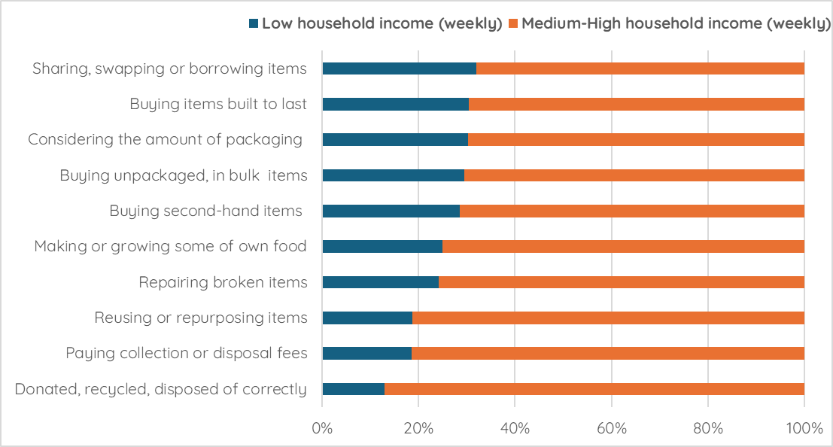
Data source: Community survey

Figure 6 shows that low income households were more likely to perceive the following as barriers that are challenging or difficult to do:
- Sharing, swapping or borrowing items instead of buying them (32.0%).
- Buying items that are built to last (30.4%).
- Considering the amount of packaging before buying items from a shop (30.3%).
- Buying unpackaged, in bulk or refilled items (29.5%).
- Buying second-hand items when they can (28.6%).

Medium-high income households were more likely to perceive the following as barriers:
- Making sure things are donated, recycled, composted or disposed of correctly (87.1%).
- Paying collection or disposal fees to recycle particular items (81.4%).
- Reusing or repurposing items instead of throwing them away (81.3%).

When looking at dwelling types, it is important to consider that particular age groups and households at different life stages will be living in detached houses or, in higher density living. The demographic variables will be influencing resident behaviour in addition to their dwelling type.
Figure 7 shows that residents living in detached houses were more likely to perceive the following as barriers that are challenging or difficult to do:
- Repairing broken items to extend their life and value (66.7%).
- Buying unpackaged, in bulk or refilled items (65.2%).
- Buying items that are built to last (64.0%).

Residents living in higher density housing were more likely to perceive the following as barriers:
- Making sure things are donated, recycled, composted or disposed of correctly (54.8%).
- Reusing or repurposing items instead of throwing them away (44.4%).
- Making or growing some of our own food (43.9%).

Figure 7: Perceived barriers by dwelling types
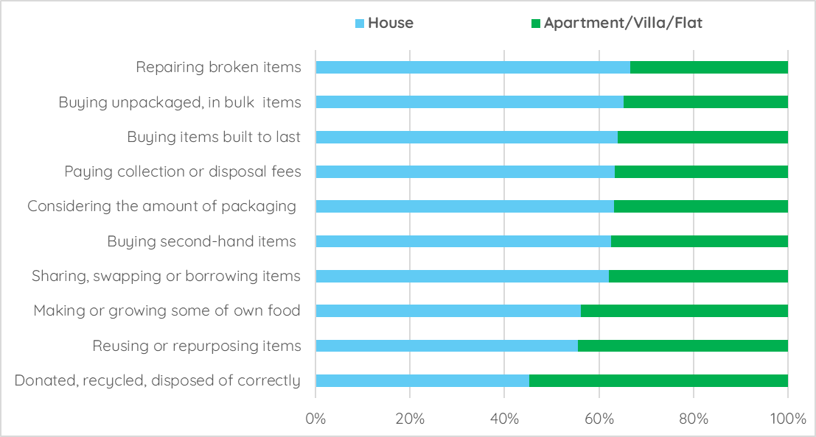
Data source: Community survey

4.2.3 Examples of barriers to participating in CE practices
There were a total of 186 open-ended community responses to this question across the pop-ups, multicultural workshops and the survey. Table 6 presents these themes in more detail with verbatim quotes from participants. Some participants mentioned more than one theme.

Table 6. Barriers (examples)
Barriers | Examples | Verbatim Quotes
Making sure things are donated, recycled, composted or disposed of correctly  (19 mentions) | - Unsure of what is recyclable and how to prepare items for the bins, i.e removing lids, washing, etc  - Unsure of what can be donated.  - Disposing of specific items not collected in kerbside collection: soft plastics, electronics  - Lack of local drop-off points  - Health or physical barriers to taking specific items to be recycled.  - Less convenient and time consuming.  - Composting at home and using FOGO bins is stinky, unhygienic, undesirable.  - Mistrust in kerbside collection: perception that waste is not recycled  - Shared bins in high density residences where some neighbours do not organise their waste correctly, creates a disincentive. | “Shared bins: people put the wrong things in there and it's disappointing when we try”  “Lack of consistency, visibility and clarity of recycling labelling. e.g. size and location of the 10 cent deposit scheme logo on products varies. It's sometimes really hard to find. Not sure what some recycling logos mean in terms of how/where you can recycle certain products”  “I can't take plastic to the supermarket I can barely walk”
Buy secondhand items when we can  (11 mentions) | - Second-hand stigma among particular cultural communities or at school: i.e clothes, textbooks  - The perception that second-hand items are unsafe, poor quality or unhygienic  - Inconvenience of shopping for second-hand items; takes time, often unable to find the items you want  - The perception that the op shop is more expensive than other retailers  - Participants unable to access cash or wary of scams using sites like Facebook Marketplace or Depop | “Only rich people buy second-hand”  “Poor/unknown quality of the second-hand items especially white goods, tools, electronics”  “Access to ATM/cash for facebook marketplace purchases. Specific for Fawkner”
Repairing broken items to extend their life and value (cheaper to buy new ones)  (14 mentions) | - Lack of local services for repair  - Cost of repair services  - Cost of tailoring and mending services  - A lack of skills surrounding mending and repairs  - Limitations to the items you are allowed to repair: appliances, electronics | “It's easier and safer not to repair - i get stumped on how to repair vacuums etc”  “Lack of knowledge, skills, time or money to repair items, or ability to find a professional willing to repair small items”
Buying unpackaged, in bulk or refilled items  (11 mentions) | - Inability to access items without packaging at local shops or purchase particular items without packaging  - Older residents and smaller households found it difficult to buy in bulk or manage heavy loads.  - Older residents and residents without access to transport limited to what is available locally | “Reusable containers are sometimes a hassle. Do the benefits outweigh the hassle?”  “Berry punnets- you just can't get certain items without plastic”
Comments on kerbside waste service  (9 mentions) | - Bins are too small for big households, households with young children  - Following the bin timetable is difficult  - Bins block residential streets  - Too many bins, inconvenient to separate everything  - Dissatisfaction with fortnightly recycling collection  - Lack of public rubbish bins or separation in public rubbish bins | “We only have 1 bin, for 3 units which house 3 families with a total of 10 children!”  “There's a lot of responsibility and stress on us (individual consumers) to recycle things correctly”  “Recycling only once a fortnight, with the same size bin as before”
Buying items that are built to last  (7 mentions) | The main barrier participants outlined was cost:  - Being unable to afford durable items  - Not having the choice to purchase items that are built to last (items are unavailable locally, time pressures)  - Planned obsolescence and the quality of everyday items deteriorating | “Plastics; the quality has deteriorated and you can't reuse. For hardwares the quality is terrible”  “Always often expensive but so worth it for long life and durability”
Making or growing some of our own food  (6 mentions) | - Access to space to grow food  - Health concerns with food growing and lead levels  - Renters prevented from using their garden spaces to grow food or unwilling to make long term investments with housing insecurity.  - Apartment body corporates prevent composting and food growing in green spaces | “Living in rental property limits people on what they can do with the backyards. Also, setting up raised beds is an investment which is high if you move every 1-2-3 years”
Sharing, swapping or borrowing items instead of buying them  (4 mentions) | - Safety concerns  - Availability of items | “Safety risk for electrical items”  “Harder to find free second hand stuff coz of changes to hard waste”
Considering the amount of packaging before buying items  (4 mentions) | - Purchasing packaged items, particularly plastics is unavoidable  - Items needed for work and study; stationery  - Medical needs creating lots of waste  - Time pressures or lack of access to transport make it more convenient to buy online  - Fast fashion and peer pressure among young people  - Participants who simply do not have the choice of receiving unpackaged items: meals on wheels users, homelessness service users | “Buying online creates so much waste and unnecessary packaging but its the cheapest and more accessible”  “Manufacturing is more than 50% of the problem. Offer us green products in the first place”  “Difficult with medications, they have so much packaging”
Paying more to recycle particular items (collection or disposal fees)  (2 mentions) | - Cost of tip fees  - Lack of local waste management facilities | “Cost is the biggest barrier for me especially as I am a full-time carer and don’t have much time or income”
Reusing or repurposing items instead of throwing them away  (1 mentions) | - Sometimes convenience outweighs desire to participate in CE practices: holidays, parties, takeaway (11)  - Time pressures - full time work, school, caring duties (6) | “It's often less convenient, more time consuming or expensive to recycle, reuse and repurpose”
Other barriers  (40 comments) | - Not knowing what to do or where to find information (6)  - Health concerns: plastic particles, compostable containers contain PFAS (3)  - Difficulties for older people to organise/reduce their waste (3)  - Expense in managing green waste- i.e mulching (2)  - A desire to have more say in corporate decision making (2)  - Mistrust in recycling process (2)  - Social pressures/stigma (3)  - Expense (2)  - General comments (17) | “Shall I drive 20 mins to recycle? Sometimes it's hard to find the balance between two options”  “Too much efficiency might spoil the pleasure- sometimes the hassle can prohibit”  “We have never talked about CE or recycling at school”  “These practices take too long”  “There’s a significant difference between finding it difficult and being reluctant!”
4.2.4 Contributing factors to these barriers
To further explore some of these barriers, community participants were asked about any life events or situations that can contribute to these barriers. For example, a family household with young children will have to consider what type of nappies to use and how to dispose of them (if required).

Table 7 shows that limited time and energy was the biggest factor for participants (n=48), followed by limited skills (n=44) and cost of living pressures (n=36). Many participants in free-text comments expressed interest in learning new skills to support adopting CE practices. Participants also shared the sentiment that burdens are often placed on the consumer and more action is needed among producers and retailers.

Table 7. Current life events/situations contributing to barriers
Current life event or situation | No. | %
Limited time or energy for ‘additional’ tasks | 48 | 21.6
Limited skills for these kinds of tasks | 44 | 19.8
Need to reduce everyday cost of living expenses | 36 | 16.2
Need to purchase cheaper household items that may not last as long | 29 | 13.1
Use of products that create extra waste (e.g.medical supplies) | 21 | 9.5
I/we have children or a large household | 21 | 9.5
Belief that new items are safer and better than repaired ones | 11 | 5.0
I/we don’t feel that we can make any more changes to reduce waste | 4 | 1.8
No interest in these practices | 0 | 0
Other comments | 8 | 3.6
TOTAL responses | 222 | 100%
Data source: Community survey. Note that there was a survey error with multiple selection which was corrected during the engagement period.
Note: This is a multi-response question, percentages are expressed as % of all responses.

Other comments made were that there was a lack of information about where to dispose of particular materials like soft plastics and crockery and a discomfort in not knowing whether they are doing the right thing (n=3), a lack of trust in the waste system in Australia and belief that all rubbish will end up in landfill (n=2), the lack of repair services (n=2) and a lack of space and skills to undertake these practices (n=2).

4.2.5 Barriers for businesses
The perceived barriers to participation in circular economy (CE) practices differed distinctly between businesses and community stakeholders.

Businesses at the workshop were asked to nominate the areas on the CE cycle that were the biggest pinch points for them. Businesses were most likely to nominate the design phase as the most challenging, with equal mentions to raw materials, distribution, consumption, maintenance, reuse and recycling.

Businesses in the survey and the workshop were asked what barriers they faced in adopting CE practices. Overall, businesses were most likely to rank ‘It’s difficult for us to influence our supply chain’ as their biggest barrier followed by ‘We don’t have the time or energy for additional tasks’ and ‘We don’t have the skills or knowledge’.

This is supported by feedback from the Business Workshop participants particularly those from small businesses, who felt they had no buying power to influence packaging or other waste passed onto them or felt reusing or more sustainable packaging added additional processes and cost (n=3).

Time pressure was a factor for taking up sustainable practices but also for upcycling businesses who commented it is often difficult to communicate to clients or customers that processing, storage and developing products from discarded materials takes time (n=3).

Participants in the Business Workshop showed an interest in the circular economy, with many of them building their business models on these principles. However, cost was a big barrier for participants, particularly when considering taking on new projects or scaling up.

Circular economy practices in business were understood by participants to involve more labour intensive practices, greater need for storage capacity, more expensive materials, more logistics and continuous redesign of internal systems to build in efficiencies (n=6). Participants shared that often it is difficult to build this into the cost of an end product for consumers however, these attitudes are changing.

Participants also mentioned difficulties with changes to zoning for warehouse space or storage of items being preventative to local producers along with the cost of tip fees.

4.3 Enablers for future change

4.3.1 Enablers for community members
Community survey participants were asked the question ‘What might help you to reduce, reuse, repair or recycle more in your household?’ and were able to select multiple options from a list. There were a total of 253 responses to this question.

Community participants understood information and education as the biggest enablers to uptake of CE practices and behaviour change in households. Participants wanted information and tools (n=57), workshops and courses to learn practical information with hands on learning (n=53) and being part of a community to practice CE with (n=41). In free-text feedback participants noted the importance of engaging and supporting existing community groups or organisations that have the knowledge in these particular practices and making it more accessible for others to join. There was a sentiment among participants that sharing CE skills and practices could link nicely with other community focused work like intergenerational programs, women’s groups and community arts.

Table 8. Enablers to make changes in the future - community
Enabler | No. | %
Better access to the tools/information needed to make it easier | 57 | 22.5
Local workshops/courses to learn basic skills to repair, reuse, compost | 53 | 20.9
Being invited to join a local community/taking part with other people | 41 | 16.2
Hearing positive stories about how other households have made changes | 31 | 12.3
Being able to go to events/workshops about waste reduction | 27 | 10.7
Other enablers | 23 | 9.1
Understanding how actions could improve things for household and planet | 21 | 8.3
TOTAL responses | 253 | 100
Data sources: Community survey.
Note: This is a multi-response question, percentages are expressed as % of all responses.

Other enablers mentioned were:
- Need for localised or neighbourhood services (n=9).
- Need for advocacy to the government and the private sector (n=7).
- Access and affordability (n=3).
- Comments on kerbside waste collection (n=3).

4.3.2 Enablers for businesses
Businesses in the survey were asked what their biggest enablers for future change could be. There were a total of nine responses to this question. Participants selected practical information about CE implementation (n=3) and Government rebates (n=3), information about changing customer expectations and learning from other businesses.

Participants in the Business Workshop said that local governments could support businesses by creating supportive governance structures, sharing information and linking up businesses who are interested in adopting CE practices.

4.4 Waste stream priorities
4.4.1 Waste stream priorities for community
Participants were asked to nominate which waste streams Council should prioritise in the Strategy and Action Plan. Community participants were asked the question: ‘Thinking about the types of waste in your household, which materials do you think Council should prioritise (for action on waste reduction) over the next 5 years?’.
Community survey respondents were asked to rank waste streams in order of priority with 1 being the highest priority, and 11 being the lowest. Participants at pop-ups were able to select their top three priorities and Table 9 presents the findings for community participant priorities overall.

Community members prioritised the waste streams (top five) as follows:
- Soft plastics.
- Textiles.
- Food waste (already a kerbside service).
- Small electronic waste.
- Waste from building and renovation projects.

Table 9: Waste stream priorities for community
Waste materials | Community  survey  Ranking | Community  pop-ups  Top three
Soft plastics (scrunchable) | 1 | 1
Waste from building and renovation projects | 4 | 4
Textiles (damaged clothing, bedding, towels) | 2 | 2
Food waste | 3 | 3
Small electronic waste (toys, gaming devices) | - | 5
Kitchenware (damaged frypans, plates, glasses) | 8 | 8
Cleaning products and household chemicals | 7 | 6
Cooking and vehicle oils | 5 | 9
Damaged toys, sporting equipment or tools | 9 | 7
Polystyrene packaging | 6 | 6
Stationery items from school or home office | - | 10
Data sources: Community survey (ranking), pop-ups (top three). Total responses depict the total number of selections or total number of rankings overall - Community survey n=91 and at pop-ups, a total of 137 selections.

Community survey respondents were asked to mention any other materials they wished Council to prioritise. There were 59 comments provided. Survey respondents mentioned electronic waste (n=10), appliances (n=6), construction waste i.e bricks, timber, asbestos (n=6), medical waste (n=5), Tetra Paks (n=4), furniture and hard rubbish (n=4), improve/expand green waste and FOGO (n=44), bike wheels and other metals (n=2), batteries (n=1), protect water; subsidise microplastics filters for washing machines (n=2), styrofoam (n=1) and nappies (n=1).

4.4.2 Waste stream priorities for businesses
Business survey respondents were prompted to select their top three priorities from a list of waste items. Participants at the Business Workshop participated in a ranking activity in small groups, adding their reasoning for prioritising the items. There were a total of 10 participants in this exercise.

Businesses prioritised the waste streams (top five) as follows:
- Appliances and machines.
- Food waste.
- Textiles.
- Soft plastics.
- Cleaning products and household chemicals.

Workshop participants communicated they felt that action on food waste could have the biggest impact. Participants also reflected on money making opportunities by focussing on construction and e-waste as these streams contain significant opportunities for resource recovery.

Participants understood construction waste as a growing issue in the municipality but with some infrastructure for recovery in place that could be expanded upon or supported. Participants also reflected on opportunities to extend Council’s community building and social cohesion work by tackling appliances, machines and cleaning products, understanding these waste streams as an entry point for helpful community programs, identity building and intergenerational activities.

4.5 Priority actions for Council
Participants across all engagement activities gave feedback on desired actions for Council. This was considered the key engagement question, feeding into the draft Strategy and associated Action Plan.

Community participants were asked the question ‘How do you think Council could best support you and other community members to avoid unnecessary purchases and extend the life of the things you already own?’ Business participants were asked the variation of ‘How do you think Council could best support your business to introduce changes that could shift towards low waste and more circular practices?’.

4.5.1 Actions for Council nominated by different stakeholders
Table 10 presents the priority actions for Council, collected from different engagement activities, with number 1 being the most important action.

Across all stakeholder groups, the top five priority Council actions were:
- Provide funding to community groups to help reuse, repair, share/borrow or recycle items.
- Promote businesses or community groups that borrow/share items or buy in bulk.
- Send households and businesses information or tools.
- Organise events for the reuse, recycling or swapping of goods.
- Promotion of local courses and workshops on CE topics.

Table 10. Priority Council actions to support community and business
Potential actions for Council | Community  Survey  Ranking  of top four | Community Pop-ups  Top three | Community Pop-ups/  Workshops  Verbatim
Promote businesses/groups that borrow/share items or buy in bulk | 1 | 1 | 5
Provide funding to community groups to help reuse, repair, share/borrow or recycle items | 2 | 3 | 1
Send households and businesses information or tools | 3 | 2 | 4
Run (or sponsor) events and workshops about waste reduction | 5 | 6 | 7
Promotion of local courses and workshops on CE topics | 7 | 4 | 2
Organise events for the reuse, recycling or swapping of goods | 4 | 5 | 3
Run/sponsor events and workshops on how to save money | 6 | 7 | 6
Data sources: Community survey (ranking of top four, n=93), pop-ups (select top three,n=71), Workshops and pop-up participants (free text responses, where appropriate, coded back into these categories, n=225 comments)

Businesses in the survey selected ‘support businesses to find each other’ as their top priority overall followed by ‘Run (or sponsor) events and workshops about waste reduction’ as the second priority and ‘Advocate for federal funding’ and ‘Send households and businesses information or tools’ as the equal third priorities.

4.5.2 Examples of actions for Council suggested by the community
There were a total of 225 open-ended community responses to this question across the pop-ups, multicultural workshops and the survey. Table 11 presents these themes in more detail with verbatim quotes from participants. Some comments mentioned more than one theme.

Table 11: Council actions (examples)
Council actions | Examples | Verbatim Quotes
Provide funding to community groups to help people to reuse, repair, share/borrow and recycle items  (32 mentions) | - Important role of community members, community-based services and organisations in CE practices, is an opportunity for community building  - Need for affordable, accessible, local services or spaces e.g.  - repair cafes/services  - community gardens  - tool and toy libraries  - more spaces to store larger items i.e hard rubbish  - furniture maker spaces and mending workshops  - services to repair electronics, appliances.  - Facilities such as mens’ sheds, neighbourhood houses, women’s groups, walking groups and seniors groups are great access points  - Need for childcare/child-friendly services to enable parents to take part  - CE practices present good opportunities for intergenerational activities and engaging with older people. | “outsource some of the waste reduction work to community- incentivise this to get people on board”  “getting intergenerational opportunities for knowledge sharing, skills”  “reverse garbage to be established – place for craft equipment and packaging”  “community groups, run in libraries, food swaps, classes in community hubs and walking groups “
Promote local courses and workshops on topics such as composting, mending, growing food and basic household repairs  (19 mentions) | - Learn particular skills to support the adoption of CE practices - short, practical courses for all ages, with qualified teachers.  - Skills such as mending, sewing, gardening, preserving, making soaps and cleaning products, household repairs, simple plumbing and electrical repairs | “Run workshops or community activities about veggie gardening, swapping seeds etc - How to start and sustain your own veggie garden”  “learn through doing not talking e.g workshops e.g olive oil event”
Partnering with schools  (14 mentions) | - CE practices not currently taught in local schools  - Opportunities for Council to partner with schools  - Promotion of CE through a schools challenge  - Providing waste collection points at schools | “Running reduce waste programs in schools, people who have less money find it harder but schools include everyone”  “Bring the little bins kids game to schools”
Advocate to private sector and businesses to make changes  (13 mentions) | - Regulation of producers to embed CE practices at the production end and ‘point of sale’ to reduce burden on consumers  - Advocate for drop off points at local supermarkets  - Advocate to small local shops and producers to reduce packaging and use alternative materials  - Encourage hospitality businesses to reduce food waste  - Encourage pharmacies to take back blister packs  - Advocate to businesses to sell reusable items | “Manufacturers and retailers must be pushed to act- pass on to their suppliers start with local shops asking for small things i.e use bread crates instead of plastic bread bags”  “Multiple bins at supermarkets . In Vienna, supermarkets are mandated to take packaging and people leave it there onsite”
Information on correct waste sorting  (13 mentions) | - Clearer communications and instruction on how to dispose of items correctly and prepare rubbish for the bin  - Information on what goes in what bin  - Simplified messaging  - Translated services  - Information on where local recycling depots are located  - More bin audits/monitoring to assure people they are doing the right thing | “an app to tell you where a product is made, comes from, what are its components and how to reuse/dispose of correctly”  “Regular bin checks- education, regular reminder about correct binning”
Promotion and communications  (13 mentions) | - Increased promotion and awareness building  - Working with religious communities, sports clubs, multicultural groups  - More promotion on social media- create case studies or CE heroes  - Introducing a challenge or competition for upcycling or waste reduction with schools or local businesses  - Communications need to restore trust in the Australian waste management system particularly recycling | “News of failed recycling efforts doesn't help (e.g. soft plastics stored, then caught on fire!)”  “Target women (or those who cook at home) with information about sustainable food practices and waste management”  “Community awareness building 'small acts can make a big impact', VicGov is a good precedent”
Promotion and education: specific practice  (13 mentions) | - Use social media, videos and ‘how to’ guides  - Reusable container shopping guides  - Second-hand shopping guides  - 10c deposit scheme  - Composting and worm farms  - Cooking and gardening  - Crafts and upcycling | “Promotion of 10c recycling and build awareness: how to use it, where to find it, what can I get out of it?”  “Promotion of rooftop gardens, organic compost in apartments”
Invest in more collection points  (12 mentions) | - Conveniently located rubbish collection points for containers, glass, soft plastics, 10c recycling, polystyrene and electronics. | “Recycling glass points like Randazzo Park in Brunswick are great, bring more of these”
Discussions of kerbside waste  (12 mentions) | - More regular bin collection  - Reduced amount of bins or separation  - Cheaper bin services  - Improvements to FOGO like accepting compostable bin liners  - Suggestions to make bin sizes smaller to encourage waste reduction  - Improvements to public bins | “Instead of 4 bins, different recycle bin having a bin partition in the middle so it can reduce the bin space in my garden”  “Make the bins smaller.”  “Appropriate bins in parks, trams, bus”
Incentives/subsidies to support behaviour change  (11 mentions) | - Provide materials like bins, composting systems  - Subsidise services  - Expand CDS | “Subsidised nappy washing service”  “To be paid for recycle products”
Suggestions to use the planning scheme and development to embed CE practices  (9 mentions) | - For high density developments - food planting in public space, reuse green waste  - Protect waterways from pollution  - Greater assessment and guidelines for new builds and businesses  - Create precincts and spaces for storage/CE projects | “Target new apartments and organic waste, make compost bins freely available”  “What do Council do to assess the impact of new businesses packaging?”
Organise events for the reuse, recycling or swapping of goods  (9 mentions) | - More swap events e.g. markets and car boot sales | “Community markets … seeing it in person is better than social media/flyers (some people speak great English but don't read/write in English),”
Send households/  businesses information or tools  (8 mentions) | - Time-poor people can access information at home as required | “DIY instructions”  “Swapping and reuse education materials i.e what is safe to swap”
Promote businesses or community groups that borrow/share items or buy in bulk  (7 mentions) | - Direct community to consumer information and advice, registries or guides  - Promotion and creation of more specialised local community buy, swap, sell forums | “Buying good quality items Reddit 'buy it for life' page- Council could share this or do something like it”
Council to role model behaviour  (7 mentions) | - Use reusable items at events and festivals  - Creating dishwashing precincts in public dining  - Purchasing locally  - Sharing environmental impact  - Sourcing providers who practice CE | “Council should purchase locally to reduce carbon footprint”  “Council should lead by example when planning public events to change habits”
Host or fund events and workshops  (6 mentions) | - Balancing take up of CE practices whilst meeting the rising cost of living pressures | “We would be happy to pass on our knowledge at a workshop or event”  “Need to know how habit changes have positive benefits”
Host or fund events about waste reduction  (3 mentions) | - Gain general information and practical knowledge | “Garbage truck demonstrations. Show people how to do it …Stories from waste workers”
Other comments  (33) | - Develop more products from waste material (6)  - Provide affordable/ accessible services (4)  - Introduce penalties or enforcement (3)  - Help facilitate businesses to find each other (2)  - Advocate for State or Federal funding (2)  - Work across LGAs (1)  - General comments (15) | “finding more ways to use recycling -make furniture reusing things for public infrastructure”  “Introduce penalties for throwing away good items”
Data sources: Community survey, pop-ups, Multicultural Workshops

4.5.3 Council actions nominated by businesses
Free text feedback from workshop participants was consistent with business survey results. The most frequent request for Council action from businesses was to facilitate connection between other businesses to support mutual adoption and a network of support to embed CE practices in business models (n=9).

Participants understood this as an opportunity to:
- Create mentor/mentee relationships among the business community.
- Create networks or spaces for innovation between businesses both upstream and downstream.
- Establish more efficient systems for local supply of items including items for reuse, to shorten local supply chains.

The second most desired action was provision of tailored support for businesses to adopt CE practices (n=8). Participants desired to learn particular skills like negotiating with suppliers to reduce packaging, consulting or education to adopt particular CE practices to develop efficiencies tailored to business models or sector, access to research and LCAs and grants for research, development and innovation.

Businesses also saw a role for Council in promoting sustainable businesses to consumers by creating a registry of sustainable businesses or a CE guide for residents, showcasing successful practices as case studies or through tours and creating market identities for precincts in terms of lifestyle and culture to draw in wider community i.e. preloved precinct, upcycle precincts.

Additionally, business participants discussed the need for more rubbish collection points and a desire for greater collaboration with other councils to provide more services, reduce waste tariffs and provide subsidies or incentives.

Business participants saw an opportunity for Council to support CE business through the planning scheme, reflecting that Brunswick and Coburg are slated for major development. Participants felt future development could negatively impact upcycle producers who need large industrial spaces to run their businesses but also presented opportunities for resource recovery, reducing red tape on reuse of construction waste and embedding CE design principles within new builds.

4.6 Council procurement practices
Participants in both surveys and pop-ups were asked to consider a question about future Council procurement priorities. The engagement question was: ‘When Council is making purchasing decisions, would you like to see them prioritise waste reduction, reuse, repair and recycling in their decision making – even if it means goods cost more or take longer to manufacture or deliver?

There were a total of 338 respondents to this question. Figure 8 shows that overwhelmingly, participants preferred Council to demonstrate commitment to CE in its procurement practices by prioritising waste reduction, reuse, repair and recycling (even if it meant that goods would cost more or take longer to manufacture or deliver).

Facilitators at the pop-ups observed a particular preference by young people for Council adopting sustainable practices and spending accordingly. Participants also mentioned a desire to know more about Council spending and the impact or footprint of organisations it employs, to make a more educated decision.

Participants at the pop-ups selecting the ‘No’ option most commonly cited the cost of living and high Council rates as the driver for their decision. Participants who selected ‘No’ were more likely to live in larger households in the northern suburbs such as Fawkner, Pascoe Vale and Coburg North.

Figure 8: Community view on Council procurement practices
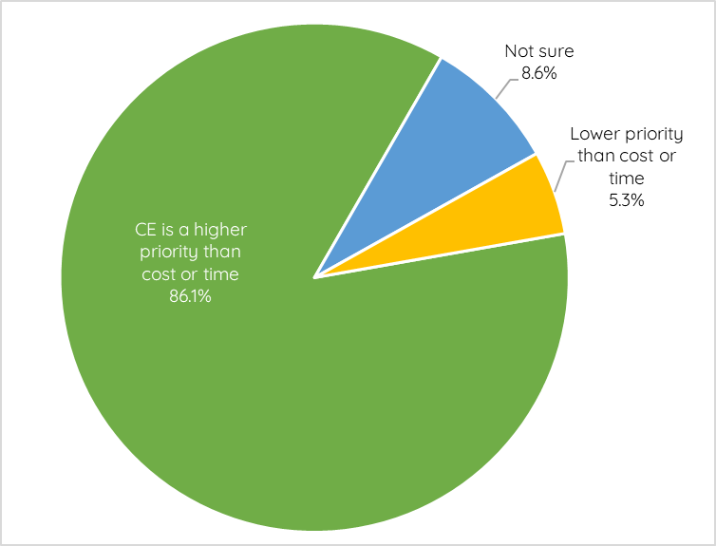
Data sources: Community survey, Business survey, pop-ups

4.7 Other feedback
Participants were asked if they had any other additional feedback or comments they would like to share with Council. There were a total of 66 responses to this question.
The main themes from this feedback were:
- A desire for advocacy to other levels of government and the private sector to make high impact changes (n=19) e.g. businesses to be accountable and more active in reducing waste, behaviour change among consumers needed to be supported by systemic change.
- More education on reducing waste, demonstrating the impacts or consequences of continuing a linear economy model (n=13).
- Introducing subsidies and supports (n=8) or penalties and enforcement (n=3) to encourage behaviour change.
- Further investment in community groups or organisations that have specific knowledge in this sector to enable mending and repair of items in local neighbourhoods (n=10).
- More promotion of sustainable businesses and guides on local alternatives to linear waste practices alongside funding or support for local businesses to improve their practices (n=7).
- More Council leadership to role model and create supportive environments for consumers to adopt CE practices (n=6) e.g. introducing circular systems within the organisation, encouraging CE practices through planning schemes, resource recovery, investment in spaces for CE groups, improving open space and maintenance governance.

Survey respondents also named local programs or services that Council could support (or establish) to promote the reuse, repair or recycling of products and materials in Merri-bek. These were:
- A local business making small objects and furniture from 100% post consumer recycled plastics.
- Go Full Circle run by Stonnington/City of Melbourne/Boroondara councils.
- Small workshops to provide repair cafes and resource basic materials.

5. Engagement evaluation
The following measures of success were noted in the Council engagement plan.

Table 15. Measures of success for engagement evaluation
Measure | Success Criteria | Result
Participation by a representative group of Merri-bek residents across the municipality | Participation numbers by group and count of individual participants  Documentation of communications distributed/sent | Biggest representation from  Brunswick (n= 63), Coburg (n=30)  Less representation and interest among residents from the northern suburbs.  Good cross-section of household types: Families (n=51)  Singles/Couple only (n=66)  Group households (n=19)  Good cross section of dwelling types:  Detached house (n=82)  High density (n=50)  Good representation of multicultural community:  LOTE (n=38) and 15 languages represented  Largely middle income bracket households represented (n=68). Low representation of high income households (n=18)  Higher than Census representation of low income households (n=34)
Participation of targeted industries and businesses including:  - Hospitality.  - Food production.  - Retail.  - Construction.  - Health Care. | Participation numbers by business name and count of individual participants. | Underrepresentation from businesses. All businesses represented were small local businesses with a prior interest in CE.  Reach:  - Hospitality (n=0)  - Food production (n=2)  - Retail (n=1)  - Construction (n=0)  - Health Care (n=0)  Incentives may have supported better engagement.
Participation of targeted stakeholders - by group and count of individual participants  - Children and Youth  - CALD groups  - Aged and disability community  - Environmental Sustainability Advisory Committee (ESAC)  - Community networks and interest groups:  Hard Rubbish Rescue, Repair Cafes, Brunswick Tool Library, Ecological Justice Hub, NUCA | Council advisory groups and targeted stakeholders participate in small group discussion | Great representation of CALD groups through attendance at the Multicultural Workshops (n=42) and non-English speakers participants in pop up/surveys (n=41)  Age group was not recorded as household composition was considered more insightful. Facilitators observed good engagement with children and young people at pop-ups and workshops - Brunswick and Coburg pop-ups had high levels of kids and student engagement, particularly with ball activity. Workshop 4 had student participants.  Disability demographics not recorded  Attendance at ESAC, survey shared with representatives on group (e.g. NUCA, EJA)  Community networks reached through email networks and via Council eNews channels - MyMerri-bek and Eco eNews  Partnered with RMIT and Tool library for Sydney Rd Street Festival event.
Quality of analysis and reporting about engagement | Findings of the engagement analysed and presented with clarity to Council.  Council report includes the Engagement Summary Report and its key findings | To be assessed during April-July 2024.

6. Issues to consider for the draft Strategy
The following issues are based on the broader participant feedback received from this Stage 1 engagement process. They are not made on the basis of any technical expertise in waste management.

Issues to consider - Draft Strategy / Action Plan
- That Council implement a communications campaign to address the mistrust in the community about the destination of different kerbside recycling streams, to increase confidence in the recycling program.
- That Council implement a communications campaign about circular economy emphasising examples of the Reuse and Reduce behaviours to encourage current household practices.
- That Council work with and support local businesses and residents by disseminating guides or consumer information about CE practices in businesses.
- That Council considers incorporating CE practices and waste regulation as part of the next review of the Merri-bek Planning Scheme.
- That Council support households by advocating for changes to the waste system with State and Federal governments.
- That Council advocate to private businesses to adopt CE practices and reduce the amount of packaging passed onto consumers.
- That Council fund and support community organisations, events and services for repair, sharing and borrowing of items.
- That Council work with other councils to provide equitable access to waste drop-off points across the municipality.
- That Council support practical information, how to guides, and in person demonstrations or courses to teach specific CE skills.
- That Council partner with schools to teach correct disposal of waste and waste reduction.

Engagement recommendations
- That Council keeps the Merri-bek community updated about the progress of the draft Strategy. The Council project page should be updated thanking participants for participating in the project to date and for sharing their ideas. Attendees at the Business Workshop should be acknowledged. Social media is a useful channel for this task.
- That Council prepares a snapshot of the engagement findings using infographics to help participants digest the information in an easy-to-understand format.
- That Council shares the engagement feedback across the organisation to relevant teams.
- That engagement questions across the various activities are asked in a consistent manner to assist with data analysis (rankings versus top three choices, top five choices etc.). That question amendments made for ease of community pop-ups are comparable with survey questions (note for consultant also).
- That prior to re-engaging with the business community, additional communications are done to ensure the appropriate businesses are aware and informed about the project.
- Investigate further options to better engage in the northern wards of the municipality. Timing engagements with events in suburbs like Glenroy, Fawkner, Hadfield and Oak Park.

Next Steps
Following this engagement summary report, the next steps for Council will be to:
- Prepare the draft Circular Economy Strategy and Action Plan.
- Conduct Stage 2 community consultation on the draft Strategy to collect final feedback from the community (March - April 2025).
- Share summary findings from Stage 2 consultation with Councillors and the community.
- Present the final Strategy and Action Plan to Council for endorsement (June-July 2025).

