

Heat Health and Heat Wave
  - English as an Additional Language Lesson Plan

Contents
Topics 2
Themes/Concepts and Ideas 2
Key learning objectives 2
Key sounds/words and phrases 3
Learning Plan 4
Heatwave Resource Guide 11
Who do we need to take care of? 12
Scenarios 13
Word Find 19
References 20

Topics
- What is a heat wave?
- Being prepared for a heat wave.
- Taking care of others.
- Taking care of yourself.
- How to stay cool.

Themes/Concepts and Ideas
What is a heatwave? | How do I stay cool?
What happens if the power goes out? | Caring for others
Caring for yourself | Caring for pets
Doing the right thing | Knowing when to call for help
Taking medication | How much to drink
Planning and preparation | Food storage

Key learning objectives
Students will be able to:
- Understand what a heatwave is.
- Understand how a heatwave can affect their health and those around them.
- How to prepare for a heatwave when it has been forecasted.
- Learn how to take care of themselves and others during a heatwave.

Key sounds/words and phrases
Keeping cool | Hot | Pets
Sun | Sunscreen | Heat cramps
Heatstroke | Shade | No power
Heat stress | Medicines | Black out
Water | Drink | Hospital
Older | Dizziness | Heat exhaustion
Younger | Air conditioner | Curtains / Blinds
Car | Pets | Melting
Check | Health | Hospital
Children | Ambulance | Cool

Learning Plan

Background Information
Course Name/Description: | Institution: | Lesson Length:
Lesson Information
Lesson Objectives — Students will be able to:
  - Understand what a heatwave is.
  - Understand how a heatwave can affect their health and those around them.
  - Be able to take steps to prepare themselves and others for heat waves.
  - Know how to stay cool.

Lesson Plan
Time | Procedure | Materials/Rationale
What is a Heatwave?

Guided discussion
Materials and Resources: Pictures can be placed on the board or given to the students.

This activity is designed to familiarise students with the definition of a heatwave and to understand how a heatwave event is declared.

Definition:

A Heatwave is:
  - Three or more days of very hot weather.
  - Heatwaves can last for many days and affect lots of people.
  - Heatwaves can make people who are sick worse.

Lead a guided discussion with the students about heatwaves. Ask the following questions.

  - What do you think a heatwave is?
  - Can you remember the last heatwave?
  - How did the heat affect you?
  - What did you do to stay cool?
How a heatwave can affect you or others

In this lesson plan, students will look at how individuals have different reactions to heat:

- The very young
- The elderly
- People who are unwell or have chronic disease.
- People who take medications
- People with a disability
- Pregnant and breastfeeding mothers
- People who have drug and alcohol issues

It will discuss how heatwaves are dangerous to people, animals and plants as well as explaining what happens to critical infrastructure during a heatwave event.

Ask the students:

Who do you think we need to take care of during a heatwave?
(Refer to list above)

Why do we need to take care of certain people in the hot weather?
Answer: Some people can have problems staying cool or do not drink enough. Others may not understand how the heat can affect you. Some people are sick and not able to tell you if they are hot or cold. Animals also need to be looked after as they can become sick in heatwaves as well. We need to make sure that our pets have plenty of water and a shady place to stay.

What do you think can happen if you get too hot?
(Refer to chart and explain symptoms or illnesses that may occur if you get too hot).

ILLNESS |  | SYMPTOMS | WHAT TO DO
Heat Cramps |  | - Muscle pains  - Pain in the stomach, arms or legs. | - Sit down and stop all activities.  - Have a drink.  - Rest for a few hours.  - Go to the doctor if the pain does not stop
Heat Exhaustion |  | - Pale and sweating  - Heart beating fast.  - Sore muscles  - Feeling weak  - Vomiting and feeling very sick in the stomach  - Fainting | - Go somewhere cool and sit down.  - Take off heavy clothing.  - Wet skin with cool water and wet clothes  - Go to the doctor
Heat Stroke |  | - Pale  - Heart beating very fast  - Feeling very weak  - Skin is dry with no sweating.  - Person is unable to remember or talk properly.  - Person may not be awake.  - Person may have a seizure/fit. | - Call an ambulance.  - Lie the person in a cool place.  - Fan and wet their skin.  - Take off their clothing.  - Make sure the person is still breathing and put them on their side.  - Stay with the person.
Time | Procedure |  |  | Materials/Rationale
How to stay cool in a Heatwave

In this lesson plan, students will investigate what they can do to keep themselves cool during a heatwave event. This will include:

- Drink plenty of water even if you don’t feel thirsty.
- Keep yourself cool by using wet towels, putting your feet in cool water and taking cool showers.
- Spend as much time as possible in cool or air-conditioned buildings.
- Close your curtains and blinds at home to block out the sun.
- Open the windows if there is a cool breeze.
- Stay out of the sun in the warmest part of the day.
- Plan your outings and if you must go out, stay in the shade and drink plenty of water.
- Wear a hat and light clothing.
- Eat smaller meals more often and cold meals such as salad.
- Make sure you store food properly and keep it in the fridge.
- Avoid heavy activities such as sport.
- Watch or listen to news reports to find out more about extreme heat.
- Never leave children unattended in cars – even for short amounts of time.

Illicit from students what they could do to stay cool.

Discuss the themes above and categorize actions into self/body, house, clothing/what to wear, planning/news. Read out the scenarios or ask students.

to go into small groups. Ask students what they think they can do in the scenarios.
Scenarios include:
- It is a very hot day. You need to go to the shops, but the children have fallen asleep in the car.
- You hear on the news that it is going to be a very hot couple of days and there will be a heatwave. What do you do to prepare?
- There is no power and it is really hot in the house. What can you do to keep cool? How do you make sure your food is OK?
- You have an appointment, and it is very hot outside. What do you need to take with you if you are going outside?
- You have a pet cat or dog. How can you help them to stay cool?
- Your neighbour is very old and has been sick. They do not have any family. How can you help them during a heatwave?
- You have a newborn baby, or you are pregnant. How do you take care of yourself?

Kids in cars

In this lesson, students will discuss why children, people who are unable to open car doors (e.g., the elderly or people with disabilities and animals should never be left alone in the car.

Discuss the following:
- A child’s body temperature rises three to five times faster than an adult, even on a mild day.
- The temperature inside a parked car can be 20 to 30 degrees hotter than the temperature outside.
- When it’s 30 degrees outside, the car can be over 60 degrees.
- Leaving the windows down has little effect on the inside temperature of the car.
- Large cars heat up as quickly as smaller cars.
Story about heatwaves – gap fill activity:

- Read the story and fill in the gaps from the word list.

See attached for the gap activity.

Revision

Home Activities:

Materials and Resources:
- Word Search
Take home activities will assist with further consolidation of skills learnt in class.

Word Search:
- Complete the word search which has useful revision on English words that you will hear about Heatwaves.

Talk to your family:
- Have a discussion with your family about Heatwaves.
- Talk about the dangers of leaving children or pets in cars.

Lesson Evaluation
1. What do you think the students actually learned? How do you know?
2. What parts were most successful/least successful? Why?
3. Did you finish the lesson on time? If not, why?
4. What changes (if any) will you make in your teaching and why (or why not)?

Heatwave Resource Guide

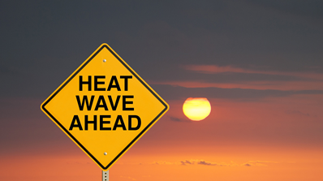

Who do we need to take care of?

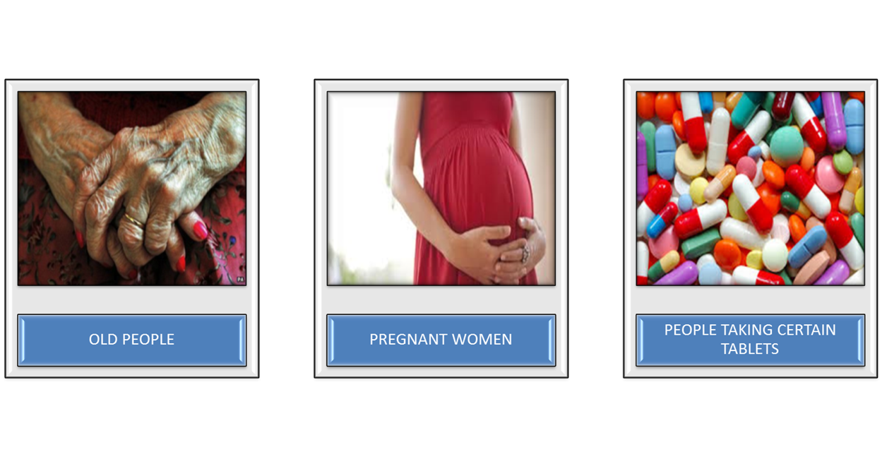
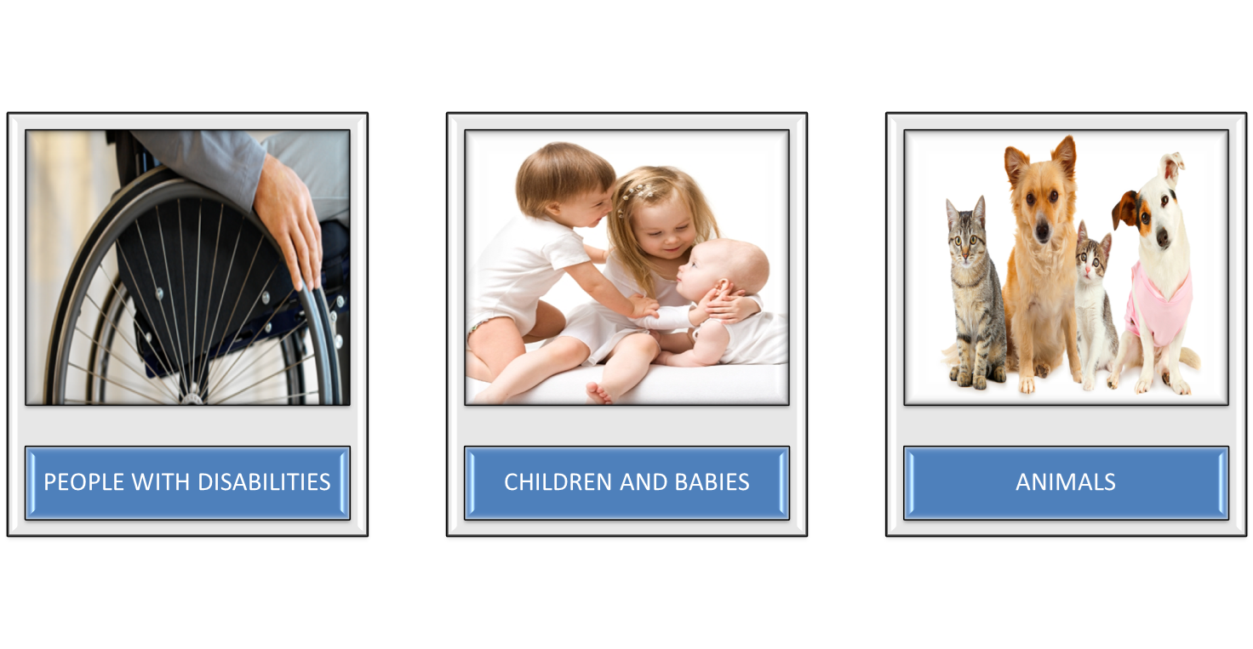

Scenarios
Scenario One
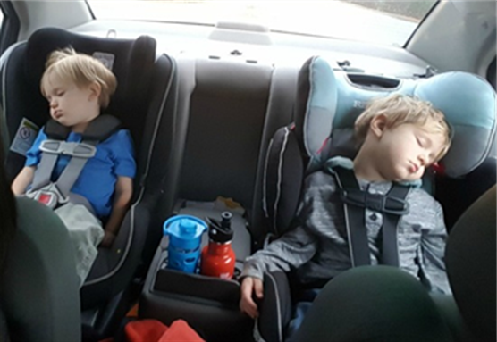

• It is a very hot day.
• You need to go into the shops.
• Your children have fallen asleep in the car.
• What should you do?

Scenario Two
• You hear on the news that it is going to be a very hot couple of days.
• They have said it will be a heatwave.
• What are you going to do to prepare?

Scenario Three

- There is no power and it is really hot in the house.
- What can you do to keep cool?
- How do you make sure your food is OK?
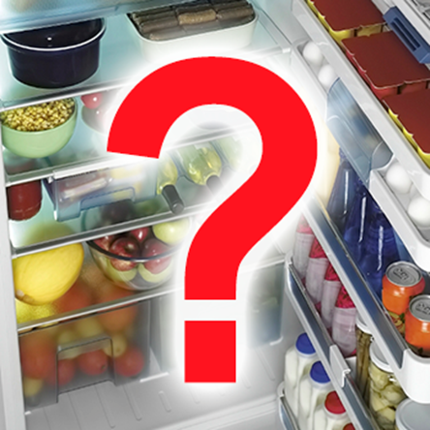
Scenario Four
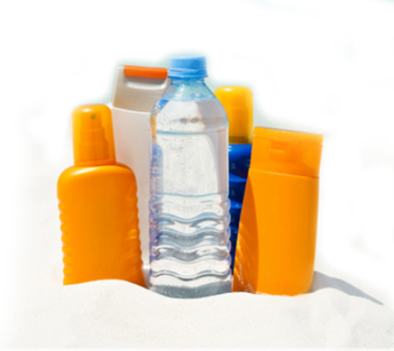

• You have an appointment.
• It is very hot outside.
• What do you need to with you?

Scenario Five

- You have a dog or other pets.
• It is going to be very hot.
• How can you help them stay cool?
• How can you help other animals in the heat?
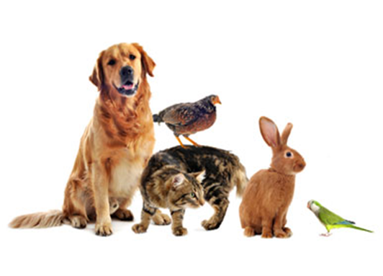
Scenario Six
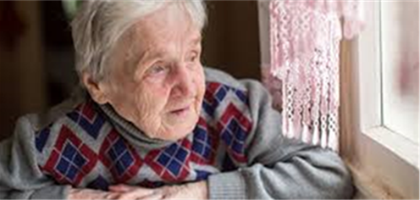

• Your neighbour is very old and sick.
• They do not have any family.
• How can you help them during the heatwave?

Scenario Seven


• You have a newborn baby.
• You are breastfeeding.
• How do you take care of yourself in the heat?
• How do you take care of your baby?

READING AND FILLING IN THE GAPS
Melbourne is getting ready for a _____________.
The news has said it is going to be for three days_________________.
They are worried that the __________ will go out.
They are worried that there may be fires too.
People have been told to get _____________.
Make sure you keep your _________cool.
Close your ___________to keep the heat out.
Check on your ________________and _____________who are older or __________.
Keep your ____________ inside or cool.
____________ plenty of water and wear _______________ outside.
Do not leave anyone in cars.
Stay inside when it is the ________________ part of the day.
Keep yourself cool by using ______________, putting your ______________in cool water and taking cool showers.

curtains | feet
people | power
Drink | ready
hottest | very hot
wet towels | animals
Heatwave | sick
house | neighbours

Answer Page:
Melbourne is getting ready for a heatwave.
The news has said it is going to be very hot for three days.
They are worried that the power will go out.
They are worried that there may be fires too.
People have been told to get ready.
Make sure you keep your house cool.
Close your curtains to keep the heat out.
Check on your neighbours and people who are older or sick.
Keep your animals inside or cool.
Drink plenty of water and wear sunscreen outside.
Do not leave anyone in cars.
Stay inside when it is the hottest part of the day.
Keep yourself cool by using wet towels, putting your feed in cool water and taking cool showers.

Word Find

W Q R T S H S K U H A Y R J S
Y E O E E E N R E V I O E V N
S H A A W I N A A P R U D D A
O H L T R O T I B C C N L N F
D T A D H S H M C J O G O E C
H F C D T E R S S I N E Z E H
I C E R E W R S E W D R N R E
G A E W A T E R K Z I E W C C
K S T O L N S T E P T E M S K
S H C H I L D R E N I V K N A
P J P Z R O T C O D O Q P U E
A Y Z F Y C T W B A N O V S C
A I E K O R T S T A E H K O Q
D F J E I T K P Q C R N O X D
O O T X P Q D Z Z B P L W Z K

AIRCONDITIONER | DOCTOR | HOT | SHOWER
CARS | DRINK | ICE | SUNSCREEN
CHECK | FANS | MEDICINES | WATER
CHILDREN | HEALTH | OLDER | WEATHER
COOL | HEATSTRESS | PETS | YOUNGER
DIZZINESS | HEATSTROKE | SHADE

References
Disaster resilience Education, Australian Emergency Management Institute, Australian Government, http://disasterresilience.com.au/
Emergency Management Planning for Children and Young People, Planning Guide for local government, Department of Human Services, 2013
SES Natural Hazards Children’s Program https://www.ses.vic.gov.au/get-ready
SES home Emergency Plan, https://www.ses.vic.gov.au/get-ready/emergency-plans-and-kits
Better Health Channel, Victorian State Government

Department of Health and Human Services, Victorian State Government, Heat Health Plan, 2016, https://www2.health.vic.gov.au/public-health/environmental-health/climate-weather-and-public-health/heatwaves-and-extreme-heat/heatwave-community-resources

