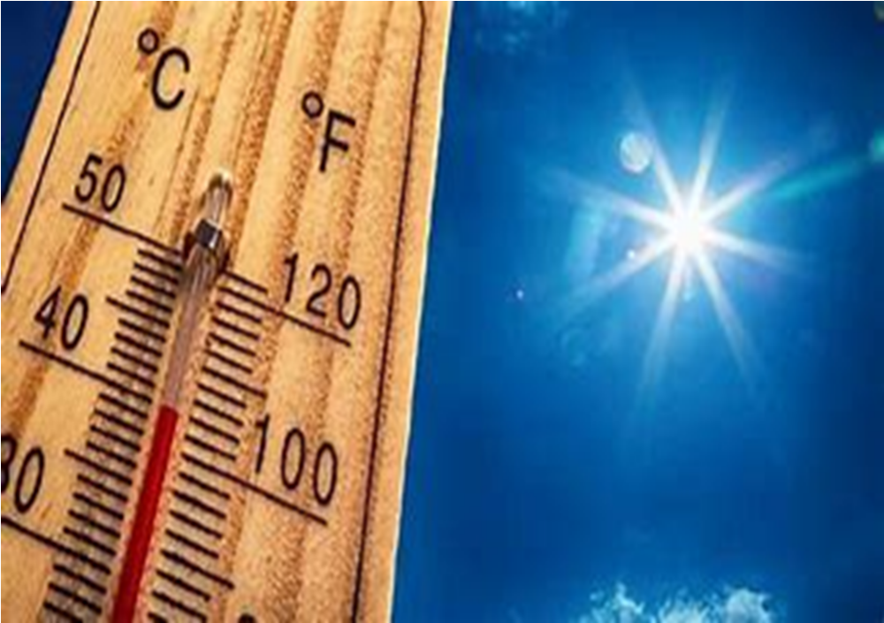


Heat Assessment and Information Tool
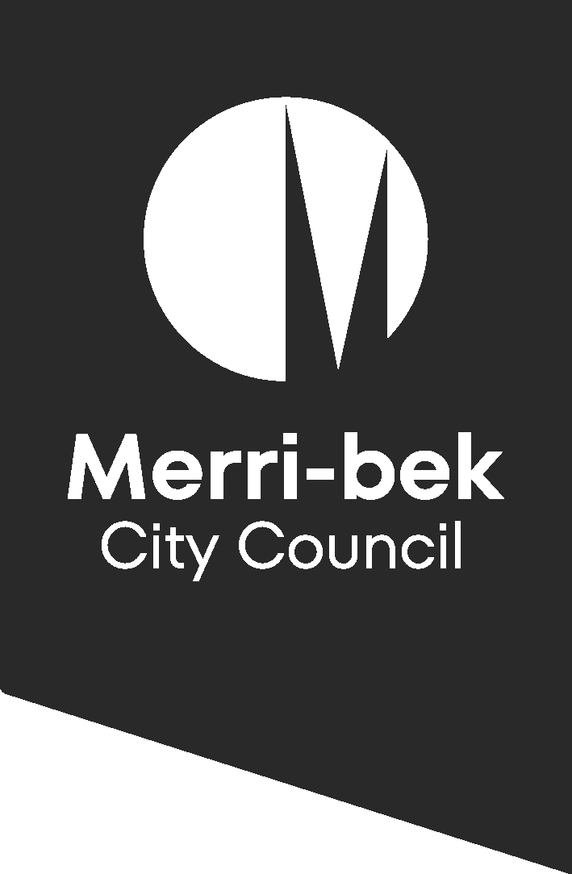

Background

Emergencies impact many different cohorts of the community in unique ways. A person-centred planning approach assists practitioners and service providers to identify the needs of an individual, their capabilities and capacity to function, plan and stay safe during an emergency via a strength-based approach.

The impacts of climate change will have an ongoing effect on all Victorians and especially those who may not have resources readily available, supports or plans in place. This assessment tool is specifically designed to begin the conversation and put plans into place to assist people who may be at risk, to ensure their health and safety during a heat wave event.

The assessment will identify the following:
- Expertise and knowledge – what does the person already know?
- What does the person do in preparing for a heat wave?
- Your Home
- Your Health
- Cognition
- Assistance
- Your Social Connection

Information for Assessment Practitioners
The assessment tool has been developed to prompt service providers to discuss heat and potential impacts to health and wellbeing.
Many questions may have been answered in the initial screening and can be used to complete the Heat Assessment Tool.
Resources and advice have been included in the tool so practitioners are able to give simple advice around keeping cool. The tool also includes a tip sheet on practical and cost-effective ways to stay cool and how to create a ‘cool room’.
These questions are relevant to heat, however the Red Cross Australia have developed the RediPlan which has a planning tool for an all-hazards approach to emergencies. This is available in an easy read version and has templates which may be used for recording information about emergency preparedness. https://www.redcross.org.au/prepare/

Assessment Tool
What do you know?
These questions will give the practitioner information about what the person already knows about keeping safe in the heat.
What do you know about heat waves? | - Understands what a heat wave is.  - Has some understanding.  - Does not understand.  Comments:
Do you know how to get information about heat waves? | - Yes  - No
What do you normally do to stay cool? | - Yes – can give information about staying cool.  - No – is unable to give information about staying cool.  - Has some understanding about staying cool.  Comments:
Your Home
What do you normally do to stay cool in your house? | Comments:
Do you have air conditioning? | - Yes  - No | Comments:
Are you able/willing to keep the air conditioning on? | - Yes  - No | Comments:
Do you have fans? | - Yes  - No | Comments:
Do your curtains and blinds block out the sun? | - Yes  - No | Comments:
Are you able to open windows in your home? | - Yes  - No | Comments:
Are you able to make a cool space within your home? | - Yes  - No | Comments:
Do you feel safe in your home? | - Yes  - No | Comments:
Your Health
Age | - Over 65 | Comments:
Are you on medication that restricts fluid intake or your ability to regulate body temperature? | - Yes  - No | Medication:
Do you have a medical condition which affects your ability to regulate body temperature? | - Yes  - No | Medical Condition:
Are you pregnant or breastfeeding? | - Yes  - No | Comments:
Do you require life support devices – ventilator etc. which need power? | - Yes  - No | Comments:
Do you require mobility aids? | - Yes  - No | Comments:
Do you have concerns around alcohol or drug abuse? | - Yes  - No | Comments:
Do you have a mental health issue which may affect you during the heat? | - Yes  - No | Comments:
Is the person considered overweight/obese? | - Yes  - No | Comments:
Do you have any visual or hearing impairments? | - Yes  - No | Comments:
Are you able to buy food to last you for three to four days during a heatwave? | - Yes  - No | Comments:
Cognition
Do you have any concerns with your memory/cognition? | - Yes  - No | Comments:
Do you know who to call for help if needed? | - Yes  - No | Comments:
Assistance/Transport
Do you need assistance in the home? (This can include personal care services, shopping, cleaning etc.) | - Yes  - No | Comments:
Are you able to leave the house independently to go to a cooler space? | - Yes  - No | Comments:
Social Networks
Do you have friends or family that you can visit to stay cool? | - Yes  - No | Comments:
Do you know your neighbours? | - Yes  - No | Comments:
Are you part of any social groups? | - Yes  - No | Comments:
Pets
Do you have pets and do you have a plan to keep them cool during a heatwave? | - Yes  - No | Comments:

Actions from assessment
Assessment answer | Suggested action
Your Home
Air conditioning - Yes | - Strongly encourage the person to utilise their air conditioning during a heat wave.  - Encourage them to complete forms/speak to their doctor about medical cooling allowance eligibility.  - Refer to tips for keeping your home cool.
Air conditioning - No | - Speak about creating a cool space/room within the home – resident may need some assistance to identify the most appropriate area.  - Refer to tips for keeping your home cool.
Safety | - If there is a risk of family violence or safety concerns, ensure the person has a plan of where they can go or contact. Heat can often increase the incidents of family violence.
Health | - Talk to the person around their health concerns and how these can increase their risk of becoming unwell during a heat wave.  - Encourage the person to always have extra medication available in case it is too hot to go out.
Essential medical equipment | - Ensure registration with Jemena’s Life Support Customer database.  - Speak to the person about the Life Support Equipment – preparing for outages.
Cognition/Memory | - Assist the person to fill out a Red Cross Emergency RediPlan with important contact numbers and information. (Link attached in resources)
Social Networks | - Include social networks, phone numbers etc in the Emergency Plan.  - Does the person need a check in phone call?  - Identify other service providers who may also check in.
Pet Care | - Discuss how they are going to look after their pets in the heat.
Leaving home | - Encourage the person to only leave home during the cooler parts of the day.  - Discuss how they are going to get there and home – driving self or public transport, walking etc.  - Encourage the person to have a ‘leaving home’ kit with plenty of water, sunscreen, the route they will take, phone etc.  - Let someone know they are going out and what time they expect to be back.

Advice and Information
(Further advice via Seven tips for a cooler home)

Create a cool room:
Focus on keeping one room cool to save money.
- Find the coolest room in your home.
- Close windows and doors to other rooms.
- If your home is open plan, block off unused areas with curtains, or blankets.
- Use fans and air-conditioning to cool the room.
- Set your air-conditioner to 26 to reduce energy use.
- Turn your air-conditioner on early. It will need to work harder if the house is already hot.

Keeping yourself cool:
- Follow the weather reports and plan what you are going to do over the heat wave period.
- Spray yourself with cool water, take cool showers (not cold), put your feet in a bucket of cool water, place wet towels around your shoulders or neck.
- Wear light, loose fitting clothing.
- Turn on your air conditioner early.
- Drink plenty of water even if you are not thirsty.
- Wear light and loose clothing
- Limit tea, coffee and alcohol as these can contribute to dehydration.
- Stay out of the sun if possible. If you must go out wear a hat, light coloured clothing and sunscreen and try to go out before 11am.
- Buy food which requires little cooking – cooking can increase the heat in your home.
- Stock up on medicines and essentials so you don’t have to go out in the heat.
- Stock up on cold water – put some extra jugs/containers in the fridge the day before a heatwave.
- Make extra ice – make ice cubes to have on hand.
- Put some damp face washers or towels in the freezer.
- To keep cool at night, place your sheets in a plastic bag and pop these in the freezer. Make your bed up before retiring and these will stay cool for a few hours.
- Identify the coolest area of your home and prepare this for sleeping.
- Take note of the colour of your urine – if it is dark or brown you need more to drink.
Keep hydrated!

Preparing for power failure:
Explain the following:
There are often power failures or ‘brown outs’ during a heat wave. These can last up to two hours at a time. There are no warnings as to when and where this will happen, so it is important to be prepared.
- If you rely on ventilators or other equipment, make sure your batteries are fully charged at all times.
- Have a torch, fully charged mobile phone and portable charger, a battery-operated radio and some spare batteries.
- Try to not open the fridge or freezer often as this will keep the food inside fresh or frozen longer.
- Consider buying a battery operated or hand-held fan.

Life Support Equipment Advice – preparing for an outage:

(Jemena’s advice)

Know your home:
- Do you know where your electrical switchboard is located?
- Do you know how to check that your main power switch in case it trips?
- If not, could you ask a neighbour or friend to help if you need to check your switchboard?

Know your equipment:
- Does your life support equipment have a backup battery built into the machine?
- Do you have a backup battery for your life support machine?
- If you require oxygen, do you have full backup oxygen tanks prepared?

If the power goes out
- Will you be ok without your life support equipment running for up to 4 hours?
- Do you have a phone that will work?
- Can you ask one of your neighbours to check on you?
- Have you discussed an Electricity Outage Action Plan with your doctor?
- Do you have Jemena’s 24/7 faults and Emergency number 131 626 and other emergency contact numbers in a convenient and easy to find location?

Getting help:
- Stay in touch with family, friends and service providers and seek assistance if you feel the heat is becoming too much for you.
- Your GP (doctor)
- NURSE-ON-CALL, Tel. 1300 60 60 24 – for expert health information and advice (24 hours, 7 days)
- If it is an emergency, call Triple Zero 000

Symptoms of heat related illness:
- Headache
- Dizziness
- Feeling or being sick
- Rapid pulse
- Muscle cramps
- Sweating too much or not at all
- Confusion
If you feel any of these symptoms or are concerned, please seek medical advice.

Medical cooling concession Victoria
The Medical cooling concession is available from November 1 – 30 April. The allowance gives an extra 17.5% off electricity bills for this period to assist with the costs of cooling their home.

Eligibility
- Holds an eligible concession card (Pensioner, Health Care or Veterans’ Affairs Gold Card)
- Have a medical condition that affects their body's ability to self-regulate temperature or
- Have a household member with such a medical condition.
Have pre-approved conditions:
- Multiple Sclerosis
- Lymphoedema
- Parkinson’s disease
- Fibromyalgia
- Post-polio Syndrome/Poliomyelitis
- Motor Neurone Disease.
Other medical conditions may be approved by the Department of Families, Fairness and Housing upon application.
All conditions must be confirmed by the person’s doctor.
Further advice:
Medical cooling concession - DFFH Services

Resources
- Extreme heat – supporting people via phone: Staying healthy in the heat: supporting people by telephone
- Survive the heat campaign: https://www.betterhealth.vic.gov.au/survive-heat-media-kit
- Red Cross RediPlan: https://www.redcross.org.au/prepare/ (comprehensive guide to assist people to plan for emergencies – has easy English versions)
- Jemena Life Support Customers: Life Support Customers - Jemena – information on how to register your life support needs.

