delwp.vic.gov.au

Naming rules for places in Victoria
  - Statutory requirements for naming roads, features and localities - 2022

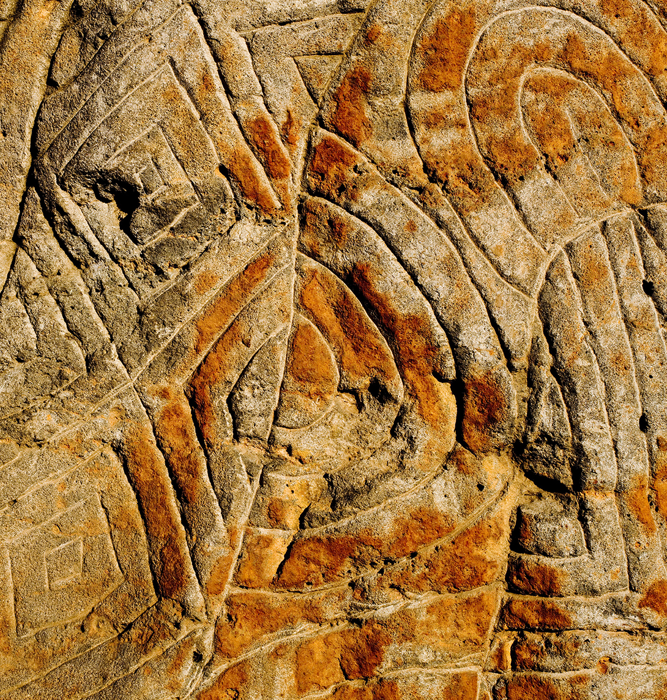

 | 

Acknowledgements

Geographic Names Victoria would like to thank the Naming Rules Review Committee, the Municipal Council Reference Group and the Traditional Owner Reference Group for their assistance throughout the review process of this document. These three groups contributed to many of the amendments through detailed conversations in this version of the naming rules and their work is greatly appreciated.
In addition, it is acknowledged that state and territory naming authorities across Australia provided advice and an opportunity to align our policies and procedures.
The document could not have been published without the support of Land Use Victoria – Office of the Chief Executive, Communications, Legal, Geographic Names Victoria and Department of Environment, Land, Water and Environment, Communications and Graphics staff.
Staff from Land Use Victoria and the Geographic Place Names Advisory Panel would like to acknowledge the significant contributions by Ms Vikki Hope to the review of the Statutory guidelines in 2015/16. Vikki sadly passed away in 2020 but her work on the naming rules has made them what they are today.
Author
Geographic Names Victoria, Land Use Victoria, Department of Environment, Land, Water and Planning.
Cover photos
Left: Albert Park, Melbourne. Middle: Aboriginal rock carving at Birrarung Marr, Credit: Visit Victoria. Right: Wodonga, Victoria

Acknowledgment
We acknowledge and respect Victorian Traditional Owners as the original custodians of Victoria's land and waters, their unique ability to care for Country and deep spiritual connection to it. We honour Elders past and present whose knowledge and wisdom has ensured the continuation of culture and traditional practices.
We are committed to genuinely partner, and meaningfully engage, with Victoria's Traditional Owners and Aboriginal communities to support the protection of Country, the maintenance of spiritual and cultural practices and their broader aspirations in the 21st century and beyond.
© The State of Victoria Department of Environment, Land, Water and Planning 2020

This work is licensed under a Creative Commons Attribution 4.0 International licence. You are free to re-use the work under that licence, on the condition that you credit the State of Victoria as author. The licence does not apply to any images, photographs or branding, including the Victorian Coat of Arms, the Victorian Government logo and the Department of Environment, Land, Water and Planning (DELWP) logo. To view a copy of this licence, visit https://www.delwp.vic.gov.au/copyright.
ISBN 978-1-76105-824-0
Disclaimer
This publication may be of assistance to you but the State of Victoria and its employees do not guarantee that the publication is without flaw of any kind or is wholly appropriate for your particular purposes and therefore disclaims all liability for any error, loss or other consequence which may arise from you relying on any information in this publication.
Accessibility
If you would like to receive this publication in an alternative format, please telephone the DELWP Customer Service Centre on 136186, email customer.service@delwp.vic.gov.au or via the National Relay Service on 133 677 www.relayservice.com.au. This document is also available on the internet at www.delwp.vic.gov.au.

Preface
Geographic Names Victoria is pleased to release the Naming rules for places in Victoria 2022 - Statutory requirements for naming roads, features and localities (the naming rules). This review fulfils our requirement under the Geographic Place Names Act 1998 section 6 to review the ‘guidelines’ once every five years. The engagement process for this review has taken place through a virtual environment to enable the release this document.
As Registrar of Geographic Names it is pleasing to see the continued focus and support for Traditional Owner languages. With the passing of the Gender Equality Act 2020 these naming rules support commemorative naming of places after women. We must recognise the diversity of our Victorian population and ensure we are inclusive of all communities regardless of gender or race.
The naming rules provide processes and procedures for naming roads, features and localities across Victoria. This ensures we protect communities through unambiguous naming practices, names are enduring and preserve our cultural identify through strong links to place.
Place names help us to identify important historic and cultural significant locations and features. They commemorate and acknowledge our past. They help us define ourselves and our place within society. They provide our community with a reference point for what makes us unique.
Victoria remains unique in that we have devolved naming process whereby naming authorities, typically councils, state government departments and agencies, undertake the naming of roads features and localities in compliance with these naming rules.
Our work in place naming supports the process of developing the ideal community as defined in the United Nations Sustainable Development Goals (SDGs). Spatial information and place names underpin the reporting requirements against the SDGs. For example Goal 5 Gender Equality and Goal 10 Reduced Inequalities can be supported through diversity in the assignment of place names. The UN Group of Experts on Geographic Names (UNGEGN) has resolved to encourage commemorative naming and the use of Traditional Owner languages for the naming of places. Victorian Aboriginal Affairs Framework supports and encourages the use of Traditional Owner languages through place naming.
I anticipate naming authorities will support these initiatives through the assignment of place names. GNV is considering its role in supporting the UN declaration that 2022 – 2032 will be the Decade of Indigenous Languages.
GNV looks forward to developing initiatives to support gender equality in naming. Amendments have already been made to VICNAMES, the Register of Geographic Names, to allow reporting of gender specific names.
These revised naming rules support naming authorities to align to these important initiatives. They offer flexibility in the naming process to ensure we collaborate and engage our communities to achieve place names that are enduring and with a strong link to place
We will continue to protect our communities and preserve our cultural identify through place names.

Craig Sandy
Registrar of Geographic Names

Contents
Preface 1
Contents 2
Section 1 Introduction 7
1.1 The naming rules 7
1.2 Legislation that applies 8
1.3 Why there is a need for naming rules 9
1.3.1 United Nations Group of Experts on Geographic Names 9
1.3.2 United Nations Sustainable Development Goals 10
1.3.3 Victorian Aboriginal Affairs Framework 10
1.4 What can be named using the naming rules? 10
1.5 Who can name roads, features and localities in Victoria and who oversees the process? 11
1.5.1 Members of the public and other stakeholders 13
1.5.2 Naming authorities 13
1.5.3 Minister responsible for the Geographic Places Names Act 1998 14
1.5.4 Registrar of Geographic Names 14
1.5.5 Geographic Places Names Advisory Panel and committees 15
1.6 VICNAMES – the Register of Geographic Names 15
1.7 Status of names in VICNAMES 16
1.8 Updating the naming rules 16
1.9 How long is the naming process? 16
Section 2 Naming principles 19
Principle A - Ensuring public safety 19
Unregistered names 19
Principle B - Recognising the public interest 19
Principle C - Linking the name to place 19
Greater than local significance 20
Principle D - Ensuring names are not duplicated 20
Principle E - Recognition and use of Traditional Owner languages 21
Principle F - Names must not discriminate or be offensive 22
Principle G - Gender equality 22
Principle H - Dual names 22
Principle I - Using commemorative names 23
Naming after living people 24
Principle J - Using commercial and business names 24
Principle K - Language 25
Principle L - Directional names to be avoided 26
Principle M - Assigning extent to a road, feature or locality 26
Section 3 Roads 27
3.1 What is a road? 27
3.2 Statutory requirements applied to roads 27
3.2.1 Rural and urban addressing 27
3.2.2 Extent: road course, start and end points 27
3.2.3 Road types 28
3.2.4 Unacceptable road names 28
3.2.5 Obstructed or altered roads 29
3.3 Roads that can be named 29
3.4 Who can name roads? 30
3.5 Roads with more than one naming authority 30
3.6 Council coordination of public roads’ naming 31
3.7 Government department or agencies coordination of public roads’ naming 31
3.8 Naming roads in new residential or commercial subdivisions 31
3.8.1 Responsibility for naming roads in residential or commercial subdivisions 31
3.8.2 The naming process 31
3.8.3 Entering subdivision road names into VICNAMES 32
3.8.4 Road name history 32
3.8.5 Maintenance and responsibility 32
3.9 Naming private roads on private property and within complex sites 32
3.9.1 The naming process 33
3.9.2 Entering a private road in VICNAMES 34
3.9.3 Maintenance and responsibility 34
3.9.4 Complex site addressing program 34
Section 4 Features 35
4.1 What is a feature? 35
4.2 Statutory requirements applied to features 35
4.2.1 Feature type 35
4.2.2 Waterways 35
4.2.3 Locational names 35
4.2.4 Base names 36
4.3 Features that can be named 36
4.3.1 Undersea feature names 36
4.3.2 Unregistered feature names 36
4.3.3 Cemeteries 36
4.3.4 Early childhood centres 36
4.4 Who can name features? 37
4.5 Features with more than one naming authority 37
4.6 Council coordination of feature naming 37
4.7 Features with government departments or agencies as the naming authority 37
4.8 Features on private land 37
4.8.1 The naming process 38
4.8.2 Entering a private feature in VICNAMES 38
4.8.3 Maintenance and responsibility 38
4.9 Features with Traditional Owner names 38
4.10 Naming features in new residential or commercial subdivisions 39
4.10.1 The naming process 39
4.10.2 Feature name history 39
4.10.3 Maintenance and responsibility 39
Section 5 Localities 41
5.1 What is a locality? 41
5.2 Statutory requirements applied to localities 41
5.2.1 Boundaries 41
5.2.2 Estate and subdivision names 45
5.2.3 Promoting a new estate 45
5.2.4 Size 45
5.2.5 Hyphens 45
5.2.6 Local government area boundary review 46
5.2.7 Locality names unique within Australia 46
5.3 Who can name localities and amend boundaries? 46
5.3.1 Creating a new locality 46
5.3.2 Reservation of locality names 46
5.4 Localities with more than one naming authority 47
5.5 New localities created by councils, government departments or authorities 47
5.6 Changes to existing locality name(s) or boundaries 47
5.7 What should not be done? 47
Section 6 Initiating a proposal and checking required information 49
6.1 Initiating a proposal 49
6.1.1 General public 49
6.1.2 Emergency management or other public service providers 49
6.1.3 Traditional Owners, Traditional Owner Group(s) and Registered Aboriginal Parties (RAPs) 50
6.1.4 Councils 51
6.1.5 Government departments or agencies 52
6.2 Naming proposal process 52
6.2.1 Check information 52
6.2.2 Apply the naming rules 52
6.2.3 Seeking the Registrar’s in-principle support 52
Section 7 Consultation 54
7.1 Minimum requirements 54
7.1.1 Government departments and agencies 55
7.2 The consultation process 56
7.2.1 Prepare a naming proposal 56
7.2.2 Develop a consultation strategy 56
7.2.3 Determine who should be consulted 57
7.2.4 Build awareness of the proposal and invite feedback 59
7.2.5 Analyse feedback from the community 67
7.2.6 When to re-consult 68
7.2.7 Implied consent 68
7.3 Developing a Traditional Owner language naming proposal 70
7.3.1 Introduction 70
7.3.2 Preparing a naming proposal 71
7.3.3 Determining Traditional Owner group(s) for consultation 71
7.3.4 Traditional Owner collaboration 71
7.3.5 Building awareness of the proposal within the wider community 72
7.3.6 Feedback from the community 72
7.3.8 Reimbursement of costs 72
Section 8 Submissions and Objections 73
8.1 What to submit 73
8.2 Who can object or support a proposal? 73
8.3 Lodging a submission 73
8.4 How submissions are considered 73
8.4.1 Minimal community support for a name 74
8.5 Notifying submitters and objectors 74
Section 9 Finalising the proposal and informing the community of a decision 76
9.1 Informing the community of a decision 76
Section 10 Lodging a proposal with GNV 79
10.1 Information a naming authority must lodge with GNV 79
Section 11 Registrar’s consideration of a proposal 80
Section 12 Appeals to the Registrar of Geographic Names 81
Section 13 Gazettal of a proposed name or boundaries 82
Section 14 Implementation 84
14.1 Registration 84
14.2 Notification 84
14.2.1 Who Geographic Names Victoria notifies 84
14.2.2 Who the naming authority must notify 85
14.2.3 Updating other databases, including private companies 86
14.2.4 Updating emergency services databases 87
14.3 Signage 87
14.3.1 Requirements for road signage 87
14.3.2 Requirements for feature signage 89
14.3.3 Requirements for locality signage 90
14.4 History 90
14.4.1 Recording historical information in VICNAMES 90
APPENDIX 92
APPENDIX A Road types accepted for registration 92
APPENDIX B Naming principles - additional information 95
Regional urban area 97
Rural or remote areas 98
Names not considered duplicates 99
Multiple names 100
APPENDIX C Checklists 101
APPENDIX D AS4819:2011 Rural and urban addressing 108
Glossary 112

Section 1 Introduction

1.1 The naming rules
Naming rules for places in Victoria – Statutory requirements for naming roads, features and localities – 2022 (naming rules) sets out step-by-step information on naming or changing the boundaries of roads, features and localities in Victoria. It replaces the Naming rules for places in Victoria – Statutory requirements for naming roads, features and localities – 2016. ‘Naming’ includes naming or amending the name of a road, feature or locality.
These naming rules are the statutory guidelines provided for under section 5 of the Geographic Place Names Act 1998; they are therefore mandatory for all naming authorities in Victoria – councils, government departments and other authorities – and include all government-owned or administered roads, features (natural or otherwise) and localities.
When a road or feature is not owned or maintained by a government department or agency (such as some cultural centres, sporting centres, education facilities or aged care facilities) the private owners are strongly encouraged to adopt the principles, requirements and procedures detailed in these naming rules. To ensure the Register of Geographic Names - VICNAMES (the state’s authoritative place names register) accurately reflects the status of named roads and features in Victoria, the names of these privately owned roads and features are recorded and these names are also available in Vicmap (the state’s authoritative spatial database).
Appropriate naming is essential to identify locations for managing emergencies and delivering goods and services in Victoria. The naming rules are based on national standards and policies. They provide a strong basis for regulated and unambiguous naming procedures across the state. They have been developed through detailed consultation with councils, government departments, Traditional Owner Groups, emergency agencies, public service providers and the wider community.
These naming rules have been developed to be inclusive to all Victorians.
These naming rules are aligned with national principles around the consistent use of place names within Australia, including the Australia & New Zealand Working Group on Place Names – Principles for the consistent use of place names, AS/NZS4819:2011 Rural and urban addressing and the United Nations Group of Experts on Geographical Names (UNGEGN) publications. Geographic Names Victoria (GNV) overseas the naming and registration of roads, features and localities in Victoria. GNV works closely with naming authorities, emergency services and delivery agencies and with jurisdictions across Australia to achieve consistency in naming.
Note: the easiest way to navigate this document when using Microsoft Word is to turn on the navigation pane. To do this select ‘view’ from the tabs at the top of the screen and select the tick box next to ‘navigation pane.’ You then can click on sections relevant to you on the left-hand side of the screen.

1.2 Legislation that applies
The naming rules are the guidelines provided for under section 5 of the Geographic Place Names Act 1998 (the Act), where it states that:
- The Governor in Council, on the recommendation of the Minister, by Order published in the Government Gazette, may make guidelines relating to procedures to be implemented in selecting, assigning, or amending names of places.
- Without limiting the generality of subsection (1), the guidelines:
- must set out the rules and process to be followed in selecting, assigning, or amending a name of a place;
- must set out the process to be followed before selecting or assigning an Aboriginal or Torres Strait Islander name of a place;
- must specify criteria for the assessment of cultural heritage or other significance in relation to the naming of places;
- must set out requirements for consultation before a name of a place is selected, assigned, or amended; and
- may specify any other matter or thing appropriate in relation to the naming of places.
These naming rules provide details in relation to the Register of Geographic Names – VICNAMES (refer to Section 1.6), information on the role of the Minister responsible for the Act, the Registrar of Geographic Names, the Geographic Place Names Advisory Panel and various naming authorities.
The definition of ‘place’ under section 3 of the Act states:
Place means any place or building that is, or is likely to be, of public or historical interest and includes, but is not restricted to:
- township, area, park, garden, reserve of land, suburb and locality;
- topographical feature, including undersea feature;
- street, road, transport station, government school, government hospital and government nursing home.
Refer to Section 11 Registrar’s Consideration of a proposal for the information regarding the registration of names under the Act.
Other legislation, regulations and policies relevant to geographic naming include:
- Local Government Act 1989
- Local Government Act 2020
- Road Management Act 2004
- Aboriginal Heritage Act 2006
- Aboriginal Heritage Regulations 2018
- AS/NZS 4819:2011 Rural and urban addressing
- Survey Co-ordination Act 1958
- Subdivision (Procedures) Regulations 2011
This list is not exclusive. The legislation, regulations and policies relevant to geographic naming may change over time.
Note: Some naming authorities have their own naming policies or guidelines that augment these naming rules.
These naming rules should not be applied to past naming decisions; they only apply to current naming proposals (for the duration of this edition’s official circulation).
When naming a road, feature or locality these naming rules will apply. If advised of a risk to public safety due to a place’s name, or a name is deemed offensive, naming authorities should also seek to rename it (where practical) and must apply these naming rules.

1.3 Why there is a need for naming rules
The naming rules provide a structure for ensuring that assigning names to roads, features and localities in Victoria is undertaken in a consistent way for the community’s benefit. Those benefits include:

- recognition and identification
- connection to country and place
- culture
- emergency service response and natural disaster relief
- heritage
- landscape
- communications, including postal and news services
- trade and commerce
- population censuses and statistics
- property rights and cadastre
- urban and regional planning
- environmental management
- map and atlas production
- navigation
- tourism

Naming of any place in accordance with these naming rules enables it to be clearly identified, which means its precise location can be determined. The uniqueness and accuracy of a place name reduces the likelihood of delaying an emergency services vehicle due to inadequate or confusing location details, which might have life threatening consequences. Proper naming also assists with service delivery by other agencies and companies.

United Nations Group of Experts on Geographic Names

Victoria complies with a number of United Nations Group of Experts on Geographic Names (UNGEGN) resolutions. In compiling a naming proposal, naming authorities are encouraged to indicate how individual naming proposals align with particular UNGEGN resolutions. Further information is available online.

UNGEGN resolutions
Applicable UNGEGN resolutions:
- UNGEGN Resolution V111/2 Commemorative naming practices for geographical features
- UNGEGN Resolution – I/4 (national) standardisation
- UNGEGN Resolution V/22 Aboriginal/ native geographical names
- UNGEGN Resolution VIII/1 Promotion of minority group and indigenous geographical names
- UNGEGN Resolution IX/5 Promotion of the recording and use of indigenous minority and regional language group geographical names
- UNGEGN Resolution X/4 Discouraging the commercialisation of geographical names

United Nations Sustainable Development Goals

The United Nations Sustainable Development Goals (SDGs) are a group of 17 goals with 169 targets to achieve these goals. Place naming supports the SDGs as standardised names of places and roads are required for delivery and effective reporting of the majority of the SDGs.
Through place naming, Victoria is supporting a number of SDGs. In compiling a naming proposal, naming authorities are encouraged to indicate how individual naming proposals align with a particular SDG. Further information is available online.

Victorian Aboriginal Affairs Framework
The Victorian Aboriginal Affairs Framework 2018-2023 (the VAAF) is the Victorian Government’s overarching framework for working with Traditional Owners, organisations and the wider community to drive action and improve outcomes.
The use of Traditional Owner language in the naming of roads, features and localities supports the following VAAF goals:
- Goal 18 Aboriginal land, water and cultural rights are realised
- Goal 19 Aboriginal culture and language are supported and celebrated
In compiling a naming proposal, naming authorities are encouraged to indicate how individual naming proposals support VAAF goals. Further information is available online.

1.4 What can be named using the naming rules?
Any public or private road, feature or locality within Victoria can be named or have its boundary changed, using the naming rules.
There are many different roads and feature types in Victoria (refer to APPENDIX A for associated road types and the Land.Vic website for associated feature types). The responsibility for preparing naming proposals and submitting them to the Registrar can vary. Please refer to the relevant sections and appendices in these naming rules to determine what is required. If you need help, please contact GNV for advice.

1.5 Who can name roads, features and localities in Victoria and who oversees the process?
The following are the four stages in the naming process for individuals or organisations.
Stage | Who can do it | Further information
Stage 1:  Who can propose a new name?  Who can propose a name change?  Who can propose a boundary change? | Anyone (individuals, community groups, organisations, government departments or authorities) can propose a new name, change to an existing name or boundary change.  Further information for the general public is available online. | Section 1.5.1
Stage 2:  Who can develop a naming or boundary change proposal? | A naming authority is often responsible for or administering the named location or feature and as part of that role provides the Registrar of Geographic Names with any naming proposals. Naming authorities include councils, government departments and other authorities, and some private organisations.  Information on authorities responsible for road naming can be found in Section 3.4.  Details of authorities responsible for developing naming proposals for features are provided in Section 4.4.  For localities, the authority is usually the council(s) within which the locality is situated. See Section 5.  If requested by the Registrar or Minister, a Geographic Place Names Advisory Committee can develop or review a naming proposal if a road, feature, or locality is determined to have greater than local significance. | Section 1.5.2  Section 3  Section 4  Section 5  Section 1.5.5.
Stage 3:  Who can object or support the naming proposal? | Anyone (individuals, community groups, organisations, government departments or authorities). | Section 8
Stage 4:  Who has authority to endorse and enter a name in VICNAMES? | The Registrar of Geographic Names.  The Minister responsible under the Act may direct the Registrar to enter a name. | Section 1.5.4  Section 1.5.5  Section 1.5.3  Section 11

Diagram: People, organisations and processes involved in naming or changing the boundary of a road, feature or locality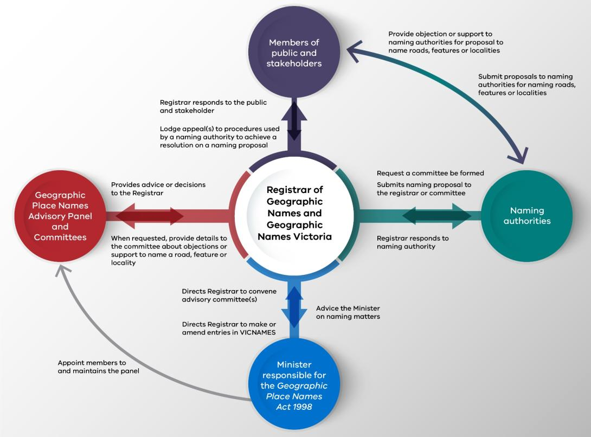

1.5.1 Members of the public and other stakeholders
Members of the public are encouraged to participate in the naming process by initiating a proposal or responding to a naming authority about a naming proposal. Other stakeholders include emergency service organisations, Australia Post, owners corporations, private institutions, Traditional Owners, historical societies, utility or other service providers, and those involved in the subdivision of land. Members of the public and other stakeholders can be involved in the naming process in three ways:
- propose a name or boundary for a road, feature or locality to the responsible naming authority
- alert a naming authority and the Registrar of Geographic Names to an issue with an existing name or boundary for a road, feature or locality and request that the matter be investigated
- comment on whether a naming or boundary change proposal conforms with the naming rules.
The Traditional Owner community in Victoria includes the descendants of various Traditional Owner groups, who, at the time of colonisation in 1835, maintained complex societies with languages, laws and customs, and a connection to their land. Traditional Owners today continue to assert their identity and connection to their Country and are a key stakeholder in the naming process. The use of Traditional Owner languages to name roads, features and localities has played, and continues to play, a significant role in promoting Traditional Owners’ relationships with Victorian landscapes.
Further information is outlined in the relevant sections (specifically, Section 2 Naming Principles, Section 4 Features and Section 7 Consultation) of the naming rules.
Further information about how to identify Traditional Owner communities, convene consultation meetings and respond to issues that may arise is available in Section 7.3 Developing a Traditional Owner language naming proposal.

Errors and omissions
If you find errors or omissions in place names you should inform the relevant authority or organisation to have the name corrected. Depending on the source of the information you should approach the council, state government department or agency or private organisation. Please note that some private organisations crowd source information as well as taking data from authoritative sources.

1.5.2 Naming authorities
Naming authorities are responsible for submitting naming proposals that comply with these naming rules to the Registrar. Due to the variety of roads, features or localities that can be named, there are multiple types of naming authorities. In most cases, councils, government departments or other authorities and private organisations are the naming authorities when they are responsible for a particular road or feature. This may apply even when they are not the owners and/or responsible for the maintenance of the road or feature, for example, Crown land committees of management or leased/licensed facilities with maintenance obligations.

Traditional Owner Group(s) including Registered Aboriginal Parties
The Victorian Aboriginal Heritage Act 2006 recognises Registered Aboriginal Parties (RAPs) as the primary guardians, keepers and knowledge holders of Aboriginal Cultural Heritage. RAPs are the primary source of advice and knowledge on matters relating to Aboriginal places or Aboriginal objects in their region. Further information is available on the Victorian Aboriginal Heritage Council website.
Traditional Owner group(s) and RAPs in some circumstances are considered naming authorities. They can develop a proposal to have their language recorded for places in Victoria in VICNAMES – the Register of Geographic Names. Refer to Section 4.9 Features with Traditional Owner names. In addition, a naming authority may provide its written agreement to allow a RAP or relevant Traditional Owner group(s) to progress and manage the naming process in accordance with these naming rules, for example, a government department allowing a RAP to name a road or feature on Crown land.
Alternatively, Traditional Owner group(s) and RAPs can request to name a road, feature, or locality, refer to Section 6.1.3.

1.5.3 Minister responsible for the Geographic Places Names Act 1998
The Minister responsible for the Geographic Place Names Act 1998 is responsible for all matters under the Act, including appointing the Registrar of Geographic Names (provided for under section 7 of the Act) and members of the Geographic Place Names Advisory Panel (provided for under section 14 of the Act).
Section 11(5) of the Act provides that the Minister may direct the Registrar to enter geographic names into VICNAMES, and under section 12(1) of the Act may also direct the Registrar to refer a naming matter to a committee for its advice. When addresses are affected, the naming authority, which is typically a council, will be contacted. It is expected that the naming authority will engage with the community to seek comments, when necessary. The Minister has the power under the Act to overturn any decision made by a naming authority, the Registrar, or committee.

1.5.4 Registrar of Geographic Names
The powers and functions of the Registrar, as set out in section 8 of the Act, include:
- To carry out the functions under the Act of registering names of places
- To keep and maintain the Register
- To advise the Minister on the establishment and development of the guidelines
- To disseminate information on the guidelines
- To monitor and review compliance with the guidelines
- Such other functions are conferred on the Registrar by or under the Act.
The Registrar has the necessary powers to carry out the functions of the Registrar under the Act.
The Registrar:
- oversees GNV, whose primary role is to assist members of the public and naming authorities to develop robust naming proposals for roads, features or localities
- maintains the Register of Geographic Names - VICNAMES in Victoria and enters and/or amends entries on the Registrar’s own volition and as required by the Minister, Geographic Place Names Advisory Committees or naming authorities
- is responsible for maintaining the Geographic Place Names Advisory Panel appointed by the Minister and for allocating members of the panel to select committees, as required from time-to-time by the Minister, or in instances of a naming proposal being considered to be of greater than local significance (refer to Principle C).

Non-compliant names
If a name of a road, feature or locality is approved and entered into VICNAMES but is later shown to not comply with the naming rules, the Registrar may ask the naming authority to change the name. The change should be undertaken collaboratively between the naming authority and GNV.
If it can be shown that the name as it is registered will cause an issue for emergency or other service providers or is determined to be offensive or derogatory, the name must be changed when requested by the Registrar. The Registrar will offer advice on how to amend the name in compliance with the naming rules. The naming authority must change the name to a compliant alternative within 90 days of receiving the Registrar’s request / advice, or outline to the Registrar the naming authority’s intended action to respond to the Registrar’s direction.
GNV is not responsible for any costs associated with naming, changing or amending names.

1.5.5 Geographic Places Names Advisory Panel and committees
The Geographic Place Names Advisory Panel and its committees are responsible for providing expert advice and recommendations to the Registrar on geographic place naming policies and principles; and place naming issues of regional, state and national significance.
Committees may be convened by direction of the Minister or Registrar; or, at the request of a naming authority, if deemed appropriate by the Registrar.
The appointment of members to a Geographic Place Names Advisory Panel and procedures governing its processes and committees are outlined in section 12 to section 17 of the Act. Information on Geographic Place Names Advisory Panels and committees is available on the Land.Vic website. Refer to Principle C Linking to place for information on when a committee can be formed.

VICNAMES – the Register of Geographic Names
Section 9 of the Act provides for a Register of Geographic Names, which includes place names and the names of streets and roads.
The Register of Geographic Names is an electronic system known as VICNAMES.
VICNAMES stores information and data related to all officially gazetted, registered and recorded road, feature and locality names in Victoria. There are some differences in the data stored for place and road records in VICNAMES and the following information is typically available:

- name
- status of name (refer to Section 1.7)
- historical name (if available)
- traditional owner origins
- registration date
- gazette notice date and reference
- place name identification
- feature descriptor
- Vicmap ID – persistent feature identifier (PFI)
- location description
- coordinates (centroid)
- Grid reference
- Datum
- Municipality – local government area where the place is located
- naming authority
- permalink – a persistent permanent link to the record
- feature description
- history of the name (if available)
- supporting historical documents (if available)
- map source information.

VICNAMES is linked to Vicmap, the Victorian government spatial data set. Linking VICNAMES to Vicmap ensures that the information in VICNAMES is aligned to the spatial representation of roads, features and localities, and that Vicmap references all officially registered or recorded names for roads, features and localities. Vicmap includes data that may not be officially registered under the Act.

Status of names in VICNAMES
Seven categories are applied to names in VICNAMES:
Place name status | Description
Registered | This type is legally recognised for the purposes of the Act as an official name for a road, feature or locality administered or coordinated by a government authority. For example; Watson Creek or Lorne.
Dual | This type consists of one non-Traditional Owner and one Traditional Owner name, which must be used together as the registered legally recognised name for the feature. For example; Point Ritchie/Moyjil. For further information refer to Principle H Dual names.
Historical | This is a name no longer in official use but recorded for information purposes. For example, Alexanders Head is now known as Brock Monument and Jeremal Creek is now known as Corryong Creek.
Base | This is a lifetime name for a feature, if the recorded name is subject to limited-term private contracts (refer to Section 4.2.4). For example; Docklands Stadium is the base name and the current registered name alters depending on the current site sponsor, which is Marvel Stadium.
Recorded | This is the name of a feature if a private entity has naming rights or the source of the name has yet to be confirmed with the naming authority. They are included in VICNAMES in the interests of public safety and information. For example, Ault Beeac Falls or Amaroo Neighbourhood Centre.
Traditional | This is a Traditional Owner language name that is not the registered name or used as a dual name for a feature. For example, Wallermeryong Creek is the Traditional Owner name for Main Creek.
Archived | Names no longer amended in the Register. For example, Ascot Telephone Exchange.

Updating the naming rules
The Registrar must ensure that the naming rules are reviewed at least once every five years and that a report on any review is given to the Minister.
With constant improvements and changes in naming rules, policies and procedures on a state, national and international level and the spatial information sector, it may be necessary to occasionally amend the naming rules to ensure up-to-date regulations are reflected. Updates need to be approved by the relevant Minister and Governor in Council. Other interested parties will be notified of any updated process and or approved amendments.

How long is the naming process?
Each naming proposal is unique and timelines for completion are guides only.
If a proposed naming or boundary change is small-scale and only affects a limited number of residents, ratepayers and businesses, the process may be shorter than described below. If the road, feature or locality is known to a lot of people and is, or will be, used extensively by the wider community, the process may take longer.
Proposal | Proposal initiation | Consultation | Compliance checks and reporting | GNV audit, gazette and notification
Naming a road | 1–2 weeks | 30–90 days | 30–60 days | 30–60 days
Naming a feature | 1–2 weeks | 30–90 days | 30–60 days | 30–60 days
Naming a locality | 3–4 weeks | 30–90 days | 30–60 days | 30–60 days
Boundary change of a road | 1–2 weeks | 30–90 days | 30–60 days | 30–60 days
Boundary change of a feature | 1–2 weeks | 30–90 days | 30–60 days | 30–60 days
Boundary change of a locality | 3–4 weeks | 30–90 days | 30–60 days | 30–60 days
The process can become extended if the naming authority is consulting on multiple names, if objections and appeals are received, if more than one naming authority is involved, or if GNV requires additional information.
The process can be reduced if the naming authority has a bank of pre-approved names. Councils will often have a bank of names relevant to an area.

The diagram shows the end-to-end process.

1
2
3
4
5
6
7
8
9
Consider a name for a road, feature or locality
Check for compliance with the relevant naming principles (Section 2, 3, 4 and 5)
Initiate a proposal to the naming authority (Section 6)
Naming authority undertakes community consultation (Section 7 and Section 8)
Finalising the proposal by the naming authority (Section 9)
Complete the checklist - optional (APPENDIX C)
Lodge a proposal with GNV (Section 10)
Registrar's consideration of a proposal (Section 11 and Section 12 Appeals)
Endorsement: gazettal and registration of a proposal (Section 13)
Implementation, signage and recording the history in VICNAMES (Section 14)

Section 2 Naming principles
The following principles must be used in conjunction with the relevant statutory requirements outlined in the other sections of the naming rules related to roads, features and localities. They are designed to ensure that names are enduring and there is no ambiguity, confusion, error or discrimination caused by the naming or locality boundary change process. All naming principles are equally important.

Principle A - Ensuring public safety
To protect our communities, geographic names and boundaries must not put public and operational safety for emergency response at risk; or cause confusion for transport, communication and mail services. Many emergency services and other public services (such as mail) are determined by locality boundaries or road extents, and naming proposals must ensure that operations will not be adversely affected.
For example, the boundary of a locality must be applied in a way that makes sense, not only for the local community but also for visitors. Similarly, the extent of a road name should ensure easy navigation for pedestrians and vehicles along the entire route, from one end to the other.

Unregistered names
Unregistered names are roads and features that have been named by a naming authority and/or are locally known but have not been officially gazetted and registered in the Register of Geographic Names – VICNAMES. To ensure public safety it is vital that these names are provided to GNV. GNV will determine whether the names are gazetted and what status they are given in VICNAMES.

Principle B - Recognising the public interest
To preserve our cultural heritage names should be enduring. When naming or adjusting the geographic boundary of a place, naming authorities must consider the long-term benefits and short-term effects on the wider community. Changes may affect current and future residents, emergency response zones and addresses, property owners, businesses and visitors.
A proposal will only be registered if the long-term benefits to the community can be shown to outweigh any private or corporate interests, or short-term effects.
Benefits include clear unambiguous names and addresses, leading to improved provision of emergency services and delivery of goods and services. Other benefits may include the opportunity to support Traditional Owner self-determination and gender equality in naming as well as the creation of communities with a strong link to place. Changing of names may have short term inconveniences but are outweighed by the long-term benefits.

Principle C - Linking the name to place
Names should have a link to place to ensure the preservation of our cultural heritage. Naming authorities play an important role in recognising and promoting our cultural heritage, as do surveyors, developers and the general public in suggesting names.
Place names should be relevant to the local area with preference given to unofficial names used by the immediate community. If named after a person (refer to Principle I Using commemorative names), that person should be held in strong regard by the community.
Names that link the name to the place could relate to Traditional Owner culture and occupation of the land (Refer to Principle E). Other examples include local flora and fauna, Australian war contributions (refer to ANZAC Commemorative naming project), past exploration and settlement, local geography and geology, significant events, the cultural diversity of past and current inhabitants, or patterns of land usage and industrial/mineral/agricultural production.
For new estates, naming themes can be used to provide a strong link to place. Names of estates should not be applied to roads, features or localities to avoid possible future ambiguity and issues related to address. Those that have a historical connection to place are allowed (refer to Principle J). Please consider contacting GNV for advice.
It can be difficult for naming authorities to determine appropriate names, especially in growth areas where large numbers of new names must be identified. Naming themes can address this issue. Names which link to place could be relevant to not just the local area, but to the wider municipality, or state. For example, in commemorating Australian writers or artists, there may not be a direct link to place, but rather to the state. In addition, consider approaching local historical societies for advice. Further assistance is available from GNV.
Infrastructure features should use the name of the locality, for example Tarneit Railway Station. Features that use the name of locality are not considered duplicates but must have a unique identifier that distinguishes the feature from other similarly named features. (Refer to 4.2.3 Locational names).

Greater than local significance
A place of greater than local significance should have a name relevant to the wider community. A road, feature or locality of greater than local significance will usually fall into one or more of the following categories:
- it is located in two or more municipal areas
- it is located in a significant tourist precinct
- it is proposed to be created as part of a state or federal government project
- it is a major waterway
- it is a major undersea or shoreline feature
- it has major cultural, natural or recreational landscape features
- it is linked to a significant Traditional Owner feature, story or landscape. Refer to Principle E Recognition and use of Traditional Owner languages.
In these instances, a naming authority can request that the Registrar convenes a Geographic Place Names Advisory Committee to develop or determine a decision on a naming proposal (refer to Section 1.5.5).

Principle D - Ensuring names are not duplicated
To protect our communities proposed names must not duplicate another name within a locality or the distances listed below, irrespective of council boundaries. Duplicates are considered to be two (or more) names within close proximity, or names that are identical or have similar spelling or pronunciation. Examples of names that are similar and considered to be both duplicates and not duplicates are provided in APPENDIX B.
If naming authorities have a proposed name that is not duplicated within the same locality, but is duplicated marginally within the radius deemed to be a duplicate, contact GNV for further advice.
VICNAMES can be used to check for a duplicate road, feature and locality names. Select the road or place and select duplicate. Refer to the VICNAMES web page for further advice.
Note: the radius will default to either 5, 15 or 30 kilometres based on the location classification listed below. The defaulted radius provides the minimum required distance between duplications for that area.

Duplication is not allowed within the same locality or the following default distances:
- metropolitan urban areas, within a 5 kilometre radius (metropolitan Melbourne and Geelong, city centres and surrounding suburbs)
- regional urban areas, within a 15 kilometre radius (a regional urban area consists of a town centre and its surrounding suburbs)
- rural or remote areas, within a 30 kilometre radius (a rural or remote area is an area located outside of towns).
If a naming authority is uncertain of which classification to apply, it should contact GNV for advice. Alternatively, apply a cautionary approach when checking for duplication and use the 30 kilometre radius search.
If the proposed name is duplicated, consider assigning it to something other than what you want to name (such as a park, reserve, road or a locality), outside of the duplicate search radius. If a feature or road is located near a state boundary, care should also be taken to avoid duplication with names in the other states, according to the distances set out above.
When considering the assignment of locality names, the above requirements are not applicable. Locality names must be unique within Australia. Naming authorities should refer to Section 5: Localities.
An exception to this principle is the assignment of multiple feature names within, for example, a park or reserve. The feature names must have a direct relationship with each other. Examples include; Mildura Wharf Carpark adjacent to and servicing Mildura Wharf, Neulynes Carpark adjacent to Neulynes Mill Site and Albert Park Lake and Albert Park Playing Fields located in Albert Park (the park). This exception is not allowed for the assignment of locality names or road names, which must be unique. For further advice please contact GNV.

Principle E - Recognition and use of Traditional Owner languages
Traditional Owner languages are often based on location; languages are deeply rooted to the land and offer an ideal opportunity to connect a name to a place. The use of Traditional Owner languages enables the wider community to be educated about Traditional Owner history and shared culture.
The use of Traditional Owner languages in the naming of roads, features and localities is encouraged, and is subject to agreement from the relevant Traditional Owner group(s). If the application of a Traditional Owner name is being considered to be applied as a dual name, then refer to Principle H Dual names.
Naming authorities must consult with the relevant Traditional Owner group(s) prior to any public consultation on the proposed name(s) in Traditional Owner language. In instances of more than one relevant Traditional Owner group, naming authorities must consult all Traditional Owner groups.
Further information about how to identify the appropriate Traditional Owner group(s), convene consultation meetings and respond to issues that may arise, is available in Section 7.3 Developing a Traditional Owner naming proposal.
In some circumstances Traditional Owner groups(s) including RAPs may be considered naming authorities, refer to Section 1.5.2 Naming authorities.
Traditional Owner group(s) and RAPs can develop a proposal to have their language recorded for places in Victoria in VICNAMES, refer to Section 4.9 Features with Traditional Owner names. Alternatively Traditional Owners and RAPs can request a naming authority to amend a name or change the name of a road, feature, or locality, including a locality’s boundaries. Refer to Section 6.1.3 Traditional Owners, Traditional Owner Group(s) and RAPs.

Principle F - Names must not discriminate or be offensive
Place names must not discriminate or cause offense. Refer to the Equal Opportunity Act 2010 for further information on what constitutes discrimination.
If an existing named road, feature or locality is considered to be derogatory or patently offensive, contact GNV for advice. A proposal to change a name must include the reasons why the current name should not remain in use.
In considering a proposal, a naming authority and or GNV will give careful consideration to all relevant factors, including the extent and distribution of usage, historical context, user perceptions and intent, and lexical meanings.

Principle G - Gender equality
Gender equality in the naming of roads, features and localities is encouraged. When developing a naming proposal consideration should be given to gender equality.
Gender equality is when people of all genders have equal rights, responsibilities, and opportunities. Everyone is affected by gender inequality - women, men, trans and gender diverse people, children, and families. It impacts people of all ages and backgrounds.
Further information is available online.

Principle H - Dual names
Dual names may only be assigned to geographic features. Dual names cannot be assigned to roads or localities.
Dual names with Traditional Owner place names are encouraged as a transitional step toward the adoption of the Traditional Owner name, as set out below.
Traditional Owner place names come from many different languages and dialects. Traditional language is a living culture which continues to be revitalised and evolve. While many names continue to be used today for roads and features, others were altered or replaced by names with no connection to place the origins of which are sometimes unknown.
Traditional Owner and dual naming provide an opportunity to:
- restore Traditional Owner names to geographic features
- incorporate Traditional Owner language and culture into everyday communications
- increase the knowledge and understanding for the whole community about the connection of Traditional Owners with Country.
Australian states and territories use dual names as a way of recognising the names given to places by different enduring cultural and language groups. For further information refer to the Principles for the Consistent Use of Place Names.
In Victoria, the approach to giving simultaneous and joint recognition of Traditional Owners and non-Traditional Owner cultures through naming is to form a dual name with two distinct name parts, usually one part of non-Traditional Owner language origin and the other of Traditional Owner language origin.
Naming authorities wishing to develop dual naming proposals must consider the following:
- Dual names can be applied to natural topographical features (e.g. islands, mountains, mountain ranges and rivers) and mapped or bounded areas such as state forests, national parks, Crown land reserves and open space recreation reserves. For example, Point Ritchie / Moyjil.
- To avoid possible confusion for addressing or the provision of emergency management, dual names cannot be adopted for:
- Localities, towns, or rural districts
- constructed features such as roads, highways, bridges or communication towers.
- Dual naming is a priority consideration when a feature already has a widely accepted name of non-Traditional Owner origin and newly available information indicates that a Traditional Owner name could also apply or when Traditional Owners have proposed an alternative name to a naming authority.
- The naming authority in consultation with Traditional Owners and the immediate community should consider the format of a dual name. For example, if a non-Traditional Owner name has weak support in the immediate community and the origin and application of a Traditional Owner name is well supported, a dual name may be formed with the Traditional Owner name part appearing first.
- In some cases, a single well-supported Traditional Owner name could be substituted for the weakly supported non-Traditional Owner name, instead of adopting a dual name.
- Dual names can be used in a transitional manner, for example; a dual name is applied and when determined appropriate by the naming authority (and typically in consultation with Traditional Owners and the immediate community) the name transitions from a non-Traditional Owner name, to a dual name and then to a Traditional Owner name.
- This approach may see names ‘transition’ over a five or ten-year period, as indicted below:
- Non-Traditional Owner name (existing name)
- Non-Traditional Owner name / Traditional Owner name – year one
- Traditional Owner name / Non-Traditional Owner name – year five
- Traditional Owner name – year ten
Dual names will be formally registered without any distinction between non-Traditional Owner and Traditional Owner name parts other than sequence. If a visual separator is required for clarity, it should be a solidus ( / ) preceded and followed by a space. The feature type should only be included with the non-Traditional Owner name. The following examples would be acceptable:
- Gariwerd / Grampians National Park
- Grampians National Park / Gariwerd
- Nambruc / Aberfeldy State Forest
- Colquhoun State Forest / Boyanga Gidi.
Dual names once registered are to be used in full, shortened versions are not to be used.

Principle I - Using commemorative names
Naming often commemorates an event, person or place. Examples include recognising Traditional Owners, cultural events or following a theme such as Australian war contributions (refer to the ANZAC Commemorative naming webpage). When considering a commemorative name, the following must be considered:
- If named after a person, that person should be or have been held in strong regard by the community, with preference given to unofficial names used by the immediate community.
When deciding on the assignment of a commemorative name, naming authorities should consider:
  - the person’s achievements,
  - relevant history and association to the area,
  - the significance of the family/person to the area/land.
For example, a family that has been associated with an area for at least 25 years.
A detailed biography of the person being commemorated must be included in any proposal submitted to GNV.
- A naming authority should make every effort to gain consent from family members of the person being commemorated. Supporting evidence that shows a naming authority’s attempts to consult family members should be provided to GNV when lodging the proposal.
- The names of people who are still alive must be avoided because community attitudes and opinions can change over time.
- Commemorative names of a deceased person should be applied no less than two years posthumously. If a naming authority wishes to name within two years it is required to seek an exemption; refer to exemption request below.
- A commemorative name applied to a locality or road may use the last name or the first name of a person; although it is preferred that only the last name be used.
- A commemorative name applied to a feature can use the first name and last name of a person; although it is preferred that only one name be used.
- The initials of a given name must not be used in any instance.
- This approach ensures that emergency and postal services are not delayed because of the inconsistent application of a name. For example, Smith Park is a clearer name than John Edward Smith Park because it is possible John Park, Edward Park, John Smith Park, J. E. Smith Park or J. E. S. Park might be used by the public.
Note: if a name is duplicated consider using a first or middle name or a locally used name; however, the naming authority should contact GNV for further advice.
When lodging a request with GNV supporting evidence is required, such as copies of letters sent to the family, copies of newspaper advertisements, internet, or social media posts calling for consent or contact details of the family. When a naming authority is unable to locate existing family members, the naming authority may use the newspaper notice, internet, or social media posts advertising the proposed name to also call for consent from the family and/or request family contact details from the community. Refer to Section 7.2.4 Build awareness of the proposal and invite feedback. Any response from the family should be included in the proposal sent to the Registrar.
If a naming authority has exhausted avenues to contact families and the proposal is the name of a person who passed away at least 70 years ago, the Registrar will consider the naming proposal.

Naming after living people
Commemoration of a living person is strongly discouraged and is generally not permitted. In exceptional circumstances, if the naming authority wishes to name a road, feature or locality after a living person, it must apply in writing to the Registrar to seek an exemption from this principle before any public consultation or a decision is made. Consent from the person should be sought prior to any exemption request being submitted to GNV. The naming authority must outline the reasons for proposing a living person’s name, including but not limited to:
- evidence about the person’s achievements which are of national or state significance
- relevant history and association to the area which ensures a link to place.
Fulfilling these points does not mean the Registrar will provide an exemption. Each case is considered on its own merits.

Principle J - Using commercial and business names
For similar reasons to those outlined in Principle I Using commemorative names, naming authorities should not name places after:
- commercial businesses
- trade names
- estate names (which are solely commercial in nature)
- not-for-profit organisations.
Names of estates should not be applied to roads, features or localities to avoid possible ambiguity and issues related to addressing. Names with historical connections to places are required. This may include estate names which have a demonstrated link to place.
Note: Estate names include names applied to residential estates, commercial or mixed estates, for example; residential subdivisions and business parks or commercial/industrial zoned land. Where roads, features and localities are named using the estate name and have no link to place, the name will not be allowed.
Naming authorities should use their discretion as to whether an exemption request is required. For further advice contact GNV.
Exceptions may apply if the business, organisation or name had an association with the area over a substantial period of time and is held in high regard by the community, for example; Lions Park Mallacoota, Vegemite Way.
In these circumstances, the naming authority must apply in writing to the Registrar to seek exemption from this principle, including but not limited to evidence of the business or organisation’s association with the area and any known community views. This exemption request must be sought prior to commencing any public consultation or reaching a decision on the final naming proposal.

Principle K - Language
The use of names from Australian English, Traditional Owner names and names from other languages need to be given careful consideration. The following points must be considered.

- Geographic names, except when they are proper nouns, must be written in standard Australian English or a recognised format of a Traditional Owner language local to the area of the road, feature or locality.
- Geographic names should be easy to pronounce, spell and write, and preferably not exceed three words (including feature or road type) and/or 25 characters. An exception to this is in the use of Traditional Owner languages, when it is accepted that Traditional Owner names that initially appear complex will, over time, become familiar and easy to use.
- Mitigating steps to allow more complicated names could include pronunciation, phonetic pronunciation and information associated with the name added to signage and or provided residents.
- Names taken from a language other than English may be acceptable and represent Victoria’s diverse multicultural society but must be written in Australian English.
- Names taken from a language other than English that represent geographical features generally use generic terms and will be allowed, unless the combination produces a duplication of sense. For example; Tor Mountain would not be allowed because Tor means mountain.
- ‘The’ is not a suitable prefix in naming of any road, feature or locality and must not be used. For example; The Avenue is not acceptable.
- Although discouraged, hyphens can be used within place names that indicate the extent of the feature, for instance Mellick-Munjie Parish or Hattah-Kulkyne National Park. They can also be used when the name incorporates a hyphenated last name, for instance Kingsford-Smith Ulm Reserve. Hyphens in road names are not allowed. Diacritical marks (symbols such as ´, ¸ or ¯) will be omitted from names drawn from languages that use such marks. For example, Cape Reamur (not Cape Réamur).
- Punctuation marks such as commas and full stops are not allowed.
- An apostrophe must be deleted from geographic names written with a final ’s and the possessive ’s should not be included. For example, Wilsons Promontory (not Wilson’s Promontory) or OReilly (not O’Reilly).
- Abbreviations are not allowed. An exception applies to the use of the honorific Saint. For example, Mount must be registered or recorded in full, but Saint can be recorded as St if requested by the naming authority. For example, St Agness Hill, Saint Georges Point and Mount Alfred are all acceptable.
- For the purposes of consistency, names starting with Mc or Mac must not have a space included between the Mc or Mac and the rest of the name. For example, MacKenzie Falls, McAdam Gap and McCarthy Spur are all acceptable.
- A name cannot be a numeric value either in full alphabetised or numeric format. For example: 1st Street; 101 Road; Fourth Road; 5th Avenue; 9 Mile Creek; One Tree Hill and Nine Mile Creek are all unacceptable.
- Roads and features must use approved road and feature types which are located in APPENDIX A Road types accepted for registration and the Land.Vic website for feature types.

Principle L - Directional names to be avoided
Cardinal directions (north, south, east and west) must be avoided. A proposed name that uses a cardinal direction to distinguish itself from another similar name is considered a duplicate name. In these instances, a different name must be chosen to allow for a clear distinction between two or more roads, features or localities.
An example of an unacceptable name is Smith Street being renamed Smith Street West and Smith Street East. Either one or both ends of the street must be entirely renamed.

Principle M - Assigning extent to a road, feature or locality
When a proposal to name a road, feature or locality is being developed, the naming authority must clearly define the area and/or extent to which the name will apply. As a minimum, a proposal for a road or waterway must include the line details, a feature (excluding a waterway) must include the centroid coordinates, and a locality must include the polygon attributes.
For example, the name of a road should apply from one end of the road to the other, to the points where the road finishes or intersects with other roads.
The name of a waterway should apply from the beginning of the watercourse to its confluence with another waterway or body.

Section 3 Roads

3.1 What is a road?
For the purposes of these naming rules, a road is considered to be any public or private land-based thoroughfare or course navigable by vehicle or foot. It can be used for assigning addresses or allowing access between points or to a feature. Examples of roads include alleyways, streets, highways, fire tracks, bike paths and walking tracks.

3.2 Statutory requirements applied to roads
Naming authorities must ensure that a naming proposal conforms to all relevant principles outlined in Section 2 as well as the requirements outlined in Section 3 below, specifically Sections 3.2.1 – 3.2.5.

3.2.1 Rural and urban addressing
Except where provisions are already made in these naming rules, the naming of a road must conform to the provisions of AS/NZS 4819:2011 Rural and urban addressing. The standard outlines how to derive datum points and how address numbers are assigned. Further advice is available in APPENDIX D.

3.2.2 Extent: road course, start and end points
Any proposal to name a road needs to clearly indicate the extent to which the name will apply. The extent of a road is considered to be its start and end points, and the course (including bends, divided carriageway sections and curves) of the road between these two points.
A road name must not be applied in an ambiguous or confusing way for road users. For example, the road name should be applied to a single, unobscured, and unobstructed roadway that leads from a start point to an end point, in a clear and logical manner. The road name should not be applied in a ‘disjointed’ or confusing way. Isolated road segments should be uniquely named.
The examples below provide appropriate road types with clear extents. If you are unsure about which road type is appropriate and whether an extent is compliant you should contact GNV for advice.
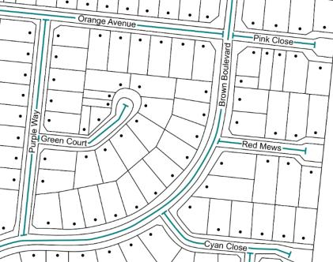
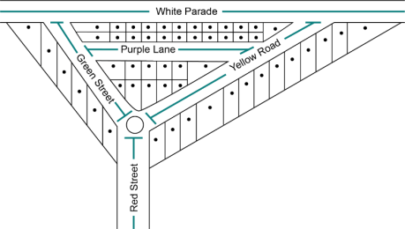
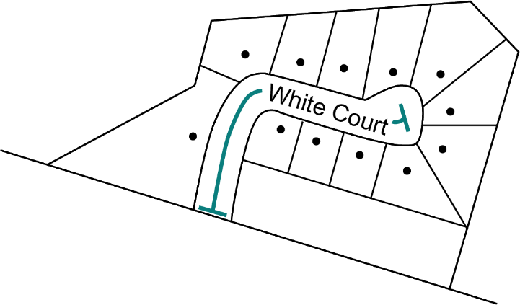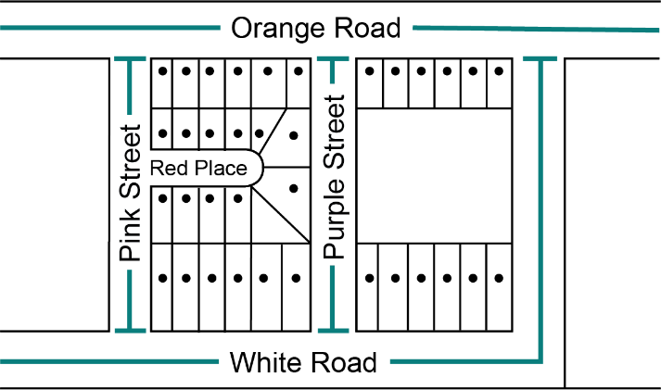
In some cases, a renaming will be proposed for only one section of a road. In these instances, the road authority must clearly indicate which section of the road will be renamed and which section will remain the same (usually with an annotated and, possibly, dimensioned map or schematic diagram). Renamed roads should have a naming proposal created and submitted to GNV. An error or past amendment not represented in Vicmap or VICNAMES should be submitted via the Vicmap Editing Service (VES).
If a proposed road is being constructed in multiple stages as part of a multi-lot subdivision development and the proposed road has been constructed at either end but the middle section is yet to be built, both ends of the road should have unique names applied. When the middle section of road is constructed, the two unique road names should extend from their datum points (refer to APPENDIX D) until they meet at a cross road on the newly constructed middle section.
If one name is to be assigned to the completed road, renaming of the two unique roads and renumbering should take place to recognise the full extent of the road.
Note: any current or pending residents and landowners should be advised of the plan to rename the road in the future and possible renumbering implications.

3.2.3 Road types
All roads must have a road type assigned that suitably describes the road’s characteristics. The road type must be selected from the list of acceptable road types provided in APPENDIX A. The list of road types is compliant to AS/NZS 4819:2011 Rural and urban addressing.
In new estates, road types can be chosen with the ultimate estate configuration in mind. For example, a road that is initially a cul-de-sac may be given an open-ended road type if it can be demonstrated that the road will eventually become a through road.
Road types must not be used to distinguish different roads of the same, similar sounding or spelt names. For example, the roads White Street, White Crescent and White Lane are considered duplications and are unacceptable. The same applies to, Whyte Street, Wite Crescent and Wyte Lane (or similar combinations).

3.2.4 Unacceptable road names
There are many road names within Victoria that today would not be allowed. The following are examples of unacceptable road names.
- Use of the definite article ‘the’ is not acceptable for sole use as a road name (for example, it is not acceptable to name a road The Avenue).
- Road types are not to be used in the formation of a road name (for example, Back Street Road, Arcade Walk, Track Way or Boulevard Street are not acceptable).
- The use of numerals is unacceptable, either in full alphabetised or numeric format because of the possible confusion between the road name and address number (for example, Four, Fourth, 4 or 4th are unacceptable).
- A prefixed or suffixed extension of the name is not to be used as part of a road name, for example, upper, lower, little, old or new and the cardinal directions north, south, east and west. The only exceptions are:
- when the name is derived from a local feature such as Old Mine Hill, Upper Axedale Quarry Road or South Coal Mine Road
- when the name is derived from a locality name that uses a cardinal direction, for example, Geelong West Road is an acceptable name because Geelong West is a locality name; however, Smith South Road, South Smith Road and Lower Smith Road are unacceptable because they do not reflect a locality name.
- Destination-to-destination names, for example, Katamatite-Yarrawonga Road or Melbourne-Geelong Road are unacceptable. This is because there are too many possible aliases (for example, Katamatite Road, Yarrawonga Road; Katamatite-Yarrawonga Road, Melbourne Road, Geelong Road, Geelong-Melbourne Road and perhaps even a local name such as High Street where the road runs through a township). Therefore, a single name is required.
- Hyphens and the word ‘and’ are not to be used.
- The naming of a road after an estate, which is solely commercial in nature, is not acceptable. Refer to Principle J - Using Commercial and business names.

3.2.5 Obstructed or altered roads
If the course of a road is to be permanently obstructed or closed, due to construction of other roads or features, a new unique name must be applied to one end of the road. This is particularly important when an emergency service vehicle cannot navigate the entire course of the road from one end to the other.
It is not appropriate to apply a cardinal direction (north, south, east or west) to one or both ends of the road in these instances because community recognition of them as unique roads in the same area is limited. Emergency and postal service delivery can also be severely affected.
In the example below, some members of the community could omit the use of the cardinal directions when requesting emergency services or sending mail and this can impede the efficient delivery of these services.
The address: | 7 Smith Street South  Melbourne  Victoria 3000
Could easily be confused as these addresses: | 7 Smith Street  Melbourne  Victoria 3000 | 7 Smith Street  South Melbourne  Victoria 3000

3.3 Roads that can be named
All roads, whether they are public or private, should be named and registered in VICNAMES and Vicmap. This facilitates accurate addressing and location identification across Victoria. Therefore, any land course navigable by vehicle or foot should be officially named according to the naming rules.
Emergency services and other service providers rely on road names being officially registered and sign-posted. This ensures that a road’s location and extent is uniquely identified in the Victorian government’s spatial databases and becomes accessible to the majority of relevant organisational and public mapping products. The registration of road names also means that properties or features located on or associated with the road can be assigned suitable and officially recognised street address numbers.

Addresses allocated through the official registration process are used for emergency and other service provision, as well as for the distribution of emergency warning notices to mobile and landline phones. Emergency and other services are often impeded from accurately locating residents and businesses when road names are not registered and addresses are not officially allocated.
Other than public roads, the following are some examples of roads that should be named and registered: access tracks to points of interest including rivers or levees, service roads between or behind buildings and private roads that give access to plantations or multiple properties.
Note: Driveways or common property do not need to be named if the sites themselves are addressed to the main road. Exceptions can be made when benefits such as improved public safety or delivery of goods and services can be expected.

3.4 Who can name roads?
Subject to the provisions of the Local Government Act 1989, Local Government Act 2020 and the Road Management Act 2004, the main road naming authorities (road authorities) in Victoria include:
- Councils
- Head, Transport for Victoria
- State government departments or agencies (including Port of Melbourne, Alpine Resort Management Boards, Places Victoria and Parks Victoria).
Both the Road Management Act 2004 and the Local Government Act 1989 Schedule Ten allow for road authorities to name roads and publish gazette notices informing of official road naming. However, these Acts state that, in all instances, the road authorities must act in accordance with the naming rules (refer to Section 1.1).
Typically, GNV gazettes roads on behalf of a council. When road authorities publish a gazette notice, the authority must act in accordance with the naming rules.
Importantly, road authorities must seek the Registrar’s endorsement for the proposed road name prior to publishing a gazette notice. Information on the processes and procedures required to be undertaken prior to gazettal are provided in Section 10.
Private road naming can be initiated by an owner, developer, emergency service provider, council or public interest group; however, the registration of the name is a process that needs to be completed by the relevant naming authority. Details on the naming processes and procedures for private roads are outlined in Section 3.9.
Naming authorities should lodge the proposal with GNV using VES. This online facility allows for the easy submission and tracking of proposals from the naming authority through to the Registrar and on to the Department of Environment, Land, Water and Planning’s (DELWP) Land Information and Spatial Services (LISS). Details on how to register for and use VES are on the website.
If a naming authority discovers a mistake with a road name, for example, the name is correct in the gazettal and incorrect on the map base, then a VES request should be submitted to Vicmap to correct the mistake.
Note: if residents have been advised of the incorrect name and that name is in use, then changing the name may require a naming proposal to be lodged. Refer to Section 7.2.3 Determine who should be consulted.

3.5 Roads with more than one naming authority
A checklist that naming authorities can use to prepare a proposal for the Registrar’s endorsement is available in APPENDIX C.
Naming authorities own or maintain numerous roads and sometimes share the responsibility for their maintenance with council, government departments and authorities.
If the road is situated across two or more municipal areas, the collaborating naming authorities should engage with staff from the respective organisations and coordinate the proposals based on these naming rules. They may contact GNV for advice and coordination assistance or consider referring a proposal to a Geographic Place Names Advisory Committee.

3.6 Council coordination of public roads’ naming
A checklist that councils can use to prepare a proposal for the Registrar’s endorsement is available in APPENDIX C.
Road type changes may not require a full consultation exercise, contact GNV for advice (Refer to Section 7.2.3).
Refer to Sections 6–14 for information on how to prepare a proposal.

3.7 Government department or agencies coordination of public roads’ naming
A checklist that government departments and agencies can use to prepare a proposal for the Registrar’s endorsement is available in APPENDIX C.
State government departments and authorities should follow the procedures outlined in these naming rules. Further information regarding initiating a proposal is covered under Section 6.1.5.

3.8 Naming roads in new residential or commercial subdivisions
New road names in new residential or commercial subdivisions are entered using SPEAR. SPEAR is an acronym for Surveying and Planning through Electronic Applications and Referrals. The system allows registered users to process planning permits and subdivision applications online, including the submission of associated road names and addresses.

3.8.1 Responsibility for naming roads in residential or commercial subdivisions
Road naming within plans of subdivision is usually the developer’s role, although land surveyors often help to choose names and add them to the plans of subdivision. It should be noted that plans of subdivision need to be approved by the responsible road naming authority. This is the responsibility of the council or state government department or agency charged with approving the subdivision plans.
The developer and road naming authority are encouraged to work collaboratively to develop compliant road names for the subdivision.

3.8.2 The naming process
Prior to council certification, developers should consult the road naming authority when preparing plans of subdivision. This consultation may incorporate discussion of possible names for roads in the area and whether the road naming authority might suggest suitable themes (such as Traditional Owner heritage, ANZAC-related or other local historical events or figures) for the developer to consider.
Developers and land surveyors must ensure that road names included on plans of subdivision, for the purposes of certification, conform to these naming rules. Failure to comply with these statutory requirements may result in a name needing to be changed either prior to or after registration of the subdivision.
Further information is available from the Quick reference guide for land surveyors.
Further information on compliant road types is available in APPENDIX A.
During the certification stage of the subdivision process, the road naming authority or subdivision approval and certification body must ensure that the road names allocated to the plans conform to the naming rules. If any of the parties believe that one or more of the road names do not conform, it should seek to have the land surveyor, in consultation with the developer, change the unsuitable names to ensure compliance.
The naming of common property can be beneficial for the provision of emergency services and delivery of goods and services. If common property is to be named, the name should be added to the plan of subdivision in brackets for example, (Sandy Road). The plan should clearly indicate that the area being named is common property. In addition, on the cover page within the notation it should state ‘Common Property 1 consists of a private road named Sandy Road’.
When plans of subdivision are lodged for registration with Land Use Victoria, an audit of the road names may be undertaken by GNV. If GNV determines that the road names on a lodged plan do not conform to the naming rules, GNV will send a request to the subdivision approval and certification body for the non-conforming names to be changed.
GNV will not be responsible for any costs associated with changing or amending plans of subdivision.

3.8.3 Entering subdivision road names into VICNAMES
Once a plan of subdivision has been registered, the road names are entered into VICNAMES. Notification of registration is not formally supplied by the Registrar. Entering the names into VICNAMES acts as a de-facto notification system.

3.8.4 Road name history
The road name history form enables naming authorities to ensure preservation of our cultural heritage and can be uploaded to SPEAR with a plan of subdivision. Typically, one form may be used per plan of subdivision. Those looking to name multiple roads should liaise with the appropriate road naming authority to discuss the most efficient way to provide the information.
A certifying authority may require the completion of this form prior to any approval of the plan, then the developer or land surveyor may be compelled to comply.
Providing detailed historical information will assist the approval process for the road naming authority. Also, if GNV chooses to audit the plan of subdivision, the information provided will help ensure that the name is appropriate and complies with the naming rules.
When the name has been officially registered in VICNAMES, the road naming authority or land surveyor should submit the historical information to VICNAMES. This will ensure the history behind the name is recorded.

3.8.5 Maintenance and responsibility
Naming a road in a new subdivision, when the maintenance of that road is the responsibility of the developer and/or private land owners, does not imply or transfer responsibility for road maintenance to the road naming authority (council or state government department or agency) processing the naming proposal.

3.9 Naming private roads on private property and within complex sites
A checklist that can be used to prepare a proposal is available in APPENDIX C.
The irregular and ungoverned naming of roads within complexes can lead to problems for emergency and other service providers, especially when the names do not conform to these naming rules and/or are not officially registered.
This section outlines the process for naming roads located on private properties for addressing or navigation purposes. Private roads include (but are not limited to) roads in commercial logging sites, caravan parks, lifestyle villages, retirement villages, apartment complexes, shopping centres, schools, universities, hospitals, industrial estates or closed-gate communities. Refer to Section 3.9.4 Complex site addressing program for further information.
Private roads should be named and registered. It is particularly important if:
- the road gives access to one or more properties that cannot be assigned an unambiguous urban or rural address using the name of other public roads to the property
- the road provides a traffic thoroughfare between two other roads
Roads on private properties are not usually open to public access (but this is not always the case) and, sometimes, they have restricted access through security gates. Even though these roads are not generally accessible by the public, they are usually named to allow for easy navigation within the complex.
If a road on private property does not have a name registered in VICNAMES, the official address for residences or businesses the primary address of the complex. For example, in a caravan park, when no matter what names were applied to particular roads within the complex, all sites may have the same address (see table).
The use of primary addresses and complex addresses (see table) in these situations is not ideal; therefore, the Registrar requires the official registration of road names within complexes. Officially registering road names within complexes ensures that the details are stored in Vicmap and are therefore accessible on the majority of relevant organisational and public mapping products.
The registration of private road names also means that properties or features located on private roads can be assigned suitable and officially recognised address numbers (see table).
All sites: | Complex address: | Registered private road name:
Ms R Smith  c/o Sunshine Caravan Park  457 Green Road  Melbourne  Victoria 3000 | Ms R Smith  Site 4, Happy Street  c/o Sunshine Caravan Park  457 Green Road  Melbourne  Victoria 3000 | Ms R Smith  4 Happy Street  Melbourne  Victoria 3000

Note: street number allocation should be in accordance with AS/NZS4819:2011 Rural and urban addressing standard.

3.9.1 The naming process
An owner of a private road or complex is considered the naming authority and is advised to consult the relevant council when developing roads on their site. This consultation might incorporate a discussion of possible names for roads if the naming authority wants to suggest suitable themes for the owner’s consideration.
Owners must ensure that road names conform to the naming rules, noting that there is no requirement to consult with the immediate community.
An owner of a complex must submit to the relevant council a plan/map for naming the roads within their property. The council will then check that the proposal conforms to the naming rules and, if suitable, send the proposal to the Registrar for endorsement.
If it can be shown that the proposed name will cause an issue for emergency or other service providers, the name must be changed within 90 days of receiving a request from the naming authority or the Registrar or the complex owner must outline to the Registrar their intended action to redress the issue.
If it can be shown that the name will cause an issue for emergency or other service providers or is determined to be offensive or derogatory, the name must be changed when requested by the Registrar. The Registrar will offer advice on how to amend the name in compliance with the naming rules. The naming authority or the complex owner must change the name to a compliant alternative within 90 days of receiving the Registrar’s request advice, or outline to the Registrar the intended action to respond to the Registrar’s direction.

3.9.2 Entering a private road in VICNAMES
Typically the council on behalf of the private owner will lodge a request using VES to have the private road name gazetted and registered.
When considering the proposal, the Registrar will check that the proposed name(s) conform(s) to the naming rules. If the Registrar deems that the proposal conforms to the naming rules, GNV will gazette the proposed name and have the name registered in VICNAMES.
If the Registrar deems the proposal non-conforming, the proposal will be returned to the council with a request for further information or advice about how the proposal should be redesigned for future consideration and registration.

3.9.3 Maintenance and responsibility
Registering the name of a road in a private property or complex, when the maintenance of that road is the responsibility of the land owner or body of management, does not imply or transfer responsibility for road maintenance to the road naming authority (council or state government department or agency) processing the naming proposal.

3.9.4 Complex site addressing program
Victoria has a complex site addressing program, more information can be found online.
For further information on initiating a naming proposal, refer to Sections 6–14 of these naming rules.

Section 4 Features

4.1 What is a feature?
A feature is considered to be a unique geographical place or attribute that is easily distinguished within the landscape. For example, a feature can be a mountain, watercourse, building, prominent structure or park.
A list of features accepted for registration and included in VICNAMES can be found on the Land.Vic website.

4.2 Statutory requirements applied to features
Naming authorities must ensure that a naming proposal conforms to all relevant principles outlined in Section 2, as well as the requirements outlined in Section 4 below, specifically Sections 4.2.1–4.2.4.

4.2.1 Feature type
The feature type should be included in a feature’s name and located after the unique feature name. This is to minimise possible confusion over the feature type to which the name applies. For example, the naming of Waterlands Park enables users to understand that the feature Waterlands is parkland.
An exception to this is the use of Traditional Owner names or words if the Traditional Owner name already includes details of the feature type. For example ‘wonguim willum’ would not be named wonguim willum Place as ‘willum’ means place in Wurundjeri woi wurrung language.

4.2.2 Waterways
For the purposes of complying with these naming rules, it is necessary for naming authorities to describe in exact detail the full extent of any waterway it is proposing to name, which will ensure official records are unambiguous.
The name of a waterway must be applied from the beginning of the watercourse to its confluence with another waterway or body, but not including` tributaries.
The naming of waterways may have implications under the Aboriginal Heritage Act 2006 and the Aboriginal Heritage Regulations 2018.

4.2.3 Locational names
If choosing a name based on location, the feature should be given the name of the official locality. If the name of a locality is used to define and locate a feature, for example, Ballarat Avenue of Honour, the locality’s name should appear first in the feature’s name.
The names of neighbourhoods, residential estates and subdivisions should not be applied to a feature. The reason for this approach is that if many features are named after a local estate or neighbourhood rather than the official locality, there can be public confusion about the official addresses in the area.
For example, an unnamed reserve located within an estate known as Blue Water Lakes within the locality of Smithurst should not be proposed with the name ‘Blue Water Lakes Reserve’. Instead, the name ‘Smithurst Reserve’ should be proposed or, if this is already in use, another name should be chosen (perhaps one that commemorates a local historical event or person).
For example, it is not appropriate to name a piece of infrastructure ‘North Yarra Community Centre’ if the officially gazetted locality is Yarra North. It is important that naming authorities preserve the officially gazetted locality name.
Refer to APPENDIX B for information about duplicate names.

4.2.4 Base names
Features named under private sponsorship contracts that will attract high visitor numbers (such as sporting stadiums or concert halls) should also, for the purposes of emergency service management, be assigned a ‘base name’. The purpose of the base name is to provide a consistent name over the feature’s lifespan, particularly when the private sponsorship name may change.
An example is the sporting stadium in Melbourne’s Docklands. Originally named Colonial Stadium, then Telstra Dome, then Etihad Stadium followed by Marvel Stadium, the base name is considered to be Docklands Stadium. The sponsorship names would be recorded in VICNAMES only at the time the sponsorship contract applies, after which time the name would be converted to historical status. Sponsorship names are not gazetted, the base name would be gazetted and registered in VICNAMES for the feature’s lifespan.

4.3 Features that can be named
The Registrar requires that naming authorities given the task of naming public and private features adhere to the naming rules because it is important to ensure that features in Victoria are clearly and unambiguously named, especially for emergency and other service reasons (a full list of features can be found on (Land.Vic website).
Information contained in VICNAMES is considered the definitive data source for geographical names information and is distributed regularly to a nationwide network of emergency service, postal, and spatial information and mapping agencies.
Providing details to the Registrar of publicly and privately named features ensures that all relevant organisations are aware of the existence and locations of features and the correct spelling of their names.

4.3.1 Undersea feature names
Undersea features within the three-mile nautical limit may be named by relevant naming authorities within Victoria. Outside of this limit there are specific processes in place to deal with the naming of undersea features. Should you require further advice please contact GNV.

4.3.2 Unregistered feature names
Unregistered feature names are names of features that have been named by a naming authority and/or are locally known but are not officially registered nor have been added into VICNAMES. Naming authorities are encouraged to register these features. Naming authorities requiring further information should contact GNV for advice. GNV will determine whether the names are gazetted and what status is applied to the names in VICNAMES.

4.3.3 Cemeteries
A cemetery is a place for the internment of bodily remains and cremated remains. Responsibility for naming cemeteries resides with the Department of Health and individual cemetery trusts. For further information about amendment to or creation of a cemetery name, contact the Cemetery Sector Governance Support Program Department of Health on 1800 034 280 or email cemeteries@health.vic.gov.au.

4.3.4 Early childhood centres
Early childhood centres may be named by naming authorities and officially gazetted and registered by GNV. GNV does not gazette and register service names, for example the early childhood service operating from the centre. If the centre’s name is the same name as the service operating from the centre, the name will need to be officially approved by the Department of Education and Training prior to a formal naming proposal being lodged with GNV.
For further information (including the approval status of children’s services operating under the Children’s Services Act 1996 (for example, occasional care or limited hours services), please contact the Quality Assessment and Regulation Division, DET on 1300 307 415 or email licensed.childrens.services@education.vic.gov.au.

4.4 Who can name features?
Naming authorities (refer to Section 1.5.2), companies and people who own or maintain a feature considered to be of public interest (such as a park, reserve, pavilion, sports stadium, concert hall, vineyard or a prominent structure) may name features and are required to submit the details of the feature’s extent and location along with background information on the name via VES or in writing to the Registrar. Upon consideration of this information, the Registrar will determine appropriate action – whether to gazette and register or record the name in VICNAMES and provide information to all relevant stakeholders (as detailed in Section 13).
Features named under private sponsorship contracts that will attract high visitor numbers (such as sporting stadiums or concert halls) might also, for the purposes of emergency service management, be assigned base names. The base name may be determined by government, a private entity or GNV (refer to Section 4.2.4).

4.5 Features with more than one naming authority
A checklist that naming authorities can use to prepare a proposal for the Registrar’s endorsement is available in APPENDIX C.
Naming authorities own or maintain numerous public features such as parks, reserves, picnic areas and bridges. A list of features to be included in VICNAMES and the relevant naming authorities can be found on the naming rules page on the Land.Vic website.
If the feature is situated across two or more municipal areas, the collaborating naming authorities should engage with staff from the respective organisations and coordinate the proposals based on these naming rules. They may contact GNV for advice and coordination assistance or consider referring a proposal to a Geographic Place Names Advisory Committee.

4.6 Council coordination of feature naming
A checklist that councils can use to prepare a proposal for the Registrar’s endorsement is available in APPENDIX C. Refer to Sections 6–14 for the process steps in preparing a proposal.

4.7 Features with government departments or agencies as the naming authority
A checklist that government departments and agencies can use to prepare a proposal for the Registrar’s endorsement is available in APPENDIX C.
State government departments or agencies that own or maintain public features such as schools and hospitals are the naming authorities for these features. Refer to the naming rules page on the Land.Vic website for a list of features considered to be owned or maintained by state government departments or agencies.
State government departments and agencies should follow the procedures outlined in these naming rules. Further information regarding initiating a proposal is covered under Section 6.1.5.

4.8 Features on private land
A checklist that can be used to prepare a proposal for the Registrar’s endorsement is available in APPENDIX C.
There are many features that have companies or individuals as their naming authorities. Examples include sporting stadiums and precincts, hospitals, aged care facilities, tourist attractions, entertainment complexes or shopping centres. A full list of feature types that should be included in VICNAMES is available on the naming rules page on the Land.Vic website or GNV can be contacted for more information.
Private features should be named and recorded if the feature has an unrecorded official name or a locally accepted name. The naming of features within private property is usually the role of the owner of the site in which the feature is situated. For further information refer to Section 1.7.
The irregular and ungoverned naming of features can lead to emergency response and other service provision interruptions and problems, especially when the names do not conform to these naming rules and/or are not officially registered.

4.8.1 The naming process
Owners of features on private property should contact the relevant council when considering the naming of features. This consultation might include discussions about possible names for the feature and the council may know the locally accepted name and/or wish to suggest suitable themes for the owner’s consideration.
Owners must ensure that feature names conform to the naming rules.
An owner of a feature must submit to the council responsible for the area a proposal including information available in Section 6. The council will then check that the proposal conforms to these naming rules and if suitable, send the proposal to the Registrar for endorsement. A non-compliant name should not be submitted on behalf of the owner.

4.8.2 Entering a private feature in VICNAMES
Upon receiving a proposal to name a private feature on private property, GNV will acknowledge receipt of the proposal.
When considering the proposal, the Registrar will check that the proposed name(s) conform(s) to the naming rules. If the Registrar deems that the proposal conforms to the naming rules, GNV will gazette the proposed name and have the name registered in VICNAMES.
If the Registrar deems the proposal non-conforming, the proposal will be returned to the naming authority with a request for further information or advice about how the proposal should be redesigned for future consideration and registration.
If it can be shown that the name will cause an issue for emergency or other service providers or is determined to be offensive or derogatory, the name must be changed when requested by the Registrar. The Registrar will offer advice on how to amend the name in compliance with the naming rules. The naming authority or the private owner must change the name to a compliant alternative within 90 days of receiving the Registrar’s request advice, or outline to the Registrar the naming authority’s intended action to respond to the Registrar’s direction.

4.8.3 Maintenance and responsibility
Registering the name of a feature in a private property, when the maintenance of that feature is the responsibility of the land owner or body of management, does not imply or transfer responsibility for a feature’s maintenance to the council that is processing the naming proposal.

4.9 Features with Traditional Owner names
Any proposal to use Traditional Owner language must seek approval from the relevant Traditional Owners.
There are numerous features in Victoria that have Traditional Owner names. In many instances, these features are defined differently to western concepts of place (for example, middens, rocky escarpments, sites on a mountain or beach, rocky outcrops or stone arrangements), but their names are just as important to include in VICNAMES.
Traditional Owner Group(s) including RAPs can apply directly to GNV to have their Traditional Owner language names added to VICNAMES. If approved the process involves one of the following:
- Recording the Traditional Owner language name as ‘registered’ (see Section 1.7) or ‘dual’ results in the Traditional language name being recognised as the official name in use for the feature. The name will appear on Vicmap standard maps for the area.
- Recording the Traditional Owner language name as ‘traditional’ or ‘historic’ results in the Traditional Owner language name being recognised on Vicmap standard maps and the name can be located by researchers and be used on specialised maps.
All names, regardless of their status, will be held in VICNAMES.
For further information refer to Section 6 Initiating a proposal and checking required information and Section 7.3 Developing a Traditional Owner naming proposal.
A checklist that can be used to prepare a proposal is available in APPENDIX C.

4.10 Naming features in new residential or commercial subdivisions
Feature naming within developing areas should be the role of a naming authority; although, land surveyors and developers may often help to choose names. Names must be approved by the responsible naming authority. This is the responsibility of the council or state government department or agency charged with approving the subdivision plans.
The developer and naming authority are encouraged to work collaboratively to develop compliant feature names for the subdivision.

4.10.1 The naming process
Prior to the opening of the feature, for example, a park, reserve or playground, discussions should occur of possible names for features in the area. The naming authority might suggest suitable themes (such as Traditional Owner heritage, ANZAC-related or other local historical events or figures) for the developer to consider.
Developers and land surveyors must ensure that feature name(s) conform to the naming rules. Failure to comply with these statutory requirements may result in the name needing to be changed.
The naming authority should lodge a VES proposal. A naming authority will be required to ensure the proposed name is compliant and that the feature being named appears on the cover page of the plan of subdivision under notations. For example, the notation on the cover page should state ‘Reserve 1 consists of Smith Park’. VES will require a copy of the plan of subdivision along with other information requested at submission. If multiple features are being named within a feature, you may list them in the notation. If you require further advice, please contact GNV. An audit of the feature names may be undertaken by GNV. If GNV determines that a feature name(s) lodged via VES do not conform to the naming rules, GNV will send a request to the naming authority for the non-conforming names to be changed.
GNV will not be responsible for any costs associated with changing or amending non-compliant names.
Once a feature name has been gazetted, the feature name(s) will be registered in VICNAMES.

4.10.2 Feature name history
When the feature name has been officially registered in VICNAMES, the naming authority, land surveyor or developer should submit the historical information to VICNAMES. This will ensure the history behind the name is recorded, preserving cultural identity.

4.10.3 Maintenance and responsibility
Naming a feature in developing areas, when the maintenance of that feature is the responsibility of the developer and/or private land owners, does not imply or transfer responsibility for the feature maintenance to the naming authority (council or state government department or agency) processing the naming proposal.
For further information on initiating a naming proposal, refer to Sections 6–14 of these naming rules.

Section 5 Localities

5.1 What is a locality?
A locality is a geographical area that has identifiable community and/or landscape characteristics. In urban areas, a locality is commonly referred to as a ‘suburb’. The state is divided into official localities. There are over 2,900 localities within Victoria.
Every locality should have a unique and unambiguous name. It must have recognised and registered boundaries and not overlap with other localities. A locality provides an official reference area for addressing purposes.
A named neighbourhood is not a locality because it does not have officially recognised and registered boundaries; therefore, a neighbourhood name cannot be used for addressing purposes.
A named residential estate is not recognised as a locality name, refer to sections 5.2.2 and 5.2.3.
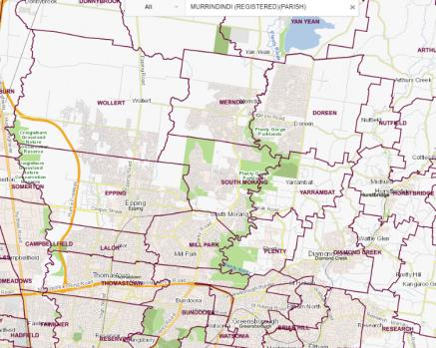

5.2 Statutory requirements applied to localities
Naming authorities must ensure that a naming proposal conforms to all relevant principles outlined in Section 2, as well as the requirements outlined in Section 5, specifically Sections 5.2.1–5.2.7.

5.2.1 Boundaries
Locality boundaries must align with the cadastral fabric, road centre lines or easily distinguishable topographical features such as waterways or ridgelines. As there are multiple options in the below examples please consider contacting GNV for advice.
The following examples must be considered.
- If major roads separate communities, the boundary of a locality should be along the road centre line. In cases of dual carriageways, please contact GNV to discuss boundary options.
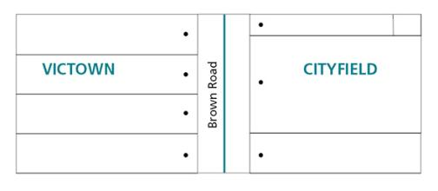
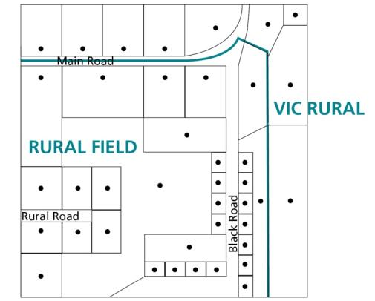

- If residents and businesses in minor roads are deemed to be part of the same community, it is advisable to place the locality boundary along the back boundary of properties facing the road.
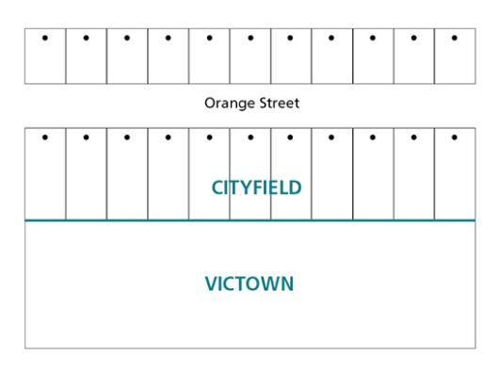
- In dead-end roads and cul-de-sacs, the locality boundary should wrap around the properties at the end of the road so that all properties accessed from the same road are addressed to the same locality.
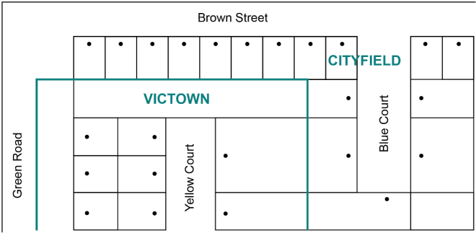
- The locality boundary for corner blocks should be the same as those for neighbouring properties accessed from the same road. There are four options for the location of boundaries, as shown in diagrams a, b, c and d below.
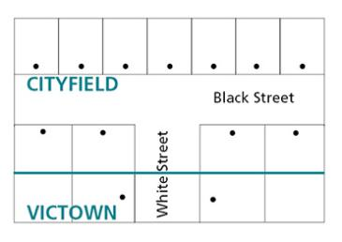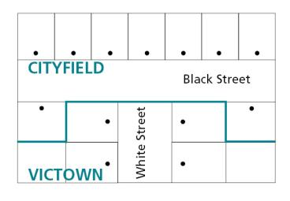
Diagram a. Diagram b.
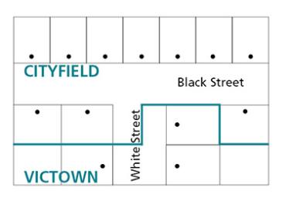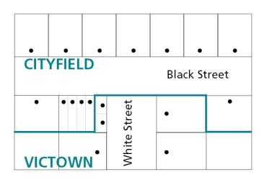
Diagram c. Diagram d.

Diagram a. shows how boundaries should be applied to properties on corner blocks accessed from Black Street.
Diagram b. shows how boundaries should be applied to properties accessed from White Street.
Diagram c. shows how boundaries should be applied to properties where one corner block is accessed from Black Street and the other is accessed from White Street.
Diagram d. shows one option on how to apply a locality boundary where multiple shop fronts or residences on one property have access to both Black Street and White Street.

- If a property is situated on a corner and the block is subdivided with one or more of the new properties accessed from a road generally being addressed to a different locality, the locality boundary should be changed to incorporate the new subdivided properties.
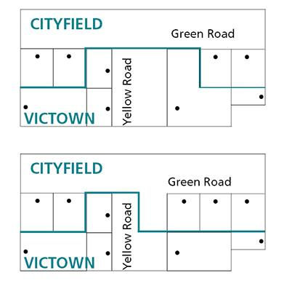
- Locality boundaries should take into account the location of battle-axe properties. Where a property is accessed through a right-of-way or private roadway from a road that forms part of a locality boundary, the locality boundary should incorporate the battle-axe property.
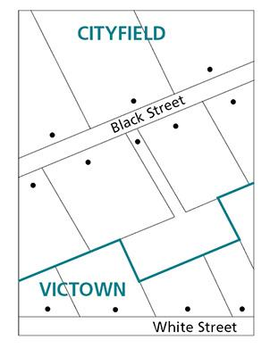
- If a natural feature such as a waterway or ridgeline is to be used as the boundary for a locality, the boundary should be applied to the centreline of the feature. Exceptions to this include the Murray River, lakes, major rivers and ocean or sea boundaries. In these instances, contact GNV for advice.
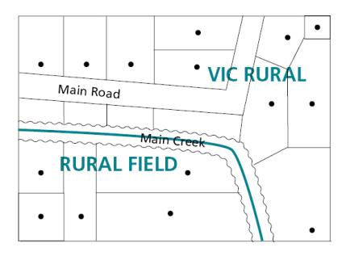
- A locality must not be defined as an island within another locality. For instance, all localities must have boundaries that run alongside two or more other localities, or one other locality and a state or sea boundary.

5.2.2 Estate and subdivision names
Estate names are often commercial in nature with the names having minimal connection to place. This is further compounded by companies set up under the estate name. Estate names that have a historical connection to place may be allowed.
Naming authorities should use their discretion as to whether an exemption request is required when wanting to name a locality after an estate. See Principle J and contact GNV for further advice.

5.2.3 Promoting a new estate
The promotion of new estates by developers and landowners must use the correct locality name. The estate name must not conflict with current locality names.
If a land development is promoted as a new locality then this could be considered to be misleading and deceptive under the Competition and Consumer Act 2010.
Precinct Structure Plan (PSP) names assigned by the Victorian Planning Authority are not to be used to create locality names unless approval is provided from GNV.

5.2.4 Size
Community areas and landscape features vary in size and it is difficult to define the recommended size of a locality.
Generally, a locality should be determined to facilitate emergency or postal service delivery. A locality should not be so small that it would make it difficult to distinguish from the surrounding area and it should not be so large that members of the public are confused about where the boundaries lie. Councils must be able to demonstrate that proposed boundaries for a locality will make sense to local residents, businesses and visitors.
A locality is an area that may contain a clear community hub that can be considered the focal point of the named locality. This sometimes consists of a shopping precinct and other economic, public, social infrastructure and provides services to the surrounding residential area.

5.2.5 Hyphens
Hyphens are not to be used in a locality’s name.

5.2.6 Local government area boundary review
Where an existing locality boundary extends across two or more local government area boundaries, the boundaries of the locality should be reviewed with the intention of aligning them within one local government area.

5.2.7 Locality names unique within Australia
Locality names must not duplicate any other locality name in Australia. For example, a new locality in Victoria should not be given the name of a locality that already exists in Queensland.
New locality names should not be similar in spelling or sound like any other existing locality names in Victoria (for example ‘White’ and ‘Whyte’) Refer to Section 2 Principle D.
Locality names duplicated in other jurisdictions and proposed for a locality in Victoria will only be considered if there is a historical connection to the area, and with an appropriate suffix. Naming authorities should contact GNV which will consider proposals on a case-by-case basis.
Naming authorities must contact GNV for national duplication checks, including checks against other state or territory reserved locality names. Typically, this process can take up to two weeks depending on jurisdictional availability. Once a unique name has been selected it may be reserved (refer to Section 5.3.2).

5.3 Who can name localities and amend boundaries?
In most instances, the administration of locality naming and boundary definition is the responsibility of the council within which the locality is situated. See below for the three exceptions to this.
- In some instances, an existing locality may cross two or more municipal areas. In this case, all affected councils need to coordinate the naming and any boundary changes. The final proposal will be assessed by a Geographic Place Names Advisory Committee (refer to Section 1.5.5).
- In other instances, an area being considered for a new locality name may lie within the jurisdiction of a government department or agency undertaking a major land redevelopment project, for example, the Victorian Planning Authority.
- Victorian islands that are often beyond the council’s area of governance. In these cases, the matter may be sent to a Geographic Place Names Advisory Committee to be assessed. Relevant stakeholders may also be consulted, including councils, state government departments and agencies and affected private landowners.

5.3.1 Creating a new locality
As the Victorian population increases, new residential and business areas are being developed. Naming authorities play an important role in ensuring that all localities are properly defined and named.
Locality boundaries should be regularly reviewed and assessed to check they adequately reflect the existing situation.
Creating a new locality allows the area’s residents and businesses to use a unique name for addressing purposes. If several major developments are proposed in an area, for example a number of subdivisions distinguishable from the surrounding landscape, naming authorities should consider creating a new locality.
GNV will work closely with council, emergency services and Australia Post to discuss any proposal to create a new locality.

5.3.2 Reservation of locality names
If there could be significant time between consulting GNV about a suitable name or names of a new locality or localities, public consultations, endorsement by the naming authority and finalising the development, the naming authority can lodge the proposed name(s) with GNV to record the name(s) online and ensure other states and territories do not duplicate the name(s). Contact GNV for more information.

5.4 Localities with more than one naming authority
A checklist that naming authorities can use to prepare a proposal for the Registrar’s endorsement is available in APPENDIX C.
If the locality is situated across two or more municipal areas, the collaborating naming authorities should engage with staff from the respective organisations and coordinate the proposals based on these naming rules. They may contact GNV for advice and coordination assistance or consider referring a proposal to a Geographic Place Names Advisory Committee.

5.5 New localities created by councils, government departments or authorities
A checklist that naming authorities can use to prepare a proposal for the Registrar’s endorsement is available in APPENDIX C.
Naming authorities should ensure that the new locality’s proposed name conforms to all of the principles outlined in Section 2 and the requirements of Section 5; in particular, linking the name to the place and not naming places after commercial interests.
Government departments and agencies sometimes undertake major land redevelopment projects. If the development is of substantial size or in a prominent position, it should consider creating a new locality to define the area.
State government departments and agencies that do not have existing tailored naming guidelines should follow the procedures outlined in Sections 6–14 of these naming rules.
The information provided in these sections should be used by government departments and agencies (for example, the Victorian Planning Authority) as a step-by-step guide to creating a new locality.

5.6 Changes to existing locality name(s) or boundaries
As communities grow, there is a need to ensure that a locality’s name and boundaries reflect community needs. A locality boundary change might be considered due to changes in the distribution of homes or businesses, or other demographic changes.
A checklist that naming authorities can use to prepare a proposal for the Registrar’s endorsement is available in APPENDIX C.
Sections 6–14 of these naming rules contain step-by-step guides to the implementation process for altering a locality name or boundary if that locality falls within one or more municipal areas.

5.7 What should not be done?
It is important to consider the following when assigning a locality name or locality boundary:
- proposed name/s should not be offensive, racist, derogatory or demeaning
- locality boundaries must not overlap any other locality boundary
- a locality should not cross municipal boundaries
- locality boundaries must not bisect properties or land – refer to the diagram below.

The below example shows how a locality boundary should not be defined. There is no clear boundary for properties on Brown Road or Orange Street.
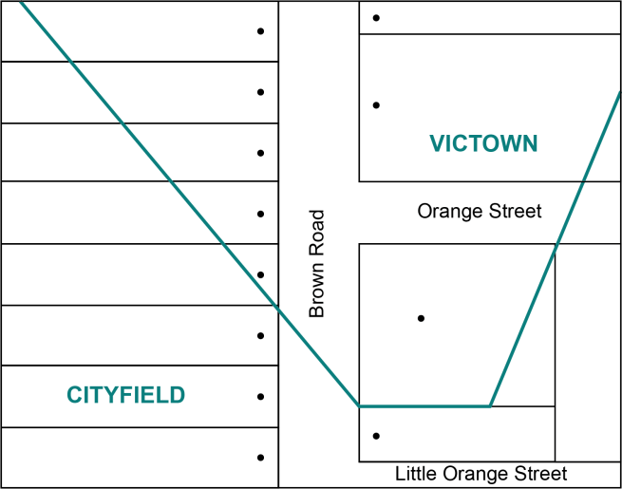
If a locality boundary is not clearly defined, the naming authority should align the boundaries to definitive and distinguishable physical features, for example, cadastral fabric, road centre lines, creeks, rivers and railways. The below example shows a compliant boundary.
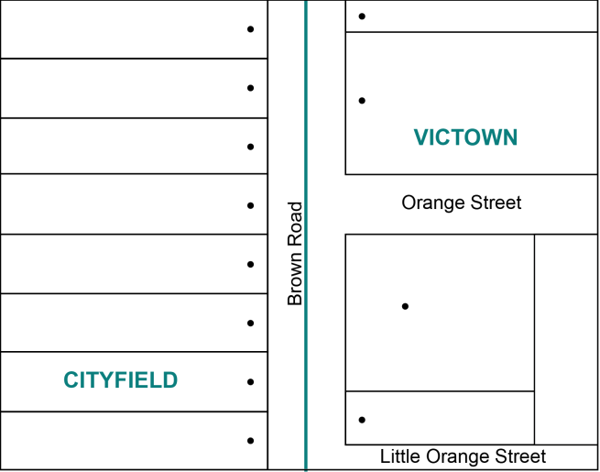

Section 6 Initiating a proposal and checking required information

6.1 Initiating a proposal
If you want to initiate a proposal to name a road, feature or locality please refer to the relevant information below. If you require further advice, please contact the relevant naming authority or GNV.

6.1.1 General public
Members of the general public and community interest groups can develop a proposal to amend a name or change the name of a road, feature or locality, including a locality’s boundaries.
The proposal needs to be submitted to the naming authority responsible for the area in which the road, feature or locality is situated. It is important to note that the council or relevant naming authority should be contacted for advice because some naming authorities may have their own naming policies or guidelines that augment these naming rules and may need to be applied.
Proposals should include:
- the proposed name
- the location of the road or feature, including a map (and, if relevant, its current name)
- background information on why the naming authority should consider naming or changing the name or boundary, for example, why the proposed name is considered appropriate (include any history or local relevance Principle C), why retaining a name may be a public safety issue.
- the reason for the proposal (a rationale should be provided why the current name is not considered appropriate or any other relevant information; names should be enduring)
- contact details of the proposer(s) and information on public consultation that has occurred and/or support and non-support that has been gathered from community members or groups
- a statement indicating the proposed name conforms to the naming rules.
A checklist available in APPENDIX C can be used to help ensure appropriate information is provided to the naming authority.
If the proposal is in the form of a petition it must include the information above. Refer to Section 8 for the requirements of a petition.
Upon receiving the proposal, the naming authority should initiate the formal proposal process detailed in Section 6.2. If a proposal is to change the name of a road, feature or locality located across two or more council administrative areas, the respective naming authorities need to coordinate the proposal’s processing. GNV can provide advice and when necessary recommend if the proposed naming needs to be referred to a Geographic Place Names Advisory Committee (refer to Section 1.5.5).
Once a naming proposal has been submitted to the naming authority, no further action is required by the member(s) of the general public or community interest group(s), unless the naming authority requires additional information or seeks to involve the public or group in the process.

6.1.2 Emergency management or other public service providers
If a request is made in the interests of public safety, the naming authority must respond to the request within 30 days, outlining intended action. Organisations that provide emergency or other services (such as postal or telecommunications) can submit a suggestion or proposal to name or change the name of a road, feature or locality to the relevant naming authority responsible for the area in which the road, feature or locality is located. The provider may only submit a proposal if it can be demonstrated to be in the community’s interest.
Proposals should include:
- the location and extent of the road, feature or locality (and if relevant its current name)
- background information on why the relevant naming authority should consider changing the existing name or registering the new name, or boundary amendments
- details on why a new name and/or boundaries are considered to be appropriate
- a statement indicating the proposed name conforms to the naming rules.
A checklist available in APPENDIX C can be used to help ensure appropriate information is provided to the naming authority.
Upon receiving the proposal from the emergency agency or other service provider, the naming authority should initiate the formal proposal process detailed in Section 6.2.
Often, emergency services or other public service providers will not provide a suggestion for the proposed new name. In these instances, the naming authority must find a suitable name.

6.1.3 Traditional Owners, Traditional Owner Group(s) and Registered Aboriginal Parties (RAPs)
Traditional Owner group(s) and RAPs can develop a proposal to have their language recorded for places in Victoria in VICNAMES – the Register of Geographic Names. Refer to Section 4.9 Features with Traditional Owner names. In addition, a naming authority may provide its written agreement to allow a RAP or relevant Traditional Owner group(s) to progress and manage the naming process in accordance with these naming rules, for example, a government department allowing a RAP to name a road or feature on Crown land.
Alternatively, Traditional Owner group(s) and RAPs can request to name a road, feature, or locality, including a locality’s boundaries.
The proposal needs to be submitted to the naming authority responsible for the area in which the road, feature or locality is situated – it is important to note that the council or relevant naming authority should be contacted for advice because some naming authorities may have their own naming policies or guidelines that augment these naming rules and may need to be applied.
Proposals should include:
- the proposed Traditional Owner name
- the location of the road or feature, including a map (and, if relevant, its current name)
- background information on why the naming authority should consider naming or changing the name or boundary, for example, why the proposed name is considered appropriate (include any history or local relevance) – see Principle C, why retaining a name may be a public safety issue
- the reason for the proposal (why the current name is not considered appropriate or any other relevant information)
- contact details of the proposer(s) and information on public consultation that has occurred and/or support and non-support that has been gathered from community members or groups
- a statement indicating that the proposed name conforms to the naming rules.
If a Traditional Owner group would like to name a road, feature or locality then they may follow the process below to submit a proposal to the relevant naming authority or GNV. Contact GNV for further advice.
Locate other names
The proposer must check whether other names are officially registered or recorded (this can be checked using VICNAMES). This will help identify the exact location of the road, feature or locality to which the proposed name will apply, and whether the immediate community uses an unofficial name.
- If an unofficial name exists, the proposer may submit the naming proposal as a dual name with the existing registered or unofficial name. There are instances where a dual name is not accepted and, therefore, the assignment of a Traditional Owner name may not proceed, for example, to avoid possible confusion for addressing or providing emergency management (refer to Principle H Dual names).
- If no other name is in use, the Traditional Owner name can be recorded as registered, traditional or historic in VICNAMES. Refer to Section 1.7 Status of names in VICNAMES and for features Section 4.9 Features with Traditional Owner names.
Verify the name
- When a Traditional Owner name has been identified, it must be verified by the relevant RAP and or Traditional Owner(s) in the area in which the road, feature or locality is located. In some instances, this might be more than one group. In all instances, the name must be verified by all Traditional Owner(s) with recognised heritage in the area (for a list of these groups refer to Section 7.3). Further advice can be obtained from First Peoples – State Relations, Department of Premier and Cabinet.).
- All relevant Traditional Owner(s) should give written consent to the name being registered for the road, feature or locality (either as a dual name or single name). If written consent has not been provided by all groups, contact GNV for further advice.
Contact the naming authority for the road, feature or locality or GNV
- The proposer typically should contact the naming authority for the road, feature or locality and submit directly to it a naming proposal, alternatively contact GNV for advice

6.1.4 Councils
Councils can generate a naming proposal in-house, including choosing an appropriate name. If a request is made of council in the interests of public safety, the council must respond to the request within 30 days, outlining intended action.
When preparing a proposal, the council must ensure compliance to the naming rules
Naming should only be considered if the council can demonstrate that the proposal is being made in the community’s best interest. Names should be enduring and changed only when necessary, for example, when causing a public safety issue and or the name is causing offense.
Councils might consider meeting on a regular basis with local interest groups (such as historical societies and charitable organisations) to develop lists of appropriate names for future use.
It is possible for a council to hold a naming competition (but not a competition for the boundaries). In such instances, the council should contact GNV with a proposed approach. GNV will provide an endorsement of the process prior to public consultation.
If the council wants to develop a naming proposal that uses Traditional Owner language, the relevant Traditional Owner group(s) and or RAP must be contacted for input at the outset of the proposal’s development.
Information on this consultation process is available from Principle E and in Section 7.3.
Once a name has been chosen and/or boundaries redefined (if relevant), councils should initiate the formal proposal process outlined in Section 6.2.
If a proposal is to name, change the name, or alter boundaries that cross municipal boundaries, the respective councils should coordinate the proposal’s processing. GNV can provide advice and where necessary recommend if the proposed naming needs to be referred to a Geographic Place Names Advisory Committee (refer to Section 1.5.5).
If there is minimal support for the chosen name, the naming authority may decide to re-consult on a new name or abandon the proposal, regardless of the proposal being compliant with these naming rules.
Note: If community support for a proposal is minimal, but the proposal has been made based on public safety concerns or that a name is offensive, the naming authority should attempt to refine and/or change the proposal so that it gains community support.
If the naming authority believes community support will not be forthcoming, then it can proceed with the proposal on the grounds of public safety or that the name is offensive (Refer to Principle F).
The naming authority may also contact GNV for advice. GNV can refer the matter to a Geographic Place Names Advisory Committee (refer to Section 1.5.5 for further information).

6.1.5 Government departments or agencies
State government departments and agencies not covered by a unique set of road, feature or locality naming guidelines should follow the procedures outlined in these naming rules.
There are three possibilities for naming roads, features or localities owned or maintained by a government department or agency, described as follows.
- The department or agency can work cooperatively with GNV to make an in-house determination on an appropriate name. This option allows for endorsement of the proposal by the Registrar of Geographic Names, the relevant Minister or a Geographic Place Names Advisory Committee, and ratification by the Registrar.
- The department or agency can develop a public consultation process, including a public competition and work with GNV to determine a final naming proposal. It also allows for the possibility of including a Geographic Place Names Advisory Committee to make a final determination on the proposal, or for the relevant Minister to make a final decision.
- The Minister responsible for the department or agency can seek a Ministerial direction by writing to the Minister responsible for the Act to request that powers under section 11(5) of the Act be excised and direct the Registrar to enter the name in VICNAMES.

6.2 Naming proposal process

6.2.1 Check information
Check all necessary information has been provided by the party proposing the name. If insufficient, request additional information within 30 days.
The decision to proceed with a name proposal rests with the naming authority.

6.2.2 Apply the naming rules
If the naming authority is not certain the naming proposal conforms to the naming rules (for instance, in cases of possible duplication or boundary confusion) the naming authority can contact GNV and if requested, seek in principle support. This process should be undertaken prior to any public consultation.
Upon selection of a name or shortlist of names and/or boundaries, the naming authority should confirm that the names and/or boundaries conform to all of the principles outlined in Section 2 and statutory requirements outlined in Section 3, 4 and 5.
A naming authority may decline to consider a naming proposal where a substantially similar application has already been decided upon by the naming authority.

6.2.3 Seeking the Registrar’s in-principle support
If a naming authority is unsure whether a name is compliant, in the first instance the naming authority must contact GNV for advice. Upon the advice of GNV you will be advised as to whether to submit an in-principle support request for the Registrar’s consideration.
In principle support can be sought using VES. It has its own workflow process and will enable GNV to review the information provided prior to seeking Registrar endorsement.
The type of information which is required using VES in-principle support workflow includes:
- the proposed name
- key aspects of the naming proposal
- why the naming authority requires in principle support
- agreement that the name complies with the naming rules
- agreement that lodgement is according to Section 10 of these naming rules
- if it is a renaming proposal and an explanation for renaming
- if the name is a Traditional Owner name
- if it is a commemorative name, consent from known family members, if available
- a map showing the extent of the road, feature of locality to be named
- historical information, reasons for the chosen name and supporting documentation
- a duplication search on VICNAMES
- if the road has an alias.

The following process flow chart details the formal process in its entirety.
1
2
3
4
5
6
7
8
9
Prepare a naming proposal – refer to Section 6.
Naming authority develops a consultation strategy – refer to Section 7.
Analyse feedback from the community and respond to any objections – refer to Sections 7 and 8.
Naming authority considers the naming proposal and ratifies, as necessary – refer to Section 9.
Naming authority lodges the proposal with GNV for consideration by the Registrar – refer to Section 10.
The Registrar considers the naming proposal – refer to Section 11.
If compliant, the Registrar gazettes the name – refer to Section 13.
If not compliant - refer to Section 6.
GNV registers the name in VICNAMES and sends out notification – refer to
Section 13.
The naming authority installs signage and updates the history behind the name in VICNAMES – refer to Section 14.

Section 7 Consultation
Consultation is a key component in the process of naming roads, features and localities. Naming authorities typically consult the public on any naming proposal and must comply with the minimum requirements under Section 7.1, where relevant.
Naming authorities must act in accordance with Section 7 of these naming rules or as agreed in writing with GNV.
The level and form of consultation can vary depending on the naming proposal. The following procedure may be used for the naming of all roads, features and localities in Victoria, whether private or public.
There are two types of community groups to consult regarding a naming or boundary change proposal:
- The immediate community, which broadly includes people who live and work within the area and owners of properties or businesses; in particular, residents, ratepayers and businesses within the immediate area directly affected by the proposal.
- The extended community, which includes residents, ratepayers and businesses surrounding the area directly affected by the proposal; in particular, any visitor groups to the area such as shoppers, tourists, recreational or dining visitors; government (for example neighbouring councils) or non-government organisations with an interest in or who service the area, including Traditional Owner group(s), RAP’s, local historical societies and eminent individual historians; service clubs such as Lions and Rotary Clubs, Country Women’s Associations, farmers groups, school parents associations, Probus clubs, senior citizens centres, ethnic associations; Emergency Services Telecommunications Authority (ESTA) and Emergency Service Organisations (ESO).
Note: This section does not apply to the naming of new roads or features within new subdivisions where currently no one is directly affected – refer to Section 3.8.
For the use of Traditional Owner names, Principle E applies – refer to Section 7.3.
In relation to a feature, if residents, businesses or ratepayers use the feature or its address will be affected, they must be consulted.

7.1 Minimum requirements
The below points must be reviewed in conjunction with Section 7.2.3 Determine who should be consulted.
- When a proposed naming or boundary change will affect current addresses, the naming authority must contact the immediate community in writing (by letter and or email) or notify the community by any other means deemed appropriate by the Registrar from time to time.
- Letters and/or emails must be sent to the ratepayers of the properties and, if the ratepayers are not the occupiers, letters or emails must also be sent to the residents and/or business occupants.
- Correspondence may include a request for input or a survey or voting poll seeking a response from the residents, ratepayers and/or businesses – refer to Section 7.2.4.
- If a naming authority needs to amend the property numbers or a road type (but not the name) then the naming authority may consider how best to engage the public. This could be a notice of its intentions or a more formal consultation exercise.

- Consultation on proposed names with the immediate and/or extended community should only occur once the naming authority is certain that the proposed name conforms to the naming rules. If the naming authority is uncertain, contact GNV for further advice or consider lodging an in-principle support request using VES. Refer to Section 6.2.3.
- Consultation with the immediate and/or extended community must be a minimum of 30 days, though may be longer.
- If the proposed new name is a Traditional Owner name, the naming authority must consult relevant Traditional Owner group(s), RAP’s from the beginning and obtain their approval. Refer to Section 7.3.
- If proposing to name a road, feature or locality after a person, then every effort should be made to gain consent from the person’s family members. Supporting evidence demonstrating the naming authority’s efforts to consult family members must be provided to GNV with the proposal lodgement. Refer to Principle I for more information.
- Objections must be addressed when they suggest the proposal does not comply with the naming rules. If it can be shown that the proposal does not conform, the naming authority must alter or abandon the proposal.

7.1.1 Government departments and agencies
The department or agency must consult the council(s) within which the road, feature or locality is or will be situated. The department or agency should seek to collaborate with the council on developing the proposal, or at a minimum inform the council of the naming plans. This will ensure the council, as the addressing authority, can assign new or altered addresses to properties on the road and/or assist with developing appropriate boundaries, consulting with the community and advising how the proposal will impact upon existing addresses in the area.

7.2 The consultation process
The consultation process by a naming authority involves six steps, which are illustrated in the diagram below:
7.2.1
7.2.2
7.2.3
7.2.4
7.2.5
7.2.6
Prepare a proposal for naming a road, feature or locality.
Develop a consultation strategy, including timelines.
Determine who will be consulted.
Build awareness of the proposal in the community and invite feedback.
Compile and analyse feedback from the community.
Inform the community of the naming authority's decision.

7.2.1 Prepare a naming proposal
Ensure that any chosen name adheres to the naming rules.
After the naming proposal has been initiated and checked that it conforms to the naming rules, naming authorities must consult Traditional Owner group(s) if the proposed name is of Traditional Owner origin.
After the initial processes have been completed, the procedures of the naming rules stipulate that community consultation is required. Refer to Section 7.2.2.

7.2.2 Develop a consultation strategy
Create a timeline and strategy for consulting the community to ensure any chosen name will have community support: who you will consult (refer to 7.2.3), how you will consult (refer to Section 7.2.4) and how you will compile the feedback (refer to Section 7.2.5). Information on each of these topics is provided below.
Preparing this information in advance means that it can be referred to in various information campaigns throughout the consultation process.
A comprehensive strategy will ensure the naming authority has a compliant process that GNV can quickly approve.

7.2.3 Determine who should be consulted
Communities that will be affected by the proposed naming or boundary adjustment of a road, feature or locality should be consulted. The naming authority must decide whether the immediate community or the extended community should be consulted or notified of a change.
- Roads: consult the owners of properties accessed from the road.
- Roads: where a road type is being changed due to public safety concerns and/or amendments to a roads extent which require a revised road type the naming authority may determine whether a notification will suffice rather than a formal consultation process.
- Features: consult any owners or managers of the feature, users of the feature, surrounding properties and people from the localities within which they fall.
- Localities: consult property owners within the current and proposed locality(ies’) boundaries and from a generous buffer zone of properties adjoining, or within 200 metres of the boundaries.
Note: When the naming authority has ensured that the proposal adheres to the naming rules, there should be no further need for consultation with emergency and other service providers. This is because the naming rules have been written in consultation with emergency services and public service providers, and have been designed to ensure that name duplication and confusion are minimised. However, naming authorities should take particular note of Section 14 regarding notification and mail delivery services for addresses on a road with a new name.
The following guide should be used to identify which members of the community to consult.
Proposal | Who to consult | Type of consultation / notification
New road | Immediate and extended community | - Letters / email  - Notices / newsletters / signs  - Surveys  - Voting poll  - Internet sites and social media  - Public meetings (if it is a large-scale proposal or potentially contentious issue)
New feature | Immediate and extended community | - Letters / email  - Notices / newsletters / signs  - Surveys  - Voting poll  - Internet sites and social media  - Public meetings (if it is a large-scale feature or potentially contentious issue)
New locality (suburb) | Immediate and extended community | - Letters / email to affected residents, ratepayers or businesses, and to residents, ratepayers and businesses in properties adjacent to the proposed new boundaries  - Notices / newsletters / signs  - Surveys  - Voting poll  - Internet sites and social media  - Public meetings (if it is a large-scale proposal or potentially contentious issue)
Renamed road | Immediate community | - Letters / email to affected residents, ratepayers or businesses  - Notices / newsletters / signs  - Surveys  - Voting poll  - Internet sites and social media  - Public meetings (if it is a large-scale proposal or potentially contentious issue)
Road type change | Immediate community | - Letters / email to notify affected residents, ratepayers or businesses
Boundary change of a road | Immediate community | - Letters / email to affected residents, ratepayers or businesses  - Notices (if it is a large-scale proposal or potentially contentious issue) / newsletters / signs  - Surveys  - Voting poll  - Internet sites and social media  - Public meetings (if it is a large-scale proposal or potentially contentious issue)
Renamed feature | Immediate and extended community | - Letters / email  - Notices / newsletters / signs  - Surveys  - Voting poll  - Internet sites and social media  - Public meetings (if it is a large-scale proposal or potentially contentious issue)
Boundary change of a feature | Immediate and extended community | - Letters / email  - Notices / newsletters / signs  - Surveys  - Voting poll  - Internet sites and social media  - Public meetings (if it is a large-scale proposal or potentially contentious issue)
Renamed locality | Immediate and extended community | - Letters / email to affected residents, ratepayers or businesses  - Notices / newsletters / signs  - Surveys  - Voting poll  - Internet sites and social media  - Public meetings (if it is a large-scale proposal or potentially contentious issue)
Boundary change of a locality | Immediate community | - Letters / email to affected residents, ratepayers or businesses, and residents, ratepayers and businesses in properties adjacent to the proposed new boundaries  - Notices (if it is a large-scale proposal or potentially contentious issue) / newsletters / signs  - Surveys  - Voting poll  - Internet sites and social media  - Public meetings (if it is a large-scale proposal or potentially contentious issue)

7.2.4 Build awareness of the proposal and invite feedback
Building awareness of the proposal is key to engaging with the community. The following methods are discussed further. Each method has its own strengths and, prior to selecting one or more of the methods, naming authorities should consider the proposal’s aims and desired outcomes of community consultation. For example, a survey is conducted to investigate opinions; a voting poll is used to make a choice for one or more options.
The following methods can be used to build awareness of the proposal and invite feedback. Each one has its own advantages and conditions of use:
- Notices / newsletters / signs
- Letters / emails to the immediate or extended community
- Surveys (for use only with the immediate community)
- Voting poll
- Internet sites and social media
- Public meetings.

Notices / newsletters / signs
This includes newspapers (including local and Traditional Owner newspapers), signs, social media and radio and television. If an advertisement is to be placed and the naming authority wants to minimise costs, it is possible to place an advertisement or notice with the basic details and refer readers to a website, phone number or council office for further details. The minimum requirements for notices are outlined below and shown in the second example notice. A reduced cost advertisement is shown in the first example notice. If using the first example, then all the information in the second list of dot-points below must be available online.
Advertisements in local newspapers alone are generally insufficient to draw people’s attention to a proposal. In addition to advertisements, notices / signs can be placed in public places, for example:
- at the site to be named
- council offices
- libraries and other council facilities
- TAFEs, universities and other education centres
- community centres and learning exchanges
- shops with community noticeboards such as newsagents, bookshops, supermarkets, organic food stores
- community notice boards
- tourist information centres
At a minimum, these notices must include the following, or the information must be available online:
- the proposed (new) name/boundary and why it has been nominated
- where the road, feature or locality is located
- information about how to provide feedback – at a public meeting (give date, time and venue); or, by phone (provide phone number), mail (include address), or email (include email address and the website’s URL)
- The required date for response, within 30 days of the notice.
Alternatively, if there is no proposed name, notices must include:
- steps for nominating a name or names (in compliance with these naming rules)
- details of how the community can have input into endorsing or selecting a name (for example, through a vote)
- information about how to provide feedback – at a public meeting (give date, time and venue); or, by phone (provide phone number), mail (include address), or email (include email address and the website’s URL).
Reduced cost format for notices
Geographic naming proposal
[Insert naming authority name here] is proposing to name a road, feature or locality or amend its boundary.
The road, feature or locality is located at [enter address and/or map].
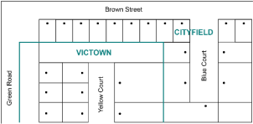
Further information about the name is available at [must provide the proposal on naming authority’s website, including URL].

Preferred format for notices
Geographic naming proposal
[Insert naming authority name here] is proposing to name a road, feature or locality, or amend its boundary.
This naming/boundary realignment is needed because…[enter in the reason for the change and any background to the name with a link to where further information can be found.]
The road, feature or locality is located at…[enter address and/or map].
Members of the public can provide feedback on the name or submit name nomination(s) by one of the following methods:
- public meeting [date, time and venue)
- phone [number]
- mail [address]
- email [address]
- website [URL].
Further information about the name is available at [must provide the proposal on naming authority’s website, include URL].
All name submissions must comply with Naming rules for places in Victoria – Statutory requirements for naming roads, features and localities – 2022.
All submissions must be received by [add date] within 30 days of this notice. [Or time frame determined by the naming authority, not less than 30 days.]
(Only include if using a commemorative name and unable to locate family members.) [Insert naming authority name here] has been unable to locate existing family members to seek permission to use the proposed name and calls for consent from the family or requests family contact details from the community.

Letters / emails
Letters / emails to members of the immediate or extended community should be clear and concise. At a minimum, they must refer to the naming rules and include the following information:
- the location and extent of the road, feature or locality proposed to be named (with a map and written description)
- the reason for choosing the proposed name
- the closing date for public feedback, which must be no less than 30 days from the date of the letter and/or public advertisement (whichever is later)
- an indication that, if the name or boundary change affects addresses, Australia Post may continue to record and recognise the old address for a period of six to 12 months to ensure a smooth transition from the old address to the new; however, it should also be stated that Australia Post might not guarantee the delivery of incorrectly addressed mail and customers should also be advised to use their official address
- a mail or email address for responses
- [Optional] If you do not respond to this letter/email it will be taken as Implied consent to the proposed name.
Example letter to community
RE: Naming/boundary realignment letter
[Insert naming authority name here] is proposing to name a road, feature or locality, or amend a locality’s boundary.
The location and extent of the road, feature or locality proposed to be named or boundary realignment [include a map and written description]
This naming/boundary realignment is needed because…[enter in the reason for the change and any background to the name with a link to where further information can be found].
Members of the public can provide feedback on the name and/or submit name nomination(s) by one of the following methods:
- public meeting [date, time and venue]
- phone [number]
- mail [address]
- email [address]
- website [URL].
Further information about the name is available at [must provide the proposal on naming authority’s website, include URL].
[Optional] If you do not respond to this survey it will be taken as implied consent to the proposed name.
Australia Post may continue to record and recognise the old address for a period of six to 12 months to ensure a smooth transition from the old address to the new; however, it should be noted that Australia Post might not guarantee the delivery of incorrectly addressed mail and customers should also use their official address.
All name submissions must comply with Naming rules for places in Victoria – Statutory requirements for naming roads, features and localities – 2022.
All submissions must be received by [add date] within 30 days of this notice. [Or time frame determined by the naming authority, not less than 30 days.]

Surveys (for use only with the immediate community)
Surveys should be used to gain an indication of community support or opposition to a naming or boundary change proposal. They should be used with the immediate community if they will be affected by an address change arising from the successful outcome of a proposal.
Typically, a survey would require re-consultation after the initial round of consultation.
If a survey is being used to gauge public opinion, tenanted properties should be afforded two responses, one response from the owner of the property and one response from the tenant of the property.
At a minimum, a survey must refer to these naming rules, and include the following details:
- a statement outlining the background of the proposal (often in the form of a cover letter)
- state that all name submissions must comply with Naming rules for places in Victoria – Statutory requirements for naming roads, features and localities – 2022
- state that all submissions must be received by (add date) within 30 days of this notice
- include the following question:
  - Do you agree or disagree with the proposal to name / adjust the boundaries of [enter name and display a map, as well as including space for respondents to include their name, address, email and phone number]?
- [Optional] If you do not respond to this survey it will be taken as implied consent to the proposed name
If the naming authority is seeking to change a name and a boundary, for example, a new locality name and a boundary change, the naming authority should include a specific question on each proposed change.
- Space for respondents to include their name, address and contact details.
Requesting a respondent’s name and address details will assist the naming authority to collate results and ensures a valid survey is undertaken.
Reponses from the community need to be clear to ascertain whether there is support for a proposal. Therefore, it may be beneficial to include the following in any survey used:
- If you do not support the proposal please indicate why and/or demonstrate why the proposal does not conform to Naming rules for places in Victoria – Statutory requirements for naming roads, features and localities – 2022.
- If you disagree, please explain why.
- If you would like to make any other comments in support of or in objection to the proposed name or boundaries, please do so.
If the naming authority has multiple proposed names, they should issue two surveys. The first should seek response from the community about their preferred name. If no response is received, then this should not be taken as implied consent to any of the proposed names.
If a preferred name can be determined from the first set of results, the community should be re-surveyed about the preferred name, and the following statement used:
‘If you do not respond to this survey it will be taken as implied consent to the proposed name’.
If after an initial or subsequent survey or vote on multiple names there is no clear preference, then the naming authority should choose a name in-house. The community must then be re-consulted and given 30 days to object to the naming authority’s preferred name.
If a naming authority is seeking to gain support from the extended community for a proposal, it should avoid using surveys and do it by publishing notices inviting written submissions. The naming authority could also consider establishing an online campaign site and facility for registering support, objections or comments (refer to the internet and social media section for further information).
Survey example
Naming/boundary realignment survey
[Insert naming authority name here] is proposing to name a road, feature or locality, or amend its boundary.
The location and extent of the road, feature or locality proposed to be named, or boundary realignment [include a map and written description].
This naming/boundary realignment is needed because…[enter in the reason for the change and any background to the name, with a link to where further information can be found].
  - Do you agree or disagree with the proposal to name/adjust the boundaries of [enter name and display a map]?
  - Agree [ ]
  - Disagree [ ]
[If the naming authority is seeking to change a name and a boundary, for example a new locality name and a boundary change, the naming authority should include a specific question on each proposed change.]
  - If you disagree please explain why.
  - If you would like to make any other comments in support of or objection to the proposed name or boundaries please do so.
[Optional] If you do not respond to this survey it will be taken as implied consent to the proposed name.
All submissions must be received by [add date] within 30 days of this notice. [Or time frame determined by the naming authority, not less than 30 days.]
All name submissions must comply with Naming rules for places in Victoria – Statutory requirements for naming roads, features and localities – 2022.
Please provide your name, address and contact details, including any comments, objections or written support of the name.

Voting poll
A formal voting poll may be used to select a name or choose between two or more names. It enables a naming authority to select a name with the most votes, subject to a naming authority’s approval.
A voting poll could be used to gain an indication of community support to a naming or boundary change proposal in the immediate community if it will be affected by an address change arising from a proposal’s successful outcome.
In the case of a voting poll being used to gauge public opinion, tenanted properties should be afforded two votes, for example, one vote to the owner of the property and one vote to the occupier of the property.
At a minimum, the voting poll document must refer to these naming rules and include the following details:
- a statement outlining the background of the proposal, often in the form of a cover letter
- one or more names or boundary proposals, including background information on each proposal
- the opportunity to object
- the following statement:
Please cast your vote by [include date]. All votes will be counted, the name with the majority of votes will become the official name of the [road, feature, locality, and/or new boundaries], subject to [insert naming authority name here] approval
- An opportunity to record the respondents name and address.
Requesting a respondent’s name and address details will assist the naming authority to collate results and ensures a valid voting poll is undertaken.
Once a vote has taken place and the responses counted, with consideration given to any objections, there is no need to re-consult as the above statement indicates that the naming authority will approve the final name – refer to Section 9. Objections must be considered and addressed, where relevant, and all those that have objected must be given the opportunity to appeal to the Registrar – refer to Section 8.

Voting poll example
Naming/boundary realignment vote
[Insert naming authority name here] is proposing to name a road, feature or locality, or amend its boundary.
The location and extent of the road, feature or locality proposed to be named, or boundary realignment [include a map and written description]
.
This naming/boundary realignment is needed because…[enter in the reason for the change and any background to the name, with a link to where further information can be found].
Only fill in one voting slip per household. Please place a tick in the box next to your preferred name. Only tick one box.
- Proposed name 1
- Proposed name 2
- Proposed name 3
Please cast your vote by [include date here]. All votes will be counted, the name with the majority of votes will become the official name of the [road, feature, locality, and/or new boundaries], subject to [insert naming authority name here] approval.
If you wish to object to the name(s) please do so by making comment below. You must explain why you do not support the name(s).
All submissions must be received by [add date] within 30 days of this notice. [Or time frame determined by the naming authority, not less than 30 days.] Please provide your name, address and contact details.

Internet and social media
Internet and social media sites can be valuable for collating all relevant information for the benefit of immediate and extended communities. A webpage can be developed within the naming authority’s existing website or as an additional page with its own domain name. Social media sites such as Facebook, and Twitter can also be useful tools.
Websites also enable members of the extended community to lodge expressions of support or objection to a naming or boundary change proposal. They are also a practical facility for a naming competition.
When a website is used as a platform for a naming proposal, clear information must be provided about the requirement for names to conform to the naming rules.
Typically, internet and social media complement other means of community engagement, for example, letters, emails, public meetings etc.
At a minimum, websites promoting a naming or boundary change proposal or competition must include the following information:
- background to the proposal
- maps indicating the location and extent of the road, feature or locality
- the closing date for submissions
- information about how expressions of support or objection can be lodged
- details on how and when a naming proposal will be lodged, if relevant
- reference and links to these naming rules.

Public meetings
If it is considered necessary, a public meeting could be held. The need for this depends on how important the road, feature or locality is to the community and how controversial the naming/boundary change might be.
If a public meeting is held then it should be organised and chaired by the naming authority. Consideration must be given to the location and timing of any public meetings so that those in full-time work can attend.
The venue should be acceptable and accessible to all sections of the community and held at an appropriate time to maximise public attendance and views on the proposal.
If one or more public meetings are held, a reasonable amount of time between the last meeting date and the closing date for feedback submissions should be provided. This will give people time to think about the issue; talk it over with their families, colleagues and friends; and give feedback to the naming authority by letter, email, social media or through the website.
Comments made at the meeting should be noted by a minute-taker and passed onto the naming authority for analysis and consideration.
If the awareness campaign results in some people from the community being opposed to the proposed name, members of the community may present a case against the name. If this occurs, care must be taken to take notice of concerns and determine to what extent the group is representative of the immediate community.
It may be that the group represents particular interests that may not align with immediate community values. The only time a group can be seen as representative of the whole community is when the community elects’ representatives to act on its behalf, specifically on the subject of a naming proposal.
Existing groups that have been formed for other purposes (for example charity or special interest groups) and generally represent a small proportion of the community, cannot speak on behalf of the immediate community. However, if groups have discussed the issue at a general meeting with a vote taken to make a submission, this may be submitted to the consultation group for consideration.
If there is opposition, a new proposal may be put forward. In this instance, the naming authority will need to recommence the naming proposal process and should consider any impacts on public safety if left unchanged. Refer to Principle A and Sections 6.1.2; 6.1.4 and 8.4.1.

7.2.5 Analyse feedback from the community
To assist in analysing the feedback, it is recommended that a spreadsheet or other analytical tool be developed to collate and organise the information. The itemised list of feedback should include:
- the source of the feedback (whether it is an individual or a community organisation, protest group, business or government department or authority)
- positive or negative responses to questions posed on the surveys or other methods, such as social media responses
- alternative suggestions provided by respondents.
All feedback must be considered by the naming authority.
If the community was consulted on one name or boundary amendment, the proposal by the naming authority has the support of the community and any objections have been addressed, then the proposal can be considered by the naming authority. Refer to Section 8 and Section 9 .
Note: Obscene, offensive and/or racist submissions are not valid objections.
Refer to Section 8 – Submissions and objections for further information.

7.2.6 When to re-consult
When the naming authority has surveyed the community to establish a set of suitable or preferred names or boundaries, the community must then be re-consulted on the final determined name/boundaries for the proposal. Any preferred names sent out to residents, ratepayers and businesses by the naming authority must comply with the naming rules.
Proposals where re-consultation has not taken place (will be rejected by the Registrar as not conforming to the naming rules. Exceptions to this include:
- the use of a voting poll, when a naming authority tallies the results and makes a decision
- if an alternative process is agreed in writing with GNV.
The consultation process may generate a list of possible names. Naming authorities should collate this information and determine if these names could be shortlisted and formed into a proposal to reconsult. Checks on whether the name(s) conform must be undertaken before they are formed into a proposal for re-consultation with the community. The naming authority may determine that any additional names supplied during consultation may be reserved for future use.
Further consultation will require one of the methods under Section 7.2.4 be used to determine support for the final proposed name.
The naming authority must continue to consult until a decision on one name is reached. Refer to Section 8.5 Notifying submitters and objectors.
Note: If the community has been notified that, dependant on community support, the proposed name will be sent to the naming authority for endorsement, the naming authority can then consider the community informed of its decision. All objections must be considered and addressed (if relevant) by the naming authority. Objectors should be advised they can appeal to the Registrar of Geographic Names about the naming authority’s decision.
If the naming authority receives objections during the consultation process and decides to uphold the objections, it can choose to abandon, refine or change the proposal to ensure it conforms to these naming rules. If the naming authority decides to refine and/or change the proposal it must then undertake another round of community consultation to determine community support.

7.2.7 Implied consent
Implied consent is a way for the naming authority to help ensure a result can be achieved from the use of a survey, letter or email. Implied consent should only be used when the naming authority is seeking responses from the community for one proposed name. The naming authority can determine when to use implied consent.

The process for consultation and re-consultation is detailed below.
1
2
3
4
5
6
7
8
Naming authority seeks a name for a road, feature or locality.
Multiple names are received.
Naming authority shortlists the names after checking for compliance.
Multiple names from shortlist sent to the community for re-consultation.
Community indicates preference on a number of names OR community informed the name with the most votes will be chosen.
Naming authority selects the name with the most votes.
Naming authority re-consults on the final preferred name (if community not informed that the name with the most votes will be chosen).
Naming authority analyses the community feedback and decides whether to lodge a proposal.

7.3 Developing a Traditional Owner language naming proposal

7.3.1 Introduction
Victoria’s rich Traditional Owner history, with over 38 Traditional Owner languages, represents diversity in culture, heritage and connection to Country. Naming with Traditional Owner languages is an ideal opportunity to connect a name to a place and to support Traditional Owners in the promotion of Traditional Owner languages.
Consultation is a key component in the process of naming roads, features and localities. To use Traditional Owner language, relevant Traditional Owners must be engaged and provide their approval for use of their language. The naming authority must collaboratively work with the Traditional Owner group(s) to determine the best approach in formalising a name.
DELWP has its own Traditional Owner and Aboriginal Community Engagement Framework, which can be viewed online.
The use of Traditional Owner languages may be considered intangible cultural heritage under the Aboriginal Heritage Act 2006. There may be restrictions and/or requirements for the use of language and any intellectual property issues relating to the use of the word should be considered and respected.
While there is a diverse range of Traditional Owner organisations in Victoria – Traditional Owner networks, health organisations, arts organisations and local advisory groups – naming proposals should be directed to the relevant Traditional Owner group(s). In Victoria, Traditional Owner groups may be legally recognised through the Native Title Act 1993 as native title holders, the Traditional Owner Settlement Act 2010 as traditional owner group entities or the Aboriginal Heritage Act 2006 as Registered Aboriginal Parties.
For more information about Native Title and Traditional Owner Settlements, visit the Department of Justice and Community Safety Native Title site.
For more information on Registered Aboriginal Parties, including contact details, visit the Victorian Aboriginal Heritage Council’s, Victoria’s current Registered Aboriginal Parties.
In areas where a Traditional Owner group has not been legally recognised, please contact Aboriginal Victoria for advice about the relevant groups to consult.
Naming authorities wishing to name a road, feature or locality using a Traditional Owner language
should consider following the steps below.
1
2
3
4
5
Identify a road, feature or locality to be named.
Determine Traditional Owner group/s to participate in consultation process.
Collaboratively discuss with the Traditional Owner group/s how they want the process to run.
Build awareness within the local community.
Review feedback from the local community.

7.3.2 Preparing a naming proposal
Initially, the naming proposal must be prepared according to the relevant sections of these naming rules. Preparation will include identifying the road, feature or locality that is to be named and considering what type of naming process would be suitable.
If a naming authority is considering using a Traditional Owner name or names in the proposal, it must consult the relevant Traditional Owner group(s) to determine an appropriate name and receive consent for the use of that name.

7.3.3 Determining Traditional Owner group(s) for consultation
It is the responsibility of the naming authority to determine which Traditional Owner group(s) to consult.
When the naming authority identifies more than one group that must be consulted it should establish a consultative group with which to liaise and determine an appropriate name or names for the proposal.
If you require advice, consider contacting GNV or the Victorian Aboriginal Heritage Council (VAHC) regarding which Traditional Owner groups to engage with. VAHC can be contacted via email VAHC@dpc.vic.gov.au.

7.3.4 Traditional Owner collaboration
When the road, feature or locality to be named could require collaboration with more than one Traditional Owner group (for example a mountain range that includes more than one RAP), a special collaborative group may need to be formed from members of the groups. The Traditional Owner group(s) should be asked how they would like to proceed.
Alternatively, to establish a collaborative group, the naming authority should contact the relevant Traditional Owner groups by phone, letter or email, and include the following information:
- background to the naming proposal
- location of the road, feature or locality to be named
- details of which Traditional Owner groups have been identified in the area
- information on the desirability of forming a consultative group, with members of relevant Traditional Owner groups
- details on how Traditional Owner groups can nominate members for the consultative group and what their responsibilities will be
- a proposed timeline for the naming program and a ‘reply-by’ date
- a contact officer within the naming authority and contact details for GNV.
The Traditional Owner groups will decide who should be appointed to the collaborative group. In order to recognise the need for the naming authority to gain confirmation of the representative status of a nominee, letters or emails supporting the membership should be provided from the representative group Chief Executive Officer or board chairperson (if it is convenient).
Members of a Traditional Owner group selected to be members of the collaborative group must have consent from their community to make decisions on naming roads, features or localities. Each member of the collaborative group should have equal voting rights and be appointed to assist the naming authority with identifying an appropriate name or names for the naming proposal.

7.3.5 Building awareness of the proposal within the wider community
When a name or names is/are selected and approved by the relevant Traditional Owner group(s), the community should be made aware of the proposed name and given the opportunity to provide feedback. Any publicity should build awareness and understanding of Traditional Owner cultural heritage, so the proposed name is seen in context.
This is the responsibility of the naming authority, but it can be helpful to involve the Traditional Owner group(s).

7.3.6 Feedback from the community
The community can provide feedback in a number of ways including letters, phone calls, a website and/or email or at public meetings. This should be coordinated by the naming authority.
Feedback should be provided within 30 days.
Naming authorities should give consideration to any feedback from the community, and whether a response is an objection or submission, refer to Section 8.
It should be noted that names that initially appear complex will, over time, become familiar and easy to use.

7.3.8 Reimbursement of costs
RAPs and or Traditional Owner groups may have a schedule of rates that detail the cost of services, including but not limited to researching, participating in meetings and using Traditional Owner language.

Section 8 Submissions and Objections
The consultation process allows members of the community to express their opinion about a naming proposal.
People can comment on, object to, or support a naming proposal.
Submissions to, or objections about an existing named road, feature or locality outside an active naming consultation period should refer back to Section 6 – Initiating a proposal and checking required information.

8.1 What to submit
A submission or objection is a way for members of the community to inform the naming authority that one or more people disagree/agree with a naming proposal. An objection or submission must explain why a proposal is opposed/supported. Simply lodging opposition/support without an explanation does not help the naming authority understand the underlying issues/benefits.
Note: Objections and submissions regarding naming proposals related to a private road or feature should be managed by the private owner. GNV does not adjudicate but can offer advice, if GNV considers it appropriate.
At a minimum, objections or submissions (including petitions and pro-forma documents) should explain:
- the person’s or group’s interest in the naming proposal – for example if their address is affected or whether they have a personal link with the place and/or name
- reasons for the name being inappropriate/appropriate, unsuitable/suitable or unsupported/supported, including how it does or does not comply with these naming rules.
Note: If a petition is used to object or support a naming proposal then a statement within the petition must, as a minimum, address the two points above. Signatories must include their printed name and property address.
Note: Obscene, offensive and/or racist submissions are not valid objections.

8.2 Who can object or support a proposal?
Any person or organisation can lodge a submission in objection or in support of a naming or boundary change proposal during the public consultation period administered by the relevant naming authority.

8.3 Lodging a submission
Submissions must be lodged directly with the naming authority within the minimum 30 days allocated for feedback. Naming authorities can, if necessary, provide a longer feedback period.

8.4 How submissions are considered
Any submission received during the public consultation period must be considered by the naming authority. The naming authority is responsible for deciding the weight to be given to competing submissions, having regard to these naming rules and any other relevant matters it identifies.
All submissions must be included in an assessment report, stating the objection or support for a proposal, indicating relevance to the naming rules and the naming authority’s consideration/response to the submission.
The decision about whether to proceed with a naming proposal resides with the naming authority.
Note: The naming authority need not consider objections that don’t explain reasons for the objector opposing the name. If a voting poll is used, however, the naming authority must consider the numbers for and against a proposal and whether or not reasons for objections are provided.
If the naming authority accepts the proposal and lodges it with the Registrar for consideration, it must provide details of what the objections were and how they will be or have been dealt with.
If the naming authority decides to uphold the objections, it can choose to abandon the proposal or refine and/or change it provided the amended name conforms to these naming rules. If the naming authority decides to refine and/or change the proposal, it must then undertake further community consultation in order to determine community support.
Naming proposals that have not addressed objections will be rejected by the Registrar as not conforming to these naming rules.

8.4.1 Minimal community support for a name
If there is minimal support for the chosen name, the naming authority may decide to re-consult on a new name or abandon the proposal, regardless of the proposal being compliant to these naming rules.
Note: If community support for a proposal is minimal, but the proposal has been made based on a name being deemed offensive or on public safety concerns, the naming authority should attempt to refine and/or change the proposal so that it gains community support.
If the naming authority believes community support will not be forthcoming, then it can proceed with the proposal to change an offensive name or on the grounds of public safety. (Refer to Principle F). The naming authority may also contact GNV for advice. GNV can refer the matter to a Geographic Place Names Advisory Committee (refer to Section 1.5.5 for further information).

8.5 Notifying submitters and objectors
Following the first round of community consultation a naming authority must respond to everyone who made a submission or an objection.
The response must include the next steps that a naming authority is proposing to take. In the case of an objection this must include the following:
- how the objection has been dealt with, for example:
  - there was overwhelming support for the name,
  - the objection is not valid,
  - the concerns raised will be mitigated
- explanation of why the naming proposal is being considered for formal approval by the naming authority.
- or if rejected, how it will subsequently be refined, changed or abandoned.
It is not necessary to allow for further objections. The objection(s) will be tabled in a report for review by the naming authority.
The example below outlines what to include to those that have either made a submission or objection.

Example written notification to submitters and objectors prior to a naming authority’s formal decision

RE: Naming/boundary realignment
You have received this correspondence because you are considered to be affected by this proposal and you have made a formal submission to the proposal.
A report will be presented to [insert naming authority name here] requesting the [insert proposed name/boundary] be endorsed.
[Insert naming authority name here] will consider the final proposed [insert proposed name/boundary] at its meeting on [enter, date, time, location of meeting].
- [Explain how the objection has been dealt with, for example, there was overwhelming support for the name, the objection is not valid, the concerns raised will be mitigated because…]
- [Explain why the naming proposal is being sent to the naming authority for endorsement/ approval for example, to Councillors or if rejected, how it will subsequently be refined, changed or abandoned.]
Your submission / objection to this naming proposal is referred to in the report to [insert naming authority name here].

[OPTIONAL] You may address [insert naming authority name here] prior to their consideration of this report by [insert process here].

If [insert naming authority name here] endorses the recommended [insert preferred name], the proposal will be submitted to the Registrar of Geographic Names for consideration and inclusion in VICNAMES.

Further correspondence will be sent to you following the [insert naming authority name here] meeting being held on [insert meeting details here] to advise you of the decision made.

Section 9 Finalising the proposal and informing the community of a decision
The naming authority must ensure that the proposed name(s) and/or boundaries and the process undertaken to reach the final proposed name conforms with the Principles of Section 2 and relevant requirements in Sections 3, Section 4 or Section 5.
It is useful to prepare a report on the proposal, which will assist in determining compliance. The report should include:
- information about how the proposal conforms to the naming rules
- discussion on and response to any objections/comments received during the consultation period(s).
The naming authority’s decision to accept or reject a proposal must be formally recorded. This may include councillors ratifying the name at council meetings, relevant Ministerial, CEO or Regional Director approval and/or when the decision has been made under delegated authority..
In some instances, council might prefer to provide a ‘delegation of authority’ for the naming process to a relevant officer within their organisation. In this case, approval for the name does not need to be granted by the councillors. It is important that the council forwards details of the delegated authority and whether this relates to roads, features and/or localities – on official letterhead signed by the CEO – to Geographic Names Victoria (GNV) for filing and future reference.

9.1 Informing the community of a decision
The community must be informed of a naming authority’s decision. For example, a letter, website notification, social media announcement, newspaper advertisement or media release.
The naming authority must notify objectors, when they’re identified, informing them of the outcome of the naming proposal. The notification to objectors must outline:
- how objections have been dealt with
- why the naming proposal went ahead even though there were objections (for example, council policy, there was overwhelming support for the name)
- specific responses to the issues raised in the submission or objection (for example, the objection is not valid, the concerns raised will be mitigated)
- why the naming proposal was accepted and sent to the Registrar for consideration and inclusion in VICNAMES.
In cases of the naming authority accepting the proposal, the notification to objectors also needs to include details of how an appeal can be made to the Registrar. An appeal can only be made if the objector can demonstrate that either:
- the naming authority did not consider the objections during its deliberations
- the proposal does not reasonably conform to the naming rules.
For further information refer to Section 12 – Appeals to the Registrar of Geographic Names.
Note: The naming authority must have already allowed the community to object to the initial proposal and the naming authority must address the issues raised in the objector’s objection, where relevant.

The example below outlines what to include to those that have either made a submission but had not objected or did not respond to the initial proposal.
Example written notification to submitters who did not object or respond
Naming/boundary realignment
As you may be aware, [insert naming authority name] has recently surveyed/notified the community of a proposal to name a road, feature or locality or amend its boundary.
You have received this correspondence because you are considered to be affected by this proposal.
As a result of the survey/notice/letter, a name was accepted / not accepted [insert preferred name].
A report was presented to [insert naming authority’s name] requesting endorsement / rejection of [insert preferred name].
If required:
[Insert naming authority name] will send the proposal to the Registrar of Geographic Names for consideration and inclusion in VICNAMES – the Register of Geographic Names.

Further correspondence will be sent to you following the name being accepted for registration.

The example below may be used for informing objectors of the ability to appeal a naming authority’s decision

Example notifications to inform objectors of their ability to appeal
Naming/boundary realignment
As you may be aware, [insert naming authority name] has recently surveyed/notified the community of a proposal to name a road, feature or locality or amend its boundary.
You have received this correspondence because you are considered to be affected by this proposal.
[Insert naming authority name] has made a final decision on the name for the [road, feature or locality or boundary amendment].
- A report was presented to [insert naming authority name] and accepted on [insert date of endorsement and link to minutes if available].
- [Explain how the objection has been dealt with, for example, there was overwhelming support for the name, the objection is not valid, the concerns raised will be mitigated because…]
- [Explain why the naming proposal was accepted and sent to the Registrar for consideration and inclusion in VICNAMES; or if rejected, how it will subsequently be refined, changed or abandoned.]
[Insert naming authority name] will now send the proposal to the Registrar of Geographic Names.
As you previously objected, you are being advised that you have the opportunity to appeal the [insert naming authority’s name] decision.
All appeals must be made in writing and sent by mail to the Registrar of Geographic Names, Geographic Names Victoria, DELWP, PO BOX 500, East Melbourne, Victoria 3002 or by email to geo.names@delwp.gov.vic.au.
All appeals must be received by [add date, which needs to be within 30 days (minimum) of this notice or timeframe determined by the naming authority].
An appeal will only be considered if the objector can demonstrate that either:
- the naming authority did not consider the objections during its deliberations
- the proposal does not reasonably conform to the requirements of Naming rules for places in Victoria – Statutory requirements for naming roads, features and localities– 2022.

Section 10 Lodging a proposal with GNV
Naming authorities should lodge the proposal with GNV using VES. This online facility allows proposals to be easily submitted and tracked, from the naming authority through to the Registrar and the addition of data to VICNAMES and Vicmap. Details on how to register for and use VES can be found at the link.
Note: VES is a workflow system whereby users need to submit a proposal to VES and then refer the proposal to GNV. A proposal ‘submitted’ to VES is not with GNV for review the proposal must be set to the status of ‘referred’, via the ‘edit details’ tab.

10.1 Information a naming authority must lodge with GNV
When submitting a proposal through VES, naming authorities must provide the following information, (where relevant):
- details of the existing and proposed extent of the road (in accordance with requirements of Section 3)
- details of the feature (including, as an example, a park’s address and access points for emergency management)
- details of the proposed boundaries for the new locality and boundaries of the existing localities in the area (in accordance with requirements of Section 5)
- a map displaying the extent of the road, feature and/or locality
- background on the proposed name and/or boundaries and why they were selected
- details of why a renaming is proposed, for example the current name is causing a public safety issue and/or the name is causing offence.
- details of the consultation process:
  - a statement from the naming authority(ies) about how they reached their decision about who to consult, for example the immediate and/or extended community
  - a statement on which method(s) of consultation was used, for example a notice, letter, survey, website etc
  - analysis of outcomes of consultation including how any objections were considered and what responses were provided to the objector
- confirmation that the name and/or boundaries conform to the naming rules
- confirmation that the proposal has been accepted by the naming authority or is being submitted by a delegated officer
- the following information (where relevant):
  - naming authority has a copy of consent from the relevant Traditional Owner group(s)
  - details of consent or attempts to gain consent from family members for the use of a commemorative name
  - copies of the notice, letter, survey, voting poll or social media content material
  - de-identified (for example, personal details removed) objections received from the public
  - copies of letters sent to objectors, indicating their ability to lodge an appeal to the Registrar (as provided in Section 8)
  - a copy of council minutes indicating acceptance of the proposal, or that council staff have delegated authority.
- An indication which UNGEGN resolutions, SDGs, VAAF goals have been achieved. Further information Section 1.3.

Section 11 Registrar’s consideration of a proposal
Upon receiving a proposal from the responsible authority to name a road, feature, or locality and/or its boundaries, GNV will advise the naming authority of the proposal’s receipt or they will be notified via VES.
If the naming authority indicates that the proposal received objections during the consultation period, the Registrar will not consider approving the proposal until 30 days have elapsed since the naming authority accepted the proposal and notified objectors. This 30 day period is to allow time for objectors to lodge an appeal, as provided in Section 8 and Section 12 . If there are no objections, the Registrar will proceed with considering the proposal.
When considering the proposal, the Registrar will check compliance with the naming rules. In particular, the Registrar will check that the name is not duplicated, appropriate community consultation has occurred and the naming authority in the creation or alteration of a locality’s boundaries has considered any proposed change to be in the community’s long-term interests.
If the Registrar deems that the proposal conforms to the naming rules, GNV will proceed to gazette the proposal.
The Registrar may consider the name is of greater than local significance and in this instance the proposal will be referred to a Geographic Place Names Advisory Committee for advice. Further details on Geographic Place Names Advisory Panel and committees are available in Section 1.5.5.
If the naming proposal does not conform to these naming rules, the Registrar will offer advice on how to amend the proposal to ensure that it will comply. Only compliant names will be gazetted and registered in VICNAMES.
Note: The Registrar has discretionary powers to enter any name into the Register.
The Registrar must comply with section 11 – Registration of Names of the Geographic Place Names Act 1998.

Section 12 Appeals to the Registrar of Geographic Names
The Registrar may only consider appeals from members of the community who have already objected directly to the naming authority’s proposal. An appeal to the Registrar can only be made if the objector can demonstrate that either:
- the naming authority did not consider the objections during its deliberations
- the proposal does not reasonably conform to the naming rules.
All appeals must be made in writing and sent to the Registrar of Geographic Names, Geographic Names Victoria, DELWP, PO BOX 500, East Melbourne, Victoria 3002 or via email to geo.names@delwp.gov.vic.au.
Appeals that do not respond/address one of the two points above will not be considered as valid appeals.
Petitions may be used to appeal a naming authority’s decision. If a petition is used to object to a naming proposal then a statement within the petition must, as a minimum, respond/address the two points above. Signatories must include their printed name and property address GNV will formally acknowledged receipt of all appeals, either via letter or email.
The Registrar will consider all valid appeals and table appeals and the naming proposal for investigation. The investigation will determine whether a naming authority has complied with the naming rules. Objectors will receive a formal response to an appeal outlining the Registrars decision to endorse and proceed with gazettal or reject a proposal.
GNV follows the below process when the Registrar considers a name proposal.
1
2
3
4
5
6
Proposal received by GNV
If objections received by the naming authority, GNV waits 30 days for any appeal
An investigation will take place which will examine the appeals and the naming proposal.
Registrar deems the proposal does not conform to the naming rules and is sent back to the naming authority with advice how to amend the proposal to ensure that it will comply.
Registrar deems proposal is of greater than local significance and sends to GPNAP Committee for advice.
Registrar deems proposal conforms to naming rules.
GNV gazettes the name in the Victoria Government Gazette and adds to VICNAMES.
GNV notifies relevant stakeholders including the naming authority.

Section 13 Gazettal of a proposed name or boundaries
When a name, new name and/or boundary(ies) is/are chosen and endorsed by the Registrar, it/they will be included in a weekly notice published in the Victoria Government Gazette , notifying registration of new or altered roads, features or locality names and/or boundaries in Victoria.
A name may also be endorsed prior to gazettal by the Minister of the department or authority from which the proposal was generated; or, through a proposal from a Geographic Place Names Advisory Committee.
The gazette notice will include the following items (where relevant):
- the VES change request number
- the pre-existing name of the road, feature or locality,
- the new name of the road, feature or locality, (if private or locally known, will be indicated)
- any name with an apostrophe, may have the name gazetted with the apostrophe but will not appear in VICNAMES or Vicmap
- the name of the private complex in which the road is located
- written details of the extent of the road, feature or locality
- the address of the feature
- the locality(ies) in which the road or feature is located
- the names of the existing localities within which the new locality is being defined
- the name of the naming authority
- a web link to GNV’s website, where a map can be viewed.
The gazette notice acts as official notification that the name and/or boundaries will be registered in the Register of Geographic Names - VICNAMES. An example of a gazette notice is below.
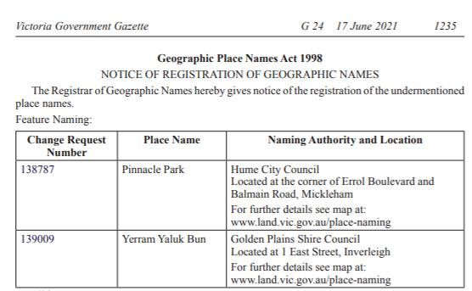

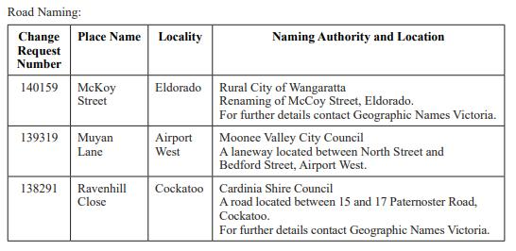

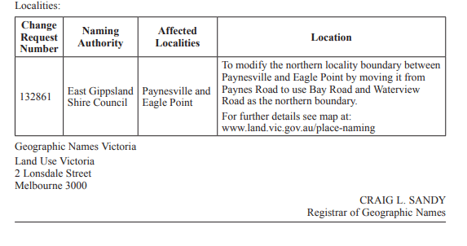

Section 14 Implementation
The implementation of any name is very important. It ensures names are widely adopted and known by the immediate and extended community. Careful consideration should be given to promotion, communication and education about a name and/or boundaries. For example, community members need to be officially told when to use a new road name for an address or a change in a locality name. The use of a Traditional Owner name may see the community being educated about its meaning and pronunciation.
Ensuring correct notification to organisations and communicating the name widely will ensure state and federal government, emergency services and postal/goods delivery services are up to date.
All naming authorities including councils, government departments/agencies and authorities should consider creating a communications plan dependent on the scale of a naming proposal. They should also ensure naming authorities’ databases, websites, related documents, local mapping and imagery are updated.
A number of requirements are involved in the implementation of a name, these include registration, notification, signage and history. Further information is available below.

14.1 Registration
Only after a naming authority receives notification from the Registrar that an official naming or boundary change has been registered in VICNAMES can it notify affected members of the immediate and/or extended community and other interested stakeholders.
Following the proposal’s gazettal, the Registrar will enter the gazette date, gazette reference and the details of the new or amended name and/or boundaries into VICNAMES. Refer to Section 1.6 for information that is typically held in VICNAMES.

14.2 Notification

14.2.1 Who Geographic Names Victoria notifies
Upon registration, GNV will inform relevant stakeholders. The naming authority is also encouraged to inform local stakeholders as advised below.
Within 30 days of a proposal’s endorsement GNV will publish a notice on the Gazetted place names webpage to the naming authority. The notice will include a link to an electronic map that naming authorities can download and distribute to local stakeholders, including local emergency and utility service providers.
When a name is gazetted and registered, GNV will organise for notification to be sent to state-wide and national bodies, including emergency and postal services, and spatial information or mapping organisations. These notifications differ whether the name is a road, feature or locality.
Road updates, including spatial extents and attributes are regularly published to the Vicmap Transport spatial layer, used by councils, state government departments and agencies and mapping agencies.
Typical organisations that GNV notifies includes:
- Australia Post
- EMSINA (Emergency Management Spatial Information Network Australia) – Victorian Committee members, including: Emergency Services Telecommunications Authority; Ambulance Victoria; Victoria Police; Country Fire Authority; Fire Rescue Victoria; State Emergency Service; Department of Environment, Land, Water and Planning; Department of Transport, Department of Justice; and Department of Health and Human Services
- Real Estate Institute of Victoria
- Australian Bureau of Statistics
- Australian Electoral Commission
- Melway and other spatial information or mapping agencies.
GNV notification process

1
2
3
4
5
GNV endorses a proposal.
Vicmap informed via VES (up to two weeks for an update to take effect).
Naming authorities and emergency services informed of update.
ESTA informed and updated (typically three times a year).
Private organisations, data is publicly and commercially available and updates can take over a year – Refer to Section 14.2.3.

14.2.2 Who the naming authority must notify
If addresses have been affected the naming authority must notify residents, ratepayers and businesses in the immediate community. Refer to the below example.

Example notification to affected residents
Naming/boundary realignment
As you are aware [insert naming authority] recently surveyed/notified the community of a proposal to name a road, feature or locality, or amend its boundaries.
You have received this correspondence because you are affected by this proposal.
As a result of the notice/ letter/ email/ survey/ voting poll, the preferred name [enter preferred name] received the most support.
[Insert naming authority] considered the proposal at its regular [insert meeting name] meeting on [insert date, time and location of meeting].
[Insert naming authority] endorsed the name and requested that the name be sent to the Registrar of Geographic Names for gazettal and registration.
The name was gazetted on [insert date and gazettal reference]. [Insert naming authority] has been informed that the name has been registered and emergency services have been informed.
Signage will be installed in due course.
[If addresses affected, include the following]
Your old address [insert old address] has now changed to [insert new address].
Australia Post may continue to record and recognise the old address for a period of six to 12 months to ensure a smooth transition from the old address to the new. It should also be noted, however, that Australia Post cannot guarantee the delivery of incorrectly addressed mail and you should endeavour to use the new official address.

It is important to distribute details of the endorsed proposal to the following local organisations. They may have an interest in knowing the new or altered name and boundaries and there can be a delay between official notification to state-wide bodies and details filtering through various systems.
The naming authority should notify the following local organisations and stakeholders:
- Australia Post offices
- real estate agents
- gas, water and electricity suppliers
- council rates departments
- local mapping agencies
- local police stations
- local ambulance stations
- local Country Fire Authority and/or Fire Rescue Victoria stations
- State Emergency Service local headquarters
- tourist information centres

14.2.3 Updating other databases, including private companies
While GNV, councils and state government departments and agencies have a responsibility to update both state and national datasets; road, feature, locality and address information can take time to filter out to various companies’ databases. Databases belonging to satellite navigation, online address searches, companies that offer address searches on the internet and service providers (such as utility companies) can take months to update.
It is not the responsibility of the naming authority to update private organisations with address information.
The naming authority can provide official proof of an address change to those experiencing problems. This may be used to inform private organisations of a change to an address.

14.2.4 Updating emergency services databases
Updates are provided to emergency services, in particular ESTA, who handles 000 calls, when a naming proposal is processed through VES or the SPEAR subdivision process. Typically, ESTA receives at least three updates a year from state government. If naming authorities are concerned that information has not been updated or want to know when it is appropriate to inform members of the public, please contact GNV for advice.

14.3 Signage
Road, feature and locality signage in Victoria must conform to the requirements outlined in this section.
All signage for a road, feature or locality must be erected within 30 days of the name being gazetted and registered or within 30 days of being notified by GNV.
In all instances, naming authorities must not erect or display signage prior to receiving Registrar’s advice that the naming proposal has been registered in VICNAMES. Existence of signage prior to lodging a naming proposal with the Registrar is not a valid argument for the name to be registered.
It is recommended that naming authorities apply to the Registrar as early as possible to ensure names can be endorsed, gazetted and registered in the time required. Appropriate and unambiguous signage will assist with delivery of goods and services and ensure adequate provision for emergency management.
Apostrophes must not appear on signage. A gazette notice may include an apostrophe in a name, the apostrophe will not be recorded in VICNAMES or Vicmap.
The names of estates and subdivisions are considered to be neighbourhood names; therefore, they are not officially recognised for addressing purposes. They should not appear on council, state government department or agency signage.
Signage design and display can differ for roads, features or localities. Specific information on signage is provided below.
It may be appropriate to install additional signage to explain the name and assists in pronunciation and phonetic pronunciation.

14.3.1 Requirements for road signage
The size, font and colour of road signs are determined in AS 1743:2018 Road signs – Specifications, AS1742 Manual of uniform traffic control devices, AS 1744-1975 Forms of letters and numerals for road signs and AS/NZS 4819:2011 Rural and urban addressing) and should be applied in all instances of road signage in Victoria.
The only acceptable road type abbreviations are provided in APPENDIX A and may be applied to road signage.
Diacritical marks should not be added to street signage, refer to Principle K and AS 1743:2018.
In addition, the location of signage is an important issue for naming authorities to consider. Road name signage should be placed at intersections and junctions, and in areas where it is not obscured from view or covered by objects such as trees and buildings. Road name signage should also be located at regular junctions and cross roads to allow members of the public to discern their location, especially in rural areas.
Signage for private roads should include reference to the fact that they are private roads, which implies they are not accessible to the general public. The cost is the responsibility of the property owner, developer or owners corporation (subject to council’s provisions and guidelines).
If the site is under construction, signage must be erected within 30 days of infrastructure work commencing at the site (this is to ensure that emergency management services can respond to any incidents that might arise in the area during the construction phase). If the road is under construction, 30 days after the name is registered, temporary signs may be erected until such time as the road is open to traffic.
When road names are approved using a the SPEAR subdivision process, signage must be erected after the certification or registration of the plans and within 30 days of infrastructure work commencing at the site.
Refer to road signage examples below. 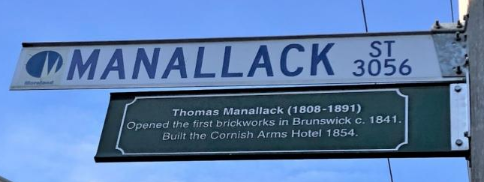 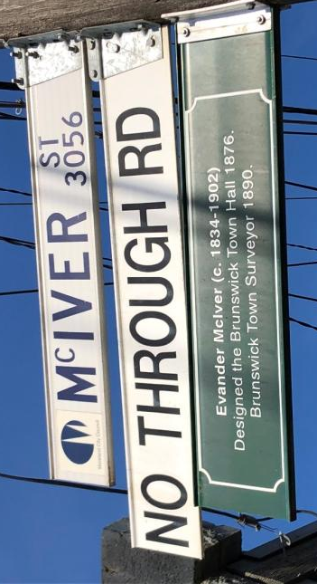 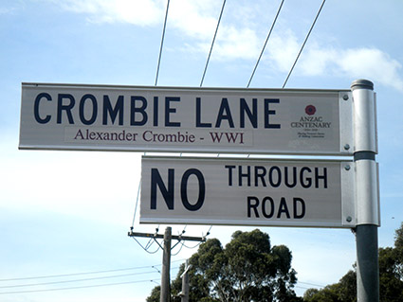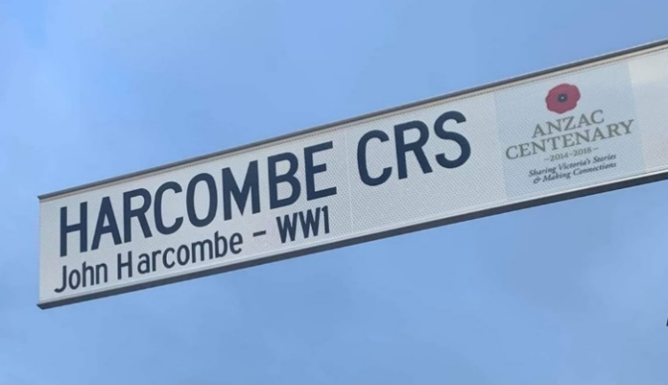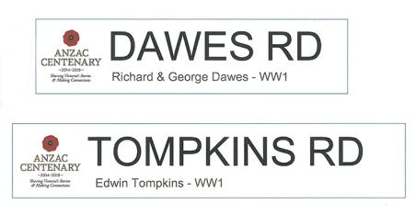 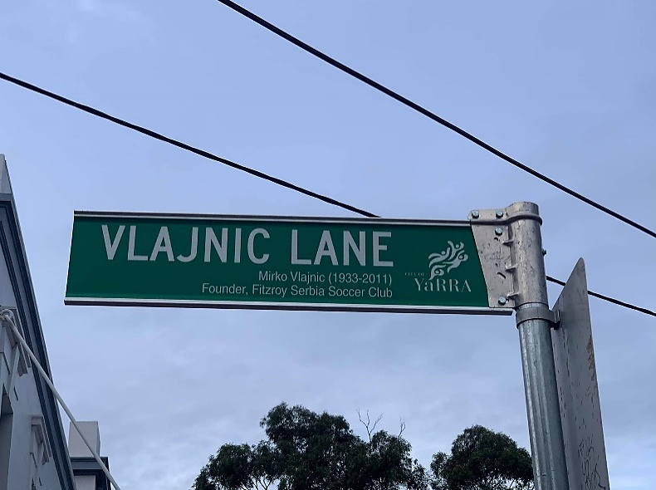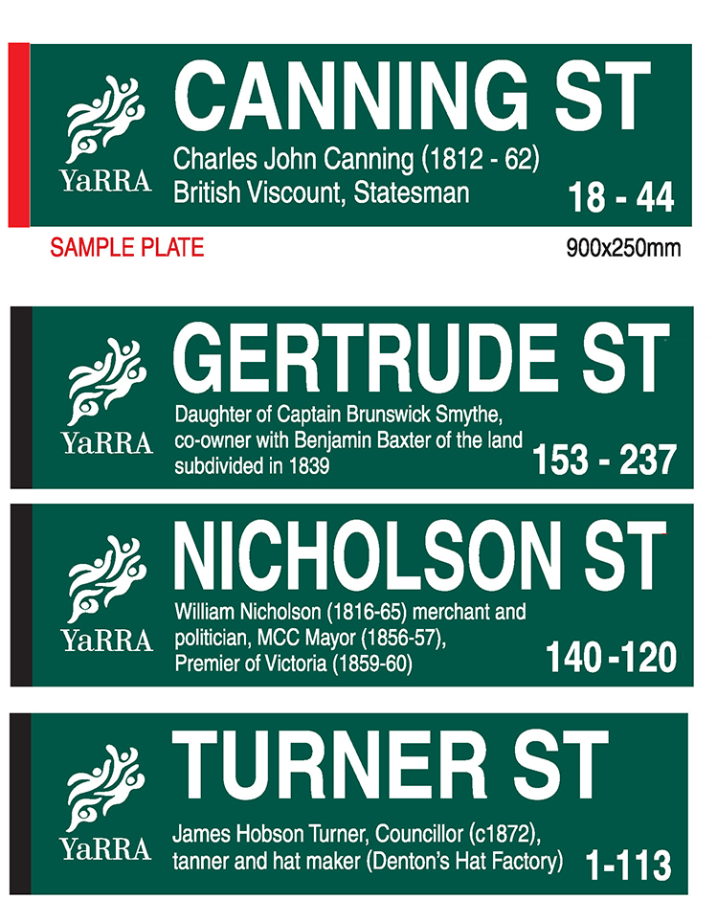

14.3.2 Requirements for feature signage
Signage for features can take whichever form or design the naming authority considers appropriate to ensure that the name can be easily identified and read by all members of the community.
At a minimum, the signage for a feature should be located at major access points to ensure people can readily identify the feature in an emergency.
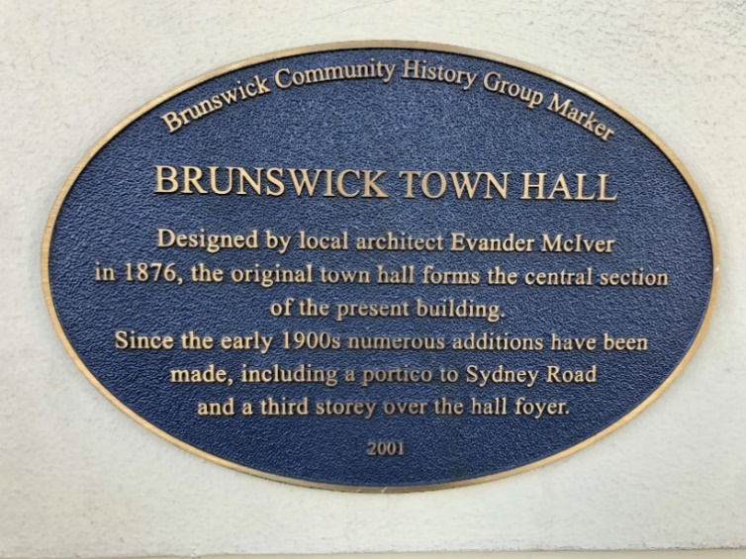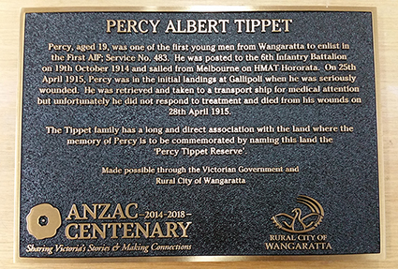

Example of feature signage
For features with addresses that visitors might find difficult to describe (for example barbecue sites in parks, swimming sites at beaches or walking tracks in state forests), there is an option to display an emergency marker. These markers are geocoded for the use of the ESTA (the organisation responsible for answering 000 calls) and can be useful for providing emergency services with accurate location information and specific directions on how to access the area.
Further information about emergency markers is available on the ESTA website.
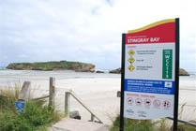
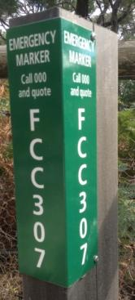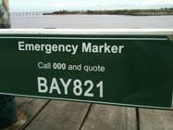

14.3.3 Requirements for locality signage
Adequate locality signage should be displayed on all major roads and thoroughfares. This is particularly important in rural and remote areas, where visitors may be unfamiliar with the area.

14.4 History

14.4.1 Recording historical information in VICNAMES
It is important to record information about why a road’s, feature’s or locality’s name was chosen. This will ensure historical information is available to future generations and provide transparency in the naming process.
When a name has been gazetted and registered, the naming authority should access VICNAMES and enter any historical information and relevant documents on the new name. This information should explain why the name was chosen and how the name has links to the local area.
Anyone can upload historical information to VICNAMES. The information should relate to an appropriate source, which includes:
- books
- an edited book section/chapter
- journal
- manuscript
- oral history
- maps
- newspaper/magazine
- artefact
- website
- council
- GNV

The Guide to VICNAMES is available online. A historical content administrator (HCA) will review the submission and either approve, reject or request further information. Once approved, the submission will be viewable in VICNAMES. If a submission relates to multiple features or roads, then associations can be made by the HCA. The submitter will be notified of the submission’s approval or rejection.
Once a submission has been approved, relevant historical information can be submitted. This could include copies of photos as jpeg files or Microsoft Word or PDF documents. This information should be emailed to geo.names@dewlp.vic.gov.au, clearly indicating the record the information relates to. The HCA can then upload this content to the record.

APPENDIX

APPENDIX A Road types accepted for registration
As per clauses 4.3, 4.6.2, 7.2 and 8.3.2(a) within the AS/NZS4819:2011: Rural and urban addressing standard, the road types specified within this appendix are the only road types that can be used.
Culs-de-sac
Road Type | Abbreviation | Description
CLOSE | CL | A short enclosed roadway.
COURT | CT | A short enclosed roadway.
MEWS | MEWS | A roadway in a group of houses.
PLACE | PL | A short, sometimes narrow enclosed roadway.
PLAZA | PLZA | A roadway enclosing the four sides of an area, forming a marketplace or open space.
RETREAT | RTT | A roadway forming a place of seclusion.
Either culs-de-sac or open-ended roads
Road Type | Abbreviation | Description
ALLEY | ALLY | Usually a narrow roadway in cities or towns. A minor roadway through the centre of city blocks or squares.
CHASE | CH | A roadway leading down to a valley.
CREST | CRST | A roadway running along the top or summit of a hill.
GLADE | GLDE | A roadway usually in a valley of trees.
GROVE | GR | A roadway that features a group of trees standing together.
LANE | LANE | A narrow way between walls, buildings or a narrow country or city roadway.
RISE | RISE | A roadway going to a higher place or position.
SQUARE | SQ | A roadway bounding the four sides of an area to be used as open space or a group of buildings.
TERRACE | TCE | A roadway usually with houses on either side raised above the road level.
VIEW | VIEW | A roadway commanding a wide panoramic view across surrounding areas.
VISTA | VSTA | A road with a view or outlook.
WHARF | WHRF | A roadway on a wharf or pier.

Open-ended roads
Road Type | Abbreviation | Description
APPROACH | APP | A roadway leading to an area of community interest, i.e. public open space, commercial area, beach etc.
AVENUE | AV | A broad roadway, usually planted with trees on each side.
BOULEVARD | BVD | A wide roadway, well paved, usually ornamented with trees and grass plots.
BREAK | BRK | A vehicular access on a formed or unformed surface, which was originally prepared as a firebreak.
BYPASS | BYPA | An alternative roadway constructed to enable through traffic to avoid congested areas or other obstructions to movement.
CIRCUIT | CCT | A roadway enclosing an area.
CONCOURSE | CON | A roadway that runs around a central area, e.g. public open space or a commercial area.
CRESCENT | CR | A crescent-shaped thoroughfare, especially where both ends join the same thoroughfare.
DRIVE | DR | A wide thoroughfare allowing a steady flow of traffic, without many cross streets.
ENTRANCE | ENT | A roadway connecting other roads.
ESPLANADE | ESP | A level roadway, often along the seaside or a river.
FIRETRAIL | FTRL | Vehicular access on a formed or unformed surface, which was originally prepared as a firebreak.
FREEWAY | FWY | An express, multi-lane highway, with limited or controlled access.
GRANGE | GRA | Roadway leading to a country estate, or focal point, public open space, shopping area etc.
HIGHWAY | HWY | A main road or thoroughfare; a main route.
LOOP | LOOP | Roadway that diverges from and re-joins the main thoroughfare.
PARADE | PDE | A public promenade or roadway that has good pedestrian facilities along the side.
PARKWAY | PWY | A roadway through parklands or an open grassland area.
PROMENADE | PROM | A roadway like an avenue with plenty of facilities for the public to take a leisurely walk; a public place for walking.
QUAYS | QYS | A roadway leading to a landing place alongside or projecting into water.
RAMP | RAMP | An access road to and from highways and freeways.
RIDGE | RDGE | A roadway along the top of a hill.
ROAD | RD | A place where one may ride; an open way or public passage for vehicles, persons and animals; or, a roadway forming a means of communication between one place and another.
STREET | ST | A public roadway in a town, city or urban area; especially a paved thoroughfare with footpaths and buildings along one or both sides.
TRACK | TRK | A roadway with a single carriageway and a roadway through a natural bushland region. The interpretation for both TRACK and TRAIL is limited to roadways; however, in many areas (e.g. Tasmania) these are more often associated with walking rather than vehicular movement.
TRAIL | TRL | See TRACK.
WAY | WAY | An access way between two streets. Usually not as straight as an avenue or street.
Pedestrian only roads
Road Type | Abbreviation | Description
ARCADE | ARC | A passage having an arched roof, or any covered passageway, especially one with shops along the sides.
BOARDWALK | BWLK | A promenade or path, especially of wooden planks, for pedestrians and sometimes vehicles along, or overlooking, a beach or waterfront.
MALL | MALL | A sheltered walk, promenade or shopping precinct.
PATH | PATH | A roadway used only for pedestrian traffic.
PASSAGE | PSGE | A narrow street for pedestrians.
STEPS | STPS | Route consisting mainly of steps.
SUBWAY | SBWY | An underground passage or tunnel that pedestrians can use for crossing under a road, railway, river, etc.
WALK | WALK | A thoroughfare with restricted access used mainly by pedestrians.
WHARF | WHRF | A roadway on a wharf or pier.

APPENDIX B Naming principles - additional information
This appendix provides additional information to the principles within Section 2.
The following table highlights some common names that would still be considered duplicates.
Name | Names considered duplicates
Brayden | Braden, Bradyn, Braeden, Braiden, Braydon
Caleb | Khaleb, Kaleb
Denise | Denis, Denice
Emily | Emely, Emilee, Emilie, Emmalee
Francis | Frances, Fransis
Ian | Ean, Iain, Eon, Eion
Riverside | River, Riverview, Riverleigh, Riverbend, Rivervalley
White | Whyte, Wite, Wiet
Zoe | Zoey, Zoie

Results from a VICNAMES duplication search
To protect our communities proposed names must not duplicate another name within a locality or the distances listed below, irrespective of council boundaries. Duplicates are considered to be two (or more) names within close proximity, or names that are identical or have similar spelling or pronunciation.
Not all results from a VICNAMES duplication search are duplicates. Common sense is required to determine similar sounding names. Sound out the name to ensure suitable difference.
Additionally, VICNAMES does not always pick up duplicates. For example, when checking a name ending with an s, the s is often omitted by the application.
As well as VICNAMES, naming authorities must use their local knowledge to avoid proposing duplicate names.

Metropolitan duplication
Duplication is not allowed in the same locality and in Melbourne and Geelong metropolitan urban areas, within 5 kilometres. Below are examples of metropolitan duplication.

Scenario: A naming authority has approved the development of a new subdivision that will be accessed via a road. In this example, the naming authority consulted the community about an appropriate name for the road and received a number of submissions. The preferred name is Taylor, which commemorates the Taylor family who were well respected in the area, ran a blacksmith shop on the site and lived in the municipality for over 50 years. As the proposed name is duplicated within a 5- kilometre radius it would not be allowed.

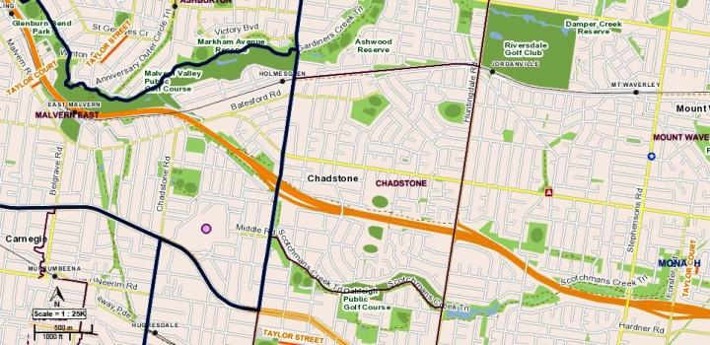

Solution: Consideration should be given to assigning the name to a feature or acknowledging the site or the goods sold. For example, Taylor Blacksmith manufactured nails, chains and repaired carriage wheels, you could consider the names below. Relevant history can then be added to the street signage, refer to Section 14.4. Examples of possible names:
- Blacksmith Court
- Carriage Place
- Nail Close
Scenario: A naming authority has approved the development of townhouses that will only be accessible via a rear laneway. The naming authority has consulted the community about an appropriate name for the laneway and received a number of submissions. The preferred name is Smith, which commemorates the Smith family who were well respected in the area, ran a grocery store nearby and lived adjacent to the street. As the proposed name is duplicated within a 5- kilometre radius it would not be allowed.
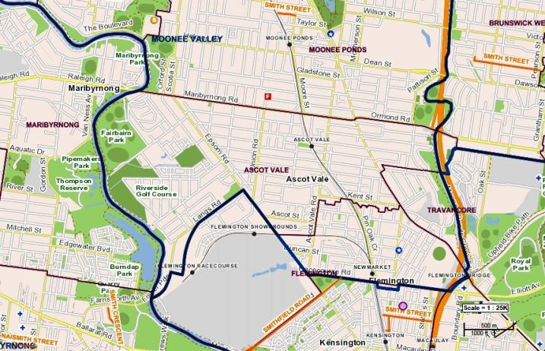

Solution: Consideration should be given to assigning the name to a feature or acknowledging the shop itself or goods sold. For example, if Smiths Grocery was the first store to sell pineapples in Victoria, you could consider the names below. Relevant history can then be added to the street signage, refer to Section 14.3. Examples of possible names:
- Grocery Lane
- Produce Lane
- Pineapple Lane

Regional urban area
Duplication is not allowed in the same locality and in regional urban areas within 15 kilometres. Below is an example of regional urban duplication.
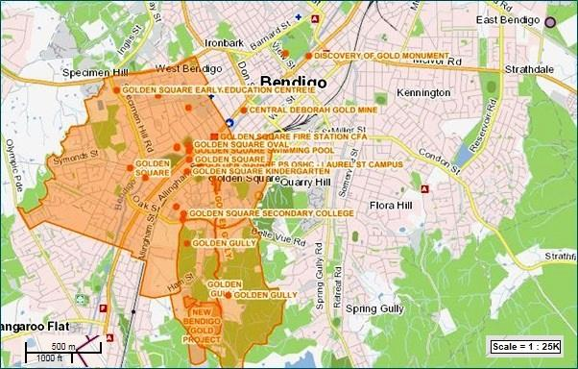

Scenario: A naming authority has received a request to name a picnic area in a local park Gold Picnic Ground to commemorate a location in Bendigo where gold was found. There are multiple places that use ‘gold’ in their names within the area. In this case, use of the word gold would not be allowed.
Solution: Consider assigning the name of the person who discovered the gold or the tool used that found the gold. Relevant history may then be added to the street signage, refer to Section 14.3. Examples of possible names are below:
- Shovel Picnic Reserve
- Pick Axe Picnic Reserve
- Nugget Reserve.

Rural or remote areas
Duplication is not allowed in the same locality and in rural or remote areas, within 30 kilometres. Below are examples of rural or remote area duplications.
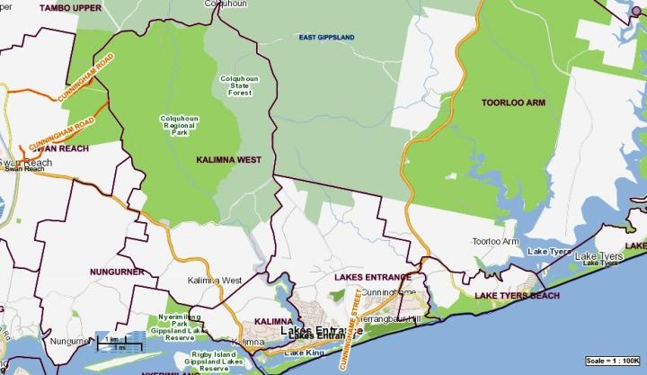

Scenario: The naming authority wishes to preserve the heritage of the area by naming a track after a well-known family that once owned the property to which it led. The proposed name for the track is Cunninghame. There are three roads with similar or direct duplicates; therefore, the naming of the track using the preferred name would not be allowed.
Solution: Consider acknowledging the Cunninghames by recognising their work, management of the land or country/place of origin, for example, the Cunninghames emigrated from Bristol, England on the boat HMAS Berrima. Relevant history may then be added to the street signage, refer to Section 14.3. Examples of possible names are below:
- Bristol Way
- Berrima Lane.

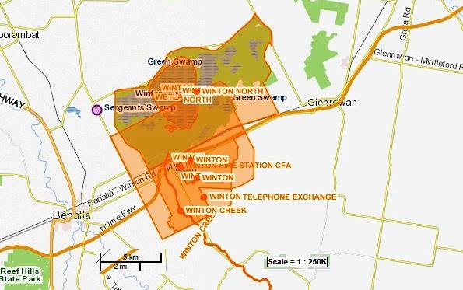
Scenario: A new bridge is being constructed, which will take traffic over the railway line. The proposed name for the bridge is Winston, after a deceased land owner and well-respected member of the community. However, there are multiple uses of the name Winton in the area; therefore, careful consideration should be given to using the name. Winton and Winston are considered a duplication and would not be allowed because they sound too similar and may be incorrectly identified between each other.
Solution: Consider the roles Mr Winston played in the community or how he used his land. For example, Mr Winston was chair of the local Landcare group for 12 years and his land was used to graze sheep and Jersey cows. Relevant history may then be added to the feature signage, refer to Section 14.3. Examples of possible names are below:
- Cow Bridge
- Jersey Bridge
- Sheep Bridge

Names not considered duplicates
Naming authorities can use the following information to determine road and feature names GNV may not consider duplicates. Naming authorities can contact GNV for further advice.
The names below are not considered duplicates because the feature names have unique identifiers that differentiate them from each other, or the feature type is different. In all examples, the requirement under 4.2.3 Locational names has been applied. The locality name in combination with the other parts of the name associate it to the area in which it is located.
The creation of Craigieburn ANZAC Park in the locality of Craigieburn is not considered a duplication, even though within a 5- kilometre radius there are the following similarly named features:
- Craigieburn Bicentennial Park
- Craigieburn Gardens.
The creation of Briagolong Botanical Park in the locality of Briagolong is not considered a duplication, even though within a 1- kilometre radius there are the following similarly named features:
- Briagolong Forest Red Gum Reserve
- Briagolong Recreation Reserve.
The creation of Belvoir Lake Park in the locality of Wodonga is not considered a duplication, even though within five kilometres radius there are the following similarly named features. This also relates to the exception for multiple feature names:
- Belvoir Park
- Belvoir Oval.
A new school called Murrayville Community College in the locality of Murrayville is not considered a duplication, even though within a 1- kilometre radius there are the following similarly named features:
- Murrayville Preschool
- Murrayville Primary School.

Multiple names
The assignment of multiple feature names within, for example, a park or reserve is not considered duplication. The feature name must have a direct relationship with one another for example, Mildura Wharf Carpark which is adjacent and services Mildura Wharf, Albert Park Playing Fields located in Albert Park.
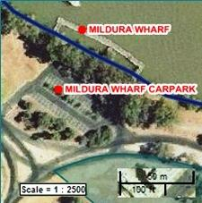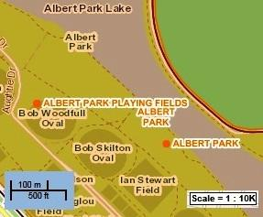

APPENDIX C Checklists
The checklists in this document should be used to ensure you have complied with:
- principles listed in Section 2
- relevant statutory requirements (as required) under Section 3, Section 4 and Section 5
- processes required for naming a road, feature or locality.
Naming authorities are encouraged to submit a copy of a completed checklist with your naming proposal to GNV
Refer to Section 10 Lodging a proposal with GNV for further information about how to submit a proposal for the Registrar’s consideration.
*NA: Not applicable
Are you seeking:
☐ |  | The Registrar’s in-principle support? If yes, refer to section 6.2.3.
☐ Gazettal and registration of a name? (continue to fill in this checklist)
Is your naming proposal related to a:
☐ |  | Road – complete sections 1, 2, 5, 6, 7, 8, 9 (of this checklist)
☐ |  | Feature – complete sections 1, 3, 5, 6, 7, 8, 9 (of this checklist)
☐ | Locality – complete sections 1, 4, 5, 6, 7, 8, 9 (of this checklist)
General Questions
If proposing a new name or to change a name, does the proposal conform to the principles in Section 2? Refer to principles below.
 |  |  | Yes | No | NA*
Principle A - Ensuring public safety |  |  | ☐ | ☐ | ☐
Principle B - Recognising the public interest |  |  | ☐ | ☐ | ☐
Principle C - Linking the name to place |  |  | ☐ | ☐ | ☐
Principle D - Ensuring names are not duplicated |  |  | ☐ | ☐ | ☐
Principle E - Recognition and use of Traditional Owner languages |  |  | ☐ | ☐ | ☐
Principle F - Names must not discriminate or be offensive |  |  | ☐ | ☐ | ☐
Principle G - Gender equality |  |  | ☐ | ☐ | ☐
Principle H - Dual names |  |  | ☐ | ☐ | ☐
Principle I - Using commemorative names |  |  | ☐ | ☐ | ☐

General Questions continued
 |  |  | Yes | No | NA*
Principle J - Using commercial and business names |  |  | ☐ | ☐ | ☐
Principle K - Language |  |  | ☐ | ☐ | ☐
Principle L - Directional names to be avoided |  |  | ☐ | ☐ | ☐
Principle M - Assigning extent to a road, feature or locality |  |  | ☐ | ☐ | ☐
If the naming proposal originally came from a member of the public, does it include sufficient information on why the name would be appropriate? |  |  | ☐ | ☐ | ☐
If you are a state government department or agency, have you checked with GNV to see if there are specific guidelines for your department or agency? If there are no specific guidelines for your department or agency, you should follow the naming rules. |  |  | ☐ | ☐ | ☐
Roads
 |  |  | Yes | No | NA*
Is your organisation the road authority for the road(s) in questions under the Roads Management Act 2004 or Local Government Act 1989 or Local Government Act 2020?  Refer to Section 3.4 for more information. |  |  | ☐ | ☐ | ☐
If there is more than one road authority, are you preparing this proposal as a collaborative project? |  |  | ☐ | ☐ | ☐
Does the proposal conform with the statutory requirements in Section 3.2 Statutory requirements that apply to roads. If not, contact GNV for advice about how to make the proposal compliant. |  |  | ☐ | ☐ | ☐
3.2.1 Rural and Urban Addressing |  |  | ☐ | ☐ | ☐
3.2.2 Extent: road course, start and end points  Does the road have clear start and end points? |  |  | ☐ | ☐ | ☐
3.2.3 Road types  Does the road name use an acceptable road type? |  |  | ☐ | ☐ | ☐
3.2.4 Unacceptable road names  Have you checked the list of unacceptable road names? E.g. ‘the’ or ‘and’ is unacceptable, as are numbers, hyphens, directions or destinations |  |  | ☐ | ☐ | ☐
3.2.5 Obstructed or altered roads |  |  | ☐ | ☐ | ☐
If a delegation of authority has been used, have details of the relevant officer been officially provided to GNV? |  |  | ☐ | ☐ | ☐
If the naming proposal is being lodged after the plan of subdivision has been certified, please ensure the appropriate documentation is attached to the proposal. Refer to Section 10.
Private Roads located on private property s continued
 |  |  | Yes | No | NA*
Are you aware that the road naming authority may not be the road authority; therefore, it is not responsible or liable for maintenance or other management of the road? Refer to Section 3.9.3. |  |  | ☐ | ☐ | ☐
Has/have the private road/roads already been constructed? |  |  | ☐ | ☐ | ☐
If so, is/are the road name/s already in use by the immediate community? |  |  | ☐ | ☐ | ☐
Does Australia Post deliver mail to the general facility or individual sites within the complex? Contact should be made with Australia Post to discuss mail delivery options for the property. |  |  | ☐ | ☐ | ☐
Continue to Consultation
Features
 |  |  | Yes | No | NA*
Is the feature of greater than local significance (for example located in more than two municipalities, in a tourist precinct or major waterway)? If so, a Geographic Place Names Advisory Committee may need to be convened. Refer to Principle C and Section 4. |  |  | ☐ | ☐ | ☐
Does the proposal conform to the statutory requirements in Section 4.2? If not, contact GNV for advice about how to make the proposal compliant. |  |  | ☐ | ☐ | ☐
4.2.1 Feature type  Is the feature type proceeding the feature’s name (for example Waterlands Park)? Refer to Section 4.2.1. |  |  | ☐ | ☐ | ☐
4.2.2 Waterways  If the feature is a waterway, has the extent been determined? |  |  | ☐ | ☐ | ☐
4.2.3 Locational name  If using a location-based name, is it the name of the locality rather than the name of the neighbourhood, estate or subdivision? |  |  | ☐ | ☐ | ☐
4.2.4 Base names  Is the feature privately owned or administered and subject to a naming sponsorship contract? If so, a base name should be assigned. |  |  | ☐ | ☐ | ☐
Traditional Owner names for features Refer to Section 4.9.
What type of proposal is being considered:
☐ |  | Addition of a Traditional Owner name as registered or dual?
☐ | Addition of a Traditional Owner name as traditional or historical?

Features continued
 |  | Yes |  | No |  |  | NA*
If recording a Traditional Owner name, does the feature already have an officially registered name or an unrecorded and/or unregistered name? If yes, the Traditional Owner name may be considered as a dual name. Refer to Principle H. |  | ☐ |  | ☐ |  |  | ☐
When recording the Traditional Owner name as registered or dual, are you aware that the name will be recognised as the official name in use for the feature?  The name will appear on regular maps for the area. |  | ☐ |  | ☐ |  |  | ☐
When recording the Traditional Owner name as traditional or historical, are you aware that the name will be recognised on regular maps?  The name can be located by researchers and be used on specialised maps. |  | ☐ |  | ☐ |  |  | ☐
Are you aware that all names, regardless of status, will be held in VICNAMES? Refer to Section 4.9. |  | ☐ |  | ☐ |  |  | ☐
Has the Traditional Owner name been verified by the area’s Traditional Owner group(s), and is there written evidence of this verification? Refer to Section 7.3. |  | ☐ |  | ☐ |  |  | ☐
Continue to Consultation
Localities
Does the proposal conform to the statutory requirements in Section 5.2? If not, contact GNV for advice about how to make the proposal compliant
5.2.1 Boundaries  Have you checked the proposal against the requirements and explanatory boundary map diagrams in Section 5.2.1? |  | ☐ |  | ☐ |  |  | ☐
5.2.2 Estate and subdivision names  Have you checked that the name is not an estate or linked to a subdivision name? Refer to Section 5.2.2. |  | ☐ |  | ☐ |  |  | ☐
5.2.4 Size  Have you checked that the size is appropriate? Refer to Section 5.2.4. |  | ☐ |  | ☐ |  |  | ☐
5.2.5 Hyphens  The name must not contain hyphens. Refer to Section 5.2.5. |  | ☐ |  | ☐ |  |  | ☐
5.2.6 Local government area boundary review  Have you checked that, if the locality boundary extends across municipal boundaries, the boundaries have been reviewed with the intention of aligning with the municipal boundaries? Refer to Section 5.2.6. |  | ☐ |  | ☐ |  |  | ☐
Localities continued
 |  | Yes |  | No |  |  | NA*
5.2.7 Locality names unique within Australia  Have you checked that the names are unique and not repeated elsewhere in Australia, or sought advice from GNV? Refer to Section 5.2.7. |  | ☐ |  | ☐ |  |  | ☐
Does the locality cover more than one municipal area, or is it part of a state government project? |  | ☐ |  | ☐ |  | ☐
Does the proposal include a detailed map of the existing and proposed boundaries? |  | ☐ |  | ☐ |  | ☐
If relevant, has consideration been given to naming the locality after a local historical figure or event? |  | ☐ |  | ☐ |  | ☐
If the new locality relates to a major land redevelopment project, has a public naming competition been considered? |  | ☐ |  | ☐ |  | ☐
Consultation
 |  | Yes |  | No |  |  | NA*
If the proposal affects addresses, have residents, ratepayers and businesses been consulted? Refer to Section 7. |  | ☐ |  | ☐ |  |  | ☐
If the proposed name is from a Traditional Owner language, has/have the relevant Traditional Owner group(s) been consulted and given their approval? Refer to Principle E and Section 7.3. |  | ☐ |  | ☐ |  |  | ☐
If the naming proposal comes from a council and relates to the local area, has it been discussed with relevant interest groups such as historical societies and community groups? |  | ☐ |  | ☐ |  |  | ☐
If the naming proposal is being developed in-house by a state government department or agency, have relevant interest groups been consulted? |  | ☐ |  | ☐ |  |  | ☐
If the naming proposal is being developed through a public competition, have you referred to the information contained in Section 7? |  | ☐ |  | ☐ |  |  | ☐
Lodging, considering and addressing objections and submissions
 |  | Yes |  | No |  |  | NA*
Have the concerns or objections raised by residents, ratepayers and businesses been addressed? Refer to Section 8. |  | ☐ |  | ☐ |  |  | ☐
If the majority of immediate community members have opposed the proposal but there is an underlying service provision need to change the name or adjust the extent, do you require the assistance of GNV and emergency response or other service providers? If so, contact GNV for advice. |  | ☐ |  | ☐ |  |  | ☐
If a delegation of authority has been used, have details of the relevant officer, been officially provided to GNV?
Notification of a naming decision
Has consideration been given to whom the naming authority should notify if the naming proposal is endorsed by the Registrar? Refer to Section 14.2.
Signage and recording historical information
Has consideration been given to signage, if the naming proposal is endorsed by the Registrar? Refer to Section 14.3. | ☐ |  | ☐ |  | ☐
Has consideration been given to recording historical information in VICNAMES if the naming proposal is endorsed by the Registrar? Refer to Section 14.4.
Naming proposal documentation
Has the naming authority prepared a report on the proposal, to help determine compliance? Refer to Section 9. Any report should include the following:  - information about how the proposal conforms with principles in Section 2 and statutory requirements in relevant sections  - discussion of and response to any objections/comments received during the consultation period(s). | ☐ |  | ☐ |  | ☐
Has the naming authority’s decision to accept or reject the proposal been formally recorded? This may involve councillors’, relevant Ministerial or CEO’s approval (if delegation of authority used). Refer to Section 9.
Are the following pieces of information attached to the naming proposal being lodged, using the online Vicmap Editing Service (VES)?
Details of the existing name | ☐ |  | ☐ |  | ☐
Background of the proposed name and why it was selected. If the proposed name is traditional or historical, include Traditional Owner language and, if possible, cultural heritage information. | ☐ |  | ☐ |  | ☐
Details of why a naming is proposed (if relevant) | ☐ |  | ☐ |  | ☐
Naming proposal documentation continued
 |  | Yes |  | No |  |  | NA*
Details of a features location (including, if possible, the address and access points for emergency response). |  | ☐ |  | ☐ |  |  | ☐
Details of the consultation process:
A statement from naming authority about how they reached their decision to consult immediate and/or extended community |  | ☐ |  | ☐ |  |  | ☐
An analysis of the consultation’s outcomes |  | ☐ |  | ☐ |  |  | ☐
How any objections were considered and what responses where provided to the objectors. |  | ☐ |  | ☐ |  |  | ☐
Confirmation that the name conforms to the naming rules. |  | ☐ |  | ☐ |  |  | ☐
Confirmation that the proposal has been accepted by the naming authority or is being submitted by a delegated officer.
Naming
The following information (where relevant):
A copy of consent from relevant Traditional Owner group(s) |  | ☐ |  | ☐ |  |  | ☐
If undertaken, details of consultation with emergency response and public service providers (if VES was used for consultation, this evidence is automatically attached to the submission to GNV) |  | ☐ |  | ☐ |  |  | ☐
Copies of notice, letter, survey or voting poll material |  | ☐ |  | ☐ |  |  | ☐
De-identified (i.e. personal details removed) objections received from the public |  | ☐ |  | ☐ |  |  | ☐
Copies of letters sent to objectors, indicating their ability to lodge an appeal to the Registrar (as provided in Section 9.1) |  | ☐ |  | ☐ |  |  | ☐
A copy of council minutes indicating acceptance of the proposal, or that council staff have delegated authority. |  | ☐ |  | ☐ |  |  | ☐

APPENDIX D AS4819:2011 Rural and urban addressing
The following basic points must always be applied when developing addresses as part of a road naming proposal. These points represent only a small collection of rules as outlined in the AS/NZS 4819:2011 Rural and urban addressing standards and road coordinating authorities are encouraged to refer to the standards for detailed advice.
There are scenarios where neither AS/NZS 4819:2011 nor these naming rules provide a best fit solution to the problem. In these cases, naming authorities should contact GNV and Vicmap for a site-specific solution.
- A unique address should be assigned to each separately owned area of land or building, whether residential or commercial – for example hospitals, railway stations, places of worship, parks, monuments, education facilities, etc.
The numbering and determination of the road must be relative to the access point from which the property, dwelling, structure or feature is accessed. The road name used in an address must be the named road nearest the main vehicular or pedestrian access to the front door or entrance of a property, building, dwelling structure or feature.
Address numbers and names should be assigned as early as possible in the development process, and well before occupation. This must be adhered to in order to ensure adequate auditing of any proposals and, more importantly, to aid responses from emergency services and delivery of goods and services.
In cases of a property or business being part of a complex (such as a shopping centre or recreational facility), the addressing rules as defined in AS/NZS 4819:2011 Rural and urban addressing should be applied. For the process of registering private roads within complexes, refer to Sections 3.8 and 3.9.
- A datum point must be chosen from which all address numbers will be applied. The origin or datum point for all address numbering should be the intersection at that end of the road from where access most commonly occurs or is planned to occur. The origin or datum point for numbering major roads such as highways should be at the capital city end, or the major city if the road is not connected to the capital city.
- Numbering should be systematic and consistent along the extent of a named road, major road and highway throughout a locality. Address numbering standards and applications differ depending on whether the property is located in an urban or rural environment. Refer to AS/NZS 4819 Rural and urban addressing for specific directions and examples.
In urban areas, address sites on the left side of the road from the datum point should be numbered from one and increase sequentially using odd numbers. Address sites on the right side of the road from the datum point should be numbered from two and increase sequentially using even numbers. Refer to point 8 for culs-de-sac numbering.
If the opposite convention has been used throughout a defined area, it may continue to be used, provided it does not extend beyond that area.

The diagram below displays road extents, datum points and the assignment of numbers (note the reservation of numbers).
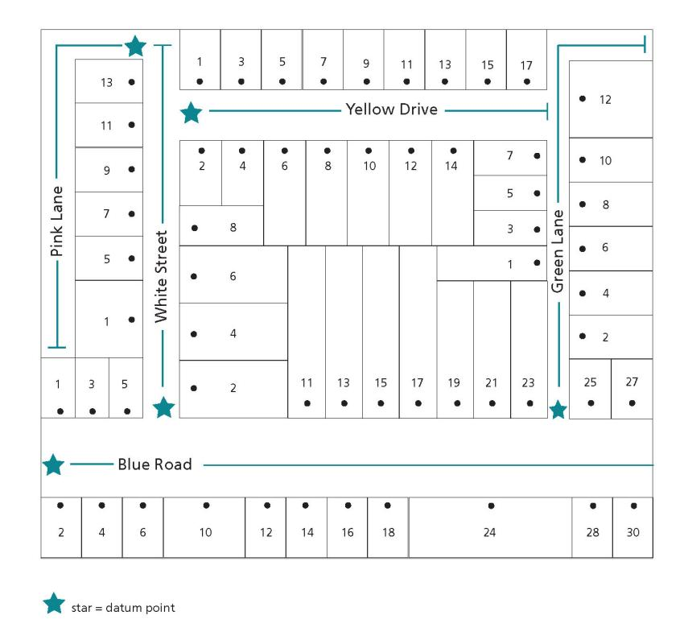
- Address numbers should be clear and logical and numbering should be sequential, ranging from the lowest to the highest. Numbers should be positive integers (no zero, fractions, or decimals). An address number should consist of no more than five numeric characters (i.e. up to 99999) and, if required, a single upper-case alphabetical suffix. The word ‘Lot’ should not precede any assigned address number.
- Do not avoid numbers; numbers must be assigned in a logical and sequential manner. However, it is possible to reserve numbers for future development.
- If a proposed road is being constructed in multiple stages as part of a multi-lot subdivision development, and the section that includes the datum point is not yet constructed, the naming and addressing authority should reserve address numbers for the first section of the road.
This does not apply when the proposed road has been constructed at either end and the middle section is yet to be built. In these instances, both ends of the road should have unique names applied. When the middle section of road is constructed, the two unique road names should extend from their datum points until they meet at a cross road on the newly constructed middle section.
If one name is to be assigned to the completed road, naming of the two unique roads and renumbering should then take place to recognise the full extent of the road.
- If a road continues with the same name through more than one locality, it is preferable that the numbering be unique and continuous for its entire length. For exceptionally long roads, logical sections may be defined by focal points and the numbering system applied to each section. The focal point should be placed so that localities are completely within a logical section.
- A short cul-de-sac that has its own road name and five or fewer detached address sites can be numbered from the left, ignoring the normal odd and even numbering on each side. Alpha suffixes in this case may also be used to minimise any renumbering.
A cul-de-sac that has more than five detached address sites should be numbered with the odd numbers on the left and even numbers on the right. Alpha suffixes in this case should not be used.
- A Department of Transport administrative road name should not be used for addressing purposes.
Address examples

Scenario 1: Residential redevelopment at number 37 Wyndham Street (highlighted) has resulted in four units, one fronting Wyndham Street and three fronting a section of Manor Street (highlighted by a red line). There are no numbers left on Manor Street for the three new units.
Option 1: Assign a new name to the section of Manor Street highlighted by a red line, a Cul-de-sac road type and assign new numbering accordingly.
Option 2: Re-number the full extent of Manor Street, taking into account possible future subdivisions at 39, 38 and 40 Wyndham Street; 39, 37, 36 and 34 High Street; and 33, 32 and 34 Margaret Street.
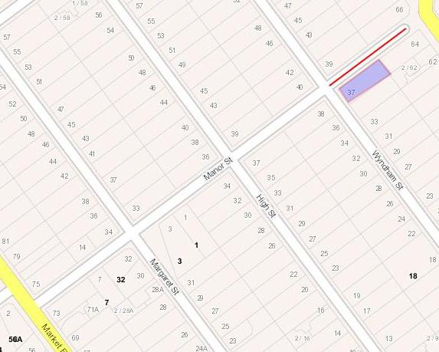
Scenario 2: It has been highlighted by emergency services that 87 Metung Road is not accessible from Metung Road. The property is accessed from Essington Close.
Option 1: Re-number 87 Metung Road to Essington Close with the address 2A Essington Close.
Option 2: Create a road that accesses 87 Metung Road and assign an appropriate name and number.
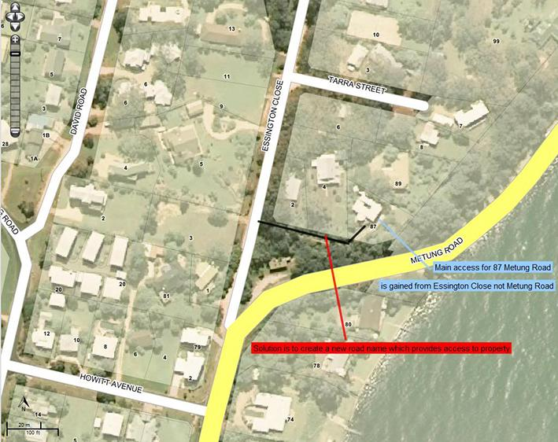

Glossary
Addressing authority | The authority responsible for addressing which is typically the council.
Council | The local government of a municipality, known throughout this document as the ‘council’.
Cadastre | The Cadastre is a comprehensive methodically arranged public inventory of parcel-based information and data concerning real property boundaries and tenure objects within Victoria.
Department of Transport Administrative Road Name | A name Department of Transport/ Head Transport of Victoria applies to roads they manage and may consist of multiple names and/or the extent of gazetted roads.
Diacritical mark | A glyph or accent added to a letter that is used to change the sound values of the letters to which they are added.
Duplicate | Duplicates are considered to be two (or more) names within the same locality or prescribed distance in Principle D. Those names which are identical or have similar spelling or pronunciation. See Section 2 Principle D.
Duplication radius | The radius in which a duplication is not allowed to occur, being 5, 15, 30KM, depending on the type of locality.
Estate names | Includes names applied to residential estates, commercial or mixed estate. For example. residential subdivisions and business parks or commercial/ industrial zoned land.
Gazette | A notice in the Victoria Government Gazette
Geographic name | The name registered in the Register of Geographic Names - VICNAMES as the name for that place.
Geographic Place Names Advisory Committee (GPNAP) | Geographic Place Names Advisory Committee, which is formed from the Geographic Place Names Advisory Panel, appointed under section 12 of the Geographic Place Names Act 1998 (the Act).
Guidelines | The guidelines having an effect under Part 2 of the Act known as Naming rules for places in Victoria – Statutory requirements for naming roads, features and localities – 2022.
Implied consent | By not responding to a naming proposal the affected party is giving implied consent to the proposal.
Naming | ‘Naming’ includes naming or amending the name of a road, feature or locality.
Naming authorities | This is the entity responsible for naming. It includes councils, government departments or agencies, Traditional Owner groups and private organisations are considered to be naming authorities when they are responsible for a particular feature or road within their jurisdiction. A naming authority may not be the owners and/or responsible for the maintenance of the feature or road e.g. Crown Land committees of management or leased/licensed facilities with maintenance obligations.
Naming rules | The abbreviated name for Naming rules for places in Victoria – Statutory requirements for naming roads, features and localities – 2022.
Place | - Means any geographic place or building that is, or is likely to be, of public or historical interest and includes, but is not restricted to:  - township, area, park, garden, reserve of land, suburb and locality  topographical feature, including undersea feature  street, road, transport station, government school, government hospital and government nursing home.
Petition | A petition is a request signed by people seeking to change a name, submitting a naming proposal or appealing a naming authority’s decision.
Registered Aboriginal Parties (RAPs)Under the Aboriginal Heritage Act 2006, Traditional Owners may be appointed as Registered Aboriginal Parties (RAPs). | Registered Aboriginal Parties (RAPs) are organisations that represent the Traditional Owners and hold decision-making responsibilities under the Aboriginal Heritage Act 2006 for the protection, management and preservation of Aboriginal cultural heritage in a specified geographical area.
Register | The Register of Geographic Names, known as VICNAMES, was established under section 9 of the Geographic Place Names Act 1998.
Registrar | The Registrar of Geographic Names appointed under section 7 of the Geographic Place Names Act 1998.
Solidus (/) | Another term for a slash or break.
Topographic | Refers to land’s height, shape and features, such as mountains and rivers in an area of land.
Traditional Owners | The primary guardians, keepers and knowledge holders of Traditional Owner cultural heritage, including language. Under the Aboriginal Heritage Act 2006, Traditional Owners may be appointed as Registered Aboriginal Parties (RAPs).
United Nations Group of Experts on Geographical Names (UNGEGN) | UNGEGN was established to provide a cooperative framework and promote geographical names standardisation, through its geographical and linguistic divisions and topical working groups, publications, website and training activities. Further information is available online.
Unregistered names | Unregistered names are roads and features that have been named by a naming authority and/or are locally known but are not officially registered and have not been added to VICNAMES.
Vicmap Editing Service (VES) | The Vicmap Editing Service (VES) is a notification and change management service that enables registered public users to advise the Department of Environment, Land, Water and Planning (DELWP) of changes required to Vicmap core spatial data products.
VICNAMES | The Register of Geographic Names, was established under section 9 of the Geographic Place Names Act 1998.

land.vic.gov.au

ESO encompasses agencies that include the Country Fire Authority (CFA), State Emergency Services (SES), Fire Rescue Victoria (FRV), Victoria Police (VicPol) and Ambulance Victoria (AV). If consulting Emergency Service agencies. Contact local, regional and corporate/state headquarters, as well as ESTA.
Naming authorities should exercise discretion when deciding who to consult. If a proposed naming or boundary change is considered small-scale and will only affect a handful of residents, ratepayers and businesses, consultation should focus on these people. If the road, feature or locality is known to a lot of people and is, or will be, used extensively by the local community, the consultation should extend to all possible stakeholders.
‘New’ includes previously unregistered roads and features that have been named by a naming authority and/or are locally known, but are neither officially registered nor added to VICNAMES.

